Software Requirement Specifications
An AI-Assisted Code Exchange and Developer Mentorship Platform



Submitted by
S23BINFT1M01071

Submitted to
Mr. Mustafa Hameed

Department of Information Technology
Faculty of Computing
The Islamia University of Bahawalpur

Meeting Details
Sr No | Details | Date | Supervisor Signature
01. | Presented the initial concept for the final year project. Supervisor approved the core idea. Agreed to focus on the core modules for the MVP (Minimum Viable Product) and begin drafting the functional requirements. | April 27, 2026

Summary
This document outlines the Software Requirements Specification (SRS) for the Developer Mentorship and Code Snippet Exchange platform.
Within the software development community, there is a distinct gap between junior developers seeking structured guidance and experienced professionals capable of providing it. While generic Q&A forums and discussion boards exist, they are optimized for isolated troubleshooting rather than continuous professional development. Novice coders often receive fragmented solutions without understanding the underlying concepts, creating a need for a dedicated ecosystem focused on long-term mentorship and architectural learning.
Analysis of current learning paradigms reveals that combining automated AI preprocessing with human expertise yields the most effective and scalable learning environment. Relying solely on human mentors creates bottlenecks and high cognitive loads for senior developers, while relying entirely on AI lacks the nuanced, career-level insight required for real growth. An integrated approach where AI handles routine syntax and logic breakdowns, and humans handle complex architectural guidance significantly accelerates the upskilling process.
The proposed system requires a secure, specialized web-based infrastructure designed exclusively for individuals with a coding background. Core system requirements include:
- A role-based architecture to connect junior developers with verified senior mentors.
- An interactive workspace for submitting and exchanging code snippets.
- The integration of an Artificial Intelligence engine required to instantly summarize the logic of submitted code blocks and provide preliminary, automated code reviews.
- A streamlined workflow that allows human mentors to review the AI-preprocessed submissions and provide high-level, structured feedback.

Table of Contents
1. Introduction 5
1.1. Purpose 5
1.2. Scope 5
1.3. Product Perspective 6
1.4. User Characteristics 6
1.5. Similar apps and systems/Literature Review 7
1.6. Proposed Technologies 8
2. Requirements 10
2.1. Function Requirements 10
2.1.1. Sign Up 10
2.1.2. Login 11
2.1.3. Submit Code Snippet 11
2.1.4. AI Preprocessing 12
2.1.5. Mentor Routing & Snippet Chaining 12
2.1.6. Provide Feedback 12
2.2. Non-Functional Requirements 13
2.2.1. System Performance 13
2.2.2. Data Security 13
2.2.3. Usability and Interface 14
3. Use Cases and Flow of Processes 15
3.1. Use Case 1 15
3.2. Use Case 2 17
3.3. Use Case 3 18
3.4. Use Case 4 19
3.5. Use Case 5 20
3.6. Use Case 6 21
3.7. Use Case 7 22
3.8. Use Case 8 23
3.9. Use Case 9 24
4. References 26

- Introduction
This project is developed as an independent, open-source initiative intended for the broader software development community rather than a specific corporate organization. Designed to be freely accessible, the platform aims to serve university students, self-taught programmers, and industry professionals globally who seek collaborative learning environments. By operating as a free and open-source ecosystem, the project removes financial barriers to high-quality mentorship, allowing developers of all backgrounds to participate in continuous professional development without the constraints of enterprise software licensing.
The current development scope focuses primarily on the core Mentorship Routing and AI-Assisted Code Review modules. This includes the implementation of a secure, role-based infrastructure that distinguishes between junior learners and senior mentors. Specifically, the system will feature an interactive workspace where code snippets are submitted and instantly processed by an integrated Artificial Intelligence engine to summarize the logic and provide preliminary feedback. This foundational module ensures that by the time a code submission reaches a human mentor, routine syntax and logic checks are already complete, allowing the senior developer to focus entirely on high-level architectural guidance and advanced problem-solving.
  - Purpose

The software development industry relies heavily on continuous learning and knowledge transfer. However, there is a significant gap between junior developers seeking structured guidance and senior developers with the expertise to provide it. Traditional Q&A forums and generic discussion boards often yield fragmented solutions without explaining the underlying concepts, leaving junior developers without meaningful mentorship. There is a pressing need for a dedicated, interactive ecosystem that prioritizes continuous professional development over one-off troubleshooting.

  - Scope
The scope of the Developer Mentorship and Code Snippet Exchange platform focuses on establishing a secure, role-based environment distinguishing between junior developers and senior mentors. The core system will feature an interactive workspace for code submissions, integrated with an AI engine to automatically generate logic summaries and preliminary code reviews. Furthermore, the platform will include a centralized mentor dashboard for routing AI-preprocessed snippets to senior developers, alongside a structured, threaded feedback system for delivering architectural guidance and text-based code critiques.
Conversely, several features fall strictly outside the system's boundaries to maintain a focused, open-source deployment. The platform will exclusively support asynchronous communication, meaning real-time collaborative code editing, video conferencing, and full in-browser code compilation (Cloud IDE capabilities) will not be developed. Additionally, as a free educational ecosystem, the system will entirely exclude financial billing modules, payment gateways, and job recruitment or resume-hosting features.

  - Product Perspective
The developed modules—specifically the AI-Assisted Code Review and Mentorship Routing engines—serve as the central processing layer within the platform’s broader client-server architecture. Positioned between the frontend user workspace and the backend database, this subsystem intercepts code submissions from junior developers before they are made visible to the broader community. Upon receiving a submission, the module acts as an intelligent dispatcher: it first securely transmits the payload to external AI APIs for logic summarization and syntax evaluation, retrieves the preprocessed data, and seamlessly merges it with the system's internal role-based routing logic. Finally, it pushes this enriched, AI-annotated submission to the specific dashboard of an available senior mentor. Ultimately, the developed module functions as the critical operational bridge that connects user-facing interfaces, third-party artificial intelligence services, and the core database infrastructure required to facilitate human-in-the-loop mentorship.

  - User Characteristics
The platform is designed exclusively for individuals with a software development background. To ensure a productive and secure mentorship ecosystem, the system identifies three primary human roles, each with distinct technical proficiencies, responsibilities, and interaction patterns:
- Junior Developers (Mentees)
  - Background: University students, self-taught programmers, or entry-level industry professionals with foundational to intermediate programming knowledge.
  - Characteristics: They are eager to learn but may lack experience with high-level system architecture and best coding practices. They require an intuitive, easy-to-navigate interface to submit their code.
  - System Interaction: They primarily interact with the interactive code workspace to submit snippets, read automated AI summaries, and review threaded feedback from mentors.
- Senior Mentors
  - Background: Experienced software engineers, technical leads, and industry veterans with advanced technical expertise and architectural knowledge.
  - Characteristics: They are highly tech-savvy but typically time-constrained. They value efficiency and streamlined workflows, which the system accommodates by using AI to pre-process routine syntax checks before the mentor even sees the submission.
  - System Interaction: They utilize the Mentor Dashboard to view AI-evaluated code queues, claim specific snippets based on their tech-stack expertise, and provide high-level, text-based architectural feedback.
- System Administrators
  - Background: Platform maintainers or core open-source contributors with strong IT and administrative skills.
  - Characteristics: They are responsible for the overall health and integrity of the platform. They focus on security, moderation, and user management rather than coding mentorship.
  - System Interaction: They access a restricted admin panel to manage user accounts, manually verify the credentials of users applying for the "Senior Mentor" role, and moderate flagged or inappropriate community content.

  - Similar apps and systems/Literature Review
While the software development community is supported by numerous knowledge-sharing platforms and artificial intelligence tools, existing systems generally fall into distinct categories that leave a significant gap for accessible, continuous mentorship. A review of current platforms highlights their features alongside critical shortcomings that this proposed project aims to resolve.
Stack Overflow and Traditional Q&A Forums Stack Overflow is the industry standard for developer troubleshooting, featuring a massive community-driven database of code problems, upvoting mechanisms, and gamified reputation systems. However, its primary shortcoming is its highly transactional nature. The platform is optimized for fixing isolated, specific errors rather than fostering long-term learning. Solutions are often fragmented, and the community can be notoriously unforgiving to junior developers asking foundational questions, creating an environment that discourages holistic mentorship and architectural understanding.
Codementor and Premium Mentorship Platforms Platforms like Codementor facilitate direct, 1-on-1 connections between junior developers and vetted senior engineers. They feature live video sessions, screen sharing, and real-time pair programming. The major shortcoming of these platforms is their commercial model. They operate on an hourly billing system, creating a significant financial barrier to entry for university students and self-taught developers. Furthermore, they rely heavily on synchronous communication, which requires complex scheduling and high time commitments from both parties.
Pure Artificial Intelligence Tools (ChatGPT, GitHub Copilot) Recent advancements have introduced purely AI-driven tools that can instantly generate code snippets, summarize logic, and identify syntax errors. While these tools excel at immediate code preprocessing, their primary shortcoming is the lack of "human-in-the-loop" validation and career-level wisdom. Pure AI lacks the contextual industry experience to provide nuanced architectural guidance, advise on team-based coding standards, or offer the career mentorship that a senior human developer can provide. Furthermore, AI is prone to "hallucinations," which can confidently mislead a junior developer if not verified by human expertise.
The Identified Gap The literature and system review indicates that junior developers are currently forced to choose between hostile Q&A forums, expensive premium mentorship, or isolated AI tools. There is a distinct lack of a free, open-source asynchronous platform that combines the speed of automated AI code preprocessing with the invaluable, high-level architectural guidance of human mentors. This project fulfills that specific, unaddressed niche in the developer ecosystem.

  - Proposed Technologies
The Developer Mentorship and Code Snippet Exchange platform is structured as a modern web-based application. To ensure scalability, type safety, and real-time responsiveness during code submissions and AI evaluations, the system will be developed using the following technologies:
- Frontend Framework: React will be utilized to build the user interface. Its component-based architecture is ideal for creating the dynamic, interactive elements required for the system, such as the code submission workspace, the real-time mentor dashboard, and the threaded feedback UI.
- Backend Framework: NestJS will serve as the core backend infrastructure. As a highly structured, TypeScript-based framework, it provides the robust architecture necessary to securely manage role-based authentication, handle API requests from the frontend, and manage the routing of code snippets to external AI services.
- Database Management System: PostgreSQL, a powerful relational database, will be used to store persistent system data. It ensures data integrity and complex querying capabilities for user profiles, mentorship logs, historical code submissions, and threaded mentor feedback.
- Object-Relational Mapper (ORM): Prisma will be integrated as the ORM bridge between the NestJS backend and the PostgreSQL database. It provides a type-safe database client that streamlines schema modeling and data migrations, ensuring reliable and efficient data retrieval operations across the platform.

- Requirements
The core functionality of the platform revolves around a seamless workflow of code submission, AI preprocessing, and structured mentorship routing. The system first manages role-based access, allowing individuals to securely register and authenticate as either junior developers or verified senior mentors. Once logged in, junior developers interact with a dedicated submission module to format and post their code snippets for review. Immediately upon submission, the platform's AI evaluation module intercepts the data to automatically generate a human-readable logic summary and conduct a preliminary syntax or vulnerability check. This enriched, preprocessed submission is then forwarded to the mentor routing module, which populates a centralized dashboard. Senior mentors use this dashboard to browse a queue of incoming requests, claim specific snippets that align with their technical expertise, and utilize a threaded feedback module to provide detailed architectural guidance, code critiques, and asynchronous mentorship back to the junior developer.
  - Function Requirements
Followings are the functional requirements:

    - Sign Up
- Name: FR001
- Purpose: Sign up process is required for a user to become a member of the platform as either a Junior Developer or Senior Mentor.
- User(s): Junior Developer, Senior Mentor
- Input:
  - Name: Actual name of user.
  - Email Address: A valid email address for account verification and notifications.
  - Password: Must be at least 8 characters long and must include a number and a special character.
  - Role Selection: User must select between “Junior Developer” or “Senior Mentor” upon registration.
  - Address: Actual residence address which is accessible by post and other staff.
  - Professional Profile Link: URL to a GitHub or LinkedIn profile for identity verification.
  - Approval from Admin: Admin will verify the professional links and approve the status of users applying specifically for the “Senior Mentor” role.
- Output: User will be the member of system and able to login with their assigned role permissions.

    - Login
- Name: FR002
- Purpose: Authenticates users so they can securely access their role-specific dashboards and platform features.
- User(s): Junior Developer, Senior Mentor, Admin
- Input:
  - Email Address: The registered email address of the user.
  - Password: The corresponding password for the account.
Output: User is successfully authenticated, a secure session is generated, and the user is redirected to their respective dashboard.

    - Submit Code Snippet
- Name: FR003
- Purpose: Allows a Junior Developer to submit a block of code into the interactive workspace for evaluation and mentorship.
- User(s): Junior Developer
- Input:
  - Title: A brief title summarizing the code's purpose or the problem encountered.
  - Programming Language: Selection of the language used (e.g., JavaScript, TypeScript, Python) from a dropdown menu.
  - Code Block: The actual raw code pasted into the workspace.
  - Description: Specific questions, context, or areas where the developer needs architectural guidance.
Output: The code submission is successfully saved to the database and immediately queued for AI preprocessing.
    - AI Preprocessing
- Name: FR004
- Purpose: Automatically analyzes the submitted code to generate a logic summary and preliminary syntax feedback before human mentor review.
- User(s): System (AI Module)
- Input:
  - Code Block: The raw code submitted by the Junior Developer.
  - Programming Language: The language context provided during submission.
Output: A plain-text logic summary and preliminary vulnerability/syntax checks are generated, attached to the original submission, and made visible on the platform.

    - Mentor Routing and snippet Claiming
- Name: FR005
- Purpose: Enables a Senior Mentor to view the global queue of AI-preprocessed submissions and claim a specific snippet to review.
- User(s): Senior Mentor
- Input:
  - Filter Criteria: Mentor can select specific programming languages or tags to filter the queue.
  - Claim Action: Mentor clicks an "Assign to Me" or "Claim Snippet" button on a specific submission.
Output: The submission status is updated to "Under Review," removed from the global queue, and exclusively assigned to the claiming mentor's active workspace.

    - Provide Structured Feedback
- Name: FR006
- Purpose: Allows a Senior Mentor to provide architectural guidance, code critiques, and career advice on a claimed snippet.
- User(s): Senior Mentor
- Input:
  - Feedback Text: Threaded comments containing the mentor's qualitative advice and logic explanation.
  - Annotated Code (Optional): Suggested code corrections, optimizations, or refactored blocks.
  - Status Update: Mentor marks the review process as "Completed".
Output: The structured feedback is permanently saved to the database and the Junior Developer receives a notification to view their reviewed code.

  - Non-Functional Requirements
Followings are some non-functional requirements:

    - System Performance and Response Time
- Name: NFR001
- Purpose: Ensures the platform remains fast and responsive, preventing user frustration during complex tasks like code evaluation.
- User(s): All Users (Junior Developers, Senior Mentors, Admins)
- Input:
  - Standard page Load: User requests to view the dashboard or a specific code submission.
  - AI Evaluation Request: Junior developer submits a code snippet to the backend.
Output: The React frontend must render standard pages within 2 seconds. The integration with the external AI API must process and return the logic summary within 5 to 8 seconds under normal server loads.

    - Data Security and Privacy
- Name: NFR002
- Purpose: Protects user credentials, personal profile information, and the integrity of the code being shared.
- User(s): All Users (Junior Developers, Senior Mentors, Admins)
- Input:
  - Authentication Data: User registers or logs in with an email and password.
  - Data Transmission: Code snippets and feedback are sent between the React frontend and NestJS backend.
Output: All passwords must be securely hashed (e.g., using bcrypt) before being stored in the PostgreSQL database. The entire platform must enforce HTTPS/SSL encryption to secure all data in transit.

    - Usability and Interface Accessibility
- Name: NFR003
- Purpose: Guarantees that the interactive workspace is intuitive, readable, and accessible for developers.
- User(s): Junior Developer, Senior Mentor
- Input:
  - Device Screen Size: User accesses the platform via desktop monitors or tablet devices.
  - Extended Usage: Developers spend long hours reading and writing code on the platform.
Output: The interface must be fully responsive, adapting seamlessly to different screen sizes. Additionally, the workspace must support standard developer usability features, such as syntax highlighting and a toggleable Dark Mode to reduce eye strain.

- Use Cases and Flow of Processes

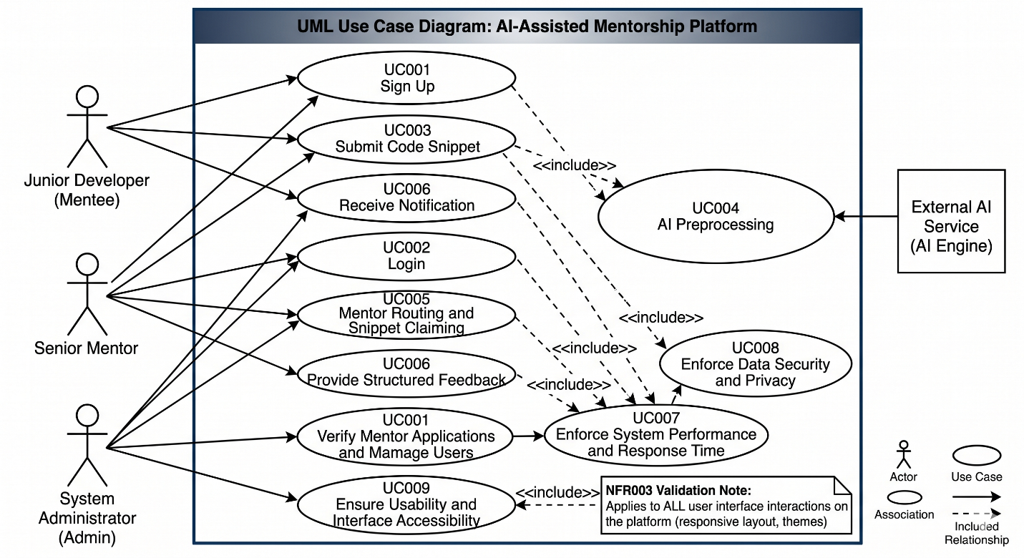
Figure 1: System Level Use Case Diagram

  - Use Case 1
ID | UC001
Name | Sign Up
Description | This use case describes the process flow for a new user to register on the platform as a Junior Developer or Senior Mentor.
Requirement(s) | FR001
Actor(s) | Junior Developer, Senior Mentor, Admin
Precondition | Actor must not already have an account registered with the provided email.
Postcondition | Actor's account is created. If applying as a Senior Mentor, they will view a message pending Admin approval.
Basic Flow | Basic Flow  1. Actor selects their desired role (Junior Developer or Senior Mentor) and enters credentials.  2. System validates the inputs.  2.1. Following fields are required:  2.1.1. Name  2.1.2. Email Address  2.1.3. Password  2.1.4. Role Selection  2.1.5. Professional Profile Link (If Senior Mentor)  2.2. Check the proper inputs for following:  2.2.1. Valid Email format.  2.2.2. Password must be 8 characters including a number and special character.  3. On successful validation, the system creates the new user.  Alternative Flow  1. Admin Sign In.  2. Create a new User manually from the admin dashboard.  Exceptions  1. Invalid input formats (e.g., weak password).  2. Email already exists in the database.

  - Use Case 2:
ID | UC002
Name | Login
Description | This use case describes the authentication process for registered users to access the platform.
Requirement(s) | FR002
Actor(s) | Junior Developer, Senior Mentor, Admin
Precondition | Actor must have a registered and (if applicable) verified account.
Postcondition | Actor is granted a secure session and redirected to their specific dashboard.
Basic Flow | Basic Flow  1. Actor navigates to the login page.  2. Actor enters Email and Password.  3. System validates the inputs.  3.1. Required fields:  3.1.1. Email  3.1.2. Password  3.2. Check database for matching credentials.  4. On successful match, system generates a session token and redirects user.  Alternative Flow  1. Actor clicks "Forgot Password".  2. System sends a password reset link to the registered email.  Exceptions  1. Incorrect email or password.  2. Account is banned or pending admin approval.

  - Use Case 3:
ID | UC003
Name | Submit Code Snippet
Description | The process flow for a Junior Developer to submit code for AI evaluation and human mentorship.
Requirement(s) | FR003
Actor(s) | Junior Developer
Precondition | Actor must be logged in as a Junior Developer.
Postcondition | The snippet is saved and its status is updated to "Pending AI Evaluation".
Basic Flow | Basic Flow  1. Actor navigates to the interactive workspace.  2. Actor enters the snippet details.  3. System validates the inputs.  3.1. Following fields are required:  3.1.1. Title  3.1.2. Programming Language  3.1.3. Code Block  3.1.4. Description  3.2. Check inputs for following:  3.2.1. Code Block must not be empty.  3.2.2. Description must meet minimum character limit.  4. On successful validation, system saves the submission to the database.  Alternative Flow  1. Actor saves the snippet as a "Draft" instead of submitting it.  Exceptions  1. Missing required fields.  2. Network timeout during submission.

  - Use Case 4:
ID | UC004
Name | AI Preprocessing
Description | A system-triggered process where the platform evaluates submitted code using an external AI API.
Requirement(s) | FR004
Actor(s) | System (AI Module)
Precondition | A code snippet must exist in the database with the status "Pending AI Evaluation".
Postcondition | The snippet contains an AI-generated logic summary and is pushed to the global mentorship queue.
Basic Flow | Basic Flow  1. System detects a new pending submission.  2. System extracts the raw Code Block and Programming Language.  3. System securely transmits data to the AI API.  4. System receives the generated logic summary and syntax check.  5. System attaches this data to the database record.  6. System updates status to "Awaiting Mentor".  Alternative Flow  None (This is a strictly automated system flow).  Exceptions  1. External AI API is down or unresponsive.  2. The code block contains unsupported characters/languages.

  - Use Case 5:
ID | UC005
Name | Mentor Routing and Snippet Claiming
Description | The process where a Senior Mentor browses the global queue and claims a snippet for review.
Requirement(s) | FR005
Actor(s) | Senior Mentor
Precondition | Actor must be logged in as a Senior Mentor and snippets must exist in the global queue.
Postcondition | The snippet is assigned exclusively to the Mentor and removed from the global queue.
Basic Flow | Basic Flow  1. Actor navigates to the Mentorship Queue dashboard.  2. System displays a list of AI-preprocessed snippets.  3. Actor clicks "Claim Snippet" on a specific entry.  4. System validates the claim action.  4.1. Check that snippet status is still "Awaiting Mentor".  5. System assigns the snippet ID to the Actor’s account and updates status to "Under Review".  Alternative Flow  1. Actor uses the search filters to sort snippets by specific programming languages before claiming.  Exceptions  1. The snippet was claimed by another mentor a fraction of a second earlier (Concurrency conflict).

  - Use Case 6:
ID | UC006
Name | Provide Structured Feedback
Description | The process flow for a Senior Mentor to submit their architectural review and guidance.
Requirement(s) | FR006
Actor(s) | Senior Mentor
Precondition | Actor must have an active snippet in their workspace with the status "Under Review".
Postcondition | Feedback is permanently saved, and the Junior Developer is notified.
Basic Flow | Basic Flow  1. Actor opens the claimed snippet workspace.  2. Actor enters architectural guidance into the feedback module.  3. System validates the inputs.  3.1. Required fields:  3.1.1. Feedback Text  4. Actor clicks "Submit Feedback and Mark Completed".  5. System saves feedback to the database.  6. System updates status to "Completed" and notifies the Mentee.  Alternative Flow  1. Actor optionally adds annotated, refactored code alongside the text feedback.  Exceptions  1. Feedback text is empty.

  - Use Case 7:
ID | UC007
Name | Enforce System Performance and Response Time
Description | Validation process to ensure the system processes requests within acceptable latency limits.
Requirement(s) | NFR001
Actor(s) | All Users, System
Precondition | The system is live and receiving HTTP requests.
Postcondition | System successfully returns the requested interface or data without timeouts.
Basic Flow | Basic Flow  1. Actor triggers an action (e.g., loads a page or submits code).  2. System receives the HTTP request.  3. System processes the backend logic (Database query or AI API call).  4. System tracks the execution time.  4.1. Execution time must be:  4.1.1. < 2 seconds for standard page loads.  4.1.2. 5 to 8 seconds for AI evaluations.  5. System renders the response to the frontend.  Alternative Flow  None.  Exceptions  1. High server load causes execution time to exceed 8 seconds; system displays a "Loading/Processing" UI to prevent user frustration.

  - Use Case 8:
ID | UC008
Name | Enforce Data Security and Privacy
Description | The process of the system securing user credentials and encrypting data transmissions.
Requirement(s) | NFR002
Actor(s) | System
Precondition | User submits sensitive information (e.g., password during registration or login).
Postcondition | Data is irreversibly encrypted in the database and protected in transit.
Basic Flow | Basic Flow  1. System intercepts incoming user data payload.  2. System checks the connection protocol.  2.1. Protocol must be HTTPS (SSL/TLS encrypted).  3. System extracts the raw password string.  4. System applies a hashing algorithm (e.g., bcrypt) with a secure salt.  5. System stores only the hashed password in the PostgreSQL database.  Alternative Flow  None.  Exceptions  1. Request sent over unencrypted HTTP is immediately rejected or forcibly redirected to HTTPS.
  - Use Case 9:
ID | UC009
Name | Ensure Usability and Interface Accessibility
Description | The system's dynamic response to differing viewport sizes and environmental conditions to maintain readability.
Requirement(s) | NFR003
Actor(s) | All Users, System
Precondition | User accesses the application via a web browser on any device.
Postcondition | The interface renders correctly without overlapping elements or unreadable text.
Basic Flow | Basic Flow  1. Actor navigates to the application URL.  2. System (Frontend React) detects the device's viewport width.  3. System applies the appropriate CSS media queries.  3.1. Renders desktop grid layout if width > 1024px.  3.2. Renders mobile stack layout if width < 768px.  4. System detects user's system theme preference (Dark/Light mode).  5. System loads the corresponding syntax highlighting theme for the code workspace.  Alternative Flow  1. Actor manually toggles the interface theme from Light to Dark mode via the UI settings.  Exceptions  1. Browser does not support modern CSS grid/flexbox (System displays a fallback basic layout).

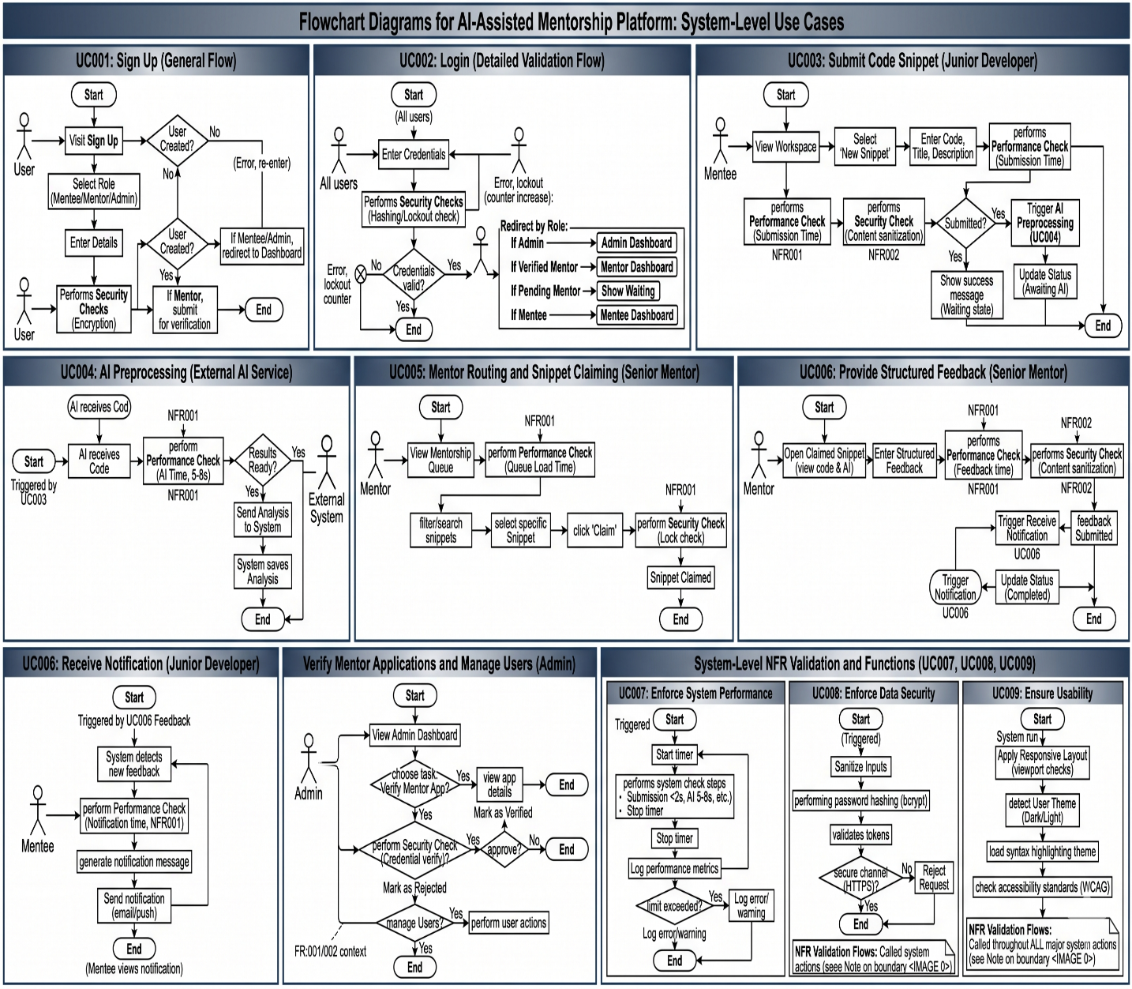

- References

[1] Meta Open Source. "React: A JavaScript library for building user interfaces." React.dev. https://react.dev/ (accessed Apr. 30, 2026).

[2] Kamil Myśliwiec. "NestJS - A progressive Node.js framework for building efficient, reliable and scalable server-side applications." Nestjs.com. https://nestjs.com/ (accessed Apr. 30, 2026). [3] Prisma Data. "Next-generation Node.js and TypeScript ORM." Prisma.io. https://www.prisma.io/ (accessed Apr. 30, 2026).

