***A&D Designs Ltd.***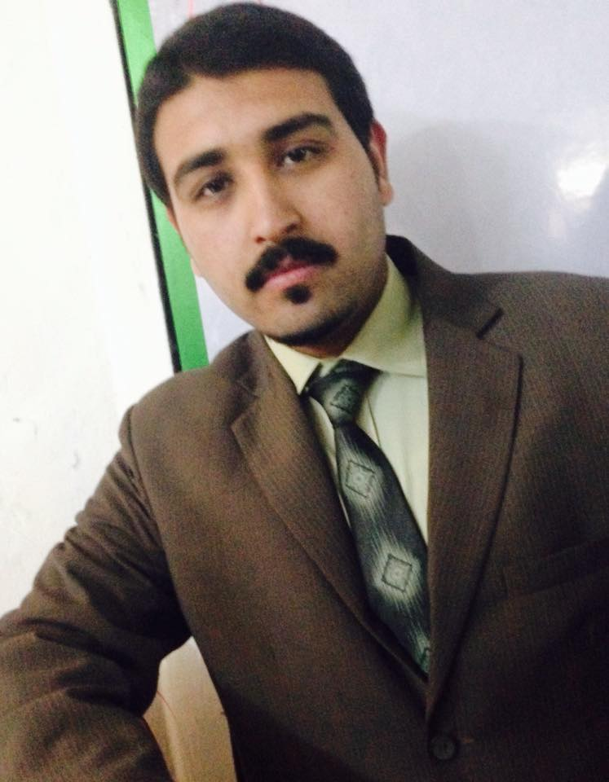

M.Danial Khan

Founder & CEO

*A&D Designs Ltd.*

I am very much impressed from the work. We continuously facing problems due to variceal graphics of our web which were not deplicit our culture. Now the problem is being solved, we got what we want. We wish the best of luck to bm designs team for their future endeavors.

TSA Sports

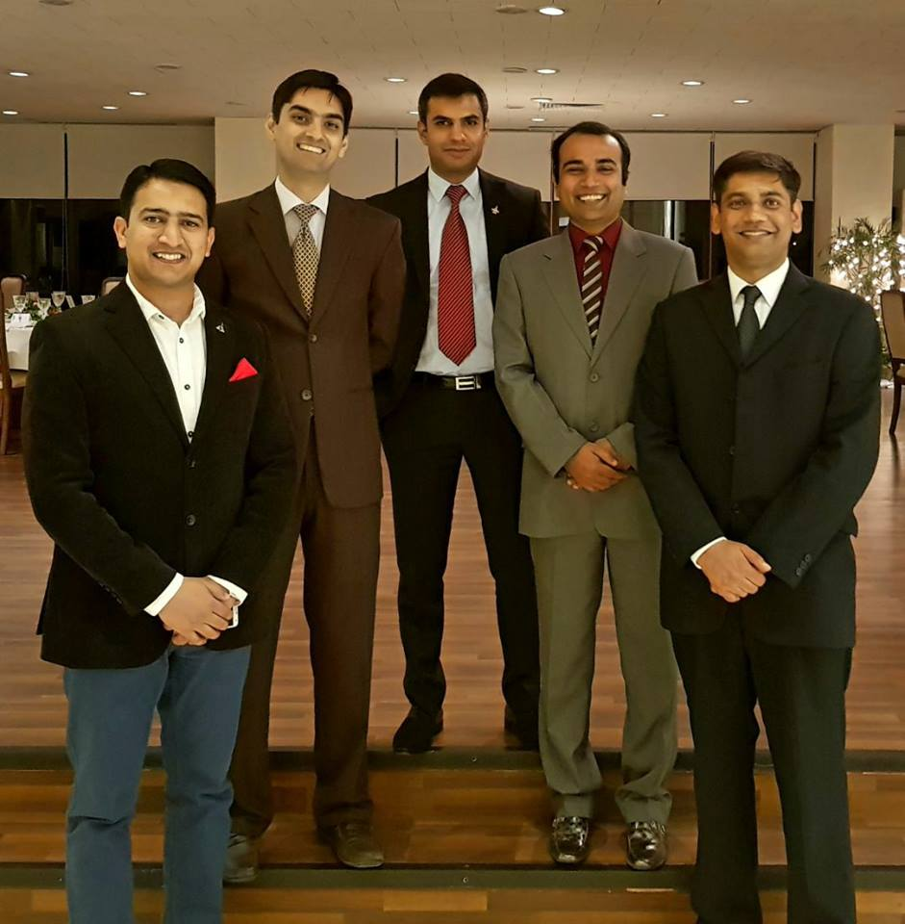

Team **TSA Sports**

Mr. Jawad Awan

Chairman

**TSA Group**

**&**

His entire team wishes best of luck to bm designs for their future ahead.

We also appreciated your hard work in making our web attractive and functional.

Thanking You & Regards,

**TSA**