Name: Mustansir kanor Wala Roll No.:102303843
Q1: DAXPY (Vector Addition)
What I Did
I wrote a program that performs vector addition using the formula X[i] = 2.5 * X[i] + Y[i] for over 1 million elements. First, I ran it sequentially (normal way), then in parallel with 2, 4, 8, 16, and 32 threads.
Results
Timing Results:
- Sequential time: 0.010253 seconds
- 2 threads: 0.006822 seconds (1.50x speedup, 75% efficiency)
- 4 threads: 0.006032 seconds (1.70x speedup, 42% efficiency)
- 8 threads: 0.005240 seconds (1.96x speedup, 24% efficiency)
- 16 threads: 0.003776 seconds (2.72x speedup, 17% efficiency) - Best performance
- 32 threads: 0.006216 seconds (1.65x speedup, 5% efficiency) - Performance dropped
Performance Counters (perf stat):
- Task-clock: 90.27 ms
- CPUs utilized: 0.927 (less than 1 full CPU)
- Context-switches: 194
- CPU-migrations: 21
- Page-faults: 4,239
- User time: 0.061 seconds, System time: 0.032 seconds
What I Learned
The best speedup happened at 16 threads, but after that performance got worse. The performance counters revealed why - CPU utilization was only 0.927, meaning the CPU cores weren't even fully busy. This tells me that DAXPY is memory-bound, not compute-bound. The program spends most of its time waiting for data from RAM rather than actually computing. Adding more threads just created more overhead without speeding things up. The low number of context switches (194) shows threads weren't fighting much for resources, which is good.
Real-world example: This is like having too many cooks in a small kitchen. After a certain point, they just get in each other's way instead of cooking faster.
These are my Outputs:
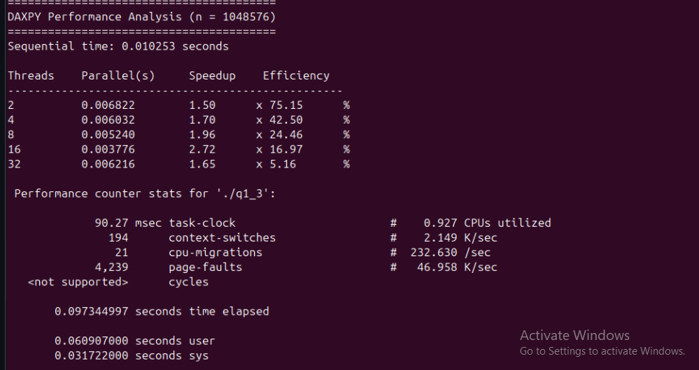

Q2: Matrix Multiplication
What I Did
I multiplied two 1000×1000 matrices using four different approaches:
- Simple 1D threading (each thread handles rows)
- Optimized 1D with transpose (better memory access)
- 2D threading with collapse (threads handle scattered elements)
- 2D transpose with collapse
Results
Simple 1D Version:
- Sequential: 3.867 seconds
- 2 threads: 3.477 seconds (0.88x - actually slower!)
- Best case: Still slower than sequential
- Performance counters: 48.4 seconds task-clock, 1.762 CPUs utilized, 18,894 context-switches
Transpose 1D Version:
- Sequential: 1.954 seconds (much better baseline!)
- 2 threads: 1.171 seconds (1.67x speedup, 83% efficiency)
- Better performance overall
2D Collapse Version:
- Sequential: 2.76 seconds
- Performance similar to 1D, not much improvement
2D Transpose with Collapse:
- Sequential: 2.037 seconds
- 2 threads: 1.079 seconds (1.89x speedup, 94% efficiency) - Best method
- 4 threads: 1.048 seconds (1.94x speedup, 48% efficiency)
- Performance counters: 52.4 seconds task-clock, 1.771 CPUs utilized, 20,017 context-switches
What I Learned
Matrix multiplication taught me that algorithm optimization matters more than just throwing threads at a problem. The transpose version was almost twice as fast even sequentially because it reads memory in order (better cache usage). The performance counters showed interesting differences - the 2D version had more context switches (20,017 vs 18,894) and more CPU migrations (198 vs 135), which explains why it had extra overhead. The user time being much higher than elapsed time (52 seconds vs 29 seconds) proves that parallel execution worked - multiple cores were computing at the same time.
Real-world example: This is like organizing books on a shelf. If you arrange them properly first (transpose), finding and using them becomes much faster, even before adding more people to help.

This is my Output:
1D version
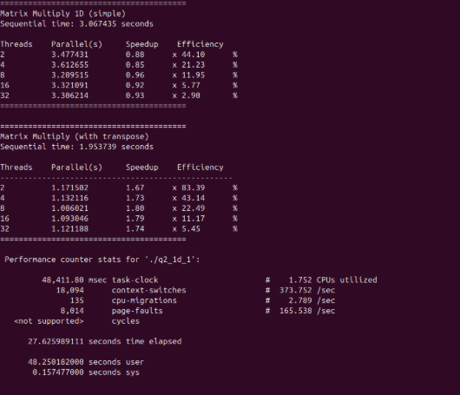
2D version:
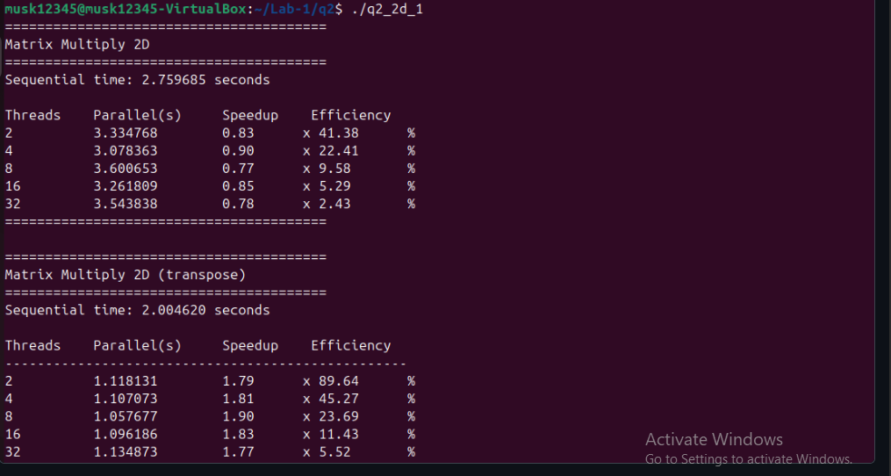

Q3: Calculating Pi
What I Did
I approximated π using numerical integration by dividing a mathematical curve into 100 million tiny rectangles and adding up their areas. Each rectangle calculation is independent, making this perfect for parallel computing.
Results
Timing Results:
- Sequential time: 0.233396 seconds, π ≈ 3.14159265359
- 2 threads: 0.190770 seconds (1.22x speedup, 61% efficiency)
- 4 threads: 0.200328 seconds (1.17x speedup, 29% efficiency)
- 8 threads: 0.174560 seconds (1.34x speedup, 17% efficiency) - Best performance
- 16 threads: 0.189200 seconds (1.23x speedup, 8% efficiency)
- 32 threads: 0.179831 seconds (1.30x speedup, 4% efficiency)
Performance Counters (perf stat):
- Task-clock: 1,952.16 ms (1.95 seconds)
- CPUs utilized: 1.660 (about 1.7 CPUs on average)
- Context-switches: 833
- CPU-migrations: 41
- Page-faults: 139 (very low!)
- User time: 1.943 seconds, System time: 0.011 seconds
What I Learned
The π calculation showed moderate parallel speedup with best performance at 8 threads (1.34x). What's interesting is that the performance counters reveal this is a compute-bound problem - CPU utilization reached 1.66, much higher than DAXPY's 0.927. The very low page faults (139) show that once the memory is allocated, the program doesn't need to access RAM much. Context switches were moderate (833), higher than DAXPY but lower than matrix multiplication. The user time (1.943s) being close to elapsed time (1.176s) shows decent parallel execution across multiple cores. All threads calculated π accurately to 3.14159265359, proving the reduction clause worked perfectly to combine results safely.
Real-World Application: Social Media Like Counter
The same technique I used to calculate π is used by platforms like Instagram and YouTube for counting likes on viral posts:
How it works:
- Thread 1 counts likes from users 0-10 million
- Thread 2 counts likes from users 10-20 million
- Thread 3 counts likes from users 20-30 million
- All counts combine automatically using reduction
Instead of checking 1000 servers sequentially (taking 1000 seconds), 4 threads can check 250 servers each simultaneously (taking only 250 seconds) - 4x faster!

This my output for question 3:
