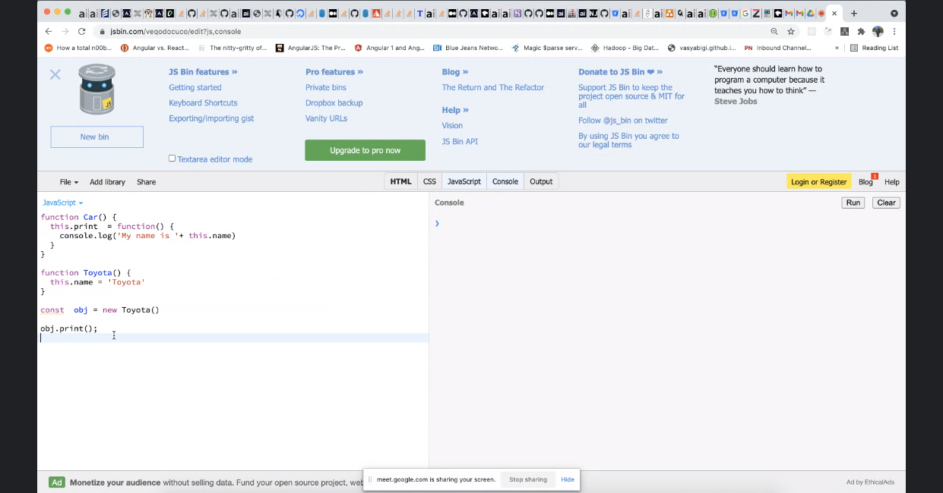

ANSWER

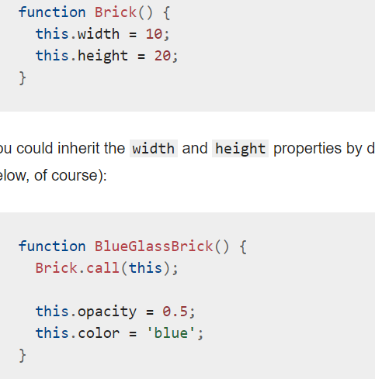

Q

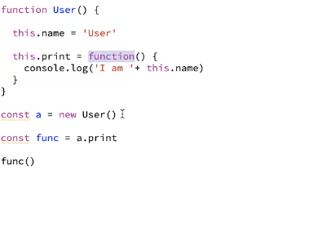

Y promise(instaneouos) b4 settimeout({},0)

Bundling in react no of bundles ? how

Can react app run in production without build ?

Err in node (MW) . central way?

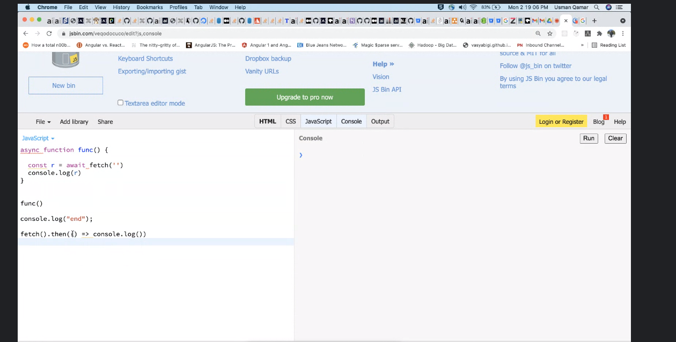

SOLID   
  
Rest Api standard  
  
OOP – 4 pillars