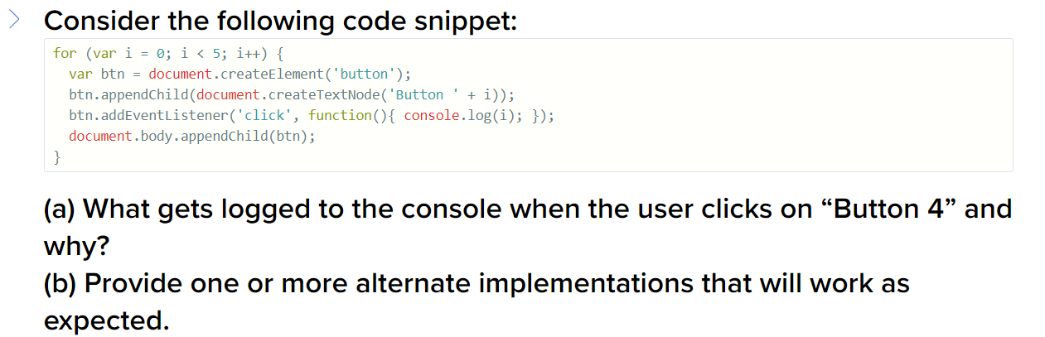

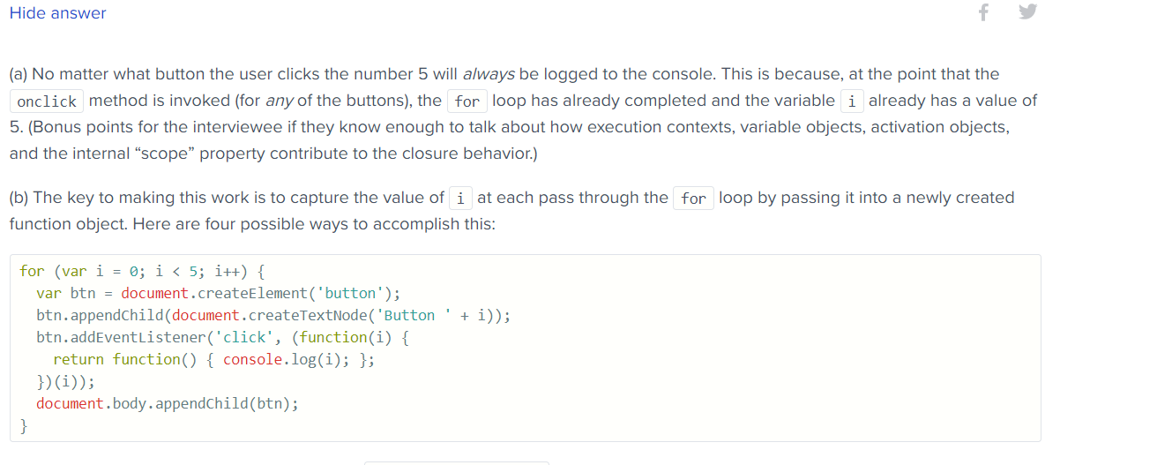

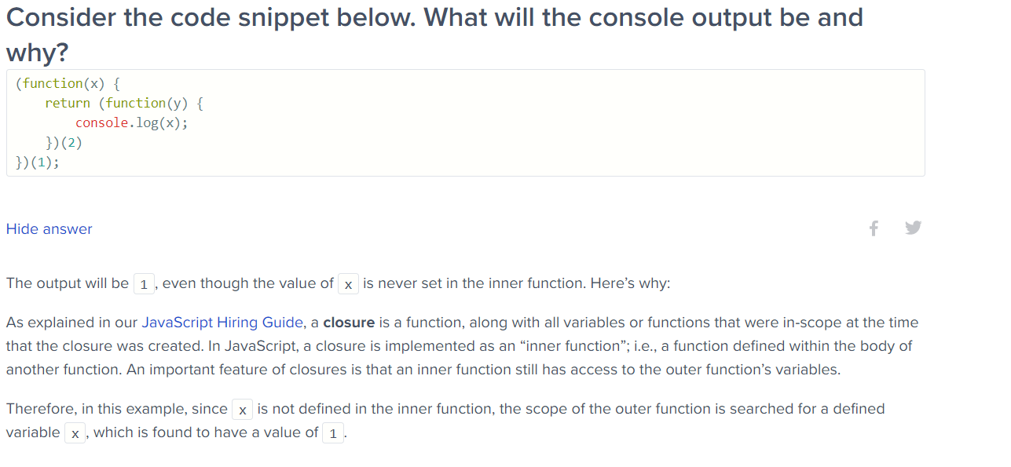

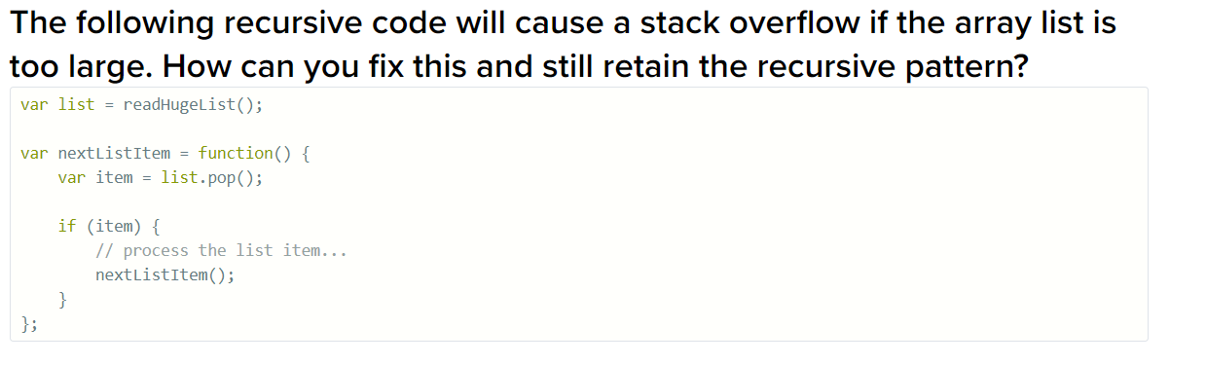

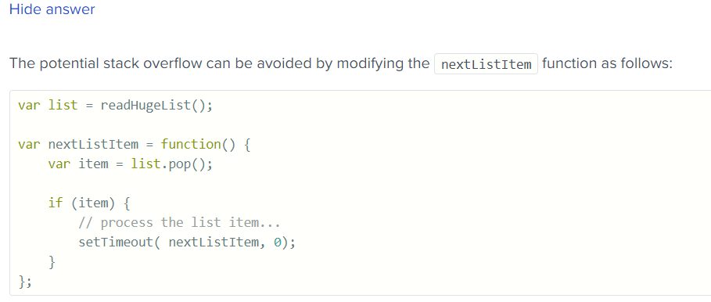

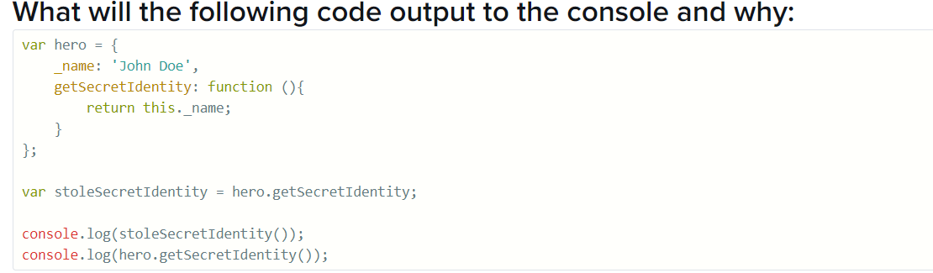

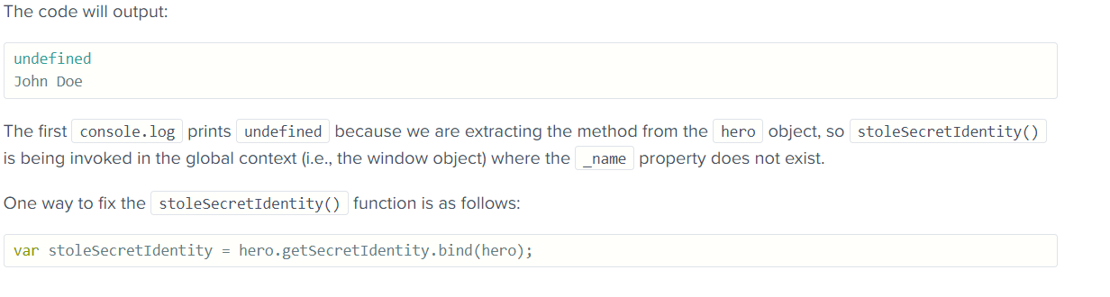

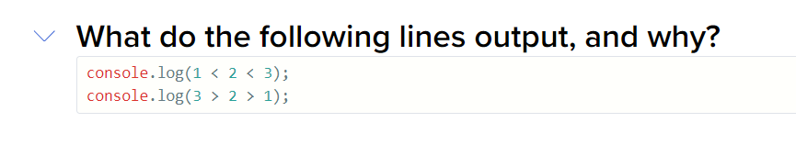

***What will be the output of the code below?***

*var Employee = { company: 'xyz' }*

*var emp1 = Object.create(Employee);*

*delete emp1.company*

*console.log (emp1.company);*

The output would be xyz.

**Q: map vs forEach**

**Q: spread vs rest operator ?**

**Q How to clone an object ? All possible ways , their benefits or limitations ?**

**Q: .call() vs .apply() vs .bind()**

**Q: Wats the 2nd argument of this.setState ? (callback function)**

**Q: how to implement above mentioned callback functionality using setstate ?**

**Q : Virtual DOM ? Anatomy of Nodes ?**

**Each Virtual Dom node contains :**

* nodeName (e.g. div, p h1)
* attributes(e.g. class)
* children(child nodes)

**Q: Flow of Redux ? Principles of Redux? Redux Saga vs thunk ? *Reducer. ?***

1. Single source of truth
2. State is read-only:
3. Changes are made with pure functions:

**Q: Error Boundry in react / functional vs class components**

**Q: use Effect alternates for which class lifecycle methods and how ?**

**Q : Key in React ? Why use ? (used for rendering lists)**

**Q: Wat is*<Unknown> in react-devtools.***