PENETRATION TESTING REPORT
FOOTPRINTING & RECONNAISSANCE PHASE
W2-PM1 | CYBERSECURITY | NETWORKWALKS
Pentester Name | Mustapha Abdullateef
Program/Batch | B083-Networkwalks
Date | 15/09/2026
Module Completed | W2-PM1 (Footprinting & Reconnaissance Attacks with Multiple Kali Tools)
Client/Target | Networkwalks.com (secured written permission via lab exercise)
Permission Secured from Client? | Yes
Phases Covered | Phase 1: Reconnaissance & Footprinting

1. Liability Disclaimer
I have performed these activities only on the systems and devices where I had secured written permission or the devices/systems that I own myself. All these materials are for education and research purposes only. I did not use anything from here to break the law. The instructor, the authors and Networkwalks are not responsible for what I do with this knowledge. Every action I take is my own responsibility. Misuse can lead to criminal charges, heavy fines, loss of employment and a permanent record. In most countries, unauthorised access is a crime even when nothing is damaged.

2. Introduction
This report covers the footprinting and reconnaissance phase carried out against the networkwalks.com domain using multiple built-in tools (W2-PM1). This module demonstrates how an attacker gathers publicly available information about a target before any direct engagement, forming the foundation for later scanning and exploitation phases.
All commands were executed from a Linux terminal environment (Termux on Android) configured with the required reconnaissance tools. Every step below includes the exact command used, the result observed, a screenshot as evidence, and a short note on why the finding matters from an attacker's point of view.

3. Tools Used
The table below lists each tool used in this report and its purpose.
Tool | Purpose
Termux (Android) | Linux terminal environment used to run all reconnaissance tools.
WHOIS | Find domain registration details (owner, dates, name servers).
WhatWeb | Fingerprint web technologies (server, CMS, plugins, IP).
Nslookup | Resolve the domain name to its IP address using DNS.
Curl -I | Read the HTTP response headers of the website.
Wafw00f | Detect whether a Web Application Firewall protects the site.
DNSRecon | Enumerate all DNS records (NS, MX, SPF, TXT, SRV).

4. Activities Performed

4.1 Footprinting & Reconnaissance
I performed reconnaissance against the networkwalks.com domain using six tools: WHOIS, WhatWeb, Nslookup, Curl, Wafw00f and DNSRecon. Each tool was used to collect a different type of information about the target.
First, I used WHOIS to obtain publicly available domain registration information and identify the domain's name servers. The results showed the domain is registered with GoDaddy.com, LLC, created on 06 November 2019 and set to expire on 06 November 2027, with name servers NS6135.HOSTGATOR.COM and NS6136.HOSTGATOR.COM, revealing that the site is hosted on HostGator infrastructure. The registrant identity is protected through Domains By Proxy, LLC.
I then used WhatWeb to identify technologies used by the website. The results identified WordPress 7.1 and WordPress Download Manager 3.3.58, running on an Apache server with Bootstrap 7.1 and jQuery 3.7.1, and confirmed the server IP address as 192.232.216.135.
Using Nslookup, I resolved the domain name to its IP address via Google's public DNS server (8.8.8.8). The result confirmed the IP address 192.232.216.135, matching the IP identified by WhatWeb.
I used Curl with the -I option to inspect the HTTP response headers. The response returned HTTP/2 200, confirmed the server as Apache, revealed an x-nginx-cache header referencing WordPress, showed a __wpdm_client cookie being set, and exposed the WordPress REST API endpoint via the Link header (/wp-json/).
Next, I used Wafw00f to determine whether a Web Application Firewall was protecting the website. The result identified that the site is behind ModSecurity (SpiderLabs) WAF.
Finally, I used DNSRecon to enumerate DNS records. The results showed that DNSSEC is not configured for the domain. The enumeration returned the SOA record (ns6135.hostgator.com), two NS records (ns6135 and ns6136.hostgator.com), an MX record (mail.networkwalks.com), an A record confirming the IP 192.232.216.135, an SPF-related TXT record authorizing specific mail servers, and a Google site-verification TXT record. No SRV records were found.

5. Risk Analysis / Impact
Based on the information collected during the footprinting activities, I identified the following potential risks.
# | Risk / Finding | Evidence / Observation | Potential Impact | Risk Level
1 | Hosting provider identified | WHOIS name servers point to HostGator | Reveals hosting infrastructure, useful for social engineering or infrastructure mapping | Low
2 | Web technology and version exposed | WhatWeb identified WordPress 7.1 and WP Download Manager 3.3.58 | Attackers may cross-reference exact versions against known CVEs / exploits | Medium
3 | Server IP address identifiable | Nslookup resolved the domain to 192.232.216.135 | Provides the real network location of the web service for direct scanning | Low
4 | HTTP technical information exposed | Curl returned response headers and exposed /wp-json/ | May assist further technology fingerprinting and API enumeration | Low
5 | WAF technology identifiable | Wafw00f identified ModSecurity (SpiderLabs) | Reveals the web application's security architecture, informing evasion attempts | Low
6 | DNS infrastructure information exposed | DNSRecon identified NS, MX, SPF and verification TXT records; DNSSEC not configured | Helps build a broader infrastructure and mail-server profile; lack of DNSSEC allows potential spoofing | Medium

The risks above are observations from the footprinting exercise, not confirmed vulnerabilities. This activity involved information gathering only. No exploitation or vulnerability validation was performed. Therefore, the presence of a software version, IP address or DNS record does not by itself mean that the system is vulnerable. Further authorized security testing would be required to confirm any actual vulnerability.

6. Recommendations
Based on the observations from this activity, I recommend the following security improvements:
- Review publicly exposed technology information — regularly audit what CMS, plugin, and version details are visible externally.
- Keep software updated — WordPress and plugins such as WP Download Manager should be kept current against security advisories.
- Review HTTP headers — remove or minimize unnecessary technical details exposed in server response headers.
- Review DNS records regularly — ensure only required records and services are publicly exposed.
- Properly configure and monitor the WAF — keep ModSecurity enabled and tuned, since it already blocks naive attacks.
- Consider enabling DNSSEC — to reduce the risk of DNS spoofing or cache poisoning.
- Perform security testing with authorization — reconnaissance and scanning should only be performed against systems where appropriate authorization has been granted.

7. Conclusion
During this module of my Cybersecurity & Ethical Hacking training at Networkwalks, I completed a practical footprinting and reconnaissance exercise against the networkwalks.com domain.
Using six different tools, I learned how WHOIS can reveal domain ownership and hosting information, WhatWeb can identify web technologies and versions, Nslookup can resolve domain names to IP addresses, Curl can inspect HTTP headers for technical details, Wafw00f can identify the presence of a Web Application Firewall, and DNSRecon can enumerate a domain's full DNS footprint.
This exercise showed me that a significant amount of information about a target can be gathered before any direct exploitation attempt, purely from data the organization has already made public. I also learned the importance of documenting findings clearly — explaining what was performed, what was discovered, what the observation means, what risk it may create, and what can be done to reduce that risk.
Finally, I confirmed that reconnaissance activities must always be performed within an authorized scope. This exercise was completed strictly as part of the assigned educational cybersecurity lab.

8. Evidence Collected
Task 1 — WHOIS Lookup
Command: whois networkwalks.com — reveals registrar (GoDaddy), creation/expiry dates, and HostGator name servers.
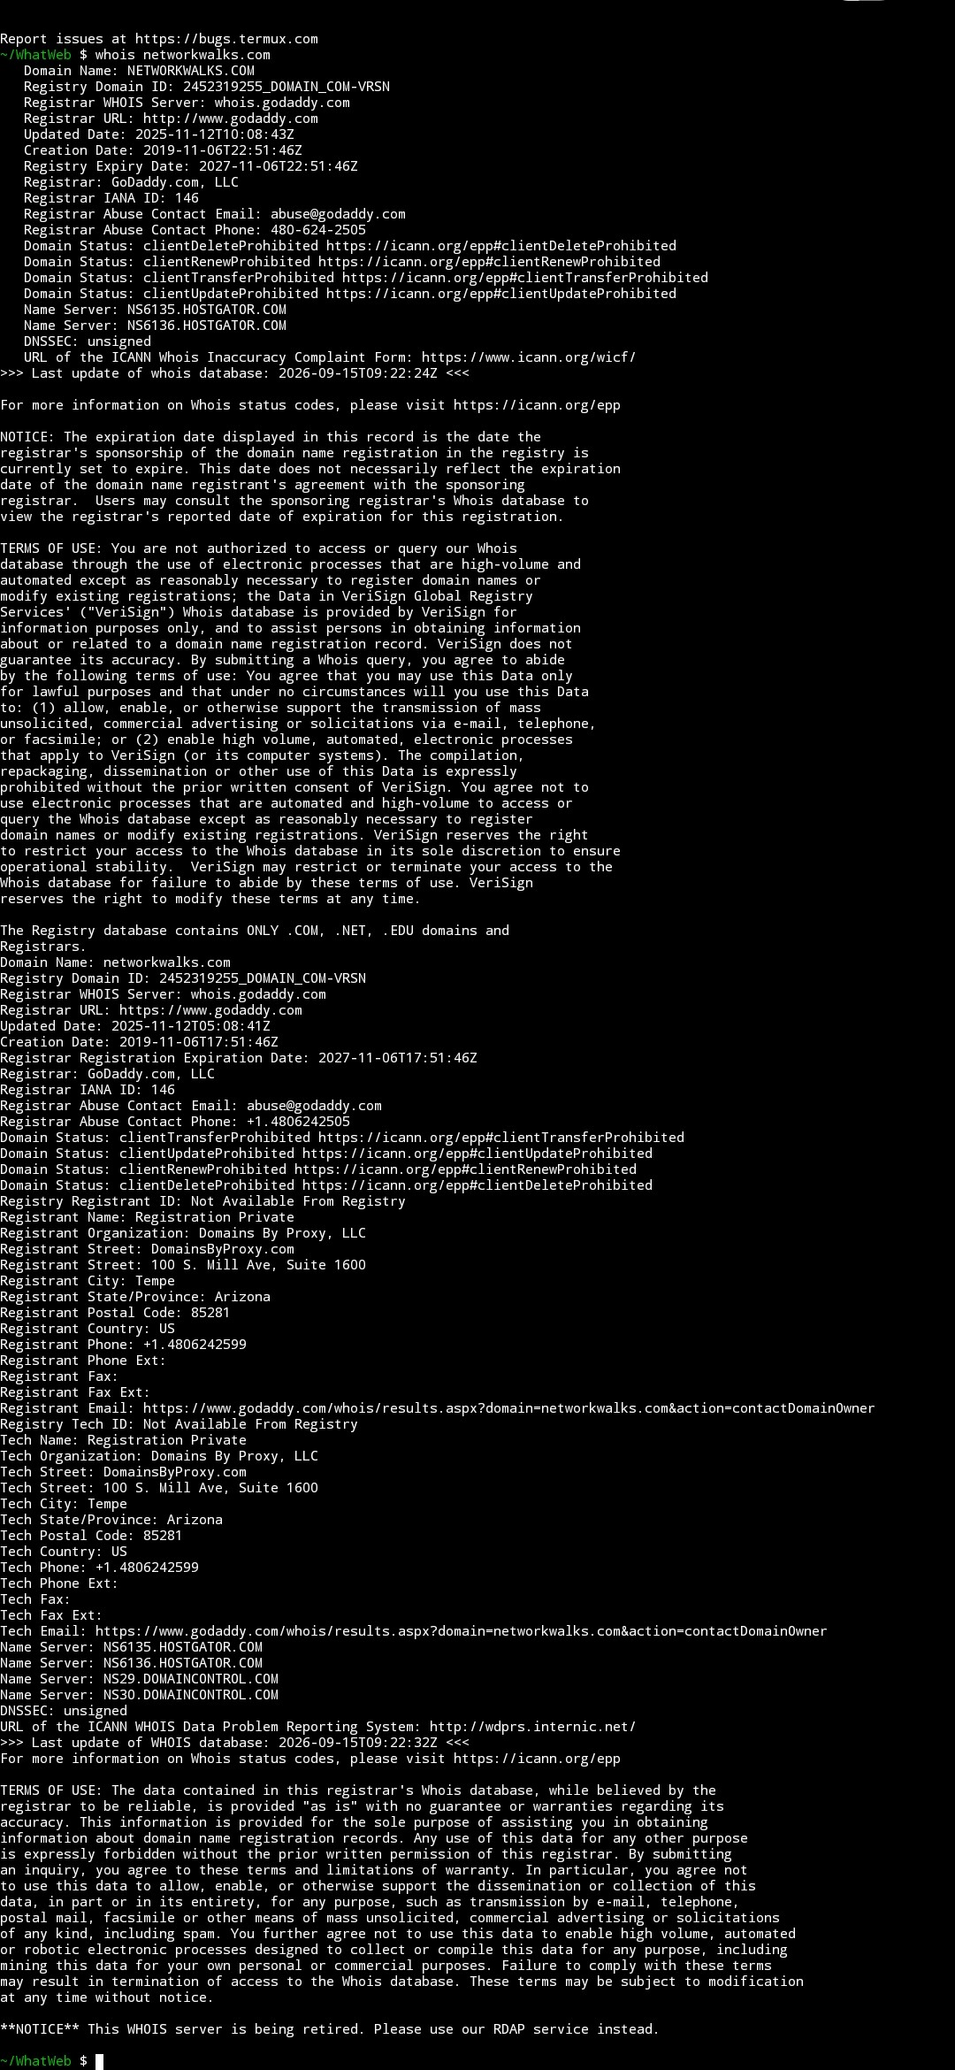
Task 2 — WhatWeb Fingerprinting
Command: ruby whatweb networkwalks.com — identifies WordPress 7.1, WP Download Manager 3.3.58, Apache, and server IP.
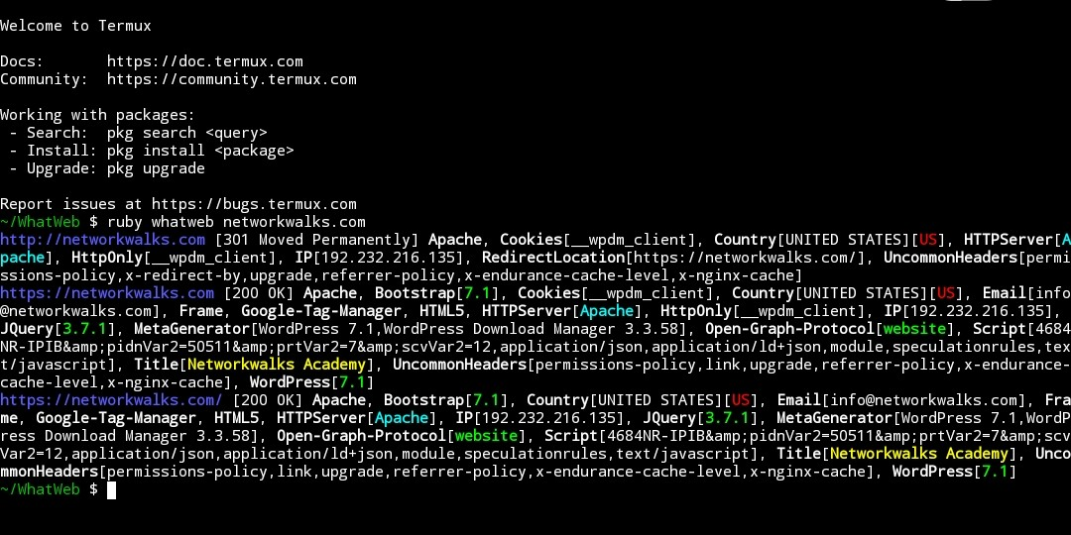
Task 3 — Nslookup DNS Resolution
Command: nslookup networkwalks.com — resolves the domain to IP address 192.232.216.135 via Google DNS (8.8.8.8).
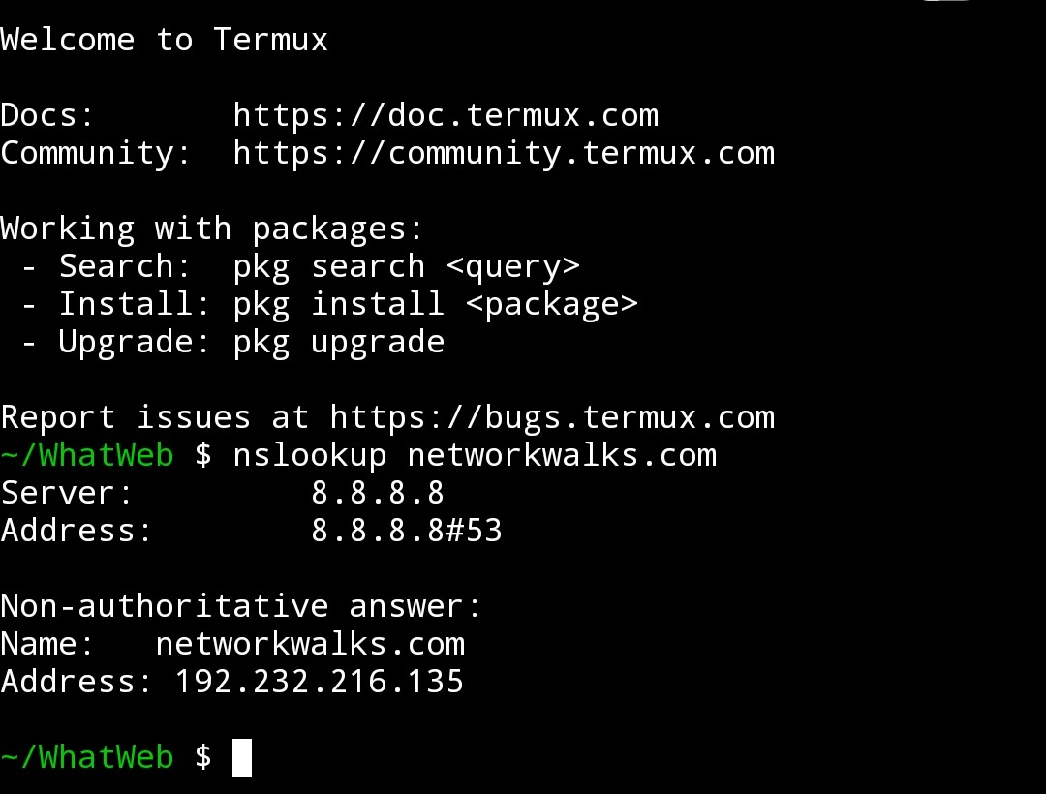
Task 4 — HTTP Header Inspection
Command: curl -I https://networkwalks.com — returns HTTP/2 200 response, Apache server header, and exposes the /wp-json/ REST API endpoint.
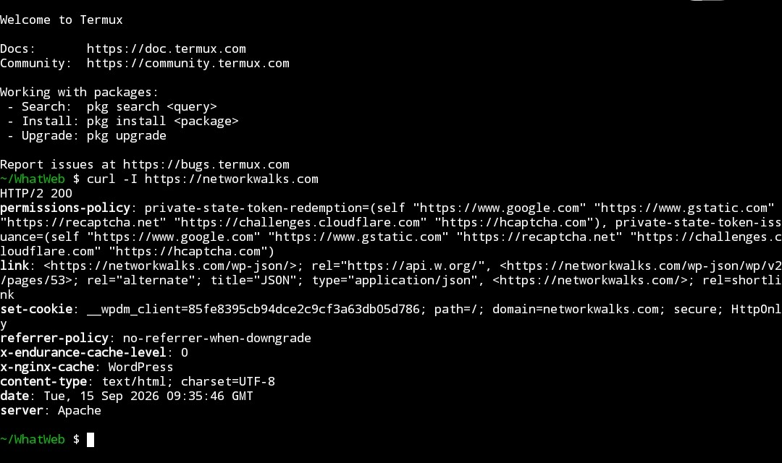
Task 5 — WAF Detection
Command: wafw00f networkwalks.com — confirms the site is protected by ModSecurity (SpiderLabs) WAF.
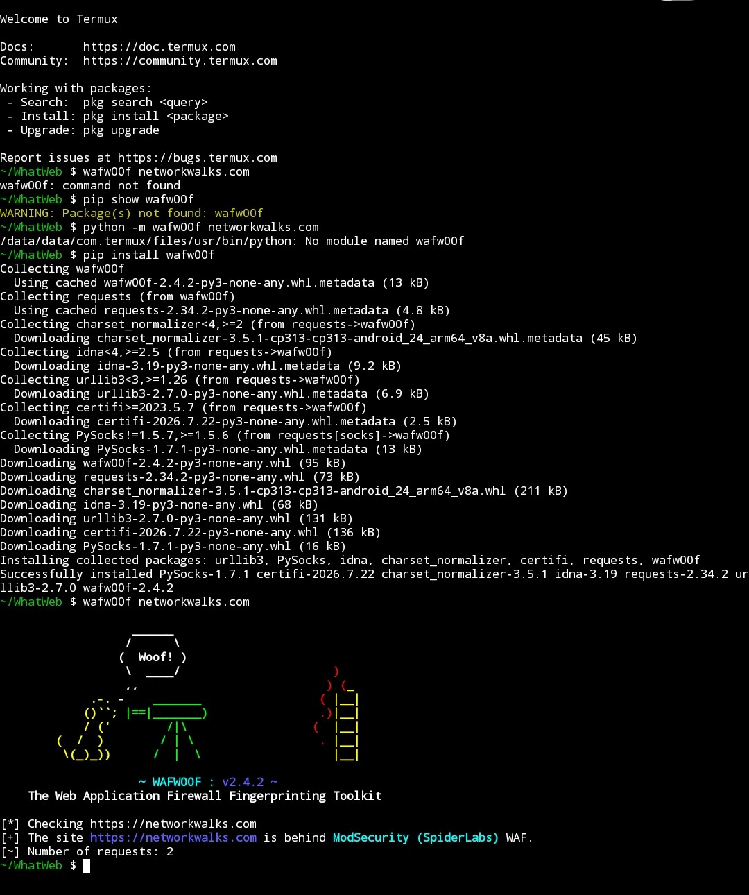
Task 6 — DNS Enumeration
Command: dnsrecon -d networkwalks.com -n 8.8.8.8 — enumerates SOA, NS, MX, A, and TXT (SPF/verification) records; confirms DNSSEC is not configured.
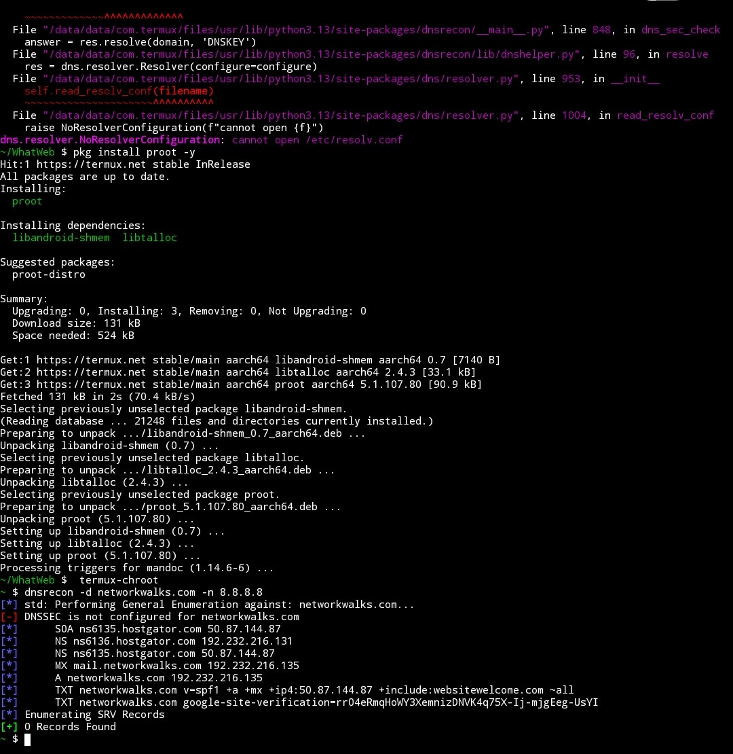
-End-
Author
Mustapha Abdullateef
Cybersecurity Trainee, Batch B083 — Networkwalks
Project Information
Program Name: Cybersecurity Program at Networkwalks | Module: W2-PM1 | Date: 15/09/2026

