Social Financing SPAC IPO

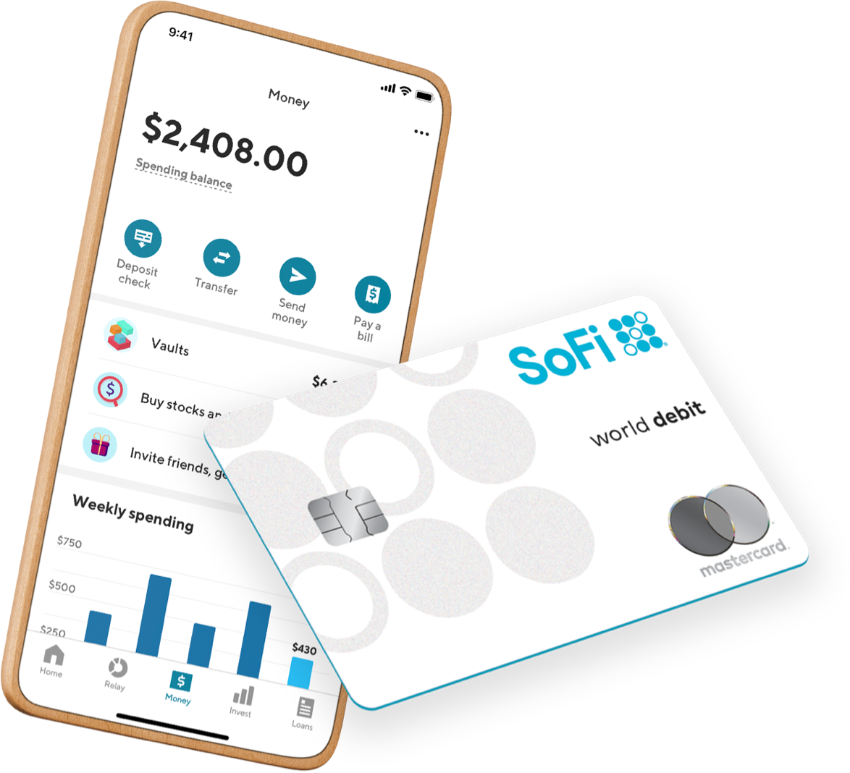

**Overview**

SoFi is a financial services firm that specializes in lending and asset management. The company focuses on early-stage professionals, offering variable and fixed-rate parent, personal, and MBA loans, as well as mortgage refinancing and other services. They develop new financial products and services to assist people in better borrowing, saving, spending, investing, and protecting their money so that they can gain financial freedom and accomplish their goals, such as buying a house, saving for retirement, and repaying student loans, among other things. Its headquarters are in San Francisco, California, where it was established in 2016.

**Products**

* **SoFi Money:** It is a cash management account that earns interest and has no account fees to attract younger customers or customers seeking to get their finances in order.  Users can also earn 15% cash back on everyday expenses if they pay with SoFi money
* **SoFi Credit Card:** This service is designed keeping in mind the consumers that need help repaying debt. This product also benefits users looking to invest and work towards saving.  It is the first credit card that allows its holders to cash in crypto via your Sofi active invest account.
* **SoFi Relay:** Users can connect all their accounts on one mobile dashboard, where they can monitor they credit score, which updates in weekly basis, track their spending and set multiple financial goals.
* **SoFi Invest:** This platform enables users to trade stocks, ETFs and crypto. This product branches out into numerous other supporting products like Active Investing, Automated Investing, Retirement Accounts, Crypto, Stock Bits and ETF Trader
* **Student Loan Refinancing:** This helps users save money and pay their education loans off faster. This category includes options like Medical Resident Refinancing and Parent Plus Refinancing
* **Personal Loans:** Taking pride in its ease of getting loans, SoFi offers easiest personal loans at no extra fees for reasons ranging from home improvement to credit card consolidation.
* **Home Loans:** This product includes mortgages, mortgage refinancing and home equity.

Sofi offers competitive rates, and many mortgage options from where to choose from. They accept as little as 5% down payment and offer a $500 discount on exclusive members.

* **Private Student Loans:** These flexible loans cover a wide array of loans for education purposes. SoFi offers loans for bachelors, grad school, law, MBA and even for parents at no extra processing fees.
* **SoFi Protect:** Assuring to protect all that matters, SoFi offers renters insurance, homeowners’ insurance, auto insurance and life insurance.
* **SoFi at Work:** This plan helps businesses integrate SoFi products in their operations as well as help employee realize benefits.
* **Small Business Financing:** As the name suggests, this product provides easy financing for small businesses. Sofi Is able to help small businesses via its branch called Lantern. Lantern looks at a variety of funding options, such as SBA schemes, small business loans, and personal loans. Get the most comprehensive range of options from our network of lenders – all in one place.

**Sponsor**

The sponsor for IPOE is the holding company SCH Sponsor V LLC. SCH Sponsor V LLC is a holding company established and operated in the Cayman Islands. SCH Sponsor V LLC is owned by the CEO of LBOE Chamath Palihapitiya and President Ian Osbourne. For all intents and purposes, SCH Sponsors V LLC shares in IPOE are attributable to Palihapitiya and Osbourne.

In July of 2020, the sponsor purchased 2,875,000 founder shares for a purchase price of $25,000. Two subsequent share recapitalizations in 2020 resulted in SCH Sponsor V LLC owning 20,025,000 total class B shares. Each class B share owned by the sponsor are convertible to 1 share of Class A after the business combination. The Sponsor, affiliates of sponsors, and certain directors of the company are also allowed to make loans up to $2,500,000 in exchange for warrants priced at $2.00 per warrant at the option of the lender.

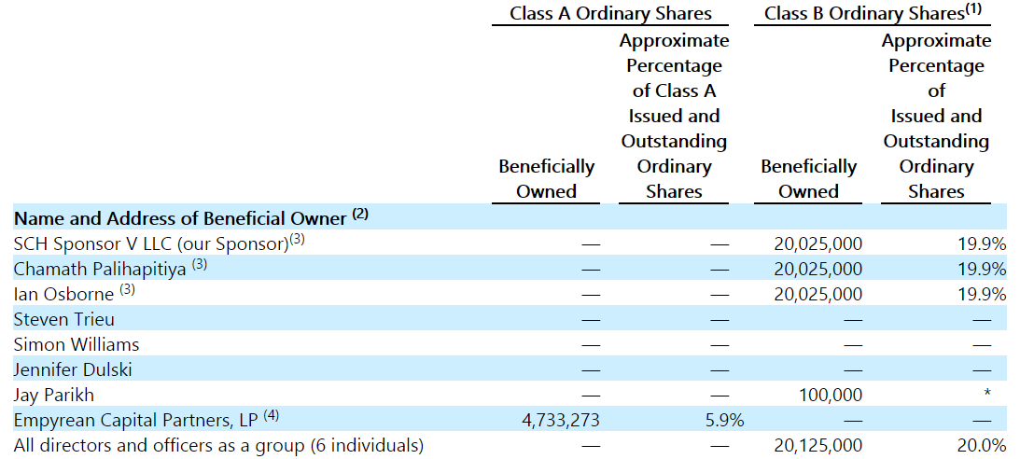

**Management:**

Chamath Palihapitiya  
Chamath Palihapitiya 44 it is an entrepreneur and venture capitalist. He founded Social Capital in 2011 with the purpose of investing in companies operating in fields being ignored by other venture capitalists such as financial services, health and education. Chamath was an early senior executive at Facebook, where he was known as a “bully” making Steve Jobs cry multiple times. He worked at Facebook for 5 years and left the company in 2011. Prior to Facebook he had leading roles in companies such as The Mayfield Fund where he worked as a Venture Capitals for a year and AOL where Chamath held the position of CFO for 2 years and then got promoted to CEO.

Ian Osborne   
Ian Osborne is the Co-Founder of Social Capital Hedosophia Holdings , a partnership between Chamath Palihapitiya and Osborne ,where he is serving as CEO since 2012. He has advised leading internet and technology companies, their founders and CEO’s since 2009. In addition, he is the founder and Chairman of Osborne & Partners a strategic advisory firm, and founder of Connaught, a financial advisory firm.

Steven Trieu  
Steven Trieu is currently serving as Chief Financial Officer Social Capital Hedosophia Holdings Corp. VI , V and IV. He has also held the same position for Social Capital Hedosophia Holdings Corp III , II and I. Prior to Social Capital Hedosophia Holdings Corp. Trieu held the position of Director of Finance and Business Operations at Facebook before accepting an offer as VP of Finance at Quora Inc.

Since there is no company to start with, no assets no product investors will bet on the expertise of the management team, and their ability to lead to a successful SPAC IPO. Three top executives of Social Capital Hedosophia Holdings Corp.V Chamath Palihapitiya ,Ian Osborne and Steven Trieu are successful venture capitalist who have been greatly exposed to SPAC IPO environment , holding the positions mentioned above for 3 fruitful SPAC IPO , including Virgin Galactic and OpenDoor Technologies. Unlike his coworkers, wo prefer to keep a low profile and have a minimum digital footprint Chamath Palihapitiya is regarded as a public figure with over 1.5 million followers in twitter. He is an influential person who uses his fame to promote his SPAC investments and attract institutional and retail investors.

**Stock Performance**

Day One

IPOE debuted on the public market on Tuesday, December 1st, 2020 at $10.60. $10.74 was the high watermark of the day for the price, with the opening day floor being $10.46 set in the first hour of trading and a close of $10.60. Excluding the first week of trading, the high, low, and close on December 1, 2020 would all be the lowest figures in the respective measures for IPOE as of May 11, 2021. The volume on day one of trading was 536,000. No official press releases about IPOE were available on the day of listing with the exception of the announcement of IPOE’s creation months prior and tweets by founder, Chamath Palihapitya.

Week One

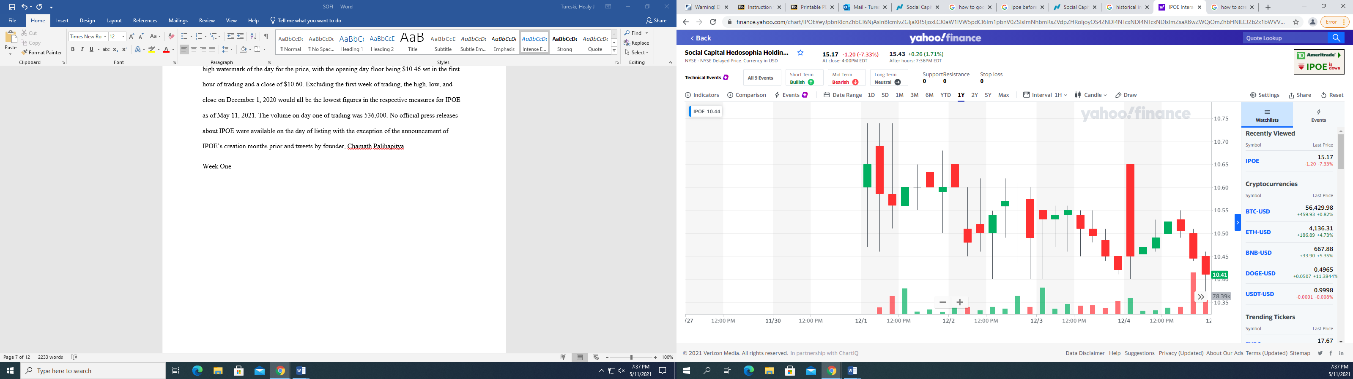As IPOE debuted on a Tuesday, the holding company’s first week of trading was truncated down to a 4-day week. Trading volume and price fell throughout the week, hitting an all-time low of $10.37 within the last 30 minutes of Friday’s trading session. The ceiling and highest closing price of the of the week were recorded on Tuesday, December 1st, 2020, the opening day.

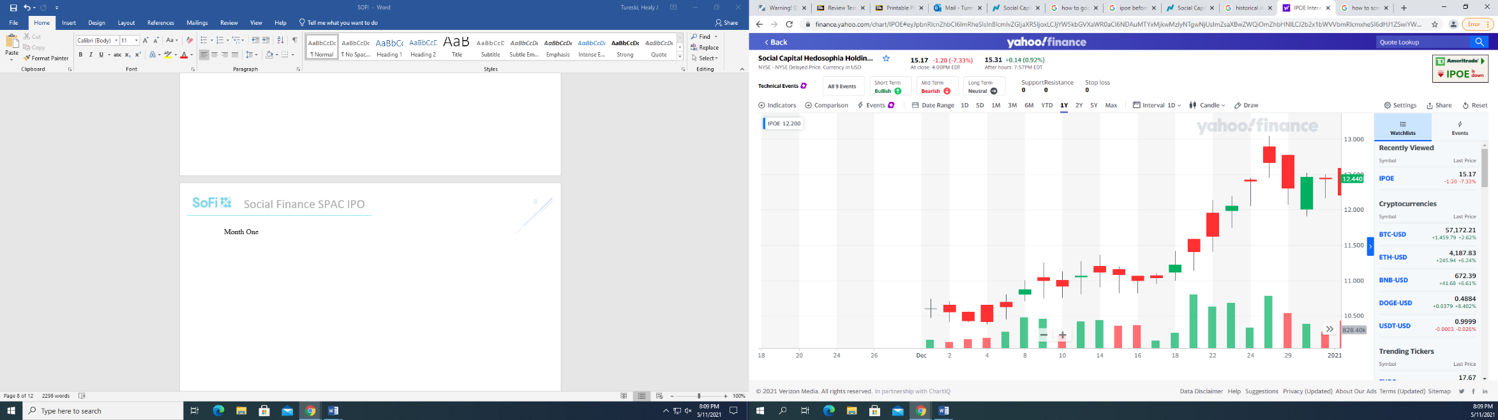Month One

On December 31, 2020, IPOE stock closed at $12.44, totaling off a 17.5% growth in stock price during the stock’s first month of trading. Trading volume picked up throughout the month as well with 2.66 million trades being executed on December 21, 2021. The highest ceiling of the month, $13.04 was measured on December 24th, 2020. The lowest close and intraday price of the month were both recorded within the first week of IPOE trading.

2021 to Date

The current year has been highly volatile for the price of IPOE. On Thursday, Janauary 7, 2021, founder Chamath Palihapitiya announced that the SPAC would be merging with SoFi. By noon, prices had risen 30% from the previous day and trading had to be halted. By the end of the day, shares hit a high price of $22 and closed at $19.14, marking 80% growth in the 5 weeks that the SPAC was on the market. Volume was significantly greater on January 7th, 2021 than it had been or would be subsequently at nearly 65 million trades. Two weeks later, prices climbed again to a new high of $24.62 on January 20, 2021 before falling to $18.18 the following week. On February 1, 2021, prices jumped to IPOE’s standing all-time high at $28.26. During this time some of the unique aspects of SPAC business composition influenced the price upward. Chamath Palihapitiya was highly vocal on his twitter account about the retail-investor driven stock frenzy. Palihapitiya pushed messaging supporting retail-investors as they navigated allegations of price manipulation, legislation, and brokerage-enforced limits on trading. Palihapitiya became a household name during the saga, leading many investors to discover his companies for the first time. Retail-Investors, frustrated with big-name brokerages such as Robinhood and TD’s handling of the situation, also became interested in lesser known FinTech services such as SoFi. The convergence of Palihapitiya growing personal popularity, and the explosive demand for retail-investor-focused FinTech led to a powerful synergy that boosted the SPAC of January and February about Price fell throughout February, hitting a lowest-post-merger-announcement price of $13.14. Since, the price of the stock, has traded in between the $15 and $19 range. IPOE saw its largest trading volume since the start of April on May 7th, 2021 when 5.82 million shares changed hands. IPOE jumped 10% on May 7th on the anouncement that the merger would be completed soon and the ticker for IPOE would become $SoFi starting June 1, 2021

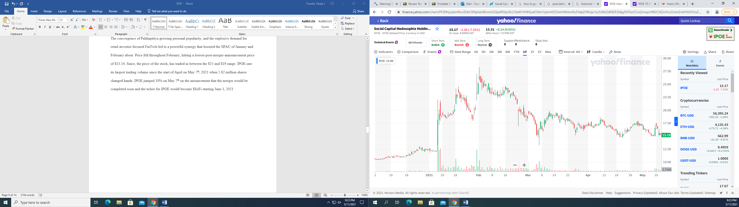

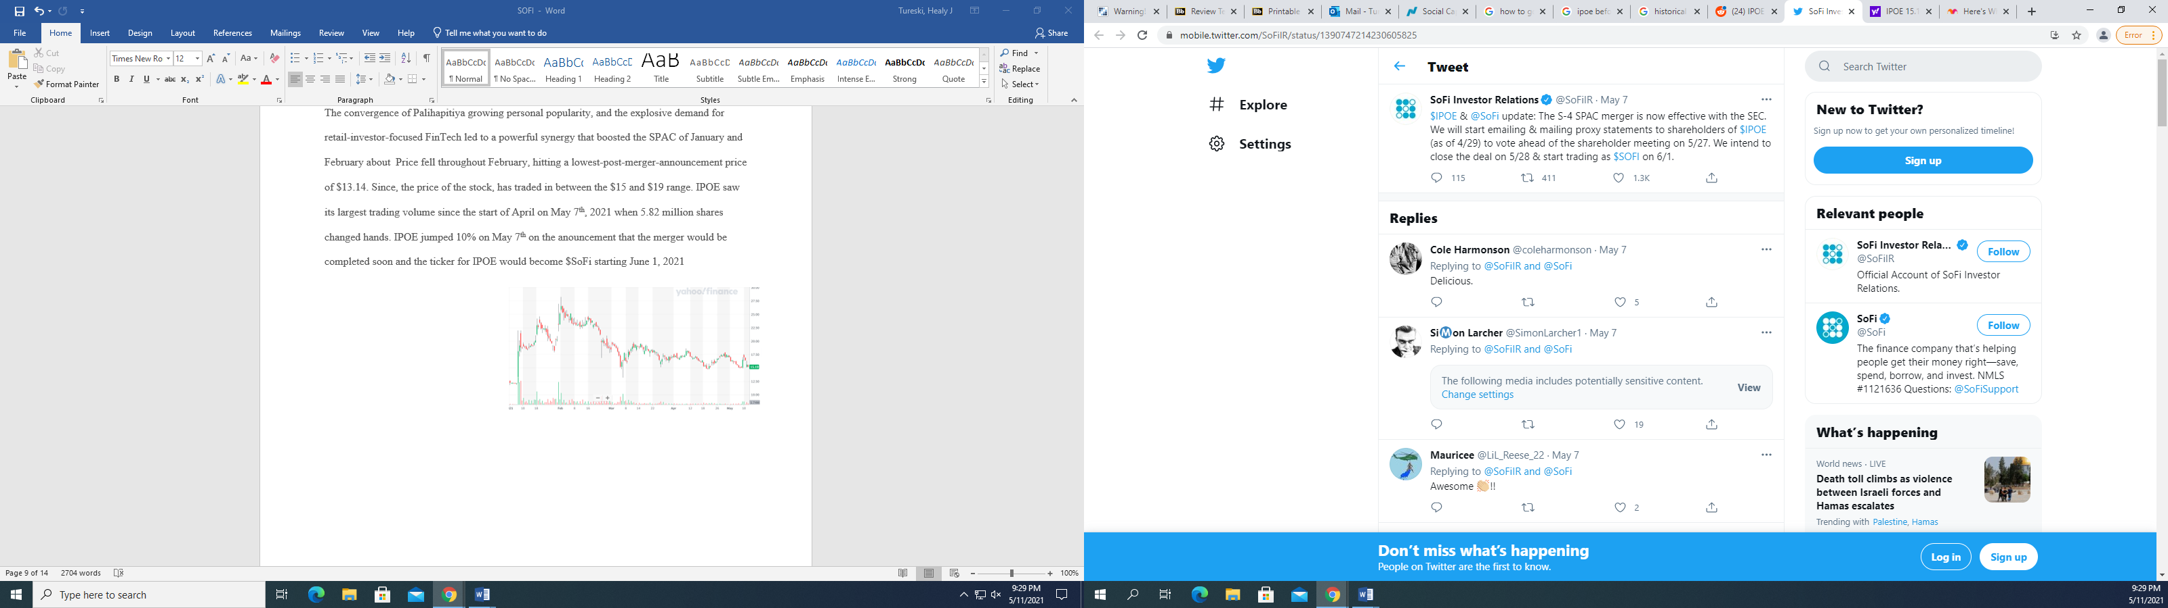

**Why SPAC**

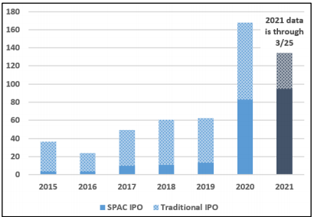SPAC IPOs in the United States raised a record $83 billion in 2020 and another $95 billion in the first quarter of 2021 alone, according to reports. During the first three months of 2021, SPAC IPOs outperformed conventional IPOs as the preferred mode of public fundraising. Therefore, a question is raised is it better for companies to go public though a SPAC IPO or should they stick out with the traditional one. In the following paragraphs we will be discussing the pros and cons of using SPAC to go IPO.

*Pros:***Faster than traditional IPO:** Going public via a SPAC will reduce the time it takes for a business to enter the market by six to eight months. Due to the absence of financial statements and related content, there are less SEC comments and queries to respond to, and the auditing process is shortened without a corporation in the actual shell. This way companies that want to benefit from current market conditions are able to do without having to endure prolonged procedures in a traditional IPO

**Easier Barrier to be accepted:** Small and mid-size businesses that want to continue investing in growth, brand recognition or even acquisitions in order to expand, are in need in capital. Most of these firms may not be the perfect candidate for a traditional IPO, therefore by merging with a SPAC sponsor, whose requirements are more lenient, they are able to raise fund that otherwise were not obtainable.

**Certainty:** With a volatile stock market, where the stock price may suffer simply because the market was down that day, it is beneficial to go public though SPAC merger, since you can negotiate the price of the stock with the SPAC sponsor as part of the merger agreement.

**Access to experienced managers:** In recent years SPAC IPO’s have been driven by major private equity groups and experienced management teams. Via SPAC IPO private companies are able to benefit from dedicated experienced and proven senior management that they would not otherwise were able to have access of.

*Cons:*

**Fees:** One of the main disadvantages that going public though SPAC are its high fees. Where in addition to underwriting fees to investment banks, the firm undergoing SPAC IPO has to give 20% of its share to its sponsors for a nominal fee. Hence the cost of raising money is larger than it would have been if the company underwent though a Traditional IPO.

In conclusion, a SPAC IPO is a great opportunity for companies that want to rasie money fast but are ignored or overseen by investors, due to their inability to fulfill all Traditional IPO requiremnt. Although a great amount of money goes to SPAC sponsors and investment banks we believe that the benefits outweights the costs and the such seen “risky” companies that want to grow and develop should persue a SPAC IPO.

***Stock Performance of SPAC dependent on Merger news***

The turbulent market-price performance for IPOE was detailed above. There have been many catalysts for the volatile movement of IPOE. The biggest drivers of normal price gain were consistently related to positive information about the merger between IPOE and SoFi. Investors of a special purpose acquisition company must consider the risk that a merger will be not be completed and the original $10 invested per share of common stock will be returned to the holder, which can be viewed as the market-enforced floor-price that the stock will not fall below. Price Movement towards the $10 floor is representative of a lack of investor faith in IPOE management to complete a merger.

As stated above, the day it was announced that IPOE would be merging with target company SoFi, January 7th, 2021, IPOE stock jumped from trading in the $12-$13 range the previous week to an $18 floor in the subequent 2 weeks. The announcement that IPOE and SoFi would merge gave investors confidence that their contributed cash would not be returned and would contribute to a succesful merger. Considering the massive volume of the stock on January 7th, 2021, it can be assumed that many new investors became attracted to the SPAC when it was understood that its investment merrits were not just espoused by SPAC sponsors, but were constituted by a known company with billions in annual revenue.

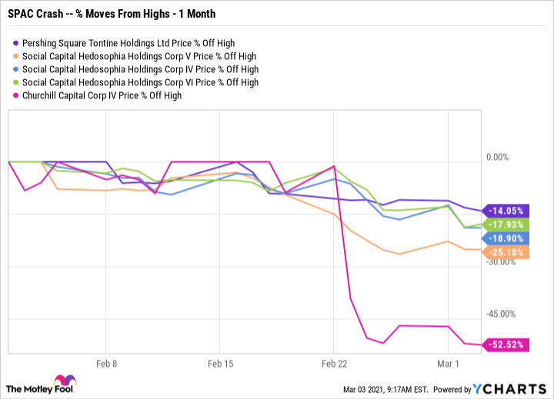The price gain of early January was sustained into late February as investors became excited about the oppurtunity to invest in a revolutionary-lending company before it hit the public market. However as the stock market began to decline in March, SPACs and high-growth stocks took a beating. IPOE’s SPAC nature and proposed merger with a high-growth firm made it difficult to sustain the price levels seen in January and February. The price adjusted downward many times as investors lost faith that the merger could be completed because of speculations of SEC regulations on conflicts-of-interest in the SPAC. However in April, 2021 Chamath Palihapitiya tweeted, stating that his SPACs were on the forefront in staying ahead of legislation and abiding by SEC regulation, quelling fears. IPOE stock continued to rise into May of 2021 subsequent to IPOE’s filing of the company’s official S-4 SEC Merger document on April 30, 2021. Prices adjusted down and then rose again on May 7th , 2021 after the announcement that the official ticker change would occur on June, 2021.

***Are SPACs good for investors?***

Companies that raise capital through SPAC IPO benefit form a number of advantages but is this the case for its investors? SPAC investment are less profitable for individual investors. Most SPACS have underperformed the market and eventually fallen below their IPO price. An investor deciding to invest in a SPAC IPO faces major risk ,but these risks vary on the type of the investor.

**Uncertainty:** When an investor decides whether or not to invest her capital, she will do her due diligence and conduct a company analysis regarding the health of the company and its potential to grow, but for SPAC’s this is not the case. **S**PACs raise money before deciding which business they want to buy. Therefore, investors are betting in the management team rather than the company itself, which gives sponsors a lot of power leading to an increased risk to retail investors. Additionally, after the money is raised sponsor have up to 2 years to find a company to acquire, if not they are obligated to return the money to the public. This time limit may lead in a rushed decision from the management team.   
On the other hand, institutional investors who have the right to buy warrants in additional to shares face no uncertainty risk. If they do not like the proposed merger they are able to execute their redemption rights and go through a DESPAC where they will be able to get their original investment back plus accrued interest. Moreover, when these investors redeem their common shares they can still keep their warrants which will eventually appreciate in value.

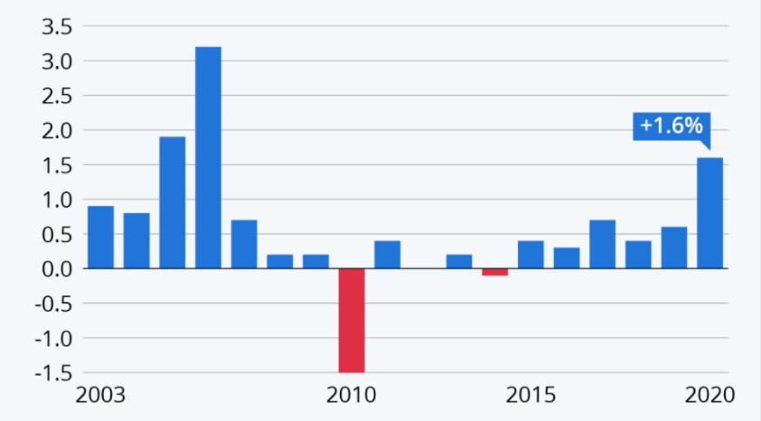**Negative Returns:** Most SPACs after they acquire the target company underperform the stock market and ultimately fall below their initial public offering (IPO) price. In the last 5 years around 89 companies have completed mergers and gone public, these companies have an average return of -18.8% and a median of negative 36.1%. In 2020 this number soared to 13.1%, but this is not due to an overall SPAC improvement. This increase was driven high mostly due to two firms DraftKings and Nikola SPAC IPO which experience high returns after they went public, XXX% and XXX% respectively.

**Conflict of Interest:** SPAC Sponsors may own up to 20% of the company after its SPAC IPO due to their class of shares and warrants purchased for a nominal amount. Therefore, these sponsors will have a significant upside if they close a transaction that may not lead to the highest return for stockholders.

*Pros*Normally a retail investor is not allowed to participate and invest in a traditional IPO on the open market on the day of trading. As a result, these investors are generally excluded from the upside available from an IPO. On the other hand, SPAC provides a rare, although mixed, opportunity for retail investors. The arrangement allows these investors to invest in a SPAC after it has gone public but before the acquisition is announced, allowing them to benefit from the “pop” until the business to be acquired is announced. However, retail investors are unable to obtain the right that institutional investors enjoy, such as warrants that allow the shareholder to buy more shares in the future. Moreover, if they are dissatisfied with the proposed merger, they do not have the right to redeem their shares for a refund of their investment. Throughout the year SPAC returns before the acquisition are positive reaching on average 9% and 2% if the merger does not take place, keeping in mind that only industry investors are able to obtain a 2% return.

Works Cited

*IPOE Stock - Social Capital Hedosophia HOLDINGS CORP. V ...* sec.report/Ticker/IPOE.

*IPOE*. www.nasdaq.com/market-activity/stocks/ipoe.

Caplinger, Dan. *Should You Buy Spacs after Their Crash?* 4 Mar. 2021, www.fool.com/investing/2021/03/04/should-you-buy-spacs-after-their-crash/?source=eptyholnk0000202&utm_source=yahoo-host&utm_medium=feed&utm_campaign=article.

*Fintech Unicorn SoFi Shells out $1.2B for Financial API Provider Galileo*. 7 Apr. 2020, siliconangle.com/2020/04/07/fintech-unicorn-sofi-shells-1-2b-financial-api-provider-galileo/.

Matthew Frankel, CFP. *Here's Why CHAMATH Palihapitiya's Fifth SPAC Is Soaring Today*. 7 Jan. 2021, www.fool.com/investing/2021/01/07/heres-why-chamath-palihapitiyas-fifth-spac-is-soar/?source=eptyholnk0000202&utm_source=yahoo-host&utm_medium=feed&utm_campaign=article.

RaShane. *@Chamath @Dasnoozefin My Shirt Came in TODAY. I Wear It with Pride. WHAT Chamath Say, I Do! @Socialcapital #Bitcoin #Spacs #IPOB #Iboc #Ipod #Ipoe #Ipof I Believe In Chamath. Join the MOVEMENT! We the PEOPLE! We Can Do It! Pic.twitter.com/gsuzh2utbo*. 15 Jan. 2021, twitter.com/RDFIT4U/status/1350209622792163332.

Relations, SoFi Investor. *$IPOE & @SoFi Update: The s-4 SPAC Merger Is Now Effective with the SEC. We Will Start Emailing & Mailing Proxy Statements to Shareholders of $IPOE (as of 4/29) to Vote Ahead of the Shareholder Meeting on 5/27. We Intend to Close the Deal ON 5/28 & Start Trading as $Sofi ON 6/1.* 7 May 2021, mobile.twitter.com/SoFiIR/status/1390747214230605825.

*Social Capital HEDOSOPHIA Holdi (IPOE) Stock Price, NEWS, Quote & History*. 12 May 2021, finance.yahoo.com/quote/IPOE?p=IPOE.