**CSC 4401 SOFTWARE ENGINEERING**

**TOPIC OF THE PROJECT: HOSPITAL MANAGEMENT SYSTEM**

**Chapter one**

**(INTRODUCTION)**

**OVERVIEW:** Today computerization is a major advancement in technology that helps in many ways: it makes information storage easier and faster thus it can save a lot of time and manpower, and many task are done in a certain amount of time. Great amount of time is being consumed by information storage, retrieval and billing process in most local hospitals and clinics.

Creating a hospital management system provides medical facilities with the required boots to deliver service to more people and give medical personnel more breathing room.

AIM AND OBJECTIVE

* To develop a software that will enable management keep track of the records of patients and doctors.
* To provide within the software a search filter, which is based to help find record easily.
* To provide within the software the ability to generate the bill of a patient upon discharge.

**LIST OF MEMBERS**

|  |  |
| --- | --- |
| **NAMES** | **REG NO** |
| 1. Mustapha adam Ibrahim | UG17CSC1042(group leader) |
| 1. Abdulaziz yau | UG17CSC1007 |
| 1. Sadiq abubakar usman | UG17CSC1040 |
| 1. Yau Muhammad lawal | UG17CSC1032 |
| 1. Tarik Mahmud muhammad | UG18CSC2102 |
| 1. Hassana auwal sani | UG17CSC1052 |
| 1. Bello Rafi’at abdullahi | UG17CSC1022 |
| 1. Ismail ali muhd | UG17CSC2093 |
| 1. Hussaini ali baba | UG16CSC0016 |
| 1. Sultan Muhammad | UG17CSC2048 |
| 1. Faizu abba aminu | UG17CSC1018 |

**Chapter two**

**(REQUIREMENTS)**

**REQUIREMENT:** Requirement can simply be defined as the description of what the system should do, the service or services that it provides and constraints on its operation.

Types of requirement:

1. Functional requirements: are the requirements that end-user specifically demands as basic facilities that the system should offer.
2. Non-functional requirements: are the quality constraints that the system must satisfy according the project contract.

**Key**

|  |  |
| --- | --- |
| **UR** | User requirement |
| **SR** | System requirement |
| **FR** | Functional requirement |
| **NFR** | Non-functional requirement |

**LIST OF REQUIREMENTS**

1. The system shall contain the following buttons at the homepage header “Home, about us, online appointment, login, registration, and contact us” **(UR).**
2. At the Home page footer the following shall be visible “ admin loginpanel, doctor login panel” for allowing them to login as an existing users. **(UR).**
3. The software shall display a clear picture of the hospital for easy identification, and also contain a login panel for booking appointment. **(UR).**
4. The system shall allow an existing user to log into his profile. **(FR)**
5. The system shall contain a brief history and services about the hospital and should contain some images that describes the hospital**.(SR)**
6. The system shall allow a new user to register with the hospital through the system. **(FR)**
7. The patient registration panel shall contain patient’s name, mobile number in the system **.(SR)**
8. The patient registration panel shall contain patient’s address, city and pin code in the system**.(SR)**
9. The patient registration panel shall contain patient’s login id and password in the system**.(SR)**
10. The system shall allow the new user to select his blood group, gender and date of birth.**(FR)**
11. The system shall allow to user to submit his data after authentication. **(FR)**
12. The system shall allow the admin to login into his profile. **(FR)**
13. The admin shall have access to the following panels (accountant, profile, patient, appointment, treatment, doctor, setting) and can logout. **(FR)**
14. The system shall contain the accountant dashboard with (number of appointment records, number of billing reports, number of patient records, number of treatment records, number of prescription) **.(SR)**
15. The system shall contain accountant dashboard database records (number of prescription records, number of treatment type, number of admin records, number of department records, number of doctor records, number of doctor timing records, number of billing records)**.(SR)**
16. The system shall contain the admin profile ( admin name, login id and password, status in the profile panel**.(SR)**
17. The system shall allow the admin to change his password when needed.**(FR)**
18. The system shall allow an exciting admin to add and delete new admin. **(FR)**
19. The system shall allow an admin to view the administrative records of the hospital. **(FR)**
20. The system shall allow admin to search for a particular patient using login Id and also allow him to view individual patient record. **(FR)**
21. The system shall allow admin to view record of pending and approved appointments. **(FR)**
22. 16.1. the admin should view appointment date and time**(FR)**
23. 16.2. admin should view department of appointment, reason of appointment, and doctor**(FR)**
24. The system shall allow admin to view patient’s treatment record. **(FR)**
25. 17.1. treatment date and time.**(NFR)**
26. 17.2. treatment type, patient and doctor’s name.**(NFR)**
27. The system shall allow admin to add new doctor record. **(FR)**
28. 18.1. doctor’s name, mobile number, password, and login Id. Spaces shall be provided by the system **(SR)**
29. 18.2 the system shall allow admin to enter doctor’s specialization, experience and consultancy charge. **(FR)**
30. 18.3.the system must allow admin to select doctor’s status(active or inactive) and submit button shall be provided. **(FR)**
31. The system should provide admin with the following services( add department, view department, add treatment type, view treatment type, add medicine, view medicine) **(SR)**
32. 19.1. the system shall allow admin to add new department by specifying( department name, description, and status). **(FR)**
33. 19.2. the system shall allow admin to view the department added with the record of all users (if any). **(FR)**
34. 19.3. the system shall allow admin to add new doctor’s timing record by specifying ( doctor’s name, status, start and closing time). **(FR)**
35. The system shall allow admin to view doctor’s timing record. **(FR)**
36. The system shall provide logout button for any user to logout. **(SR)**
37. The system shall allow the doctor to log into his account using login details. (at his dashboard a welcome message should be displayed as well as appointment and patient’s record). **(FR)**
38. The system shall allow user to change his password once needed.**(NFR)**
39. The system shall allow doctor to view his personal income record. **(NFR)**
40. Treatment, patient, and appointments records shall be viewed by the doctor in the system. **(SR)**
41. Number of approved and pending appointments record should be clearly recorded.**(FR)**
42. The system should contain three stakeholders; patient, doctor and Admin.**(SR)**
43. Every action’s date and time must be recorded for any stakeholder. .**(FR)**
44. The software shall be maintainable, dependable and user friendly. **(SR)**
45. The system should provide login page for the stakeholders**(SR)**
46. The login should contain space for Username**(SR)**
47. The system shall be available to use, any time in a working day. **(NFR)**
48. The system shall provide clear error message. **(NFR)**
49. The system should response adequately to any action. **(NFR)**
50. The system should be down not more one hour in the event of system failure. **(NFR)**
51. The system shall authenticate every user uniquely .**(FR)**

**Chapter 3 design**

Patient admin

doctor

**USE CASE DIAGRAM**

**View information**

Doctor admin

patient

**Add content**

Admin doctor

**Tabular description of the use-case**

|  |  |
| --- | --- |
| Actors | Admin, patient, doctor |
| Description | The admin is in charge of managing all activities of the system together with the remaining stakeholders like (patient, doctor and department) registration in the hospital, where the patient and doctor will register in the system to have an access to the system in order to apply for an appointment to visit a specific doctor in the hospital /edit to their account when needed. |
| Log in | This process will allow all the stakeholders to log into the system using their login Id and password. |
| View information | This process will allow the admin and doctor to view individual’s patient information. And also allow the patient to view his information. |
| Add content | In this process, several action will be perform by admin ( add department, add patient and add doctor) |
| Edit | Edit process allow every stake holder to edit his/her data(e.g., password) |
| Prescription | This is an action that can perform only by a doctor to patient. |
| Book appointment | Only patient can book an appointment using this function, in order to visit a doctor. |
| Log out | This is a bottom that allow the stakeholders ( patient, doctor, admin) to sign out from his/her profile in the system. |

**Sequence diagram for user login**

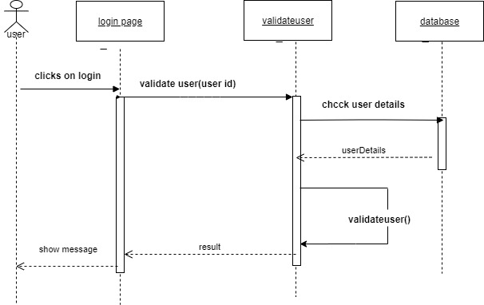

**Activity diagram for adding a doctor**

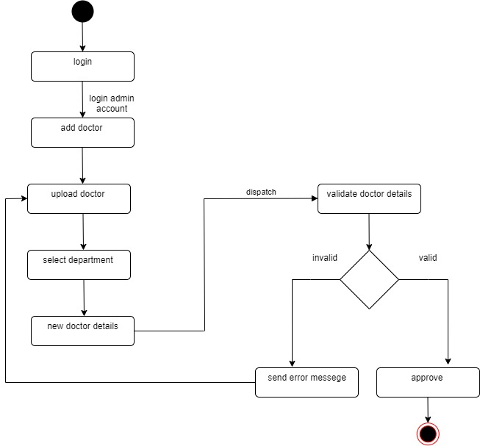

**Class diagram for prescription**

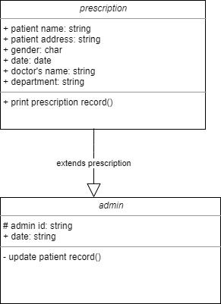

**ARCHITECTURAL DESIGN**

