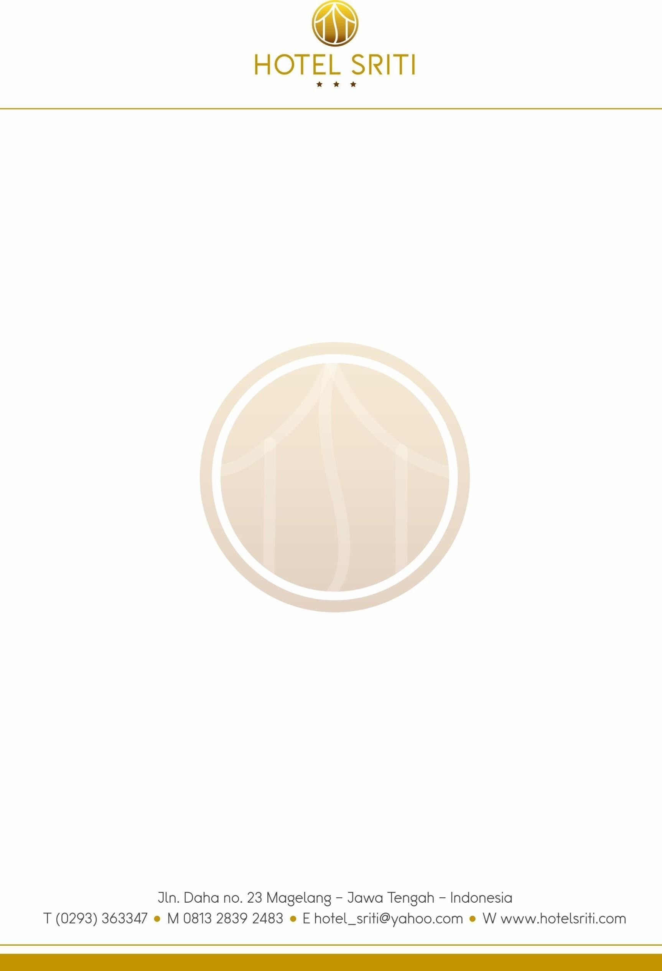
Reservation Confirmation

April, 5th 2025 Mrs. Mugi Rahayu

Thank you for choosing Hotel Sriti, we are pleased to confirm your reservation as follows: Name of Guest : Mrs. Mugi Rahayu
Number of Guest : 1 People
Arrival Date : April, 21st 2025
Departure Date : April, 24th 2025
Length of stay : 3 Nights
Number of Room : 1 Executive Room On Twin Bed
Payment : Responsible payment by Mrs. Mugi Rahayu Cancellation Policy : Non Refundable
Check in time : 03.00 PM
Check out time : 12.00 PM

Should you wish to discuss this matter further, please do not hesitate to contact us. We look forward welcoming you to our Hotel.

Yours Sincerely, ( L i n d a S )

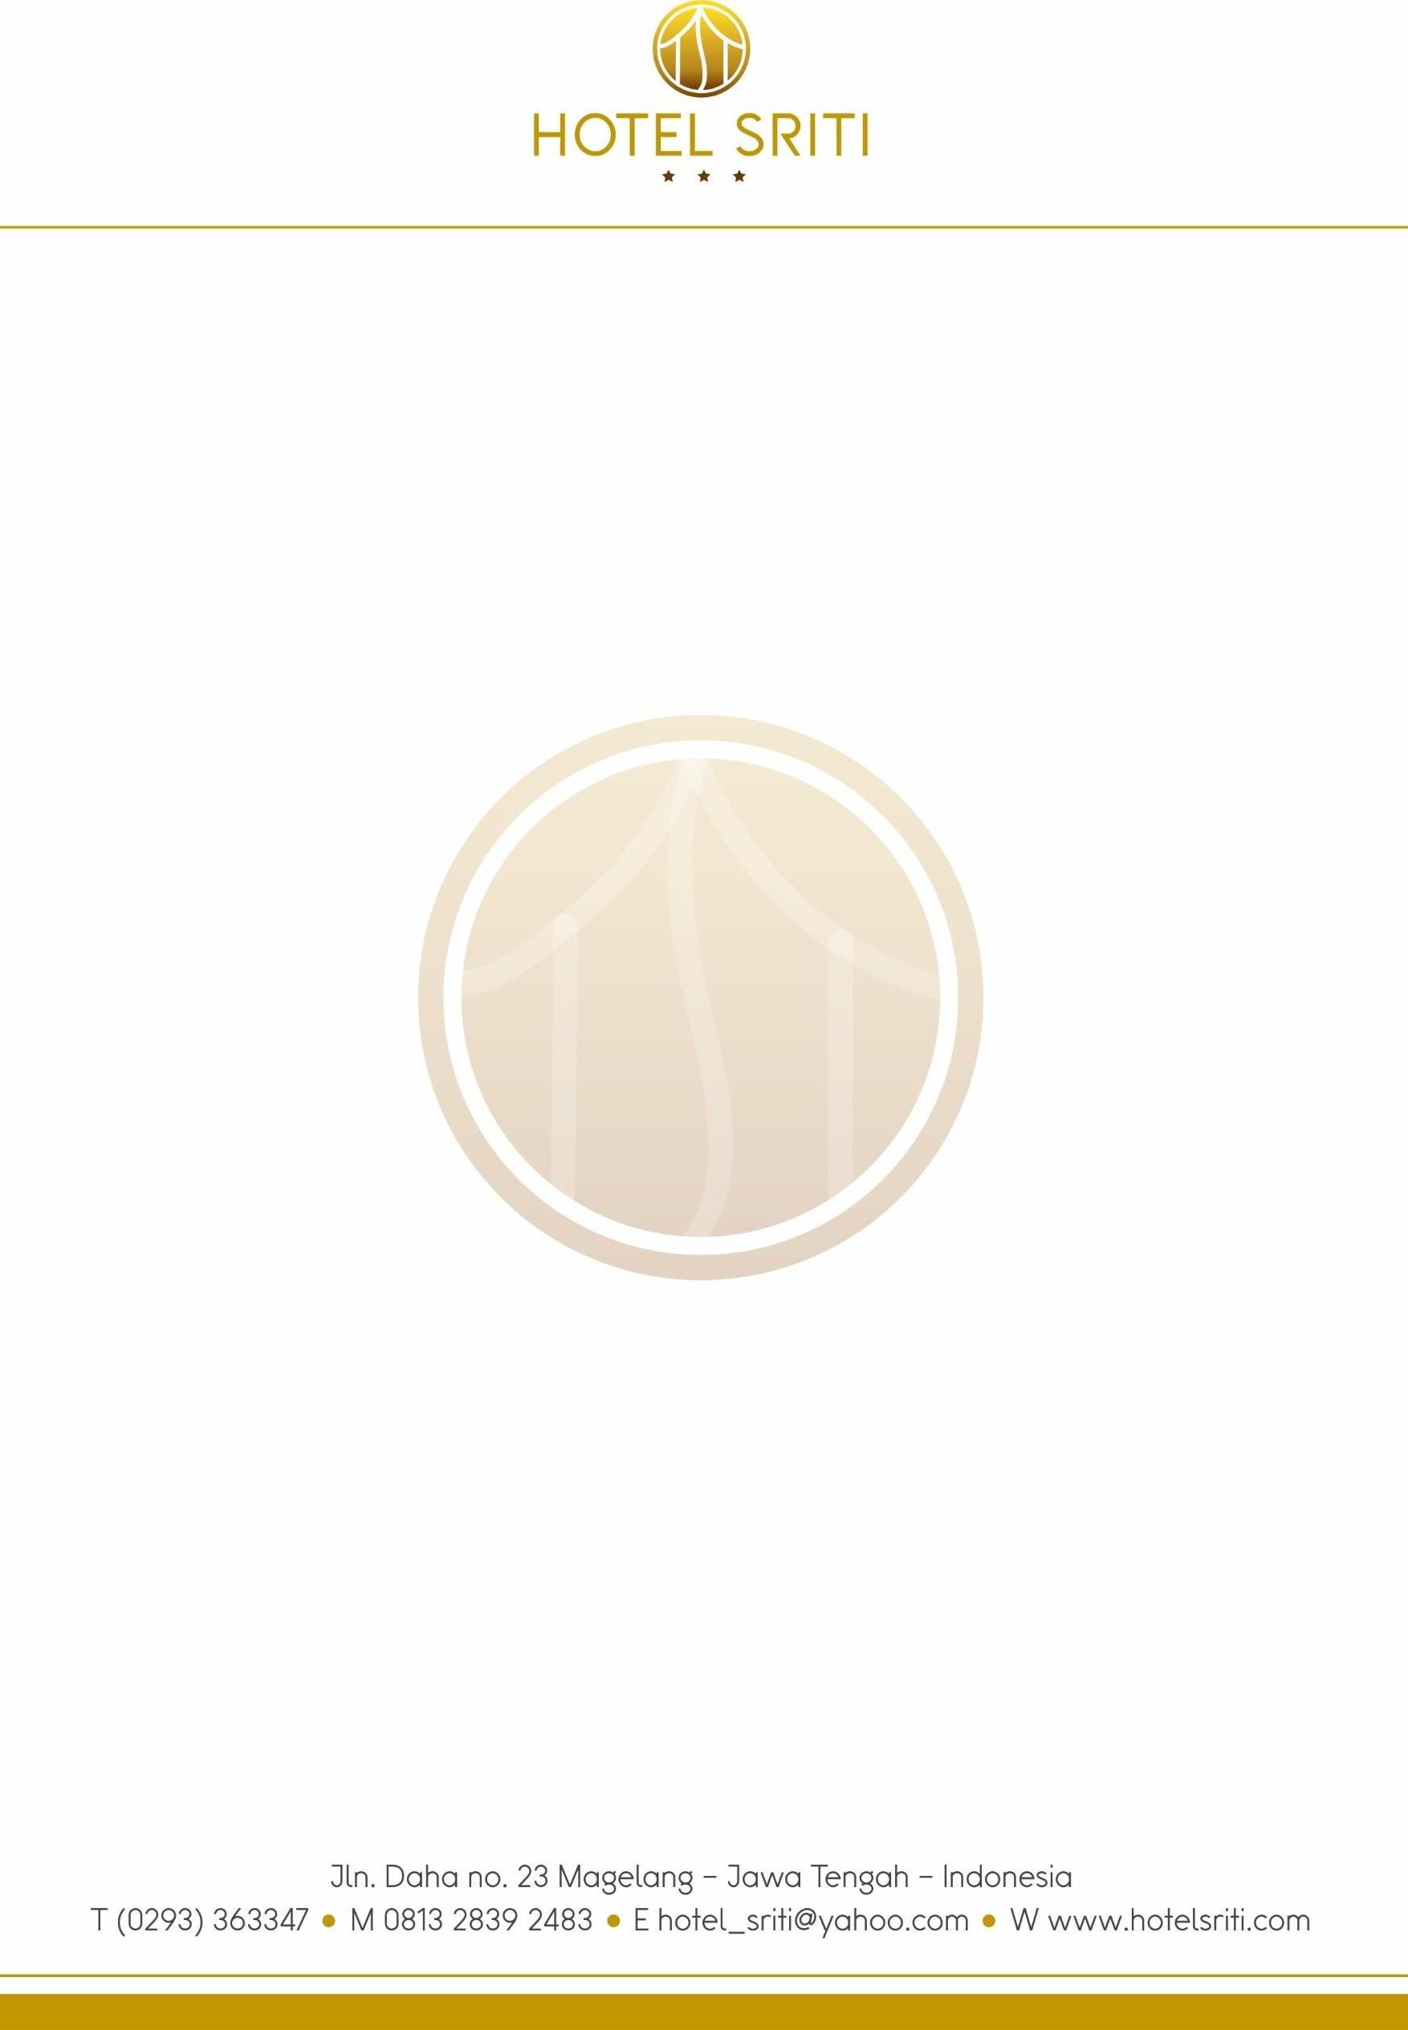
To : Mrs. Sri Nurkhayati and Mrs. Lintang Khimayatuna
Date : April, 5th 2025
Phone : +62 881-7678-679

INVOICE

Name of Guest : Mrs. Sri Nurkhayati and Mrs. Lintang Khimayatuna
Arrival Date : April, 21st 2025
Departure Date : April, 24th 2025

1 Executive Room x 3 Nights x IDR 620.000 = IDR 1.860.000

Total Amount Due = IDR 1.860.000

( Satu Juta Delapan Ratus Enam Puluh Ribu Rupiah )

Thank you for coming

Linda

