7 Steps to Complete a UX Audit (With Checklist and Tools)

A UX audit helps you uncover issues with the user experience (UX) and identify hidden opportunities to improve conversions.
According to a global study by Baymard Institute, 70.22% of all e-com visitors abandon their carts because of:
- Extra costs
- Annoyed and a lengthy account creation process
- Complicated checkout flows
But, how do you find such issues on your website? The simple answer is a good UX audit. Now, an audit isn’t necessarily needed if there is something wrong with your website. Instead, understanding the user experience helps you find more gold to leverage and optimize.
Needless to say that, in this a-bit-long guide, you will find 7 steps to do an audit like an expert. My goal is to help even the beginners, plus experts alike with the help of proven methods and practical insights that give you impactful results.

TL;DR
Don’t have 5 minutes to read this article? Here are 5 points to quickly understand UX audit:
- A UX audit is a revenue investigation, not a design beauty contest. You're hunting for friction that quietly kills conversions, not chasing prettier buttons.
- The 7 steps for a successful UX audit are: set a business goal, interview stakeholders, pull quantitative data, analyze real behavior, gather qualitative insight, run a data-backed heuristic check, then prioritize and roadmap the fixes.
- Tools like GA4 tell you where users leave. While session replays and heatmaps tell you why. You need both halves to act.
- Skip the audit entirely if you're pre-product-market-fit or your app is throwing technical errors. Fix these issues first.
- Score every finding on impact versus effort, ship the quick wins behind an A/B test, then re-audit next quarter.

What is a UX audit (and When Do You Actually Need One)?
A UX audit is a structured review of your product that ties usability problems directly to business outcomes: drop-offs, churn, stalled activations, and lost revenue.
In simple words, you try to find either issues that are hurting your leads or improve areas where you can bring more leads.
For example, while working with a Christian religious website, I added a single discount pop-up targeting exit-intent visitors. It generated $1,000 in sales within the first week, without touching a single other element on the page.
Yet there’s a fundamental difference between a UX audit for a portfolio and a real audit. Most beginners will land on this guide and may leave, finding it too technical. However, a technical audit is a way forward. Here is a quick differentiation:
 | Portfolio or interview audit | Real SaaS audit
Data | None. You guess at personas and friction. | Live GA4 or Mixpanel, session replays, heatmaps and support tickets.
Method | Heuristics only (Nielsen's 10) | Heuristics plus behavioral and funnel data
Output | A list of suspected issues | A prioritized backlog with severity and revenue impact
Decision power | None | A funded sprint or roadmap
Timeline | A day to a week | Two to six weeks

The 7 Steps to a Conversion-Focused UX Audit
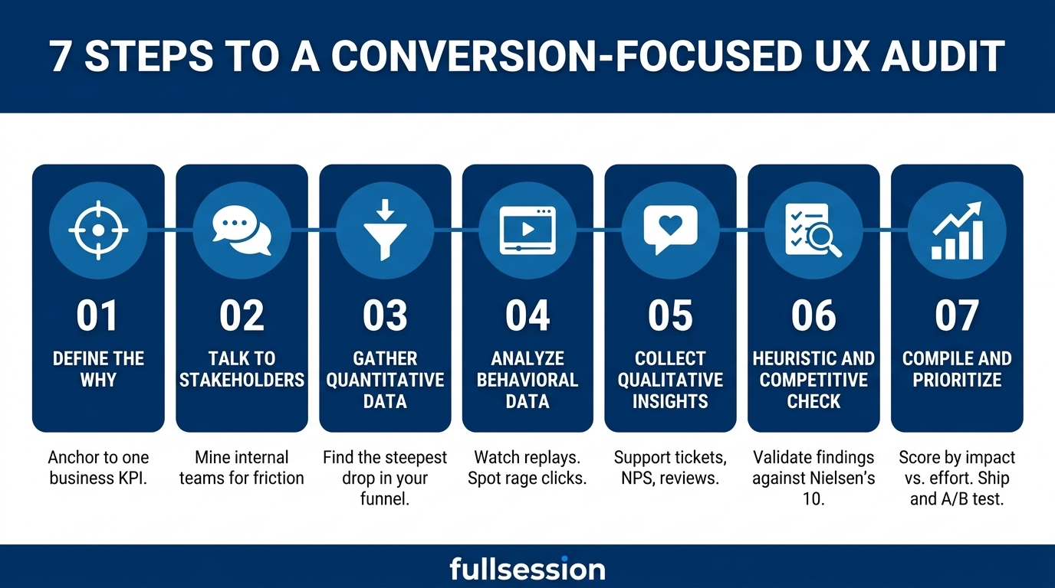
These 7 steps are pure gold. Implement them as it is and you will end with high-quality UX audit results.

Step 1: Define the "Why" Before You Touch the Service or Product
Never start an audit without a business goal. This is the mistake I see most often, and it's the one that turns a two-week project into a two-month one.
A vague brief ("make the product better") gives you no way to know when you're done or whether you succeeded. A sharp brief gives you a target you can measure against. Compare these:
- Weak: Audit our onboarding.
- Strong: Find out why our trial-to-paid rate sits at 11% when our segment median is closer to 18%, and prioritize fixes in the activation flow.
See the second version, which gives you a pretty quick idea of what is wrong and where you need to work. Anchor every audit to a single KPI you're trying to shift, whether that's trial-to-paid conversion, checkout completion, or first-week activation.
Just to Inform You: Soft skills like ICP knowledge or understanding of your brand’s USPs supersede technical skills. Ensure you have a good grip of your brand + market before initializing the UX audit.

Step 2: Talk to Your Stakeholders First
Before you open a single analytics dashboard, talk to the people who already know where the bodies are buried.
- Your customer success team can tell you the exact screen that generates the most "how do I…" messages.
- Sales can tell you which feature prospects can never find in a demo.
- Similarly, support sees the same five complaints on repeat. These people have been running an informal UX audit for months without calling it one.
Always ask quality questions before starting an audit. Keep the conversations short and pointed. A few questions that consistently surface real friction:
- "If you could fix one thing in the product tomorrow, what would it be?"
- "Which screen do customers complain about most, and what do they say?"
- "Where do deals or renewals stall that you suspect is a product problem, not a price one?"
Write down the patterns. You'll use them in Step 3 to decide where to point your data.

Step 3: Gather Quantitative Data (The "Where" of the Audit)
This is the part that tells you where the bleed is happening. Pull your funnel and look for the steepest single drop. You're not trying to understand it yet. You're just finding the wound.
In GA4 or Mixpanel, map your core flow into discrete steps and read the conversion between each one. A small, even decline across many steps is normal. A cliff is your target.
What you see | What it usually means
38% drop at the billing step | Hidden costs, payment friction, or a broken field
60% never finish onboarding | Time-to-value is too far away; users quit before the "aha"
High exit on one pricing page | Confusion, sticker shock, or a missing answer
Say you find a 38% drop right at the billing step. Hold that number. You now know where to look. What you don't know yet is why, and no amount of staring at GA4 will tell you. That's the wall every analytics-only audit hits, and it's exactly where the next step takes over.

Step 4: Analyze Behavioral Data (the "What")
Once you know where users leave, you watch what they actually do when they get there. This is the half of the audit that separates a diagnosis from a guess.

Session Replays
Let’s take that 38% drop in billing example again.
You open session replays for the people who quit on that screen, and you watch ten of them in a row. Three of them hover over a tooltip that explains your tax line, click it, and nothing happens because it was never wired up. You just watched the leak with your own eyes in under five minutes. GA4 would have shown you the drop forever and never explained it.
- That frustrated clicking has a name: a rage click, a burst of rapid clicks on the same element when a user expects something to happen and it doesn't.
- Another closely related pattern is the dead click, a single click on something that looks interactive but does nothing. Both are friction signals, and both almost never become a support ticket as the user leaves without any complaint.

Heatmaps
Heatmaps do the same job at the page level instead of the session level.
A click map shows you which elements people try to interact with. A scroll map shows you whether anyone ever reaches your strongest CTA, or whether it dies below the fold on mobile.
If you've ever wondered whether to reach for a heatmap or a replay first, we broke down each one's wins here.
Short version: heatmaps find the pattern, replays explain the cause. Use the map to spot the suspicious page, then watch the sessions behind it.

Step 5: Collect Qualitative Insights (The Real "Why")
Behavioral data shows you what people did. But qualitative data tells you how they felt while doing it, and that emotional layer is where the most fixable problems hide.
- Start with your support tickets. They're a goldmine, and they're free. Tag a month of them by the screen or task they reference, and the top 3 categories usually point straight at your worst friction.

Then, read your app-store reviews, your cancellation survey responses, and any NPS comments. People are blunt in those places in a way they never are to your face.
But here's the uncomfortable part, and it's the core of why audits matter at all. Most customers never tell you anything. They hit the broken tooltip, sigh, and churn. Research from the White House Office of Consumer Affairs found that for every customer who complains, 26 others stay silent as they silently leave.
Similarly, Contentsquare's 2025 Digital Experience Benchmark found that 40% of all visits experience some sort of frustration online. Hence, you have to dig deeper than just the logic and find the emotional and behavioral reasons why customers are leaving.
I would like to quote from Jakob Nielsen (who I think is the father of modern UX analysis) from his book, Designing Web Usability:
"To design an easy-to-use interface, pay attention to what users do, not what they say. Self-reported claims are unreliable, as are user speculations about future behavior."

Step 6: Run a Data-Backed Heuristic and Competitive Check
Now, and only now, you bring in the textbook. Heuristic evaluation means checking your product against established usability principles, the most cited being Jakob Nielsen's 10 usability heuristics:
- Visibility of system status
- Match between the system and the real world
- User control and freedom (a clear "undo")
- Consistency and standards
- Error prevention
- Recognition rather than recall
- Flexibility and efficiency of use
- Aesthetic and minimalist design
- Help users recognize, diagnose, and recover from errors
- Help and documentation
Here's the part most UX researchers get wrong, and it matters enough that I'll be blunt about it.
“If you're a pre-revenue startup with no usage data, heuristics are a reasonable way to start. However, if you have live data, heuristics are not the engine of your audit. They're the validation layer. You use them to explain the friction you already found in Steps 3 through 5, not to generate a fresh list of theoretical problems nobody is actually hitting.”

Step 7: Compile Findings and Prioritize the Fixes
Finally, compile all your issues in the form of a report. Every finding should include a recommended fix since a UX audit without remediation guidance is incomplete.
Finding the problems isn’t the actual task of a UX researcher, but rather to give a plan on how to resolve them.
Score every finding on two axes: impact (how much it could move your target KPI) vs effort (how many engineering and design days it costs).
One non-negotiable before any big change goes live to everyone: validate it with an A/B test. Run the new version against the old for at least one full business cycle, pick your success metric before you start (not after) and aim for enough traffic to trust the result.
Then do the thing almost nobody does: watch session replays from the winning variant to confirm the friction actually vanished, rather than assuming a moved number means a solved problem. A metric can improve for reasons that have nothing to do with your fix.

The Essential UX Audit Toolkit
The market is full of tools for UX audit. Frankly, tools are the least important part of a successful audit. Instead, you need to work on your brand + ICP understanding, critical judgement and built-in technical intuition.
That said, you don't need a dozen tools for a successful UX audit. Because a single tool can sometimes do more than one job. Here are the tools that I personally use and recommend:
Category | What It Does | Recommended Tools
Behavioral Analytics | Captures funnels, events, trends, and longitudinal data | Google Analytics 4 (free), Mixpanel, Amplitude, Adobe Analytics
Granular / Session Analysis | Heatmaps, session replays, interaction data, rage click alerts, and on-page feedback widgets | FullSession, Microsoft Clarity (free and surprisingly powerful), Hotjar, FullStory, Glassbox
Voice of User | Structured surveys, NPS, CSAT, open-ended feedback | Typeform, Qualtrics, Survicate, GetFeedback
Accessibility Auditing | Checks WCAG compliance, contrast, keyboard navigation and screen-reader compatibility | Deque / Axe DevTools, Google Lighthouse, AudioEye
Information Architecture | Tests labeling, navigation, and site structure through card sorting and tree testing | Optimal Workshop, UXTweak, Lyssna
Performance | Site speed, Core Web Vitals, and technical errors | Google Lighthouse, PageSpeed Insights, Semrush Site Audit
Data Analysis & Reporting | Organizes findings, builds visualizations, and turns raw data into a report | Excel / Google Sheets (pivot tables, filters, basic charts as a baseline), Looker Studio, Power BI

When is a UX Audit NOT Necessary?
Sometimes the most useful thing I can tell a team is "don't do this yet." An audit done at the wrong moment wastes money and produces findings you can't act on. Here's when to hold off a UX audit and what to do instead.
- You're pre-product-market-fit. With no steady usage and no segments to compare, there's nothing reliable to study. Instead, run a handful of moderated user interviews to test the demand.
- Your core infrastructure is breaking. If auth fails, payments fail, or the app crashes, that's not a usability problem, it's a bug list. Fix the crashes first, then audit the experience on top of a stable base.
- Your support queue is dominated by bugs. Squash the bugs, watch whether the complaints change shape, then audit to find errors or get suggestions.
- Nobody has the budget or authority to act on the findings. An audit without an owner becomes expensive shelfware. Secure a commitment to ship fixes before you spend a day investigating.
Or as Neil said in one of his blogs:
“User Experience (UX) optimization isn’t just a design choice. It’s a conversion strategy. If your site is confusing, slow, or frustrating to use, people bounce. They won’t dig for what they need. They’ll leave.”
If the site has basic core-level issues, a UX audit won’t do anything. Fix the root cause first.

Ready to Find the Issues in Your Service?
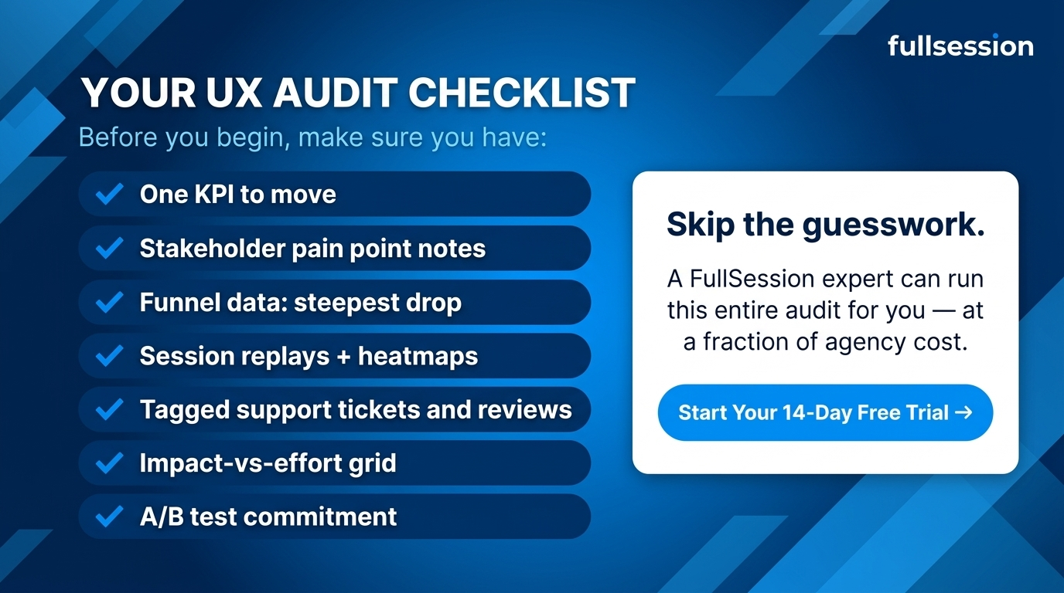
Quick checklist before you begin:
- One KPI you're trying to move
- Stakeholder notes on known pain points
- Funnel data showing your steepest drop
- Session replays and heatmaps for that drop
- A tagged sample of support tickets and reviews
- An impact-versus-effort grid to rank what you find
- A commitment to A/B test the big changes
Every one of those steps depends on actually seeing what your users do, and that's the part you can't fake with a dashboard.
And if you are a B2B SaaS founder or marketer who wants a result-driven UX audit, FullSession is here to help. It gives you the session replays, heatmaps, and funnel analytics to run every step of this audit and fix what actually moves the needle. Book now to start your 14-day free trial and turn user friction into product growth.

Frequently Asked Questions About UX Audit

How much does a UX audit typically cost?
A UX audit usually costs around $1,000 - $25,000. A specialist freelancer typically charges $2,500 to $8,000 for a focused product audit. On the other hand, a boutique studio runs $3,500 to $10,000, a full-service agency $8,000 to $25,000, and an enterprise or regulated-industry engagement can reach $30,000 to $75,000 and up.

Can a UX audit directly improve conversion rates?
Yes, a UX audit can improve conversion rates. Find the user friction areas and improve them. Similarly, value-added call to actions and clearly communicating the value can also help in getting better conversion rates.

What is the difference between a UI audit and a UX audit?
A UI audit checks the visual and interaction layer, such as typography, spacing, color contrast, button states and icon clarity. On the other hand, a UX audit includes all of that but goes wider, such as adding funnel drop-off analysis, session-replay review and friction signals like rage and dead clicks.

