Sleep Deprivation and Its Effects on the Body
What insufficient sleep can affect, how to recognize it, and when to seek help
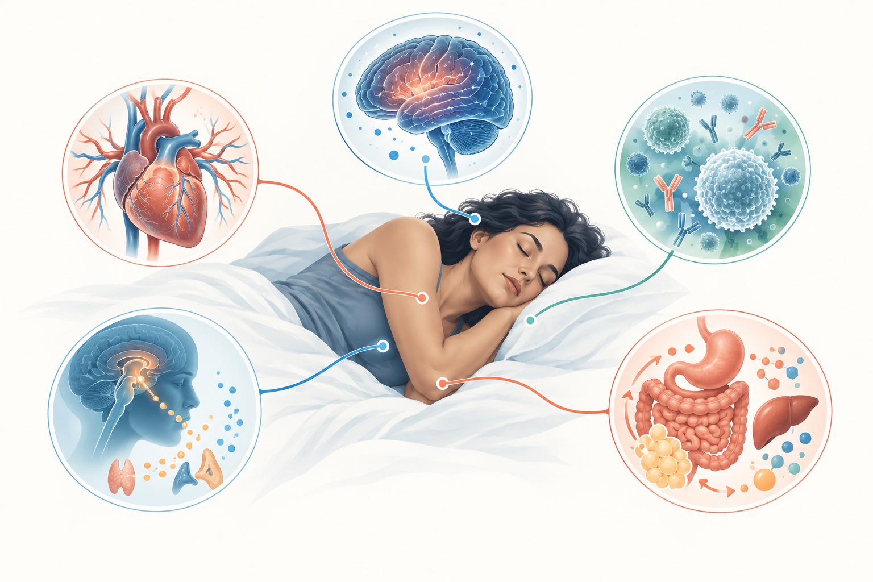
Sleep supports brain function, cardiovascular health, immunity, and metabolism.
Sleep deprivation means not getting enough sleep to support normal daytime functioning. It may result from a demanding schedule, caregiving, shift work, illness, environmental disruption, or an untreated sleep disorder. Most adults need at least seven hours of sleep in a 24-hour period, although individual needs vary. Short sleep is common: US survey data for 2024 found that 30.5% of adults averaged less than seven hours.

What sleep loss can affect
A single short night may cause sleepiness, slower reaction time, reduced concentration, irritability, and impaired judgment. Repeated sleep restriction has broader effects. Research links insufficient sleep with higher risks of obesity, type 2 diabetes, high blood pressure, heart disease, stroke, anxiety, and depression. These are associations influenced by many factors; a poor night of sleep does not by itself cause a chronic disease.
Sleep loss also affects safety. Fatigue can impair driving and workplace performance in ways that resemble alcohol impairment. People who feel sleepy while driving should stop in a safe place rather than trying to push through.

Common signs
The clearest sign is persistent daytime sleepiness, but sleep deprivation can also appear as difficulty focusing, forgetfulness, mood changes, headaches, reduced motivation, slower physical performance, or relying heavily on caffeine. Children and teenagers may become unusually active, impulsive, or irritable rather than simply looking tired.

Sleep duration and sleep quality
Duration is only one part of healthy sleep. Frequent waking, loud snoring, pauses in breathing, restless legs, pain, or an irregular schedule can leave a person unrefreshed even after enough time in bed. Insomnia is different from voluntary sleep restriction: it involves difficulty falling asleep, staying asleep, or returning to sleep despite adequate opportunity.

Practical ways to improve sleep
Keep a consistent sleep and wake time, including on weekends. Use morning daylight and regular daytime activity to support the body clock. Keep the bedroom cool, dark, and quiet. Reduce bright screens, alcohol, large meals, and caffeine close to bedtime. A short wind-down routine can help signal that the day is ending.
Do not start sleep medicines or supplements without discussing them with a healthcare professional. Some products cause next-day impairment, interact with other medicines, or mask an underlying sleep disorder.

When to seek medical advice
Talk with a healthcare professional when sleep problems last several weeks, interfere with daily life, or occur with loud snoring, gasping, breathing pauses, unusual movements, depression, or severe daytime sleepiness. Urgent help is appropriate for confusion, hallucinations, chest pain, breathing difficulty, or an immediate risk of falling asleep while driving.

Sources
- CDC. Short Sleep Duration and Sleep Difficulties Among Adults: United States, 2024. https://www.cdc.gov/nchs/products/databriefs/db559.htm
- CDC. About Sleep and Your Heart Health. https://www.cdc.gov/heart-disease/about/sleep-and-heart-health.html
This article provides general educational information and does not replace individualized medical advice, diagnosis, or treatment.

