Urine Color Guide
What common color changes may mean and when they need medical attention
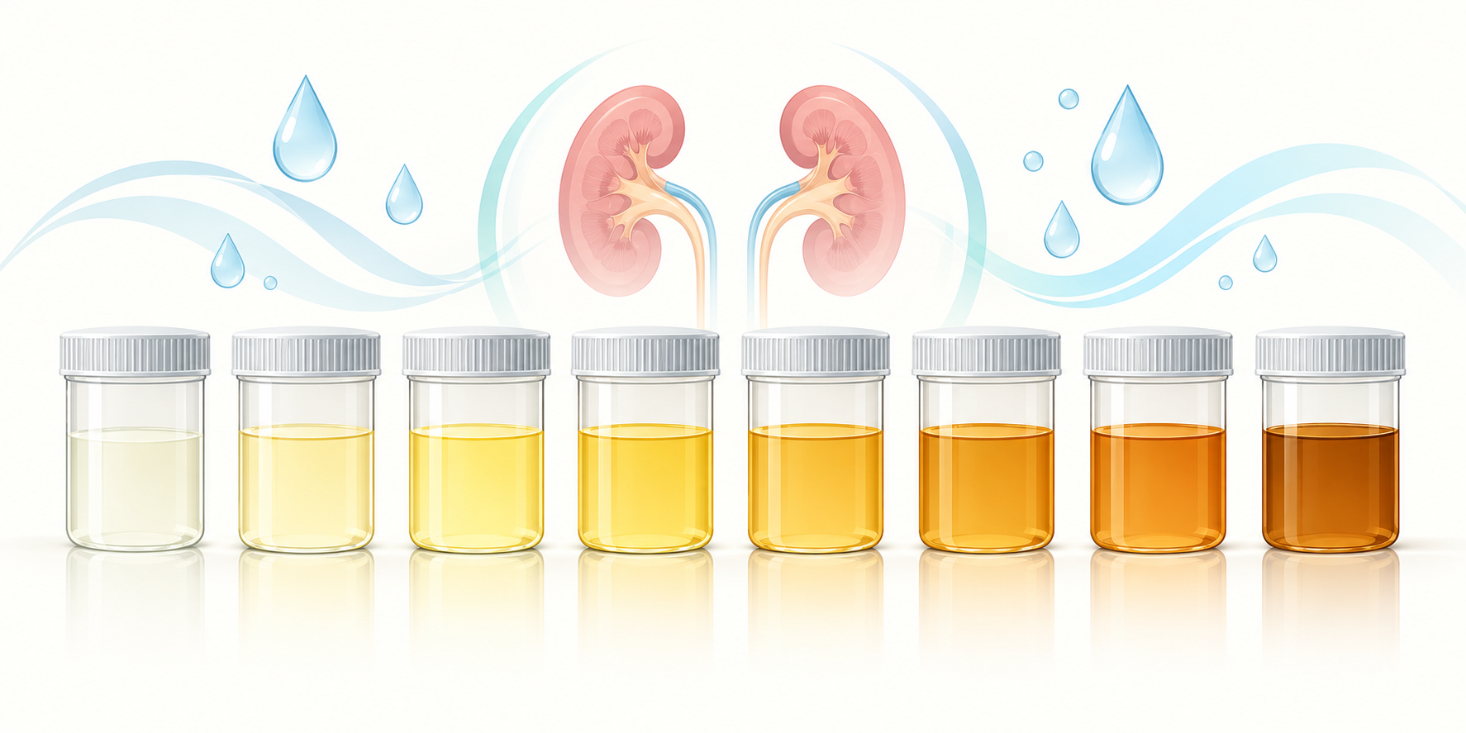
Urine usually becomes darker as it becomes more concentrated, but color is not a diagnosis.
Normal urine is usually clear to pale yellow. Its color changes with hydration, foods, vitamins, medicines, and some health conditions. Color alone cannot diagnose a disease, but a persistent or unexplained change can be a useful reason to contact a healthcare professional.
Appearance | Possible explanations | Suggested action
Clear to pale yellow | Typical hydration; very clear urine can follow high fluid intake | Use thirst and medical advice to guide intake
Dark yellow or amber | Concentrated urine, often from dehydration | Drink fluids if appropriate; seek help if severe or persistent
Orange | Dehydration, vitamins or medicines; sometimes liver or bile problems | Review medicines and seek advice if unexplained
Pink, red or smoky brown | Foods or medicines, but possibly blood in urine | Contact a healthcare professional, even if painless
Brown or tea-colored | Severe dehydration, liver problems, blood or muscle breakdown | Prompt medical assessment is appropriate
Cloudy or milky | Crystals, cells, discharge or possible infection | Seek advice if persistent or accompanied by symptoms
Blue or green | Food dyes, medicines or rarely infection | Seek advice if unexplained or persistent

Why urine is yellow
A pigment called urobilin contributes to urine's yellow color. When less water is present, the urine becomes more concentrated and usually appears darker. Hydration is therefore a common explanation for day-to-day variation, but not every dark color is caused by dehydration.

Foods, vitamins, and medicines
Beets, blackberries, food coloring, B-complex vitamins, and several medicines can alter urine color. A useful review asks what was eaten and which prescription, over-the-counter, or supplemental products were taken before the change appeared. Do not stop a prescribed medicine without professional advice.

When color may signal a problem
Visible blood can make urine pink, red, or brown and may occur with infection, stones, injury, kidney disease, prostate conditions, or urinary tract cancers. Dark brown urine may also be associated with liver disease or muscle breakdown. Cloudiness accompanied by burning, urgency, fever, or lower abdominal pain can occur with a urinary tract infection.

When to get help
Contact a healthcare professional for visible blood, an unexplained color change that does not resolve, clear dark-brown urine, or pink, red, or smoky-brown urine not explained by food or medicine. Seek urgent care when the change occurs with severe pain, inability to urinate, fever and chills, yellow skin or eyes, confusion, marked weakness, or reduced urine output.
A clinician may use urinalysis, urine culture, blood tests, imaging, or other evaluation depending on the symptoms and medical history.

Sources
- MedlinePlus. Urine - abnormal color. https://medlineplus.gov/ency/article/003139.htm
- NIDDK. Prevention of Bladder Control Problems and Bladder Health. https://www.niddk.nih.gov/health-information/urologic-diseases/bladder-control-problems/prevention
- NIDDK. Hematuria (Blood in the Urine). https://www.niddk.nih.gov/health-information/urologic-diseases/hematuria-blood-urine
This article provides general educational information and does not replace individualized medical advice, diagnosis, or treatment.

