AST Blood Test
What the test measures and how results are interpreted
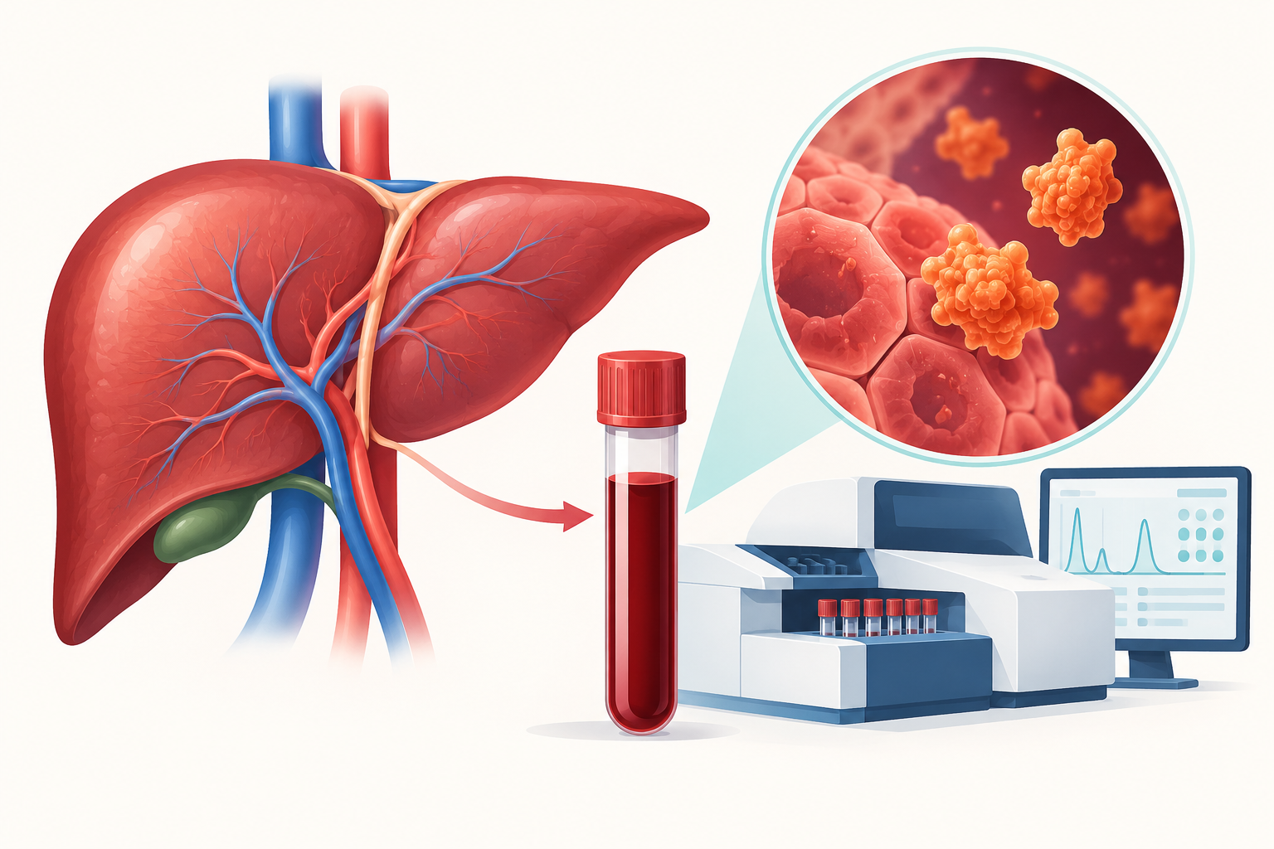
AST is usually interpreted with ALT and other clinical information rather than as a stand-alone result.
An aspartate aminotransferase test measures AST in the blood. AST is an enzyme found mainly in the liver, heart, skeletal muscle, and other tissues. When cells containing AST are injured, the enzyme can enter the bloodstream. The result can help identify or monitor tissue injury, but it cannot diagnose a specific condition by itself.

Why the test is ordered
AST may be included in a routine blood panel, ordered when symptoms suggest liver injury, or used to monitor a known liver condition or treatment. Symptoms that may lead to testing include jaundice, dark urine, pale stool, nausea, poor appetite, fatigue, abdominal swelling or pain, itching, and swelling in the legs or ankles.
Testing may also be considered when a person has risk factors such as hepatitis exposure, alcohol use disorder, obesity, diabetes, family history of liver disease, or use of a medicine that can affect the liver.

What happens during the test
A healthcare professional collects a small blood sample from a vein. The draw usually takes only a few minutes. Some combined blood panels require fasting, while an AST test alone may not. Follow the laboratory or clinician's instructions and disclose medicines and supplements; do not stop them unless instructed.

Understanding the result
Reference ranges vary by laboratory, method, age, and sex. A value marked high means it should be interpreted in context, not that a diagnosis is confirmed. AST may rise with hepatitis, cirrhosis, liver ischemia, alcohol- or medicine-related injury, muscle damage, strenuous exercise, seizures, burns, pancreatitis, or some heart conditions.
ALT is more concentrated in the liver, so clinicians frequently evaluate AST with ALT, alkaline phosphatase, bilirubin, albumin, and the medical history. The pattern and degree of change, repeat results, symptoms, and other tests matter more than a single number.

What AST cannot tell you
AST alone cannot establish how much alcohol a person drinks, diagnose diabetes, prove fatty liver disease, or determine exactly where an injury occurred. A normal value also does not rule out every liver condition. Avoid interpreting a result using a range copied from another laboratory.

Next steps
A clinician may repeat the test, review alcohol and medication exposure, order additional blood work, or use imaging when appropriate. Seek urgent care for confusion, vomiting blood, black stool, severe abdominal pain, rapidly worsening jaundice, fainting, or signs of acute illness.

Sources
- MedlinePlus. AST Test. https://medlineplus.gov/lab-tests/ast-test/
- MedlinePlus Medical Encyclopedia. Aspartate aminotransferase blood test. https://medlineplus.gov/ency/article/003472.htm
This article provides general educational information and does not replace individualized medical advice, diagnosis, or treatment.

