Cervical Dilation During Labor
How the cervix changes and how clinicians assess labor progress
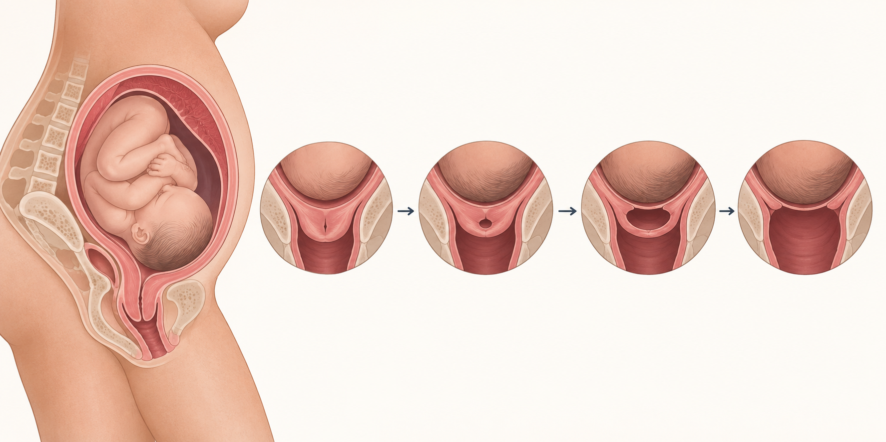
The cervix opens gradually during labor, but the pace varies widely between individuals.
Cervical dilation describes the opening of the cervix during labor. It is measured from closed to 10 centimeters. Dilation is only one part of labor assessment; clinicians also consider contractions, cervical thinning or effacement, the baby's position and descent, membrane status, and the health of the pregnant person and baby.
Stage | What it means | Typical clinical focus
First stage - latent phase | Labor begins and the cervix changes gradually | Comfort, hydration, contraction pattern, maternal and fetal wellbeing
First stage - active phase | Faster cervical change, generally beginning around 6 cm | Progress, contraction adequacy, fetal position and wellbeing
Second stage | From complete dilation at 10 cm to birth | Descent, pushing, maternal and fetal wellbeing
Third stage | From birth to delivery of the placenta | Bleeding, uterine tone and placental delivery

Latent and active labor
The first stage begins with labor and ends at complete dilation. The latent phase can vary considerably in length. Current ACOG guidance generally considers 6 cm the start of the active phase. Older expectations that everyone should dilate at least 1 cm per hour are no longer used as a universal rule.
A slow latent phase does not automatically mean labor has failed. Decisions depend on the complete clinical picture, including whether labor began spontaneously or was induced.

How dilation is assessed
A trained clinician may perform a vaginal examination to estimate dilation, effacement, cervical position, and the baby's station. Examinations are limited to what is clinically necessary because repeated exams can be uncomfortable and, after membranes rupture, may increase infection risk.

What contractions and sensations may feel like
Contractions often become longer, stronger, and closer together as labor progresses, but patterns differ. Pressure in the pelvis, back discomfort, or an urge to bear down can occur later. Symptoms alone do not accurately reveal the number of centimeters of dilation.

When to contact the maternity team
Follow the individualized instructions provided by the obstetric clinician or birth unit. Contact them for regular painful contractions, suspected rupture of membranes, vaginal bleeding more than light spotting, reduced fetal movement, severe headache, vision changes, fever, intense or constant abdominal pain, or any concern that something is wrong. Call emergency services for heavy bleeding, collapse, seizure, severe breathing difficulty, or an immediate threat to life.

After the baby is born
The second stage ends with birth. The third stage covers delivery of the placenta. The hours and weeks after birth are the postpartum period, not a fourth stage of cervical dilation. Monitoring continues for bleeding, blood pressure problems, infection, pain, feeding needs, and emotional wellbeing.

Sources
- American College of Obstetricians and Gynecologists. First and Second Stage Labor Management. https://www.acog.org/clinical/clinical-guidance/clinical-practice-guideline/articles/2024/01/first-and-second-stage-labor-management
- ACOG. reVITALize Obstetrics Data Definitions. https://www.acog.org/practice-management/health-it-and-clinical-informatics/revitalize-obstetrics-data-definitions
This article provides general educational information and does not replace individualized medical advice, diagnosis, or treatment.

