Endometrial Cancer
Symptoms, risk factors, diagnosis, and treatment
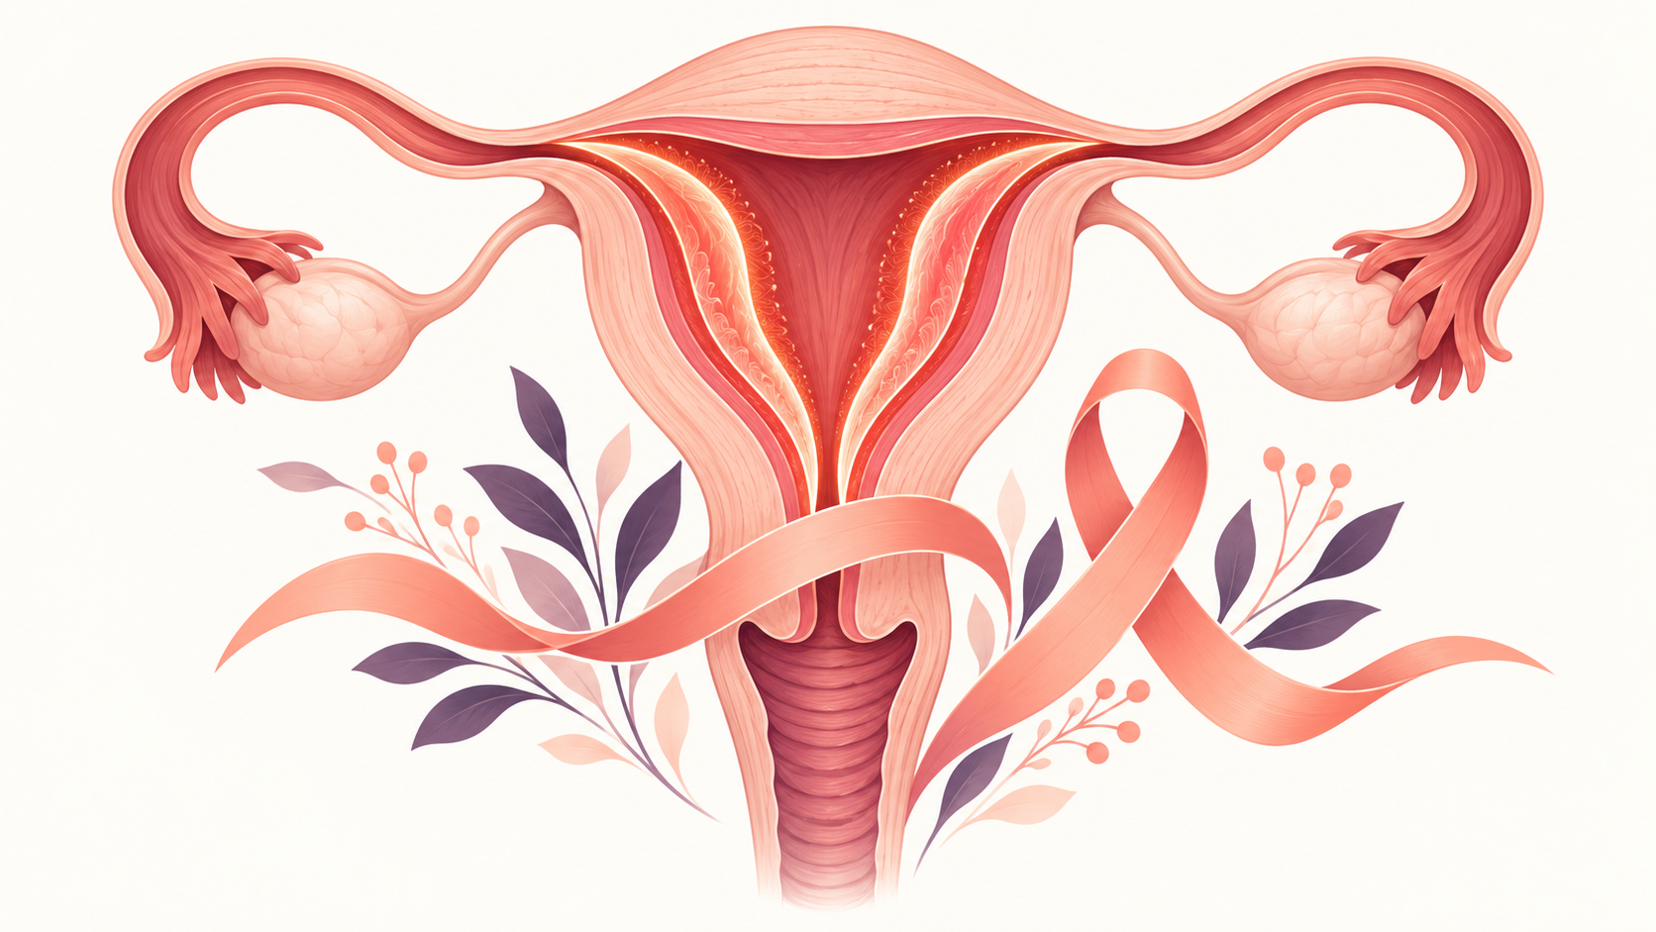
Endometrial cancer begins in the lining of the uterus and often causes abnormal bleeding.
Endometrial cancer begins in the lining of the uterus, called the endometrium. It is different from uterine sarcoma, which begins in the muscle or supporting tissue of the uterus. Abnormal vaginal bleeding is the most important warning sign, and many cases are found at an early stage because symptoms appear before the cancer has spread.

Symptoms that need assessment
Possible symptoms include bleeding after menopause, bleeding or spotting between periods, unusually heavy or prolonged periods, and abnormal vaginal discharge. Pelvic pain or pressure can occur, particularly with more advanced disease. These symptoms are often caused by noncancerous conditions, but they still deserve medical assessment.
There is no standard routine screening test for endometrial cancer in people at average risk. A Pap test screens primarily for cervical cancer and is not a reliable screening test for endometrial cancer.

Risk factors
Risk increases with age and with factors that increase lifetime exposure of the endometrium to estrogen without enough progesterone. These include obesity, endometrial hyperplasia, early menstruation, late menopause, never having been pregnant, estrogen-only menopausal hormone therapy in a person with a uterus, and some conditions that disrupt ovulation. Type 2 diabetes, tamoxifen use, Lynch syndrome, Cowden syndrome, and a first-degree family history can also increase risk.
A risk factor is not a diagnosis. Many people with risk factors never develop cancer, and some people develop cancer without an obvious risk factor.

How it is diagnosed
Evaluation may include a pelvic examination and transvaginal ultrasound, but a definitive diagnosis requires sampling the endometrial tissue. This is commonly done with an endometrial biopsy; hysteroscopy or dilation and curettage may be used in some situations. If cancer is found, pathology and imaging help determine its type, grade, molecular features, and stage.

Treatment
Surgery to remove the uterus is the most common initial treatment. The ovaries, fallopian tubes, and nearby lymph nodes may also be assessed or removed depending on the case. Radiation therapy, chemotherapy, hormone therapy, immunotherapy, or targeted therapy may be used according to stage, tumor characteristics, recurrence risk, overall health, and patient preferences.
People who want to preserve fertility should raise this before treatment. Fertility-sparing management is appropriate only in selected situations with close specialist monitoring.

When to seek care
Arrange medical assessment for any bleeding after menopause or for persistent bleeding between periods. Seek urgent care for very heavy bleeding with dizziness, fainting, chest pain, breathing difficulty, or severe weakness.

Sources
- National Cancer Institute. What Is Endometrial Cancer? https://www.cancer.gov/types/uterine/endometrial
- National Cancer Institute. Endometrial Cancer Screening. https://www.cancer.gov/types/uterine/endometrial/screening
- National Cancer Institute. Endometrial Cancer Treatment. https://www.cancer.gov/types/uterine/endometrial/treatment
This article provides general educational information and does not replace individualized medical advice, diagnosis, or treatment.

