Cluster Headache
How attacks differ from migraine and how they are treated
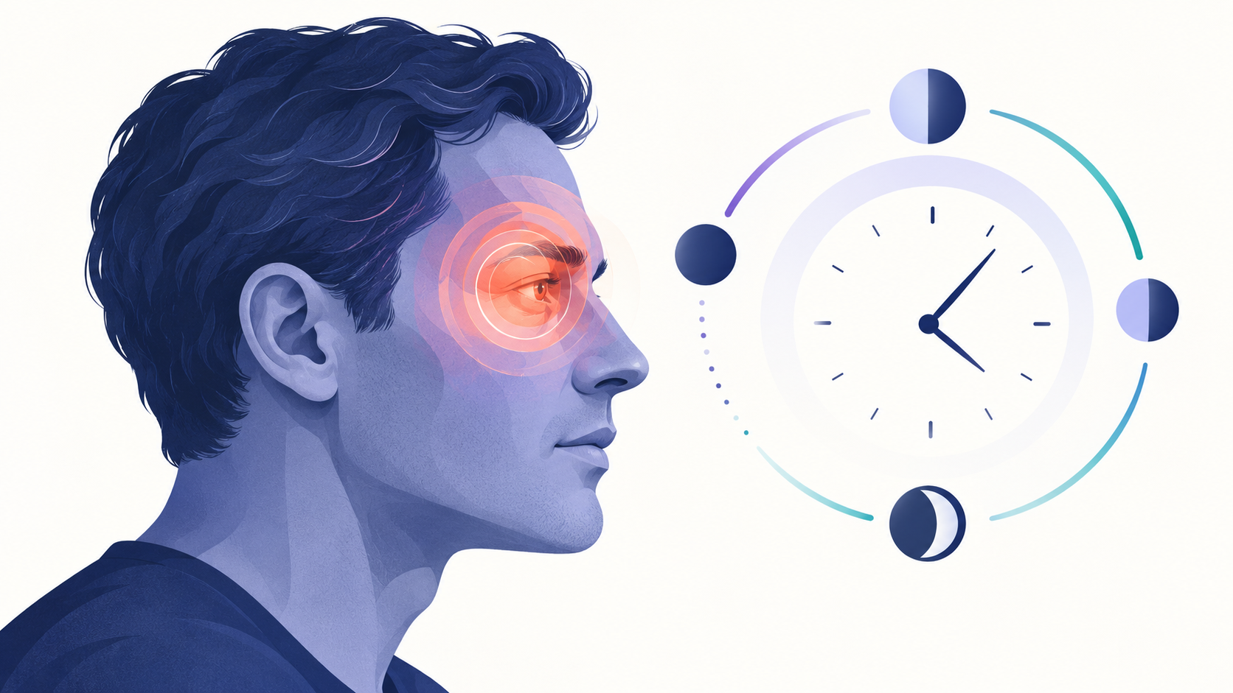
Cluster headache typically causes severe one-sided pain around the eye in repeated, time-linked attacks.
Cluster headache is a rare primary headache disorder that causes severe pain on one side of the head, usually around or behind one eye. Attacks occur in repeated bouts or clusters, often at similar times of day. The pain can be disabling, but effective acute and preventive treatments are available.
Feature | Cluster headache | Migraine
Typical duration | About 15 to 180 minutes when untreated | Usually 4 to 72 hours
Behavior during attack | Restlessness or pacing is common | Many people prefer to lie still
Associated signs | Tearing, red eye, blocked or runny nose, drooping eyelid on the painful side | Nausea, light or sound sensitivity; aura in some people
Pattern | May occur several times daily during a cluster period | Frequency varies widely

Symptoms and patterns
Pain rises quickly and is often described as piercing, burning, or excruciating. The affected side may also develop tearing, eye redness, nasal congestion or discharge, eyelid swelling or drooping, facial sweating, or a smaller pupil. Attacks commonly recur from once every other day to several times per day during an active cluster period.
Episodic cluster headache includes remission periods, while chronic cluster headache has shorter or absent remissions. Diagnosis depends on the attack pattern and associated symptoms, not on a laboratory test.

Triggers and causes
The exact cause is not fully understood. The hypothalamus and trigeminal-autonomic pathways appear to be involved. During an active cluster period, alcohol can trigger an attack in some people. Strong odors, sleep disruption, or certain medicines may also act as triggers for some individuals. Smoking is common among affected patients, but stopping smoking does not guarantee that attacks will stop.

Treatment
Acute treatments are chosen because attacks peak rapidly. High-flow oxygen delivered through an appropriate mask and fast-acting triptans are widely used. Oral pain medicines usually act too slowly. Preventive treatment aims to reduce the number and intensity of attacks during a cluster period; verapamil is commonly used, with monitoring determined by the prescriber. Other preventive or transitional options depend on the individual.
Do not use another person's oxygen or prescription medicine. Treatment choice depends on cardiovascular history, pregnancy status, other medicines, and the accuracy of the diagnosis.

When headache is an emergency
Call emergency services for a sudden 'worst headache,' headache after significant injury, or headache with fever and stiff neck, seizure, confusion, fainting, new weakness or numbness, difficulty speaking, or vision loss. A first episode of severe one-sided headache also deserves prompt medical assessment to exclude other causes.

Sources
- National Institute of Neurological Disorders and Stroke. Headache booklet. https://www.ninds.nih.gov/sites/default/files/2025-07/NINDS_Headache_Booklet_Digital_508c%20%281%29.pdf
This article provides general educational information and does not replace individualized medical advice, diagnosis, or treatment.

