LASIK Eye Surgery
How the procedure works, who may be eligible, and what risks to consider
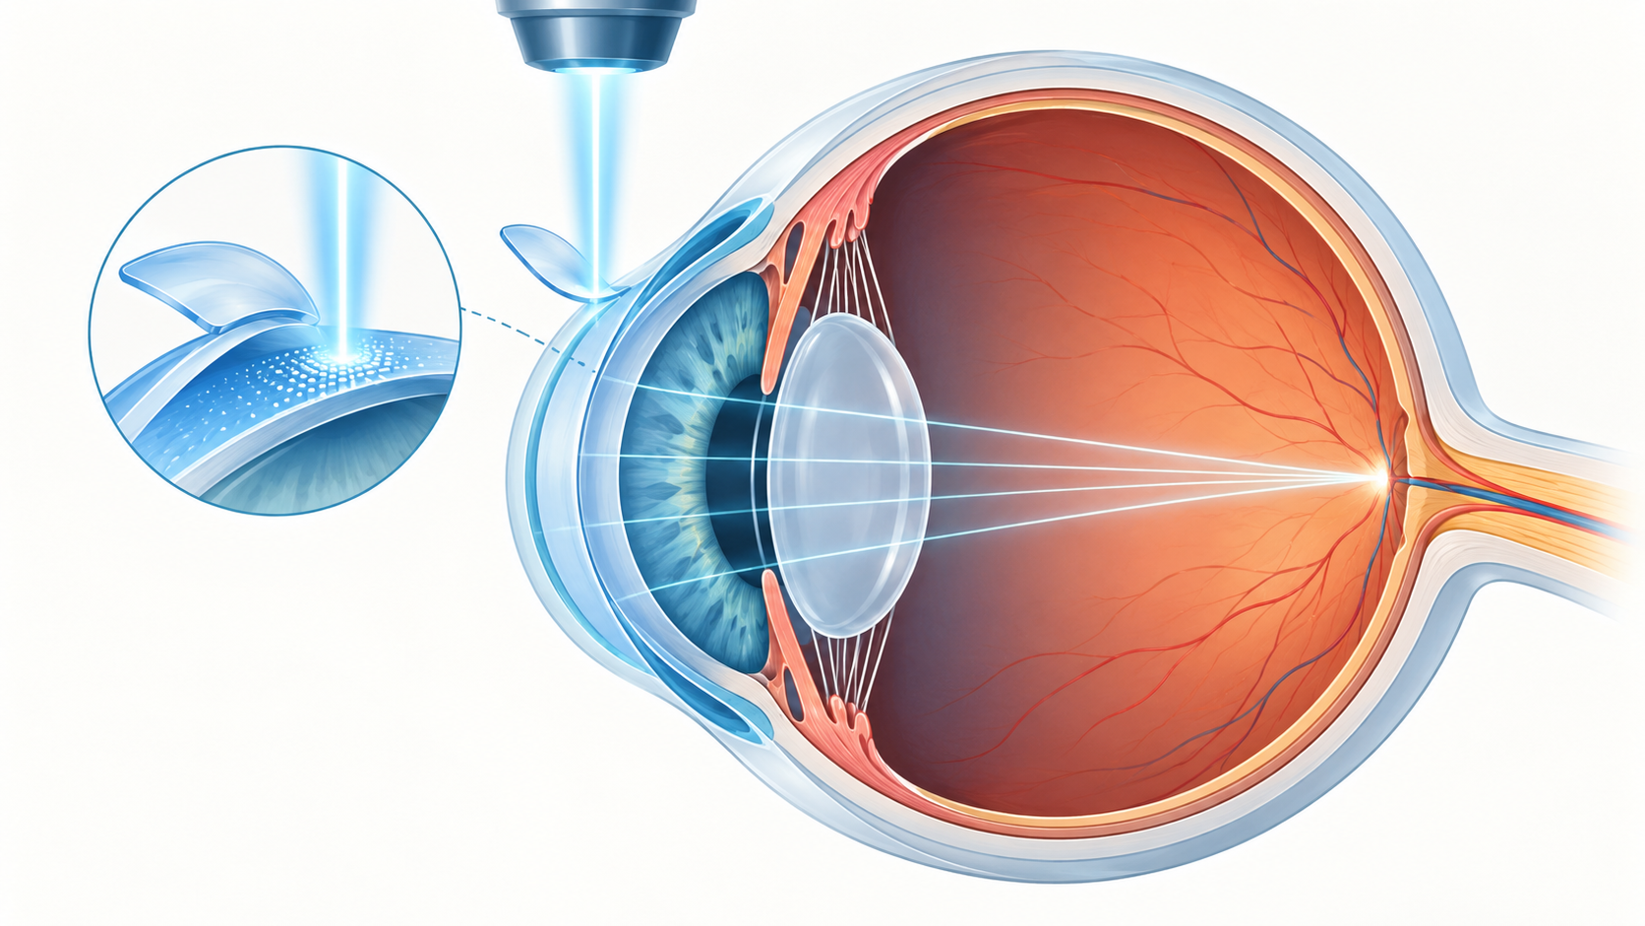
LASIK changes the shape of the cornea so light can focus more accurately on the retina.
LASIK is a refractive eye procedure that permanently reshapes the cornea with a laser to reduce dependence on glasses or contact lenses. It may correct selected cases of nearsightedness, farsightedness, and astigmatism. It does not guarantee 20/20 vision, prevent age-related vision changes, or eliminate the possibility of needing glasses later.

How LASIK works
The surgeon creates a thin flap in the cornea using a laser or microkeratome. The flap is lifted, and a computer-controlled excimer laser removes microscopic amounts of corneal tissue according to the treatment plan. The flap is then repositioned. The procedure is usually brief, but preparation, screening, and follow-up are essential parts of care.

Who may be a candidate
Candidates are adults with a stable prescription and corneas that are thick and healthy enough for the intended correction. A thorough examination assesses refraction, corneal shape and thickness, pupil size, tear production, eye disease, medications, general health, occupation, and expectations.
Pregnancy or breastfeeding, unstable vision, severe dry eye, keratoconus, thin corneas, active eye inflammation, certain autoimmune or immune conditions, poorly controlled diabetes, and medicines that interfere with healing may delay or rule out treatment. Contact sports and career requirements also matter.

Benefits and limitations
Many appropriately selected patients reduce their dependence on corrective lenses. Results vary with the starting prescription, eye anatomy, device, and surgeon experience. Some people still need glasses for driving, reading, or fine work, and age-related presbyopia continues after LASIK.

Risks and possible side effects
Common early effects include dryness, glare, halos, starbursts, fluctuating vision, and light sensitivity. Some symptoms improve during healing, but they can persist. Other risks include undercorrection, overcorrection, infection, inflammation, flap complications, corneal weakening, reduced contrast sensitivity, and loss of lines of best-corrected vision. Rare complications can be serious and irreversible.

Before and after surgery
Contact lenses may need to be stopped before the baseline examination because they can temporarily alter corneal shape. Tell the surgeon about every medicine, supplement, eye condition, and health condition. Arrange transportation for surgery and the first follow-up. Afterward, use prescribed drops and eye protection exactly as directed, avoid rubbing the eyes, and attend all follow-up appointments.
Seek urgent advice for worsening pain, sudden loss of vision, increasing redness, discharge, injury, or new severe light sensitivity.

Sources
- US Food and Drug Administration. LASIK. https://www.fda.gov/medical-devices/surgery-devices/lasik
- FDA. LASIK Surgery Checklist. https://www.fda.gov/medical-devices/lasik/lasik-surgery-checklist
- FDA. What are the risks and how can I find the right doctor for me? https://www.fda.gov/medical-devices/lasik/what-are-risks-and-how-can-i-find-right-doctor-me
This article provides general educational information and does not replace individualized medical advice, diagnosis, or treatment.

