Small Intestinal Bacterial Overgrowth
Symptoms, testing, treatment, and areas of uncertainty
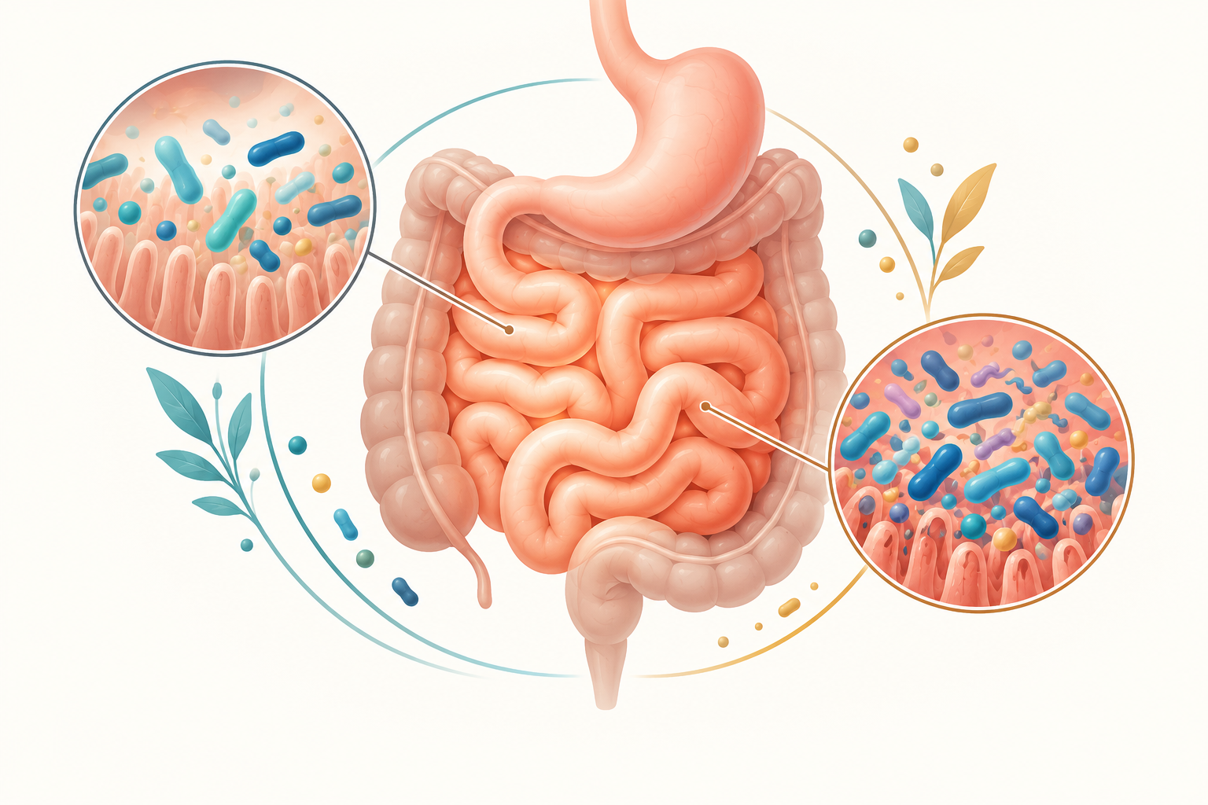
SIBO involves an abnormal bacterial burden in the small intestine, but testing and interpretation have limitations.
Small intestinal bacterial overgrowth, usually shortened to SIBO, describes gastrointestinal symptoms associated with an excessive or altered bacterial population in the small intestine. The definition and testing thresholds are not perfectly standardized, so symptoms alone should not be used to self-diagnose the condition.

Common symptoms
Bloating, abdominal discomfort, excessive gas, and diarrhea are commonly associated with SIBO. Constipation may occur in some methane-predominant cases. More severe or prolonged disease can contribute to weight loss, fatty stool, vitamin B12 deficiency, or other nutritional problems. These symptoms overlap with irritable bowel syndrome, celiac disease, lactose intolerance, inflammatory bowel disease, pancreatic disorders, and many other conditions.

Why it can develop
Risk increases when normal intestinal movement, anatomy, acid production, or immune defenses are disrupted. Examples include prior gastrointestinal surgery, narrowed or blind segments of bowel, scleroderma and other motility disorders, poorly controlled diabetes, and selected medicines or diseases that slow movement through the gut. The underlying cause matters because recurrence is common when it cannot be corrected.

How it is tested
Hydrogen and methane breath tests after a measured sugar drink are commonly used because they are noninvasive. Preparation instructions matter and may include temporary changes to antibiotics, laxatives, diet, and fasting. Breath tests have limitations and can produce misleading results. Sampling fluid from the small intestine is more direct but invasive and not routinely performed for everyone.
A clinician may also evaluate nutritional status and look for other causes of symptoms. Broad online symptom checklists or responses to a diet do not confirm SIBO.

Treatment
Treatment generally addresses three areas: the bacterial overgrowth, any nutritional deficiency, and the condition that allowed overgrowth to develop. A clinician may prescribe a short course of antibiotics. The choice should be individualized because evidence for the best regimen remains limited and repeated broad-spectrum antibiotic use has risks.
Dietary changes may help symptoms but are not a universal cure. Restrictive diets can cause nutritional problems and should not be continued unnecessarily. Evidence is insufficient to recommend the same probiotic or supplement approach for everyone.

When to seek care
Arrange assessment for persistent bloating, diarrhea, constipation, unexplained weight loss, anemia, or suspected nutrient deficiency. Seek urgent care for severe or worsening abdominal pain, repeated vomiting, black or bloody stool, fever with significant illness, dehydration, or inability to pass stool or gas.

Sources
- American College of Gastroenterology. Small Intestinal Bacterial Overgrowth. https://gi.org/topics/small-intestinal-bacterial-overgrowth-sibo/
- American Gastroenterological Association. Diagnosis and management of SIBO. https://gastro.org/clinical-guidance/diagnosis-and-management-of-small-intestinal-bacterial-overgrowth-sibo/
This article provides general educational information and does not replace individualized medical advice, diagnosis, or treatment.

