Transcranial Magnetic Stimulation
A noninvasive brain stimulation treatment for selected mental health and neurological conditions
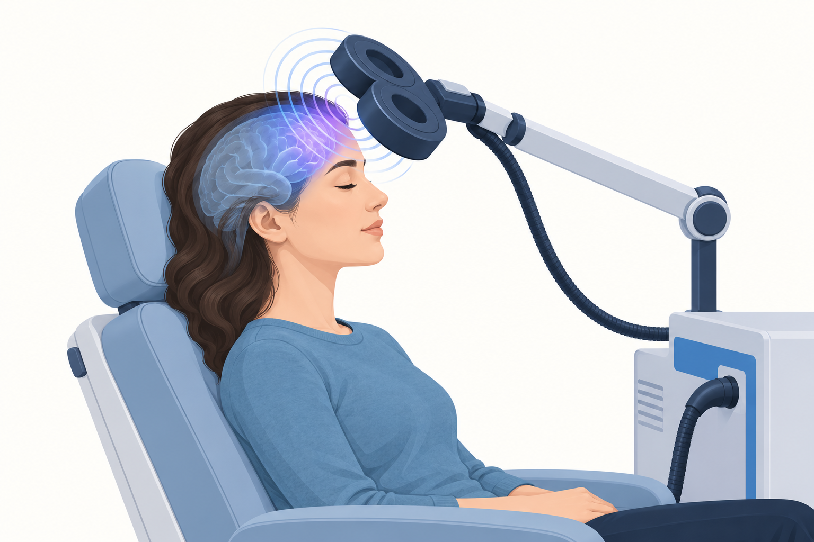
During rTMS, a magnetic coil delivers repeated pulses to a targeted area of the brain.
Repetitive transcranial magnetic stimulation, or rTMS, uses an electromagnet placed near the scalp to deliver repeated magnetic pulses. These pulses induce small electrical currents in targeted brain circuits. Treatment is noninvasive and does not require an incision or general anesthesia.

Why it is used
rTMS is best established for depression that has not improved enough with medication or psychotherapy. In the United States, specific devices and protocols have also received FDA clearance for conditions including obsessive-compulsive disorder, migraine, smoking dependence, and selected forms of depression. A device clearance applies to a particular indication and protocol; it does not mean every form of TMS is proven for every brain disorder.

What treatment involves
A clinician identifies the treatment location and determines the stimulation intensity. During sessions, the patient sits awake while the coil rests against the scalp. A course usually involves repeated outpatient sessions over several weeks, although accelerated protocols are available in selected settings. The patient can usually return to normal activities after a standard session.

Benefits and limitations
rTMS can reduce depressive symptoms for some people who have not benefited sufficiently from other treatments. Response is not guaranteed, and symptoms can return. Maintenance treatment or additional therapy may be considered. rTMS is not the same as electroconvulsive therapy and generally does not produce the same level of effect in the most severe treatment-resistant depression.

Side effects and safety
Common side effects include scalp discomfort, headache, tingling, or facial muscle twitching during treatment. These often lessen over time. Hearing protection is used because the device produces loud clicks. Seizure is a rare but serious risk. The clinician must know about implanted metal or electronic devices, a history of seizures, brain injury, pregnancy, and all medicines or substances that may affect seizure risk.

Choosing a treatment program
Ask which device and protocol will be used, what condition it is intended to treat, how outcomes are measured, what alternatives exist, and how costs are handled. Treatment should be delivered under qualified clinical supervision as part of a broader care plan.
Anyone experiencing suicidal thoughts or an immediate risk of self-harm should seek emergency help rather than waiting for a routine TMS appointment.

Sources
- National Institute of Mental Health. Brain Stimulation Therapies. https://www.nimh.nih.gov/health/topics/brain-stimulation-therapies/brain-stimulation-therapies
- National Institute of Mental Health. Depression. https://www.nimh.nih.gov/health/publications/depression
This article provides general educational information and does not replace individualized medical advice, diagnosis, or treatment.

