Severely High Blood Pressure
How to respond to a reading of 180 over 120 or higher
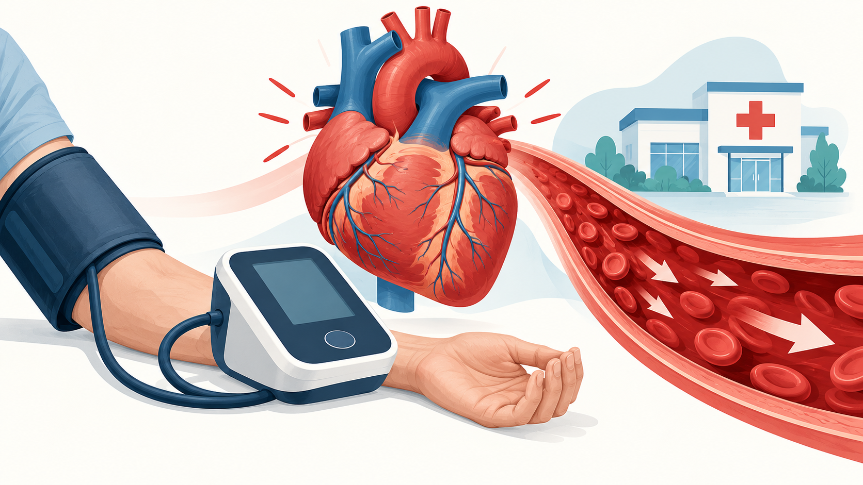
A very high reading should be repeated correctly and assessed together with symptoms.
A blood pressure reading of 180/120 mm Hg or higher is severely elevated and requires prompt attention. The most important distinction is whether there are symptoms or signs of acute organ injury. Severe blood pressure with acute injury is a hypertensive emergency and requires immediate hospital treatment.
Situation | What to do
Reading at or above 180/120 without emergency symptoms | Sit quietly, repeat after about five minutes, and contact a healthcare professional promptly if still high
Reading at or above 180/120 with chest pain, breathing difficulty, weakness, confusion, vision change, seizure, or other severe symptoms | Call emergency services immediately
Pregnancy or recent childbirth with very high blood pressure, severe headache, vision change, upper abdominal pain, or breathing difficulty | Seek emergency obstetric care immediately

Symptoms of a hypertensive emergency
Possible warning signs include chest pain, shortness of breath, back pain, weakness or numbness, difficulty speaking, confusion, seizure, severe headache with neurological symptoms, sudden vision change, or reduced consciousness. The emergency is defined by acute organ injury, not the blood pressure number alone.

What to do with a very high reading
If the reading is at least 180/120 and there are no emergency symptoms, sit quietly with the back supported and feet flat, keep the arm supported at heart level, and repeat the measurement after about five minutes. If it remains that high, contact a healthcare professional promptly for instructions. If emergency symptoms are present, do not wait for another reading - call emergency services.
Do not take extra doses, use someone else's medicine, or try to lower blood pressure rapidly unless a clinician gives specific instructions. An excessive or abrupt fall can reduce blood flow to the brain, heart, or kidneys.

How clinicians evaluate it
Assessment may include repeated blood pressure measurements, a neurological and cardiovascular examination, an electrocardiogram, blood and urine tests, and imaging guided by symptoms. Treatment depends on the organ involved. Hypertensive emergencies are usually treated with closely monitored intravenous medicine; severe hypertension without acute organ injury is generally managed more gradually.

Common contributing factors
Potential contributors include missed blood pressure medicines, drug interactions, kidney or endocrine disease, pregnancy-related hypertension, cocaine or other stimulants, and some over-the-counter medicines or supplements. Primary, secondary, resistant, and isolated systolic hypertension are categories of hypertension, not separate types of hypertensive crisis.

Prevention
Take prescribed medicines consistently, monitor blood pressure using a validated device, and bring a written or electronic log to appointments. Review decongestants, pain medicines, stimulants, supplements, and recreational substances with a clinician. Long-term management may also include reducing sodium, regular physical activity, limiting alcohol, stopping smoking, and treating sleep apnea or other contributing conditions.

Sources
- National Heart, Lung, and Blood Institute. High Blood Pressure Symptoms. https://www.nhlbi.nih.gov/health/high-blood-pressure/symptoms
- NHLBI. Seventh Report of the Joint National Committee on Prevention, Detection, Evaluation, and Treatment of High Blood Pressure. https://www.nhlbi.nih.gov/sites/default/files/media/docs/jnc7full.pdf
This article provides general educational information and does not replace individualized medical advice, diagnosis, or treatment.

