

**Chapter 1** [Al Fatihah]

**[1] In the name of God, Most Gracious, Most Merciful.**

[2] Praise be to the God, the Sustainer and Evolver (*Rabb*) of the universes (*alamin*).

[3] Most Gracious, Most Merciful;

[4] Master of the Day of Law (*Deen*).

[5] Thee do we worship, and Thine aid we seek.

[6] Guide us to the Straight Path,

[7] The Path of those on whom Thou hast bestowed Thy Grace, those whose is not wrath, and who go not astray.

**Color Code**

**Blue**: Verses of the Quran

**Black**: All other writings

**Tafsir of the Surah**

**Introduction**

The *Surah* (Chapter) stands at the outside of the Quran, as the following verse says:

“And We have bestowed upon thee the Seven Oft-repeated (this Surah) and the Grand Quran.”

[Al Quran 15:87]

So, the Surah and the Grand Quran are two different articles, revealed by the same God. The Surah is the preface of the Quran.

The Surah acquaints its readers with the God of the Quran. It motivates them to worship the God only and rely on Him only. It stirs up the unity of Muslims by using we/us in the prayer: *“Thee do we worship, and Thine aid we seek”.*

The Surah highlights the book as for the people that urge for the guidance: *“Guide us to the Straight Path…”* It is the path that the old Prophets admired:

“A voice of one calling in the desert: ‘Prepare the way for the Lord; make Straight Path for him...’”

[Gospel of Mark 1:3-4, Holy Bible]

The Surah altogether is a teaching, a motivation, and a prayer. It sets its reader into the desired state of mind to go through the Book.

**Flowchart**

Section 1 [Verse 2-4]: The God of the Quran

Section 2 [Verse 5-7]: Submission and Prayer

**Section-1** of Chapter-1 **[Verse 2-4]: The God of the Quran**

Praise be to the God, the 'Sustainer and Evolver' of the universes*.*

**Remarks:**

The above verse acquaints one with the God of the Quran. According to the verse, the God of the Quran is the 'Sustainer and Evolver' *(Rabb)* of the universes *(alamin).*

Therefore, if we can understand how a sustainer and evolver of the universes should be, we will have a better idea about the God? It is discussed under the following headings:

1. The Universes *(Alamin)*
2. The God in Form
3. The God existing Everywhere
4. Basic Knowledge about the Soul
5. How the God sustains and evolves the universes by extending several of His elementary souls into the space
6. Practical Examples of several likely extended elementary souls (force fields / ruhhs) of the God
7. How the God became God
8. Conclusion

The discussion will acquaint a reader with the real God of the universes, scientifically.

**Note**:

"Rabb" is translated by Pickthall as "Lord", and by Abdullah Yusuf Ali as "Cherisher and Sustainer". The literal meaning of the word is "sustainer, cherisher, master, and nourisher". In context of the inert universes, it is translated here as "Sustainer and Evolver". Otherwise, one of the 99 names of Allah is Sustainer (Al Mukeet) and another of His names is Evolver (Al Baari) in the Quran.

1. **The Universes *(Alamin)***

If we want to understand the God as the Sustainer and Evolver of the universes *(alamin)*, we are to know the universes at first. People have different ideas about theuniverses*.* Two of such ideas are discussed below in short:

1a. **The Idea of Multiverse**

*“The multiverse is a group of multiple universes. Together, these universes comprise everything that exists…” – WIKIPEDIA, The Free Encyclopedia.*

The different universes within a multiverse are called parallel universes, other universes, or alternate universes. These universes may have different physical constant, laws of physics, and even different fundamental particles.

The universe, where we are living now, was born with precisely perfect laws and configuration. Thus, it has evolved to the state of today.

Today the elements and compounds forming the Earth follow innumerable natural laws, perfect and correctly interactive to each other to support our lives. And, there is a huge quantity of water with unique characteristics.

Thus, the Universe is fine-tuned for a complex creature like us. It is obvious that it has been created by a super intelligent being, no less than the God described in the Quran (Allah SWT).

But, the Idea of Multiverse, found in the common books, tries to answer how a fine tuned universe could evolve without God.

*“Philosophical debates in which “fine-tuning” appears are often about the universe’s fine-tuning for life: according to many physicists, the fact that the universe is able to support life depends delicately on various of its fundamental characteristics, notably on the form of the laws of nature, on the values of some constants of nature, and on aspects of the universe’s conditions in its very early stages. Various reactions to the universe’s fine-tuning for life have been proposed: that it is a lucky coincidence which we have to accept as a primitive given; that it will be avoided by future best theories of fundamental physics; that the universe was created by some divine designer who established life-friendly conditions; and that fine-tuning for life indicates the existence of multiple other universes with conditions very different from those in our own universe…”*

*– Stanford Encyclopedia of Philosophy*

The space possesses energy, such as vacuum energy / dark energy. Therefore, there are theories suggesting that there could be billions and billions of Big Bangs, resulting in the formation of billions and billions of universes. Accidentally, one of these universes could be suitable for life. Thus, many use this explanation to account for creation without invoking a Creator.

It is evident that the Quran does not suggest such an idea through the term "alamin" or "universes". Instead, the Quran emphasizes fine-tuning as the proof of God’s existence:

"He Who created the Seven Skies one above another; not you see in the creation of Most Gracious any disparity *(tafawutin)*…"

[Al Quran 67:03]

The above verse says that there is no disparity *(tafawutin)* in the Skies, which means that the Universe is fine-tuned. The fine-tuning is done by the Him (God).

The Skies are super-giant waves of space, one inside another; like the peels of onion. The waves are produced by the distribution of matter (galaxies mainly) in the space. We are in the innermost (First) Sky.

The expanding Skies helped the concentration of matter into the galaxies. It also helps the balanced expansion of the Universe. Thus, the Skies save the Universe from disparity *(tafawutin).*

One does not have to believe the existence of Skies blindly; the formation of walls, filaments, and voids point out the existence Skies as seven super-giant waves of space. Each Sky contains many galaxies and other objects. The Skies are deliberately discussed in Section-7 of Chpter-2.

Allah is the Originator(*Fatir*) of the Universe. He set the laws and the initial configuration of the Universe perfectly so that it (the universe) could evolve as desired. We can see His initial acts (*futurin)* by returning our visions to the early universe. It is possible today by the James Webb Space Telescope:

“…So, return the vision: Can you see any ‘initial act of Originator’ (*futurin*)? Then return the vision twice—overturned to you the vision, lost, and it is tired.” [Al Quran 67:3-4]

[In above verse, *“futurin”* is normally translated as “flaw”. It is a deviated translation. *“Fatir” means “Originator”.* It is one of the names of Allah. In a human context, *“futurin”* means “breakfast” (see dictionary). So, in context of above verse, *“futurin”* should mean“the initial act of Originator”]

We may think on the Sun, Earth and Moon to understand how precisely the system is tuned:

“And the Moon, We have ordained for it phases till she returns like the date-stalk the old.

It is not permitted to the Sun to catch up the Moon, nor can the Night outstrip the Day, but all are in a sphere ( ⃰ *Falakin* / Milky Way galaxy) floating.

And a sign for them is that We bore their race in the loaded Ark (of Noah); And We have created for them similar (vessels) on which they ride.”

[Al Quran 36:39-42]

⃰ ["Falakin" is normally translated as “orbit”, but it can be translated as ship, sphere, astronomy as well (see dictionary please). A galaxy is a sphere of space carrying the stars and other objects (like a space ship). And, as the above verses say that the sun and the moon are floating in the"falakin",it should be understood as the "Milky Way Galaxy".]

The above verses point out the fine-tuning, described below:

The Moon is working from the old times as a natural calendar for the common people. To be a good natural calendar, it had to be big enough in size to appear *like the date-stalk the old* (thin crescent) at the ends*.*

But, the Sun, exposing powerful gravitational force, should snatch away a big Moon and make it a planet of its own. The problem of having a big Moon is solved by reducing its mass. Scientists think that the Moon has a remarkably small iron core for a body of its size. So, the center of gravity (CG) of the Earth–Moon-System lies inside the Earth, about 1,700 kilometers below the surface. So, the gravity of the Sun works on the Moon through the Earth. So, *it is not permitted to the Sun to catch up the Moon.*

But the mass of the Moon could not be reduced too much so that *nor can the Night outstrip the Day*. A Moon with correct mass is necessary for the stability of the Earth at 23.5 degree tilt that provides stability to the Earth in its movement and rotation, ensuring stable days and nights at each point of the Earth.

Moreover, the Moon having correct mass produces measured tides in the oceans.

The gravitational force is designed to act in fixed patterns; and masses, distances, tilts, and movements of Sun, Earth and Moon are correctly decided. They produce correct heat, tides, and currents in atmosphere and oceans. So, the sailing ships can move safely: *"And a Sign for them is that We bore their race in the loaded Ark (of Noah); And We have created for them similar (vessels) on which they ride".*

And, why the Ark of Noah is mentioned here? The boat of Noah was floating in a special situation. Allah has fixed the nature, but He is always in control. Such is the tuning by Allah that it (fine-tuning) does not negate His interference—Allah, the Most Intelligent, the Wise!

The creation of the fine-tuned universe proves the existence of God. And the Quran is His message, choreographed for the testing ground of Earth. It increases the belief of the Believers, and it increases the disbelief of the disbelievers. The same technique is applied in the creation.

So, an Atheist cannot see the act of Originator *(futurin).* He reacts to the aspect of fine-tuning by the Idea of Multiverse. He argues that there could be many Big Bangs and many universes, and as a matter of chance one has become suitable for life.

*“If there were a large (possibly infinite) number of universes, each with possibly different physical laws, then some of these universes (even if very few) would have the combination of laws and fundamental parameters that are suitable for the development of matter, astronomical structures, elemental diversity, stars, and planets that can exist long enough for life to emerge and evolve.”*

– Wikipedia / from Anthropic Principle

The space possessing energy may be exploding with the Big Bangs, but it could never produce a universe fine-tuned for a complex creature like us. The probability is zero in reality.

Moreover, the universes would collide with each other due to their gravitational forces to produce the explosions and explosions only—if there were no barrier space separating them.

By *“alamin”,* the Quran does not mean such aimlessly popping out universes.

However, in subsequent discussions, one will find that Allah has created several universes. There is a parallel universe (anti-universe) within our universe, and there are other universes at the outside of our universe.

The parallel universe that is within our universe is created from the dark matter (anti-matter is a kind of dark matter). The anti-creatures, such as the jinns, are living in the parallel universe. The jinns are intelligent and top anti-creatures.

So, our universe is a two-in-one universe. Allah has made some arrangements to save the matter and the anti-matter from random collision and frequent annihilation.

In addition, there are other universes, such as the Jannaat, at the outside of our universe. The universes are separated by a huge barrier called *“Barzakh”.*

1b. **Sufi-idea about the Alamin (Universes)**

The Sufis (Muslim Saints) too sometimes talk about the *alamin* to articulate the spectrum of spiritual rise in general. It is given below in short:

i. Hahoot: It is the world *(alam)* where only Allah exists.

ii. Yahoot: It is the world where the existence of Noor-Muhammadi is considered.

iii. Rahoot: It is the world where the ruhh exists.

iv. Jabrut: It connects. The level includes the angels.

v. Malakut: The creation we see around us is Malakut.

vi. Nasoot: A human body is considered as an alam (world) and is called Nasoot.

There are two more alamin: Alam-e-Arwah and Alam-e-Barzakh. Our souls (nafses) come from Alam-e-Arwah and go to Alam-e-Barzakh after death.

*“Allah SWT has told us in the Quran that prior to being born in this world, all human beings were formerly born in a different world. The state of human beings at the time of that initial birth is referred to as Aalam-e-Arwah. The actual definition of Aalam-e-Arwah is the time spent by humans in another world before coming down to this earth. When we come down to this earth, we are born with a body and our nafs which is called soul. When we die and leave this world, our physical body stays here in the soil and our soul is taken out. This is also a kind of Aalam-e-Arwah but Quran generally uses a different term for that stay of soul and calls it “Barzakh” meaning it is a time when there is no “body” but just the “soul”.”* – *Abu Yahya,* Inzaar.org

The Quran indicates that the Alam-e-Arwah is a virtual universe that the God created to plan the creation. It is the Master Design of God.

We were created in the virtual universe (Master Design) from our souls (nafses) and genome codes and lived a virtual life in a Holographic Earth.

Our fates are extracted from our virtual lives. One’s real life on the Earth is a repetition of the virtual life, except in the aspect of Faith [the Master Design and the Fate are deliberately discussed in Section-9 of Chapter-6].

The virtual universe still exists in the Arsh as an element in angelic establishment, executing parts of our fates by angels.

There are two worlds inside the Barzakh: Illiyin and Sijjin. These two are holographic worlds for the dead to live till the Day of Resurrection [the Illiyin and Sijjin are deliberately discussed in Chapter-83].

Our science has not developed in the direction of spiritual-awareness. So, the information derived from the sufi-thoughts cannot be used in our scientific discussion. We may end the discussion of sufi-worlds here.

1c. **The Universes (Alamin) in the Quran**

The universes (alamin) that are mentioned in the Quran are discussed below under the following headings:

i. Samawaat

ii. Jannaat

iii. Different Universes

iv. Super Space and *Barzakh*

v. Araf, Channels, and Sidratul-Muntaha

vi. Illiyin and Sijjin

vii. Arsh

1c(1). **Samawaat**

This universe, where we are living now, is called Samawaat in the Quran. Samawaat means Skies.

The study of the Quran reveals that the space of the universe (Samawaat) is shaped into seven spherical waves, one inside another—like the peels of onion. These waves of space are skies. Each sky contains innumerable galaxies. We are in the First (Innermost) Sky. The space though waved is continuous.

One does not have to believe the existence of skies blindly. Several recent observations indicate that the skies should exist—though the theories have not been developed to harness the idea in the books of science [The skies are deliberately discussed in Section-7 of Chapter-2].

1c(2). **Jannaat**

The Jannaat is a separate universe altogether. The hint of its location is given in the following verses:

“Be quick in the race for forgiveness from your Lord and for a Jannaat whose width is that of the ‘Skies and Lands’ (this universe), prepared for the righteous…” [Al Quran 3:133]

“Race to forgiveness from your Lord and the Jannaat, the width of which is as the width of the ‘Sky and Land’ (this universe)” [Al Quran 57:2]

According to the above verses, the width of the Jannaat is equal to the width of this universe (Samawaat). If two entities are equal in width, one cannot remain inside another. So, the Jannaat and the Samawaat are two separate universes.

Holy Bible gives similar indication:

"Because only a few will be saved, God created two universes, instead of only one"

– 2 ESDRAS 7:50, Holy Bible (GNB)

Some say that the Time began at the Big Bang, and that there is nothing beyond the Big Bang, and so on, because they do not know. Allah is ever living, and He has other creations at the outside of this universe.

1c(3). **Separate Universes**

The following factors confirm that the Jannaat and the Samawaat are two separate universes:

Factor 1: **Separate by Origin**

From the Big Bang, ultimately from the Big Bounce, this universe (Samawaat) has been created, not the Jannaat.

“Do not the unbelievers see that the Skies and the Lands (this universe) were joined together before We clove them asunder” [Al Quran 21:30]

According to the above verse, there were lands (dusts and asteroids) in the initial universe. But the Big Bang produced hydrogen and helium mainly (smoke). The initial universe could have heavier elements (lands) if it started from a non-singular state of the next cycle. So, in light of the Quran, the universe started from a Big Bounce, and we are living in the 2nd Cycle (see figure below).

*"The Big Bounce is a hypothesized cosmological model for the origin of the known universe. It was originally suggested as a phase of the cyclic model or oscillatory universe interpretation of the Big Bang, where the first cosmological event was the result of the collapse of a previous universe…"*

*– WIKIPEDIA, The Free Encyclopedia*

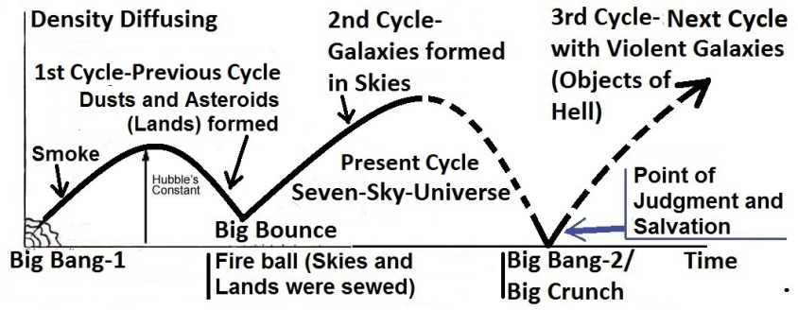

FIGURE 1.1: The Quran’s Model of Cyclic Universe

The Cyclic Model of the Quran is described below according to the verses:

**1st Cycle**:

The universe started from the Big Bang-1. It produced hydrogen and helium (smoke) mainly. The space was uniform (single-sky-universe), and the smoke spread evenly throughout the space.

Allah infused gravitational force into the universe, full of smoke:

“Moreover, infused His force (thummaistawa) into the Sky (single-sky-universe of the 1st cycle) while it had been smoke…” [Al Quran 41:11]

The gravitational force started contracting the universe. The contracting universe produced reasonable amounts of heavier elements, at least up to silicon. The heavier elements produced dusts and asteroids (lands).

“…He said to it (smoke) and to the lands, "Come ye together, willingly or unwillingly." They said, "We do come, in willing obedience."

[Al Quran 41:11]

**2nd Cycle**:

Ultimately, the contracting universe had a Big Bounce, and the universe restarted as a seven-sky-universe (Present / 2nd Cycle), which is indicated in the following verse:

“He the One Who created for you what was in the assembly of lands (in the contracted universe of the first cycle); Then He turned to the Sky (contracted single-sky-universe of the first cycle) and made them into Seven Skies (seven-sky-universe of the present cycle); and He of everything All-Knowing. [Al Quran 2:29]

The universe of the first cycle contracted and produced heavier elements at least up to silicon, which could produce dusts and asteroids (lands). The lands were in an assembly due to the universe contracted. As a result of extreme pressure and temperature the contracting universe had a Big Bounce and reinitiated as a seven-sky-universe. Thus, the present cycle (2nd Cycle) of the universe began.

In the expanding seven-sky-universe of the present cycle, the galaxies could rapidly form. The long lasting stars and planets formed in the galaxies directly from the elements up to silicon. The elements heavier than silicon, or so, formed in the stars of the present cycle.

**3rd Cycle**:

This universe will collapse again into a Big Crunch and will restart (Big Bang-2) after the Judgment and Salvation:

“On the day when We will roll up the Skies (present universe) like the rolling up of the scroll for writings (Big Crunch); as We originated the first creation (Big Bang-1), We shall reproduce it (Big Bang-2)—a promise on Us; surely We will bring it about.” [Al Quran 81:104].

In the third cycle, the sinners will be scattered in the galaxies. The galaxies are objects of hell.

[The overall picture will be clear in subsequent discussions of this Tafsir]

**Note**:

A Creator is not essential for a cyclic universe. The cycles of expansion and contraction may be going on forever. But, the Quran indicates that the universe is cyclic. However, it clearly mentions that Allah created the universe at the beginning of the previous cycle.

Therefore, the Samawaat and the Jannaat are separate creations by origin and evolution.

Factor 2: **Different Destiny**

The Jannaat is everlasting according to the Quran and Hadith. So, the Jannaat cannot exist inside a universe that will collapse by rolling up its Skies:

“On the day when We will roll up the Skies (Samawaat / this universe) like the rolling up of the scroll for writings…” [Al Quran 21:104]

“All that on it will perish, but will abide the Face of thy Lord, full of Majesty and Honor.”

[Al Quran 55: 26–27]

The Jannaat cannot be a one-inside-another anti-universe as well, because if the universe collapses, the anti-universe too will collapse.

So, the Jannaat is altogether a separate universe, existing beyond this universe (Samawaat).

Factor 3: **Different Nature**

We live in a protected planet. So, we do not understand how violent the universe (Samawaat) is! The fluctuating high-pitch sounds we hear while tuning a radio-set originate in gigantic explosions occurring in distant galaxies and quasars. The entire space is showered with harmful radiations. Nothing can remain unchanged. It is a dangerous place indeed. It cannot be a home of peace and eternal salvation.

The universe (Samawaat) is timed. Here aging and ultimate death / decay are inevitable. But, according to the Quran and Hadith, the Jannaat is evergreen by nature. So, these have to be separate universes.

Factor 4: **Homes of Jinns and Humans**

This universe (Samawaat) contains roughly six times more dark matter than matter. So, bulk of the universe is not sensible to us, and only a tiny Earth is useful. It is not our universe; it belongs to the anti-creatures like the jinns, created from anti-matter.

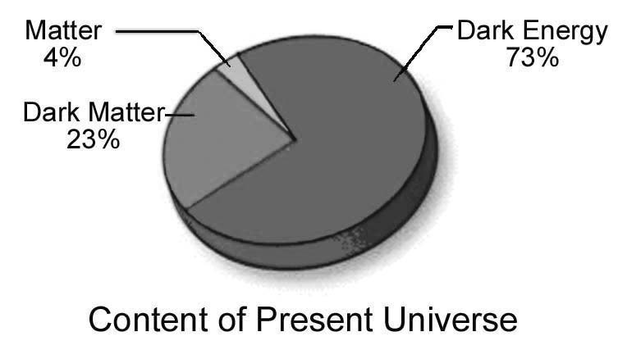

FIGURE 1.2: Matter and Dark Matter

The jinns are intelligent anti-creatures. They are living in this universe from their inception. They are created suitable for this universe. They are sometimes called sons of the Skies (Samawaat / this universe). This universe (Samawaat) is their home universe.

Primarily, Allah settled Adam and Eve in the Jannaat. So, it is obvious that He created them suitable for the Jannaat. The Jannaat is our home universe. There are billions of peaceful planets, full of water. The Believers will be taken back to the Jannaat after the Judgment. Before the creation of this universe (Samawaat), Allah created a huge quantity of water to produce the planets of the Jannaat mainly.

The Disbelievers will be left in this universe (Samawaat) full of violent galaxies and fire.

[The Jannaat is deliberately discussed in Section 23 of Chapter 3]

1c(4). **Arsh**

The Arsh is beyond the Super Space, holding the universes.

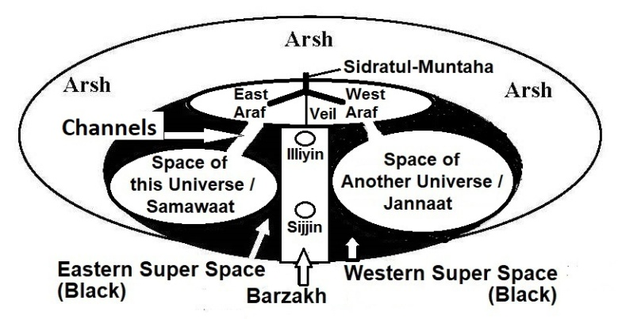

FIGURE 1.3: Likely disposition of universes

Allah has an exclusive domain in the Arsh. He comes out of the domain by extending His Kursi (Thorne):

Abu Dharr Al Ghifari narrates that the Prophet (pbuh) said, ‘By Him in whose hand is my soul, in comparison to the Kursi, the seven skies and lands (this universe) is nothing but like a ring thrown in a desert, and certainly the hugeness of the Arsh over the Kursi is like the desert over that ring.’

[Tafsir Ibn Katheer].

There are many angels as well. They are commonly called the Angels of Arsh. The Pen, Disc, and related systems are in the Arsh. The Arsh is the Headquarters of Allah.

[Arsh, Kursi, Pen, and Disc are deliberately discussed with references in Section-9 of Chapter-6]

1c(5). **Super Space and *Barzakh***

All creations, except the Arsh, are located in the Super Space.

The Super Space is divided by a super barrier (Barzakh) into two parts: the Eastern Super Space and the Western Super Space.

The Barzakh is a space with different nature where matter cannot survive. However, the light can pass through the Barzakh, as in the Night Journey, Prophet (pbuh) saw some planets of the Jannaat from an object of the Seventh Sky.

Due to the Barzakh, one cannot go from one universe to the other except through special channels:

“O ye assembly of jinns and men, if it be ye can pass beyond the boundary of the 'Skies and Lands' (this universe), pass ye! Not without authority shall ye be able to pass!” [Al Quran 55:33]

The Samawaat (this universe) is located in the Eastern Super Space and the Jannaat is located in the Western Super Space.

1c(6). **Araf, Channels, and Sidratul-Muntaha**

There is a huge land called Araf below the Arsh. “Araf” means “Elevated Land”. The Araf may be considered as the third universe. It is the preliminary sanctuary of the universal angels.

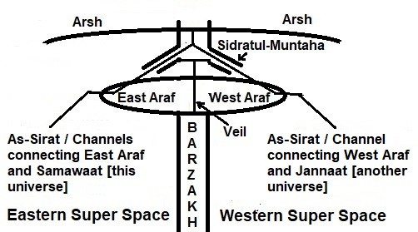

FIGURE 1.4: Barzakh and Channel

The Araf is divided by a Veil into two parts: the Eastern Araf and the Western Araf.

“Between them shall be a Veil, and on the Araf will be men who would know everyone by his marks: they will call out to the Companions of the Garden, "Peace on you": they will not have entered, but they will have an assurance.”

[Al Quran 7:46]

The Eastern Araf is extended into the Eastern Super Space, and the Western Araf is extended into the Western Super Space. See figure 1.4.

[The Araf is deliberately discussed in Section-9 of Chapter-6]

“Lord of the Two Easts and the Two Wests. Then which of the favors of your Lord will ye deny?”

[Al Quran 55:17-18]

In above verse, Two Easts are the Eastern Araf and the Samawaat (this universe) that are located in the Eastern Super Space; Two Wests are the Western Araf and the Jannaat (another universe) that are located in the Western Super Space.

The Eastern Araf connects the Samawaat by a pair of channels, and the Western Araf connects the Jannaat by another pair of channels. In the Night Journey (Miraz), Prophet Muhammad (pbuh) saw these channels. The accompanying angel called the channels as the “Channel of Light” and the “Channel of Darkness”. Prophet Muhammad (pbuh) moved into the Eastern Araf through one of these channels.

[The channels are deliberately discussed in Section-9 of Chapter-6]

The Sidratul-Muntaha is hanging over the Araf from the Arsh. It looks like an up-side-down plant with two main branches. One branch connects the Eastern Araf, and another branch connects the Western Araf.

Thus, the Sidratul-Muntaha works as the communication hub of the universes. It controls the transfer of creatures, matter, and information. Prophet Muhammad (pbuh) moved into the Arsh and later into the Jannaat through the Sidratul-Muntaha.

The Sidratul-Muntaha does another important job. An angel cannot go out of the universe for which it is created. The instructions coming down from the Arsh are passed to the angels through Sidratul-Muntaha.

An angel cannot learn at its own. Sidratul-Muntaha infuses information into the angels, and redesigns them to perform their tasks. The Sidratul-Muntaha is based on divine servers and has related systems to do these. Prophet Muhammad (pbuh) saw that the angels were falling on the leaves of Sidratul-Muntaha for being designed and tasked.

[The Sidratul-Muntaha is discussed with references in Section-9 of Chapter-6]

The Arsh is connecting the universes by Sidratul-Muntaha and Channels. See figure 1.4.

1c(7). **Illiyin and Sijjin**

The Illiyin and the Sijjin are located inside the Barzakh. See figure 1.3. These are holographic worlds of the dead humans.

The Illiyin is for the people destined to the Jannaat. It is in the high Barzakh closely below the Araf. The Sijjin is in the deep Barzakh. It is for the people destined to the hell.

A dead human is recreated virtually with his soul (nafs), genome code, and memories that are collected and stored by angels every night. The virtual human is then projected into a holographic world (Illiyin or Sijjin) where other dead humans are already living their virtual lives. They will remain in the Illiyin or Sijjin until the Day of Resurrection.

The souls (nafses) are corrected and further developed in the virtual life.

[The Illiyin and the Sijjin are deliberately discussed in Chapter-83]

2. **The God in Form**

Allah has a shape. We know from the Quran that Allah has eyes, ears, face, hands, legs, etc. The Holy Bible talks about His shape:

“And Elohim created the man in His own image; in the image of Elohim He created him. He created them male and female.”

[Genesis 1:27, Holy Bible]

So, 'Allah in form' looks like a human. Similar description is there in the Hadith as well:

"Allah, the Exalted and Glorious, created Adam in His own image with his length of sixty cubits...”

[Muslim]

'Allah in form' stays in a domain of the Arsh. The domain is bigger than this universe. He normally moves beyond His domain by extending His Kursi (Thorne).

“…Extends His Kursi into the 'Skies and Lands' (Samawaat-wal-Ard / this universe), and He feels no fatigue in guarding both of them (Samawaat and Jannaat); for He is the Most High, the Supreme.” [Al Quran 2:255]

His omnipresence is discussed in the next where it will be amply clear why there is none like unto Him:

"Say: He is God, the One and Only; God, the Eternal, Absolute; He begetteth not, nor is He begotten; And there is none like unto Him."

[Al Quran 112:1-4]

3. **The God existing Everywhere**

Allah has a form, at the same time, He is present everywhere:

“See you not that God does know that is in the Skies and on Lands? There is not a secret consultation between three but He makes the fourth among them, nor between five but He makes the sixth, nor between fewer nor more but He is with them where-so-ever they be. In the end will He tell them the truth of their conduct on the Day of Judgment; for God has full knowledge of all things.” [Al Quran 58:7]

Allah knows what we are thinking. He is closer to us than our jugular veins:

“It was We Who created man and We know what dark suggestions his soul makes to him, for We are nearer to him than (his) jugular vein.

[Al Quran 50:16]

In light of the above verses, Allah exists everywhere.

4. **Basic Idea about the Soul**

If Allah exists everywhere, He should be formless. But, He is not formless. We need to know the 'soul' to understand how Allah, having a form, can exist everywhere.

We view a soul as a spiritual stuff and remain hopeless to understand it. Actually, we know some of the souls and use those in many our instruments. But, we do not identify those as souls. The following discussion will identify the soul and will develop an idea as to how a soul works:

1. Soul in General
2. Types of Souls
3. Light and Subatomic Particles
4. Atom and Universe
5. Nafsin-Wahidatin (A Nafs Single)
6. The Nafsin-Wahidatin and the GUT Force
7. Unknown Force Fields

4a. **Soul in General**

We feel that a soul determines one’s shape and nature and sustains one’s body as a living entity. A soul does these in case of a living creature. But, if one tries to understand the soul of a living creature directly, one may fail. The basic idea about the soul is given here.

At first we will talk about the soul of matter. According to the Hadith, matter too has soul.

Several kinds of force fields sustain the natural systems of the inert world. These force fields work like souls. One of such force fields is magnetic field. We may discuss the magnetic field to assess the idea that a force field and a soul may be the same thing.

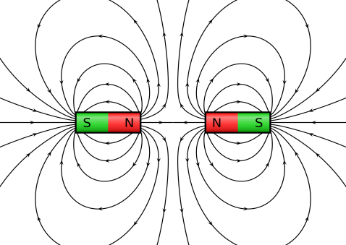

FIGURE 1.5: Magnetic Field

A soul (ruhh) is expressed in the Quran as a Command of God:

“They ask thee concerning the ruhh (elementary soul). Say: “The ruhh is command of my Lord.” Of knowledge, it is only a little that is communicated to you.” [Al Quran 17: 85]

I have discussed two cases in the following where the magnetic field works like commands:

4a(1). **Case 1**

The Earth has a huge magnetic field that resists the Solar Wind from entering the Earth. It seems that the magnetic field is commanding the Solar Wind: “Do not enter”.

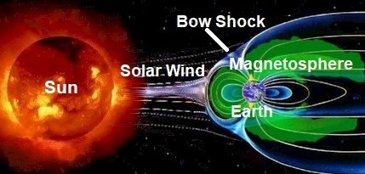

FIGURE 1.6: Earth’s Magnetic Field

The land-living creatures could not survive without this magnificent magnetic field. What is its origin? Why the Earth should have such a huge magnetic field?

The scientists say that the rotating, convecting, and electrically conducting fluid (like melted iron core of the Earth) can develop magnetic field. And, in case of a gaseous object (like the Sun), they say that the ionized gas too can develop magnetic field. They are to say something*—*as they are scientists. Actually, these are force fields invested by God as commands.

4a(2). **Case 2**

The magnetism is caused by electromagnetic force, which is one of the fundamental forces of the nature.

A moving electric charge generates a magnetic field as depicted in figure 1.7 below. It seems that the magnetic field is sustaining and directing the electrons as a commanding force.

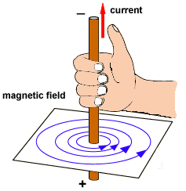

FIGURE 1.7: Magnetic Field sustaining and directing the Electrons

*“The Field is sole governing agency of the particle”* – Albert Einstein.

In other words, the Field is sole commander of the particle.

A force field is designed and invested by God as His commands:

“They ask thee concerning the ruhh (elementary soul). Say: “The ruhh is Command of my Lord.” Of knowledge, it is only a little that is communicated to you.” [Al Quran 17: 85]

Therefore, a force field and an elementary soul (ruhh) may be the same thing.

4a(3). **Soul in the Hadith**

The Hadith expresses a soul as an attractive or repulsive force:

“Prophet said: “The souls are like conscripted soldiers; those whom they recognize, they get along with; and those whom they do not recognize, they will not get along with.””

[Bukhari, Muslim]

The characteristics are seen in the force fields. The protons are repulsive to each other. The Strong Nuclear Force Field holds the protons in the nucleus of an atom. Thus, in the language of the Hadith, the Strong Nuclear Force Field recognizes the protons and holds those in the nucleus. It does not recognize the electrons, so it does not pull those inside.

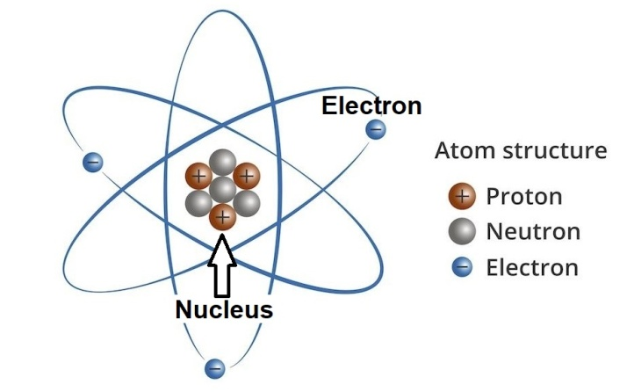

FIGURE 1.8: Atom

Similarly, the Magnetic Field recognizes the electron, so it keeps the electrons in the orbits of the atom. It does not recognize the proton, so it does not disturb those.

Therefore, a force field possesses the characteristics of a soul. It seems that the thing that the scientists call "force field" is called "soul" in the books of religion.

4b. **Types of Souls**

At this stage, I will assume that a force field and a soul is the same thing. The assumption will be confirmed in subsequent discussion.

The Quran talks about two types of souls:

I. Ruhh (Elementary Soul)

II. Nafs (Composite Soul)

4b(1). **Ruhh (Elementary Soul)**

"Ruhh" is an Arabic word. It is translated as "soul". But, it should be translated as “elementary soul”. An "elementary soul" is called "ruhh". I write it as "ruhhs" in plural form.

Allah can design a force field and can make it fixed. Once an object like the Earth, or a particle like an electron falls into the designed force field, it acts as intended. A designed force field is a ruhh. It is an elementary soul. For example, the Strong Nuclear Force Field and the Magnetic Field are different kinds of elementary souls / ruhhs.

Therefore, we may define a “ruhh” as an elementary force field, designed to act in fixed patterns, which holds or influences intended entities and commands them to act in specific ways.

**Note:**

There are different kinds of ruhhs (elementary souls), serving different purposes.

For example, the Quran calls its verses ruhhs because the words came as brain-data (low intensity electromagnetic force fields), emitted from the Protected Disc (Lawh-Mahfuz). The angels injected the data into the brain of Prophet Muhammad (pbuh) through Mohr-e-Nobuat (a swollen muscle below the neck) and back bone. It produced the memories of the verses in Prophet’s brain,

For another example, Allah breathed ruhh into Adam when he became conscious. It is a special ruhh given to a human just after his/her birth when he/she becomes conscious and cries for the first time. This ruhh works as a part of a human soul (nafs). It offers a flux encompassing a muscle of the chest, central nervous system (CNS), and brain to produce the qalb (mind). The qalb can be called virtual-brain of a human [the qalb is deliberately discussed in Section-10 of Chapter-6].

4b(2). **Nafs (Composite Soul)**

Another kind of soul is called *nafs*. "Nafs" is an Arabic word. I write it as "nafses" in plural form.

Both ruhh and nafs are translated as "soul", but there are differences between a ruhh and a nafs. A ruhh is an elementary soul (force field), but a nafs is a composite soul.

A combination of two or more force fields (elementary souls / ruhhs) makes a nafs (composite soul). For example, Strong Nuclear Force Field, Magnetic Force Field, and Weak Nuclear Force Field jointly make the nafs of an atom. The nafs holds the particles, such as electrons, protons, neutrons, etc., and forms the atom. Many natural systems and all living creatures have nafses as their main souls.

Therefore, we may define a nafs as a combination of two or more force fields, which sustains a system and determines its form, nature, and activities.

Scientists have so far discovered four kinds of force fields such as Strong Nuclear Force Field, Magnetic Force Field, Weak Nuclear Force, and Gravitational Force. There should be more kinds of force fields in the nature with different characteristics, which are not yet discovered (2021). An animal’s nafs is a combination of such undiscovered and unknown force fields.

We find the indications of the unknown force fields from consciousness and emotions, such as fear, anger, disgust, etc., of an animal. The consciousness and the emotion are inherent qualities of a force field. The more number of force fields a nafs (a composite soul) has, the more number of emotions it has.

There is no sign among the scientists that they are thinking on the force fields that may be working in an animal—trying for their detection is a far cry. They like to make bizarre theories to explain the complex natural systems.

[The human nafs is deliberately discussed in Section-10 of Chapter-6]

4c. **Light** **and Subatomic Particles**

The light is electro-magnetic force field. There are two kinds of force fields in the light such as electric field and magnetic field. So, the light should be a nafs. But, the light is called ruhh as well. The verses of the Quran came as brain data (low intensity electromagnetic force / light), which are called ruhhs in the Quran. So, the main difference between a ruhh and a nafs is that a ruhh works as a command, and a nafs sustains / supports a system.

A sub-atomic particle shows wave-particle duality—it flips back-and-forth as particle and wave. It is conscious as well. Its duality and consciousness can be detected by the following test:

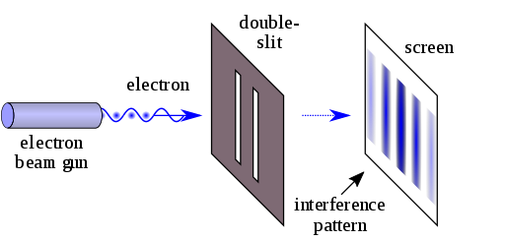

FIGURE 1.9: Double-slit Experiment

*“A laser beam illuminates a plate pierced by two parallel slits, and the light passing through the slits is observed on a screen behind the plate. The wave nature of light causes the light waves passing through the two slits to interfere, producing bright and dark bands on the screen—a result that would not be expected if light consisted of classical particles.*

*However, the light is always found to be absorbed at the screen at discrete points, as individual particles (not waves), the interference pattern appearing via the varying density of these particle hits on the screen.*

*Furthermore, versions of the experiment that include detectors at the slits find that each detected photon passes through one slit (as would a classical particle), and not through both slits (as would a wave).*

*However, such experiments demonstrate that particles do not form the interference pattern if one detects which slit they pass through.*

*These results demonstrate the principle of wave-particle duality.”*

– Wikipedia, The Free Encyclopedia

The experiment shows that a free subatomic particle, moving as wave, becomes a particle when it is observed. So, it can sense that it is being observed.

Therefore, a nafs is conscious, and it has two or more emotions.

4d. **Atom and Universe**

The atoms are the basic building blocks of the universe. Once the atoms were created, the universe was created.

An atom is created from different kinds of ruhhs (force fields) and nafses (subatomic particles). So, the universe is created from different kinds of souls.

4e. **GUT (Grand Unified Theory) Force**

The scientists have so far discovered four kinds of forces such as Electromagnetic Force Field, Weak Nuclear Force Field, Strong Nuclear Force Field, and Gravitational Force. They think that the forces originated from a Super Force.

*“Physicists had believed that there were four fundamental forces of nature: the gravitational force, the strong and weak nuclear forces and the electromagnetic force. Salam had worked on the unification of these forces from 1959 with Glashow and Weinberg. While at Imperial College London, Salam successfully showed that weak nuclear forces are not really different from electromagnetic forces, and two could inter-convert. Salam provided a theory that shows the unification of two fundamental forces of nature, weak nuclear forces and the electromagnetic forces, one into another.”*

*– Wikipedia, The Free Encyclopedia*

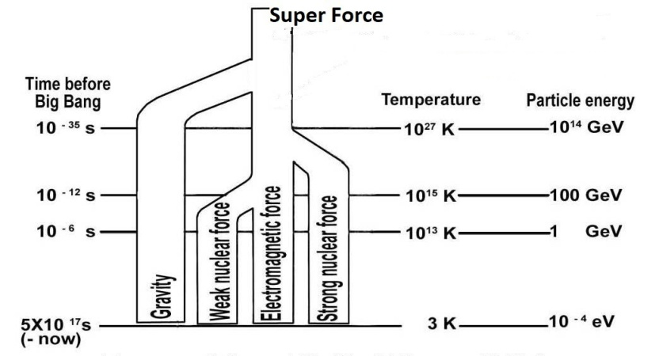

FIGURE 1.10: GUT Force

The scientists think that above 1035 degree K the forces cannot remain separate; they unify into one force. As the universe expanded and cooled, the forces separated from one another.

They think that the gravitational force separated when the temperature was above 1035 degree K.

When the temperature dropped to 1027 degree K, the Strong Nuclear Force Field separated.

The scientists find out that when the temperature dropped to 1015 degree K, the Weak Nuclear Force Field separated from the Electromagnetic Force Field (light).

The scientists consider three of above force fields, except gravitational force, as the forces of the Grand Unified Theory (GUT), which produced the Big Bang / this universe.

4f. **Nafsin-Wahidatin (A Nafs Single) and the GUT Force**

Nothing can be created from nothing. And, there was nothing except eternal Allah.

Allah has a nafs (composite soul). It permeates His body in form. He breathed out a part of His nafs and transformed it into creation.

The part of nafs that He breathed out for the creation is called *Nafsin-Wahidatin* (a Nafs Single) in the following verses:

“It is He Who has produced you from a Nafs Single (*Nafsin-Wahidatin*); here is a place of dwelling and storage—we detail Our signs for people who understand.” [Al Quran 6:98]

“He created you from a Nafs Single (Nafsin-Wahidatin), then created favorable Pairs (DNA Double Helix), and He sent down for you of the cattle eight Pairs, He creates you in the wombs of your mothers—creation after creation—three tortures (on Allah). That Allah is your Lord. For Him is the dominion. There is no god but He. Then how are you turned away?” [Al Quran 39:6]

The science says that the universe was created from the GUT Force, and the religion says that the universe was created from the Nafsin-Wahidatin (A Soul Single). Then why should we not consider the force field and the soul as the same thing? It is different in name only.

We do not view the force fields soul-like, because our knowledge is limited, and we do not know all of them and all about their qualities, such as conscious, emotions, information they carry, acts they can perform, and so forth.

4f(1). **First Part of Nafsin-Wahidatin**

From the Nafsin-Wahidatin, Allah extracted the force fields that were needed to create the nafses of living creatures.

The scientists have so far (2021) discovered four kinds of force fields such as Electromagnetic Force Field, Weak Nuclear Force Field, Strong Nuclear Force Field, and Gravitational Force with which the atoms are created and the objects are sustained.

There should be other kinds of force fields in the nature with different characteristics. The force fields are not yet discovered (2021). The consciousness and the emotions come from these force fields. The nafs of a living creature is a combination of such force fields. The force fields too were given with the Nafsin-Wahidatin.

Therefore, the Nafsin-Wahidatin may be called GUT Force + (Plus).

4f(2). **Second Part of Nafsin-Wahidatin**

From the second part of Nafsin-Wahidatin, He created the Arsh and a huge quantity of water. The water was filling a large part of the Super Space, beneath the Ash. Later, He created the Jannaat from the bulk of the water.

4f(3). **Third Part of Nafsin-Wahidatin**

From third part of the Nafsin-Wahidatin, He created this universe (Samawaat), the Kursi, and several other entities. The Holy Bible talks about this part of the Nafsin-Wahidatin in the following verses:

“In the beginning, when God created the universe, the Earth was non-existent. The raging ocean that covered everything was engulfed in total darkness and the Soul of God was hovering over the water.” [Genesis 1 (1–2), Holy Bible, GNB]

In above verse, the Soul is called the Soul of God because it belonged to God—He breathed it out from His body. In a Catholic Bible, the soul is translated as the "Breath of God":

“God, at the beginning of time created heaven (sky) and earth (land). Earth was still an empty waste and darkness hung over the deep, but already over its waters stirred the Breath of God”

[Genesis 1 (1-2), Holy Bible (Knox)]

So, the Breath of God was the part of Nafsin-Wahidatin from which the universe, the Kursi, and several other entities were created. When God commanded, “Let there be light”, the light appeared in this part:

“…Then God said: Let there be light. And the light began” [Genesis 1:3, Holy Bible (Knox)]

It means that the Soul (a part of Nafsin-Wahidatin) disintegrated on the command of “Let there be Light”. The fragments were Strong Nuclear Force Field, Weak Nuclear Force Field, and Electromagnetic Force Field (Light). Subsequently, the universe was created from the force fields at a speed looking like the Big Bang.

Therefore, the GUT Force that created the universe was the Soul (Nafs) that was hovering over the water. The Soul was a part of the Nafsin-Wahidatin.

4f(4). **To Conclude the Nafsin-Wahidatin**

Scientists do not include the gravitational force as a force of the GUT Force. In view of the Quran as well, the Gravitational Force is not from the Nafsin-Wahidatin. It is a force of Allah (discussed subsequently). So, we should draw the picture as under:

The Arsh and Water was created before the Big Bang / this universe (Samawaat):

“He it is Who created the skies and the lands (this univese) in six days, and His Arsh was over the waters…” [Al Quran 11:7].

A small part of the water was given to this universe (Samawaat). I have discussed the water deliberately in Section-3 of Chapter-41.

5. **How the God sustains and evolves the universes by extending several of His elementary souls (force fields / ruhhs) into the Space**

We have got some ideas about the souls. The souls can be defined as under:

* **Ruhh** (Elementary Soul): Aruhh is an elementary force field, designed to act in fixed patterns, which can hold an intended entity and command it to act in intended patterns.
* **Nafs** (Composite Soul): A nafs is a combination of two or more elementary force fields (ruhhs) which sustains a system, living or nonliving, and determines its form, nature, and activities.

Now we can discuss how Allah having a form can be everywhere?

Most likely, Allah had been an eternal nafs long before He began the creation. At that time, there was nothing except Him. He developed His 'body in form' from a part of His nafs. He absorbed the rest of His nafs into His body in form. Then, He had a physical body (body in form) and a nafs inside.

A nafs is not dependant on space. We know that the part of Nafsin-Wahidatin (GUT Force), from which the universe was created, had been in a point, or in a very small sphere. Similarly, the nafs of Allah can remain in His body in form, though the nafs is unimaginably huge and extremely powerful.

Allah exists everywhere by extending several force fields of His nafs beyond His body in form. The process is called *"Istawa":*

*“(Thumma* ***istawa****)* Moreover, infused His force / gravitational force *(ila i-samai)* into the Sky while it had been smoke…” [Al Quran 41:11]

The nafs of Allah may comprise 99 known and unknown force fields (elementary souls / ruhhs), or more. He has extended 15 to 20 force fields beyond His body in form. He designed the extended parts of the force fields at His will-power to act in fixed patterns, and infused those into the universes to sustain and evolve the creations. We view several effects of the infused parts of force fields as natural laws. For example, the gravitational force is a force of His nafs, which He has extended into the universe to sustain the objects.

Allah has extended the force fields together as His hands of nafs. Allah in form has physical hands, at the same time, hands of nafs. Each hand of nafs may comprise extended parts of 15 to 20 force fields. He sustains this universe by the right hands of His nafs, as the following Verse says:

“And not they honored Allah—true honor—while, on the day of resurrection, the land (the Land of Judgment) is assembling in His **hand**, and the skies (samawaat / this universe) rolled-up in His **right hand**. Glory be to Him! And high is He above what they associate!” [Al Quran 39: 67]

Both the hands, mentioned in above verse, are right hands of His nafs in light of the Hadith.

Allah sustains the Arsh by the left hand of His nafs:

“Allah is He Who raised the Skies instead of immersing (into the Big Crunch) that ye can see. Then He established Himself into the Arsh *(thumma* ***istawa*** *ala i-arshi)*. He has subjected the sun and the moon (to the fixed natural laws, followed by the forces of the hands of His nafs)! Each one runs for a term appointed. He does regulate all affairs..." [Al Quran 13:2]

Therefore, Allah did *istawa* into the Arsh by the left hands of His nafs. He sustains the Araf and the Jannaat through the Arsh.

In addition, Allah has extended several force fields of His nafs through His face. So, His face of nafs is extended everywhere. He sees, hears, and knows everything instantly.

“And for Allah the East and the West, so wherever you turn, there is the face of Allah; indeed Allah is All-Encompassing, All-Knowing.” [Al Quran 2:115]

When the Universe will collapse His hands of nafs will seize into His body in form. Only His face of nafs will sustain and evolve the collapsed universe (Big Crunch) for re-launch.

“And call not besides God on another god; there is no god but He. Everything will perish except His own Face (Face of Nafs). To Him belongs the Command and to Him will ye be brought back.”

[Al Quran 28:88]

“All that on it will perish, but will abide the Face of thy Lord (Face of Nafs), Full of Majesty, Bounty and the Honor.” [Al Quran 55: 26–27]

One of His extended force fields is not designed to act in fixed patterns. So, it is called Holy Soul (Ruhul Quddus). He uses it for special purposes.

**Note**:

Quddus is one of ninety-nine names of Allah. So, a Ruhul-Quddus is an elementary soul (force field / ruhh) of Allah. It can be called Ruhullah as well.

However, if the Holy Soul (Ruhul-Quddus / Ruhullah) is infused into Gabriel for a specific act, then Gabriel is over-powered, and he may be called Ruhul-Quddus while describing that act only.

For example, one may say, "Ruhul-Quddus planted a clone baby into the womb of Mary". But one should not say, "Ruhul-Quddus brought the verses to Prophet Muhammad (pbuh)". In this case, one should call him Gabriel.

I site two cases as another example:

Case 1: Suppose, Jesus said, “Give me a pot of water”. In this case, Jesus as a simple human was asking for a pot of water to drink.

Case 2: Suppose, Jesus said, “I am the light of the heaven and earth” (as said in Holy Bible). In this case, Jesus being infused and aided by Ruhullah was saying Who the God was?

Thus, "Istawa" is the process through which Allah has extended several force fields (elementary souls / ruhhs) of His nafs beyond His body in form and infused those into the universes to sustain and evolve the creations.

Allah has designed the force fields at His will-power to act in fixed patterns. Some of the natural laws are effects of these force fields, such as the laws of gravity.

Allah has extended the force fields together as the hands of His nafs.

Therefore, Allah in form looks like a human with two hands in form, but He has hands of nafs as well. The hands of nafs are invisible, because the forces are invisible, but the hands are unimaginably huge, immensely dynamic in fixed activities, and extremely powerful.

6. **Practical Examples of** **several likely extended elementary souls (force fields / ruhhs) of the God**

The nafs (main / composite soul) of Allah, which permeates His body in form, may comprise many force fields (elementary souls / ruhhs), but His hands of nafs comprise several force fields only. I think that 15 to 20 force fields form His hands of nafs which sustain and evolve the universes. Several likely force fields of the hands are discussed below under the following headings:

1. Gravitational Force
2. Dark Energy
3. Fields of Existence

6a. **Gravitational Force**

The activities that are done by gravitational force are mentioned in the Quran as the activities of Allah, such as: Allah holds the flying birds, He rotates the Earth, He moves the stars, He sustains the universe, etc.

“Do they not see the birds, controlled in the atmosphere of the Sky? None holds them except Allah. Most surely, there are signs in this for a people who believe” [Al Quran 16:79]

“Do they not observe the birds above them, spreading their wings and folding them in? None holds them except Most Gracious. Truly, it is He that watches over all things.” [Al Quran 67:19]

A bird flies in the air by spreading and folding its wings. But, it would be weightless and off-balanced if it were not held by gravity through its center of gravity (CG). The holding of birds by gravity is expressed in above verses as the act of Allah, and Allah only.

Allah not only holds the birds, He drives the astral objects too. The following verse talks about the act:

“He covers the night with the day, seeking it rapidly, and the sun and the moon and the stars controlled by His deed.” [Al Quran 7:54]

Allah holds the birds. He covers the night with the day (rotates the Earth). He drives the astral objects, like the stars. So, the gravitational force is a force of Allah.

A force field in a living being (Allah) should be called soul. So, the Gravitational Force Field is an elementary soul (ruhh) of His nafs (composite soul), permeating His body in form. The force is extended through the hand of His nafs. It holds the deposits of matter in the space, and exposes through the deposits. So, we find that the Earth is holding the birds. Actually, it is Allah Who is holding the birds through the Earth. He is the Sustainer. The whole universe is in the right hand of His nafs.

A soul should act on minute-to-minute wills of its owner. But, Allah has designed the extended part of the soul (universal gravitational force) by His will-power to act in fixed patterns. So, we find its acts as fixed natural laws. But, He is always in control.

According to the following verse, Allah infused the gravitational force into the single-sky-universe of the first cycle (through *istawa*).

“Moreover, infused His force *(thumma* ***istawa****)* into the Sky *(ila i-samai)* while it had been smoke…” [Al Quran 41:11-12]

The universe was full of smoke (hydrogen and helium mainly) in the first cycle. The gravitational force started contracting the universe. The contracting universe produced heavier elements, at least up to silicon. The elements formed dusts and asteroids that are called lands *(ard)* in the next part of the Verses:

“…He said to it (smoke) and to the lands (dusts and asteroids), “Come ye together, willingly or unwillingly…” [Al Quran 41: 11-12]

After the lands (dusts and asteroids) had been produced, the contracting universe re-started expanding from a Big Bounce when Allah distributed the matter in such a way that the single-sky-universe took the shape of the seven-sky-universe. It is indicated in the next part of the Verse:

“…They said, “We do come in willing obedience (Big Bounce occurred).” So, He completed them as Seven Skies in two days and inspired in each sky its affairs...” [Al Quran 41: 11-12]

Therefore, in the beginning of the present cycle (second cycle), the universe was organized as a seven-sky-universe.

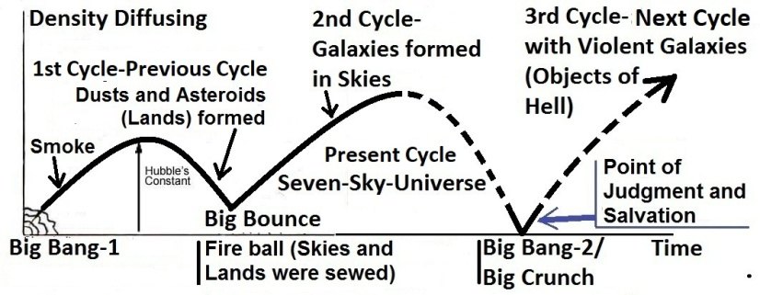

FIGURE 1.12: The Quran’s Model of Cyclic Universe

The distribution of matter formed the skies. The skies are super-giant waves of space, one inside another—like the peels of onion. There are seven skies in the universe. Each sky contains many galaxies. The space, though waved, is continuous [the skies are deliberately discussed in Section-7 of Chapter-2].

So, the gravitational force is not from the Nafsin-Wahidatin. It is an elementary soul (force field / ruhh) of Allah, which He has extended, designed, and infused into the universes through the hands of His nafs.

The right hand of His nafs comprises several other force fields as well, such as dark energy, vacuum energies, forces of existence, (quantum fields), discussed below:

6b. **Dark Energy**

In 1990’s, the scientists of “1A Supernova Cosmological Project” and “High-Z Search Team” discovered that the rate of expansion of the universe was accelerating over time, rather than slowing down. Thus, the vacuum appears to have an energy density, which is sometimes called “Dark Energy” or “Cosmological Constant”.

The “Dark Matter” is known by its likely gravitational effect on the matter; and the particles, with which it may be made of, have measurable evidence of its existence. By contrast, the “Dark Energy” remains in complete mystery. The name Dark Energy refers to the fact that some kind of stuff must fill the vast reaches of mostly empty space in the universe in order to be able to make space accelerate in its expansion. In this sense, the Dark Energy is like a magnetic field working as a repulsive force to accelerate the expansion of the universe.

On the other hand, the Quran says that Allah created the Sky with hand, and He is for the expanders:

“And the Sky, We constructed it with hand *(bi-aydin),* and Me for expanders” [Al Quran 51:47]

[In above Verse, “bi-aydin” simply means “with hand”, but the word is normally translated with different words to match the common understanding]

The above verse is talking about the hand of His nafs, with which the Sky (Universe) is constructed. And, He says, *“…Me for expanders”.*

So, the Dark Energy should be a force field (elementary soul / ruhh) of His nafs, which He has extended through the hand of His nafs to expand the universe.

So, the hands of His nafs comprise the Dark Energy as well.

6c. **Vacuum Energy**

Scientists predict the presence of “Vacuum Energy” in the space. *“Vacuum Energy is an underlying background energy that exists in space throughout the entire universe” – Wikipedia, The Free Encyclopedia.*

The Vacuum Energy is highly intense (10113 joules per cubic meter), but it is zero in our dimension.

It may be the light of Allah, which permeates the entire universe: *“Allah is the light of the 'Skies and Lands' (Samawaat-wal-Ard / this Universe)…” [Al Quran 24: 35]*

His light does not burn everything, because it is held in one or more of His elementary souls (force fields / ruhhs). So, we find its presence in a different dimension.

So, the hands of His nafs comprise force field of the light / vacuum energy.

6c. **Fields of Existence (Quantum Fields)**

The space is created with the hand of His nafs: *“And the Sky, We constructed it with hands (bi-aydin)* *and Me for expanders.”* *- Al Quran 51:47.*

The hand does not comprise the vacuum energy, force of expansion (dark energy), and the force of contraction (gravitational force) only. It comprises other force fields as well, discussed below:

The experiment carried out by Alain Aspect and his Team in 1982 provides strong evidence that even at great distances, the entangled subatomic particles remain connected to one another. If two subatomic particles are emitted from the same source, one influences other instantly, whatever is the distance. So, the modern Quantum Mechanics suggests that the universe is not made of separate elements, but it is an unbroken singular entity.

In the Standard Model of particle physics, the masses of all particles are generated as a result of their interactions with a field, detected by CERN’s Large Hadron Collider. The Higgs Particle, a very unstable particle, gain mass from the field and produce other particles. However, a particle does not derive anything from the field; it gains mass just due to its movement through the field.

Scientists think that there are 12 Fields and 4 fundamental forces that produce the universe. The fields are like fluids filling the universe. The associated particles of a field produce the subatomic particles and atoms.

down quark

up quark

electron neutrino

electron

strange quark

charm quark

muon

muon neutrino

bottom quark

tau neutrino

tau

top quark

The fields may be elementary souls of His nafs. But the fundamental particles must be from the Nafsin-Wahidatin. Maybe, bits of Nafsin-Wahidatin are held in the fields. The bits gain mass from the fields just for the movements through the field.

Maybe, fifteen to twenty force fields (elementary souls / ruhhs) of His nafs are extended through the hands of His nafs to constitute the space. The scientists are looking at several of them.

Thus, He is Sustainer and Evolver from the level of subatomic particles. Every inert thing is devotedly obedient to Him. When He decrees a matter, *He says to it, "Be", and it is!"*

“To Him is due the primal origin of the Skies and Lands (this universe); when He decrees a matter, He says to it, "Be", and it is!” [Al Quran 2:117]

Allah created this universe (Samawaat) from a part of Nafsin-Wahidatin. The part was in the palm of His right hand (hand of nafs). He transformed the part into smoke (hydrogen and helium mainly).

Later He extended the gravitational force through the hand of nafs. He contracted the universe and produced the heavier elements at least up to silicon. When the Big Bounce occurred, He organized the universe as Skies. The seven-sky-universe needed the dark energy to expand, which He infused through the same hand of His nafs at the end.

The universe may span billions of light years across, but it is in the hand of His nafs comprising 15 to 20 force fields (elementary souls / ruhhs). He sees, hears, and knows everything instantly. He can do whatever He may want to do, at any place, at any time. Even a human does not think without His will and assistance.

**Note**:

Allah provided the Nafsin-Wahidatin from His own nafs, and it became a separate entity. He produced everything from the Nafsin-Wahidatin.

A product of Nafsin-Wahidatin, such as a sub-atomic particle, cannot derive anything from an extended elementary soul of His nafs, save He wills. A product remains separate even in the form of wave. So, one should not mix up a creation with Allah.

7. **How the God became God**

It is likely that Allah was an eternal nafs (composite soul) long before He started the creation. There was nothing except Him. He did not have a physical body (body in form) at that time.

A nafs is a combination of known and unknown force fields (ruhhs). A force field is eternal, and it possesses many inherent qualities. A few of the known qualities are discussed below:

* A force field is conscious by nature. The “Double Slit Test” proves that an electron moving as wave becomes particle when it is observed. So, it is conscious and can decide to act accordingly.
* A force field possesses information. The smallest photon acts differently with different kinds of sub-atomic particles; it produces the lights of different colors at different energy levels, and so on.
* A force field has inherent emotions. A just born baby can feel interest, distress, disgust, and happiness. So, these emotions are not products of his brain. Moreover, a brain is a lump of matter; it cannot have emotions, whatever its design may be. These emotions are inherent properties of the unknown force fields constituting his/her nafs. So, force fields have emotions.

Thus, an extreme nafs, comprising many known and unknown force fields, should possess extreme will-power and intelligence, resulting from the emotions and information of the interactive force fields. Allah was an extreme and eternal nafs comprising many force fields. He developed His physical body (body in form) from a small part of His nafs.

His body in form may include many elements that He has not given to the creation. And His internal structure may be different. His body in form is not dependant on anything. As He developed His shape, He became more organized, intelligent, and capable.

In addition, a nafs is not dependant on the space. For example, the part of Nafsin-Wahidatin (GUT Force), with which the universe was created, exposed through the Big Bang. Mathematically, the Big Bang was a Singularity, defined as a super-hot, super-dense point. So, a huge nafs can remain in a small sphere. Similarly, the nafs of Allah, which is unimaginably huge and powerful, could remain in His body in form, even if His height could be equal to the height of a human.

At one stage of His personal development, He separated (breathed out) a part of His nafs called Nafsin-Wahidatin. He extracted necessary force fields from the Nafsin-Wahidatin and created the nafses of living creatures.

He created the Arsh and a huge quantity of water from a part of the Nafsin-Wahidatin. The water was filling the super space, below the Arsh.

He created this universe, Kursi, and several other entities from the leftover part of Nafsin-Wahidatin.

Allah initiated the creations at suitable stages of His personal development. And, He is sustaining and evolving the universes for billions of year. It has developed His intelligence and capabilities to an enormous height. Today, He is a smart creator, sustainer, and evolver. We are nothing in front of Him even at a comparative scale. He is a successful God indeed. He is one and only.

So, Praise be to Allah, the Sustainer and Evolver of the universes (Alamin); Most Gracious, Most Merciful; Master of the Day of Law.

8. **Conclusion**

Allah alone sustains and evolves the inert creations. None can help Him in this aspect—an atom is too small to help, and a universe is too big:

"It is Allah Who sustains the Skies and Lands (Samawaat-wal-Ard / this Universe) lest they cease, and if they should fail, there is none, not one, can sustain them thereafter. Verily, He is Most Forbearing, Oft-Forgiving.”

[Al Quran 35: 41]

Allah alone can do it, because He is evolving the universe in a single time-scale, starting on the Day of Law (Yawm-id-Deen):

“Praise be to the God, the Sustainer and Evolver of the universes; Most Gracious, Most Merciful; Master of the Day of Law (Yawm-id-Deen).”

[Al Quran 1: 2-4]

However, the living creatures have diversified activities. So, He had predicted their fates and invested angels to monitor them. The Empire of Angels is automated by a huge cybernetic system [discussed in Section-9 of Chapter-6].

'Allah in form' often comes down into the First (Innermost) Sky by extending His Kursi. He asks the angels about the humans they have worked for.

The angels say, ‘You already know what they have done’ (or words to that effect), because, though 'Allah in form' usually remains in the Arsh, He exists everywhere too, by the extended elementary souls (force fields / ruhhs) of His nafs. He sees and hears everything. Nothing can happen without His permission.

Allah says, ‘Even then you say what they have done’ (or words to that effect). It means that Allah intensely checks the activities of the angels, as the deeds they are recording will be required for the resurrection and afterlife of a human.

People ask questions. Following discussions will answer several of those:

8a. **His Control on His Nafs**

A human cannot extend an elementary soul (force field / ruhh) of his nafs into a side room and see what is happening there. But, Allah has extended several elementary souls (force fields / ruhhs) of His nafs to sustain and evolve the creations. He sees and hears everything. He says, “Be,” and it is!

So, Allah has immense control on His nafs; otherwise He could not extend the elementary souls (force fields / ruhhs) beyond His body in form.

At present, Allah in form lives in a special domain of the Arsh. He cannot be approached due to His extreme light and power—the universes are very big, and the extended elementary souls (force fields / ruhhs) of His nafs are thrusting with extreme powers to sustain and evolve the creations.

At present, Allah in form comes out of His domain by extending His Kursi that provides protection to the near creation to some extent. He comes to some "special objects" of this universe and takes the reports from the angels.

But, the Kursi has limitations. Even its highest degree of protection cannot protect a "normal object" like the Earth. The hill of Moses was burned.

However, Allah is so powerful that He can retract the extended elementary souls (force fields / ruhhs) of His nafs into His body in form. On the Day of Judgment, the universes will be contracted. So, the extended elementary souls will largely be retracted into His body in form. So, He in form will be approachable and clearly visible.

According to the Hadith, on the Day of Judgment, at first He will come on the Land of Judgment as a normal human being. But humans will not recognize Him as God. Then He will return and will come back ceremonially. He will come back after the marshalling of angels, jinns, and humans.

Allah does not need to remain concentrated on the universe to control the objects. He had designed the elementary souls (force fields / ruhhs) to act in fixed patterns, and the initial creations were configured to evolve as desired. He set the laws and configuration of the universe on the 'Day of Law':

He is sustaining and evolving the universes from the Arsh existing beyond the universes.

8b. **Absolute Creation and Annihilation**

Allah exists forever. He was never created. He separated a part of His nafs and transformed it into creation. So, He created by transformation. Absolute creation is not possible for Him [It is a positive quality of Allah].

Nothing can be annihilated as well. A thing can be transformed only. Absolute annihilation is not possible, even for Allah. If Allah destroys an entity absolutely, the ultimate products (photons) will be with Him [It is a positive quality of Allah].

According to the Hadith, Allah cannot send a thing beyond His creation. There is no space beyond His creation where He could push a thing out. If it were tried hard, the thing would return to its originality and would still be with Him. [It is a positive quality of Allah].

We are humans. We take birth. We view creation as the way of coming into reality. Though we are repeatedly told that Allah was never created or He did not take birth, a question remains in the deep of our hearts: ‘Is it true?’ We cannot perceive the reality. Allah is eternal. The creations have beginnings and ends relating to the transformations.

8c. **Believe the Quran only**

Finally, a human’s knowledge is limited, and his mind cannot perceive the greatness of Allah. So, believe what are clearly taught in the Quran: *Say: He is God, the One and Only. God, the Eternal, Absolute. He begetteth not, nor is He begotten. And there is none like unto Him.*

Most Gracious, Most Merciful

Master of the ‘Day of Law’ *(Maliki Yawmi i-Deen).*

**Remarks:**

The Verse, *“Malik Yawm-id-Deen”,* is normally translated as “Master of the Day of Judgment”.

*“Malik”* means “Master”.

*“Yawm”* means “Day”.

But, *“Deen”* does not mean “Judgment”. “Deen” means “Law”. The word is found in Aramaic and Hebrew as well, where it clearly means “Law”.

So, proper and honest translation of “Yawm-id-Deen” should be “Day of Law”. I have translated the verse as “Master of the Day of Law”.

The universe evolves according to the laws of the nature. Allah fixed the laws on a Day, heading the evolution. So, He is the Master of the Day of Law:

*“The initial configuration of the universe may have been chosen by God, or it may itself have been determined by the laws of science. In either case, it would seem that everything in the universe would then be determined by evolution according to the laws of science…”*

– *Is Everything Determined* by Stephen Hawking in “Black holes and Baby Universes and Other Essays” (BANTUM Book 0553406639).

In light of the Quran, the universe had two Days of Law—one at the beginning of previous cycle (1st cycle) and one at the beginning of present cycle (2nd Cycle). See figure 1.13 below:

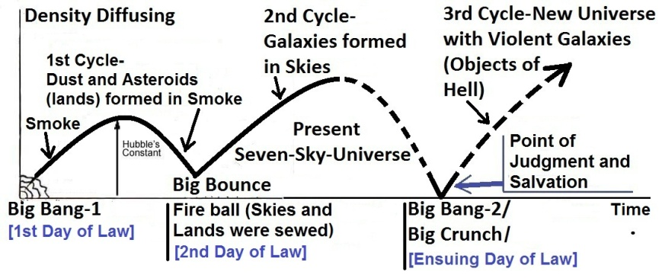

FIGURE 1.13: Days of Law

And, if the present universe collapses and reinitiates again (3rd Cycle), the reviving universe (new universe) too will have a Day of Law (Ensuing Day of Law) at the beginning.

Understanding the Day of Law (Yawm-id-Deen) is important to know the God’s Model of the Universe (Samawaat). How it relates to our fates, and why should we pray, “Guide us to the Straight Path”? It is discussed under the following headings:

1. The Effects of the Day of Law

2. 1st Day of Law

3. 2nd Day of Law

4. 3rd Day of Law

5. Approach and Events of the 3rd Day of Law

1. **The Effects of the Day of Law**

A tree is produced from a seed. Similarly, the initial universe was configured to form the universe of today. It is better understood by the idea of Stephen Hawking:

*“…there should exist a set of laws that completely determines the evolution of the Universe from its initial state...Yet how can a certain number of equations account for the complexity and trivial detail that we see around us? Can one really believe that the grand unified theory has determined that Sinead O’Connor will be the top of the hit parade this week, or that Madonna will be on the cover of Cosmopolitan?”*

– *Is Everything Determined* by Stephen Hawking in “Black holes and Baby Universes and Other Essays” (BANTUM Book 0553406639).

To come to a solution, Hawking suggests: *“...in the very early universe, everything was very close together, so there was quite a lot of uncertainty, and there were number of possible states for the universe. These different possible early states would have evolved into a whole family of different histories for the universe…There would be a history in which the Nazis won the Second World War, though the probability was low. But we just happen to live in a history in which the Allies won the war and Madonna was on the cover of Cosmopolitan.”*

Hawking suggests that the trivial details of the universe arose from the uncertainty principle. The idea is ridiculous. Hawking himself was not satisfied with his explanation, as he wrote: *“I don’t claim any great originality or depth, but it is the best I can do at the moment”*. He added that: *“It doesn’t make much difference whether this determinism is due to an omnipotent God or to the laws of science. Indeed, one could always say that the laws of science are the expression of the will of God”*.

When Adam and Eve descended, they got suitable sun, Earth, moon, plants, animals, water, and atmosphere. Everything had grown up step-by-step before they came. There are more than 92 elements in the Earth. Each follows desirable laws. The habitation of Adam would not produce if there were a minor deviation in the laws. And, if the laws and configuration of the initial universe were little different such kind of Earth could not produce.

Allah set the laws and configuration of the initial universe on the Day of Law. Thus, the evolution of the universe has been set. Now everything stands on a time-scale, and our fates are determined. Each event stands on the past and impacts the future; a change from the determined path cannot come to reality.

*“These things are to me immensely strange. Is it not extraordinary that the possibility of talking here this afternoon depends on events which were very narrowly determined over 10,000 million years ago in the very earliest moments of the universe?”*

*– Dawn of a New Era* by Sir Bernard Lovell in The Encyclopedia of Space Travel and Astronomy.

However, in Islamic view, the laws and initial configuration of the universe have not decided our fates. Rather than our fates have decided the laws and configuration. It is done in the following way:

Hadith: “The fate of everybody was written fifty thousand years before the creation” [Tirmizi]

Allah had made a dynamic virtual universe in His computer as the Master Design, before He started the creation of real universe. We were created in the virtual universe from our genome codes and nafses and passed our virtual lives in a holographic Earth. The virtual universe was adjusted to fulfill our needs. Our fates of the real lives were written from the virtual lives.

From that virtual universe, Allah must have found out the best possible laws and initial configuration of the real universe. If one is a King, one was determined to be the King on the Days of Law [Fate and Master Design are discussed in Section-9 of Chapter-6 deliberately].

Allah is not only the Master of the Day of Law He is the Sustainer and Evolver as well. It would be absurd to think that all the radiations up to Cambrian Evolution had been loaded on the Days of Law. There were multiple infusions of new information along the way of biological evolution:

A living cell is unimaginably complex. There could not be enough information in the initiating universe to build the genome (a genome is an organism's complete set of DNA including all of its genes). Allah created the first living creature in the water. Thus, the creation of universe and the creation of the living creatures come up in the Quran as separate acts of Allah; as the following Verse say:

“Do not the unbelievers see that the Skies and the Lands were joined together before We clove them asunder? We made from water every living thing. Will they not then believe?” [Al Quran 21:30]

Allah created the living things in the water and developed the animals through four stages—the water-borne animals in stage one, the reptiles' (creepers) in stage two, the two legged dinosaurs and birds in stage three, and the four legged mammals in stage four; as the following Verse say:

"And Allah has created every animal from water (stage one): of them there are some that creep on their bellies (stage two); some that walk on two legs (stage three); and some that walk on four (stage four). Allah creates what He wills; for verily Allah has power over all things."

[Al Quran 24:45]

Allah created Adam and Eve in the higher universe and descended them on the Earth later at a suitable time. Humans are created separately; they were not results of biological evolution [The Biological Evolution and the Missing Link are deliberately discussed in Section-12 of Chapter-24].

2. **1st Day of Law**

In light of the Quran, the universe is cyclic. But, it is not eternal. The universe was created in the previous cycle. The beginning of the previous cycle is the 1st Day of Law.

The universe has evolved in the previous cycle (1st Cycle) from a Singularity. The Singularity is defined as a super-hot, super-dense point where the natural laws break down. The Singularity at the beginning of the universe is called Big Bang.

We may start the story from the time just after the beginning of the 1st Cycle when the temperature of the universe (primordial fireball) was a million million degrees. Matter could not exist at that state; it was in the form of radiation. As the universe expanded and the temperature reduced, the radiation turned into matter. Initially, the simplest form of matter, hydrogen, was created. Later 25% hydrogen turned into helium.

*“The primordial fireball contained the reactions which led to the present distribution of hydrogen and helium 75% and 25% respectively, a balance that explains the evolution of stars. Very small changes in the nature of the primordial fireball would have had an immense effect on the universe. If certain atomic forces had been only slightly greater, then all the hydrogen would have become an isotope of helium and no long-lived stars could exist as they do at present. They would have been explosive. Stars would have formed but they would have used up all their energy in a very short time. There would have been no star like the sun, which gives an output of energy for thousands of millions of years. It is only with the stability on this time scale the life can evolve. If things had been just a little bit different at the beginning, therefore, there could have been no life, and the universe would be unknowable”*

*– Dawn of a New Era* by Sir Bernard Lovell in The Encyclopedia of Space Travel and Astronomy edited by John Man

How the universe with precisely determined laws could evolve is discussed below from Islamic point of view:

This universe (Samawaat) evolved from the GUT Force. The GUT Force was a part of Nafsin-Wahidatin that Allah had provided from His Own nafs to create the universes (Samawaat, Jannaat, Arsh, etc.):

“It is He Who has produced you from a Nafs Single (Nafsin-Wahidatin); here is a place of dwelling and storage…” [Al Quran 6:98]

The part of Nafsin-Wahidatin (GUT Force) that produced this universe (Samawaat) was in the right hand of His nafs. The hand comprises the force fields (elementary souls / ruhhs) that construct the space:

“And the sky (single-sky-universe of the first cycle), We constructed it with hand (right hand of His nafs*),* and Me for expanders”

[Al Quran 51:47]

[In above Verse, “bi-aydin” simply means “with hand”, but the word is normally translated with different words to match the common understanding]

The space (sky) is constructed with the hand of His nafs. He, by His will-power, designed the force fields of His hand to act in fixed patterns that we view as some of the natural laws.

Allah fragmented the GUT Forces and designed the products, such as atomic forces and sub-atomic particles to act in desired patterns. Their fixed acts are also viewed by us as some of the natural laws.

Thus, He configured the initial universe to produce the universe of today.

He did all above in the 1st Day of Law.

He is the Sustainer and Evolver as well.

3. **2nd Day of Law**

The single-sky-universe of the 1st Cycle was in the right hand of His nafs. Initially, the hand comprised the force fields that were to act at sub-atomic and atomic levels. He transformed the GUT Force (a part of Nafsin-Wahidatin) into smoke (hydrogen and helium with small amounts of a few other elements).

Subsequently, the gravitational force, another elementary soul of Allah, was infused into the smoke *(istawa)* through the same hand:

“Moreover, He did *istawa* into the Sky (single-sky-universe of the first cycle) while it had been smoke…” [Al Quran 41:11-12]

The gravitational force acts at universal level. Due to gravitational force, the single-sky-universe of the first cycle started contracting, and it produced heavier elements in the smoke, at least up to silicon (Si).

The heavier elements produced dusts and asteroids.

Eventually, due extreme pressure and temperature, the contracting universe bounced out (Big Bounce) from a state of Fireball when Allah designed the single-sky-universe into a seven-sky-universe.

“…He said to it (smoke) and to the lands (dusts and asteroids), “Come ye together, willingly or unwillingly”.

They said, “We do come in willing obedience (Big Bounce occurred)”.

So, He completed them as Seven Skies in two days and inspired in each sky its affairs...”

[Al Quran 41:11-12]

[The Fireball is a non-singular state of the universe before the Big Crunch]

During the Big Bounce, the additional laws of the seven-sky-universe (samawaat / present universe) were ordained, as the above verses say: *“…and inspired in each sky its affairs...”* The Day Allah fixed the additional laws is the 2nd Day of Law.

The Big Bounce re-initiation of the universe is clearly highlighted in the Quran, as the following verse mentions the presence of lands (dusts and asteroids) in the initial universe:

“Do not the Unbelievers see that the Skies and the Lands were sewed, and We clove them asunder (Big Bounce)…” [Al Quran 21:30]

The skies are super-giant waves of space (related to the distribution of matter), one inside another—like the peels of onion. There are seven skies. The skies ensured balanced distribution of matter. They ensure the balanced expansion of the universe as well. Due to the skies (waved space), the matter could concentrate into the galaxies easily, as the universe expanded. There are many galaxies in each sky.

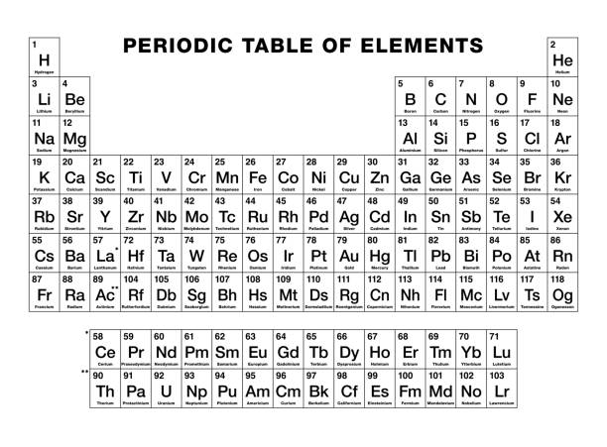

Figure 1.14: Periodic Table

The elements heavier than silicon formed into some stars of the present (2nd) cycle and scattered into the space due to super-nova explosions. The elements were added to the Earth by falling asteroids in due proportions:

“And we sent down the iron, wherein there is strength and many benefits for the people.”

[Al Quran 57:25]

“And He placed therein firmly set mountains (the Plate Tectonics that forms the mountains need iron core); and parked therein from above it (many additional elements were given by falling asteroids) and determined therein its nourishment (our foods need the additional elements) in four days equal; for those who ask.” [Al Quran 41: 10]

[The formation of the Earth is deliberately discussed in Section-3 of Chapter-41.]

4. **3rd Day of Law**

So, the universe had two Days of Law. The 1st Day of Law heads the single-sky-universe of the first cycle, and the 2nd Day of Law heads the seven-sky-universe of the present cycle.

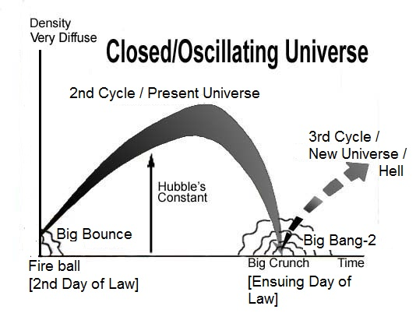

FIGURE 1.15: 2nd and 3rd cycles of the Universe

The 1st Day of Law is effective to the present cycle as well, because the 2nd Cycle started from the Big Bounce.

In future, due to the gravitational force, the universe may collapse into a Singularity. The Singularity at the end of the universe is called Big Crunch. From the Big Crunch, the universe may be born again (Big Bang-2).

“But it is also possible that expansion (of the universe) will be reversed by the pull of gravity, that all matter will collapse once again into a super-dense ‘singularity’, and that another universe will be born in another Big Bang- a cycle that could be repeated forever”.

– To the Edge of Eternity by John Gribbin in *The Encyclopedia of Space Travel and Astronomy* edited by John Man.

According to the Quran too, the universe will be collapsed and reproduced, as the following Verse say:

“On the day when We will roll up the Skies (Samawaat / this Universe) like the rolling up of the scroll for writings; as We originated the first creation, We shall reproduce it—a promise on Us; surely We will bring it about.” [Al Quran 21:104]

According to the above verse, the universe will be reproduced as the first creation was originated. The first creation was originated from a Big Bang (Big Bang-1). So, it will collapse into the Big Crunch and will restart from a Big Bang (Big Bang-2). That is the ensuing Day of Law (3rd Day of Law).

In the ensuing Day of Law, mankind will be resurrected, ascended, and assembled for Judgment on a specially created object (Land of Judgment) in the Super Space:

“And not they honored Allah—true honor—while, on the Day of Resurrection, the Land (the Land of Judgment) is assembling in His hand, and the Skies (Samawaat / this Universe) rolled-up in His right hand. Glory be to Him! And high is He above what they associate!” [Al Quran 39: 67]

After the Judgment, resurrected humans will be moved to the new destinations, either in the re-created Samawaat (this universe containing the objects of hell / galaxies) or in the Jannaat (another universe containing the objects of paradise / peaceful planets) to live forever as forgotten or rewarded vicegerents of God.

The verse under discussion is talking about the ensuing 3rd Day of Law. The Final Judgment is an event of that Day. So, “Yawm-id-Deen” can be identified as the “Day of Judgment”.

5. **Approach and Events of the 3rd Day of Law**

The lands are ultimate products of the universes. The Samawaat (this universe) is full of galaxies. A galaxy is a group of lands. The Jannaat (another universe) is full of peaceful planets; each planet is a land with ample water. Humans are being created to be the vicegerents of God over the lands:

“Behold, thy Lord said to the angels: "I will create a vicegerent on a land (on each land / group of lands)..." [Al Quran 2:30]

But, now, on the Earth, we have no power as His vicegerents. Now, we are undergoing tests to confirm who deserves what? Humans will be sent to their eternal lands on the Ensuing Day of Law. The knowledge about the Day will keep one informed about the situations. Otherwise, a blind will remain blind on the Day of Judgment as well:

“But those who were blind in this world will be blind in the hereafter, and most astray from the Path.” [Al Quran 17:72]

So, the knowledge about the Day is crucial in light of the Quran.

“And indeed, the wicked surely in hellfire. They will burn it.

The Day of Law! And they are not absent from it.

And, what can make you know what the Day of Law is!

Then, what can make you know what the Day of Law is!

The Day, not will have power a soul for a soul, anything, and the command that Day with Allah”

[Al Quran 82: 14-19]

“The Messenger of Allah said, “When Allah wishes good for someone, He bestows upon him the understanding of Deen.” [Bukhari, Muslim]

In the following, I have discussed according to the Quran how the next Day of Law is approaching, and what are the important events of the Day:

5a. Before 1920s, scientists had the idea that the universe was static.

A static universe should collapse due to gravitational force. So, the scientists presumed that the universe was infinite, and the gravitational force was repulsive at a very large distance, which maintains the balance. Moreover, an infinite universe would not have a center to collapse.

An infinite universe should be eternal. So, the idea of a Creator was not needed. That was a time of progressive people, following Marx, Darwin, and Freud!

However, in 1826, a German Astronomer, Wilhelm Olbers, put forward a question, how there could be dark nights in a static, infinite, and eternal universe?

In a static, infinite, and eternal universe, there should be infinite number of stars. And all stars emit light. The energy has no destruction. The light of a star would come to the Earth at some point of time. Once the light of a star had arrived, it would continue to come forever. So, our every line of sight would end on the surface of a star, and the whole sky would appear as bright as the star. The scientists calculated that if the universe were static, the sky would be 40,000 times brighter than the sun at noon.

Nobody could answer why the night was dark? So, it became known as the “Olber’s Paradox”.

The Paradox was resolved in 1920s when Edwin Hubble demonstrated that the universe was expanding. The expansion dissipates the light and reduces its intensity throughout the universe. So, there are dark nights and sunlit days on the Earth.

Now the scientists exclaim why they did not understand the expansion of the universe, much before Hubble’s discovery, only by the Olber’s Paradox, because the dark nights and the sunlit days can exist in an expanding universe only!

It was mentioned in the Quran as a sign of its divinity:

“What! Are you more difficult creation, or the sky? He constructed it; He raised its thickness and proportioned it—and He darkened its night and brought out a morning there of”

[Al Quran 79: 27-29]

The skies (spherical waves of space, one inside another), carrying light and heavy elements together, have expanded. So, the matter is proportionally distributed throughout the universe. So, the darkness prevails, and the sunrise can bring out a morning.

Therefore, the Quran talks about the expansion of the universe with a definite sign that does not need Hubble’s Discovery.

“So verily I swear by the receding ships (galaxies) disappear, and the night as it departs, and the dawn as it breathes.” [Al Quran 81:15-18]

5b. What is the future of the universe? The Quran is true about the past. So, it should be true about the future as well:

“On the day when We will roll up the Skies (Samawaat / this Universe) like the rolling up of the scroll for writings…” [Al Quran 21:104]

The universe will collapse by rolling up the Skies. The collapsed universe will be squeezed to an extent that the matter will disappear. The universe will be in the state of Big Crunch. The Singularity at the end of the universe is called Big Crunch.

The Big Crunch can be compared with a super-massive black hole. To understand the universe at the state of Big Crunch, we may discuss what happens to an object if it falls into a black hole:

If a space ship is falling into a black hole, it is elongating like spaghetti due to the difference between the extreme gravitational force on its tip and its tail. The ship, elongated like spaghetti, will be wrapped around the spinning black hole. Its particles will gain energy from the gravitational field and join to the accretion disk, and its anti-particles (neutrons), having opposite momentum, will fall into the black hole.

Eventually, the light of the space ship will be frozen in the compact space winding around the event horizon. It can never fall into the black hole because the more it approaches the black hole, the slower the time is. The light will preserve the complete information (photons) of the ship. Thereby, matter will be annihilated, but the ship will exist as information.

Similarly, this universe will collapse into a point (Big Crunch) where the information of all the objects will survive.

Now, Allah is sustaining the universe by the right hand of His nafs, which comprises about a dozen of force fields. At the time of Big Crunch, there will be no matter to sustain. So, the hand of His nafs will cease into His ‘body in form’. At that time, the forces of His nafs, which will be exposing through His face, will sustain the Big Crunch; as the following Verses say:

“All that on it will perish. But will abide the Face of thy Lord, full of Majesty and Honor.”

[Al Quran 55: 26–27]

“And call not besides God on another god. There is no god but He. Everything will perish except His own Face. To Him belongs the command, and to Him will ye be brought back.”

[Al Quran 28:88]

The universe will be a bright point on the face (forehead) of God. The Big Crunch is a point.

The end state of the universe may be different as well: The universe is structured into skies. If the universe collapses by rolling-up the skies, the galaxies may not join with each other to form a Big Crunch (Singularity). The galaxies may collapse into their central super-massive black holes as super-dense singularities, preserving all information. They may remain in their relative positions even in the super-compact space when the skies would be rolled-up compactly.

According to the Quran and Holy Bible, the skies will be rolled-up like a scroll for writing. Here the space is represented by a piece of paper. So, the galaxies should be represented by the dots on the piece of paper. Mathematically, a singularity is a dot preserving all information.

Finally, the super-compact space with bright points may be wrapped on His face (forehead).

5c. Subsequently, the Day of Law will begin. Allah will have vision of the next universe. He will reprogram the universe for revival. He will determine new natural laws. He is the Master of the Day of Law *(Malik Yawm-id-Deen)*.

Our fates of the next cycle will be determined on that Day (Day of Law), and some will be destined to the hell (galaxies of the next universe).

5d. From the face of God, the reprogrammed universe will revive. The reviving universe will be moving to the right hand of Allah when the Thaqal (the heavy mass of the reviving universe) will form, and the resurrection of the dead will occur:

“And when the Land (Thaqal) is enlarged and casts forth what is within it and becomes empty—and hearkens to its Lord, and it must need”

[Al Quran 84: 3-5]

The evolution of the reviving universe will be halted temporarily to carry out the Judgment.

“And among His signs is this that the Sky (Super Sky) and Land (Thaqal) stand-still on His command. Then when He calls you by a single call from the Land—behold ye come forth.”

[Al Quran 30:25]

5e. The Thaqal will throw out the resurrected living creatures and the matter of the Solar System. The ejected matter will form the Land of Judgment (a Satellite Thaqal) in the Super Space.

“On the Day, the Land (Main Thaqal) breaks away from them, quickly; that will be a gathering together (in the Satellite Thaqal / Land of Judgment) quite easy for Us.” [Al Quran 50:44]

“And not they honored Allah—true honor—while, on the Day of Resurrection, the Land (the Land of Judgment) is assembling in His hand, and the Skies (Samawaat / this Universe) rolled-up in His right hand. Glory be to Him! And high is He above what they associate!” [Al Quran 39: 67]

Thus, at the time of Judgment, there will be two Thaqals (heavy masses) in the Super Space: one is the reviving universe (Main Thaqal) held in the right hand of His nafs and the other is the Land of Judgment (Satellite Thaqal).

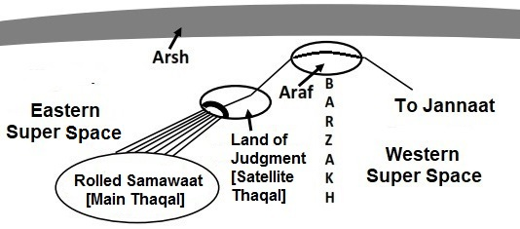

FIGURE 1.16: Super Space

“Soon shall We attend to you, O both ye Heavy Masses (Thaqalani)! Then which of the favors of your Lord will ye deny?” [Al Quran 55:31–32]

The Thaqals (Main Thaqal and Satellite Thaqal) will be in the Eastern Super Sky (Eastern Super Space).

“The Day the land will be changed—other land and the Skies; and they will come forth before Allah, the One, the Irresistible” [Al Quran 14:48]

5f. There is another universe named Jannaat in the Western Super Sky (Western Super Space):

“Be quick in the race for forgiveness from your Lord and for a Jannaat whose width is that of the Skies and Lands (this Universe), prepared for the righteous…” [Al Quran 3:133]

“Race to forgiveness from your Lord and the Jannaat, the width of which is as the width of the Sky and Land” [Al Quran 57:2]

“Because only a few will be saved, God has created two universes instead of only one”

­­­‑ 2 ESDRAS 7:50, Holy Bible, GNB

After the Judgment, a part of mankind will be shifted to the Jannaat where they will live forever in peace and satisfaction, as empowered vicegerents of God. Their verbal orders will be materialized instantly.

5g. The sinners will be left on the Land of Judgment (Satellite Thaqal). Subsequently, the Land of Judgment will be thrown into the Main Thaqal.

The halted universe (Main Thaqal / Rolled-up Samawaat) will re-start unrolling and expanding. The compact galaxies will re-start reviving just by gaining the volumes of space. Each galaxy will capture one sinner allotted to its (galaxy’s) lot.

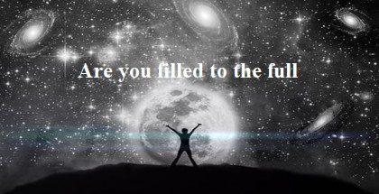

FIGURE 1.17: One Day We will ask Hell, "Art thou filled to the full?" –Al Quran 50:30

A sinner will live in his galaxy forever in disasters and pains, as forgotten vicegerent of God. He will not have any divine power.

“Allah created the ‘Skies and Lands’ (this universe) for just ends and in order that each soul may find the recompense of what it has earned and none of them be wronged.”

[Al Quran 54:22]

“We created not the ‘Skies and Lands and all between them’ (this universe) merely in sport. We created them not except for just ends. But most of them do not understand. Verily, the day of sorting out is the time appointed for all of them.”

[Al Quran 44:38–40]

.

Eventually, the unrolling universe will take the form of today, but with ever living sinners scattered in the galaxies.

“Then, he whose balance will be heavy will be in a life of good pleasure and satisfaction. But he whose balance will be light—their mother will be endless-hole (black hole); and what will explain to thee what this is—a fire blazing fiercely.”

[Al Quran 101:6-11]

5h. All creatures of matter and anti-matter will be resurrected and assembled on the Land of Judgment. One will see the dinosaurs walking on the land. After the resurrection, there is no death. According to Hadith, the animals will be merged with the land. It means that they will be scattered in the objects of the recreated Samawaat. If one wants to live with dinosaurs, demons, and jinns, one may follow a sinful life and live in the Samawaat forever. And the resurrected scorpions will be something to reckon with. And there will be extreme fire, heat, and boiling water, surging.

Thus, follow the Book of God to attain salvation to the Jannaat. Gold and silver are common building materials over there. Precious stones are falling on the streets like rubbles, neglected.

6. It is the Master Plan of Allah: To create, develop, and delegate His vicegerents (human beings) in two of His great creations (Samawaat and Jannaat) with a view to infuse life in the universes, to deploy intelligence and freedom of thought in the creations, and to open a flexible and interesting way of ruling.

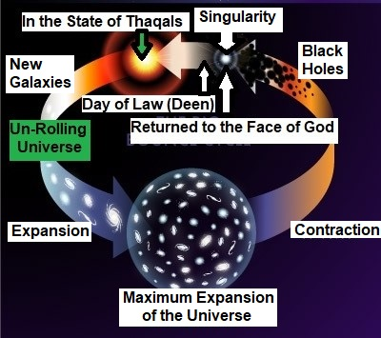

FIGURE 1.18: Moving into the Next Cyclic of Life

7. On the Earth, humans are undergoing test and development. Here, a human is not empowered as a vicegerent of God, and he has not got his ‘Area of Responsibility’. Only a fool will lose in the test of this short earthly life.

“Behold! in the creation of the Skies and Lands and the alternation of night and day—there are indeed signs for men of understanding. Men who celebrate the praises of Allah standing, sitting and lying on their sides, and think on the creation in the Skies and Lands: “Our Lord, Not for naught hast Thou created this! Glory to Thee! Give us salvation from the penalty of the fire. Our Lord, any whom thou dost admit to the fire, truly Thou cover with shame, and never will wrong doers find any helpers”!” [Al Quran 3:190–192]

The Quran in a well-planned chronology narrates the Creation, Evolution, Dooms Day, Resurrection, Judgment, and Salvation. The matter will be amply clear in the subsequent Chapters.

If one is here, one will be there too—there is no doubt what so ever—we are creatures of a Mighty Arrogant Creator. He does not fail.

**Section-2** of Chapter-1 **[Verse 5-7]: Submission and Prayer**

Thee do we worship, and Thine aid we seek.

Guide us to the Straight Path; the Path of those on whom Thou hast bestowed Thy grace, those whose is not wrath, and who go not astray.

**Remarks:**

Who can help in these affairs at astronomical level? So, we pray to Allah for salvation.

The Quran narrates the Straight Path to the Jannaat. It talks about the people on whom Allah has bestowed His grace and the people who earned His anger. Thus, it guides one to His Mercy.