1]NAME 1]NAME 2]NAME
[1]ADDRESS [2]ADDRESS
TEXT
TEXT
NAME
(EMAIL)

1

Carbon chemistry in litter decomposition
[

Abstract
TEXT
[12010Prescott] -> the amount of remaining biomass more important than the decomposition speed.
Most studies determine lignin, cellulose and hemicellulose cotents by extraction. These method were critizied as operational and unspecific repeatedly over the last decades (reeves and francis 1997 JAAP, ...). [12010Prescott] point out that while AUR and AUR:N are still a good predictor for decomposition speed, at least for non-woody material, not a proper methode for lig/cell/hemicell determination.
overestimation of lignin recalcitrance, underestimation of other recalcitrant compounds like cutin, ..

1 Material and methods
TEXT

1.1 Litter decomposition experiment
TEXT

1.1.1 Pyrolysis-GC/MS
TEXT

2 Results

2.0.2 Multivariant analysis

2.0.3 Initial composition of beech litter

3 Discussion
TEXT

4
HEADING
[Sorry. Ignored \begin{acknowledgements} ... \end{acknowledgements}]
References
[12010Prescott] Prescott, C. E.: Litter decomposition: what controls it and how can we alter it to sequester more carbon in forest soils? , Biogeochemistry, 101, 133–149, 10.1007/s10533-010-9439-0, URL http://www.springerlink.com/index/10.1007/s10533-010-9439-0, 2010.

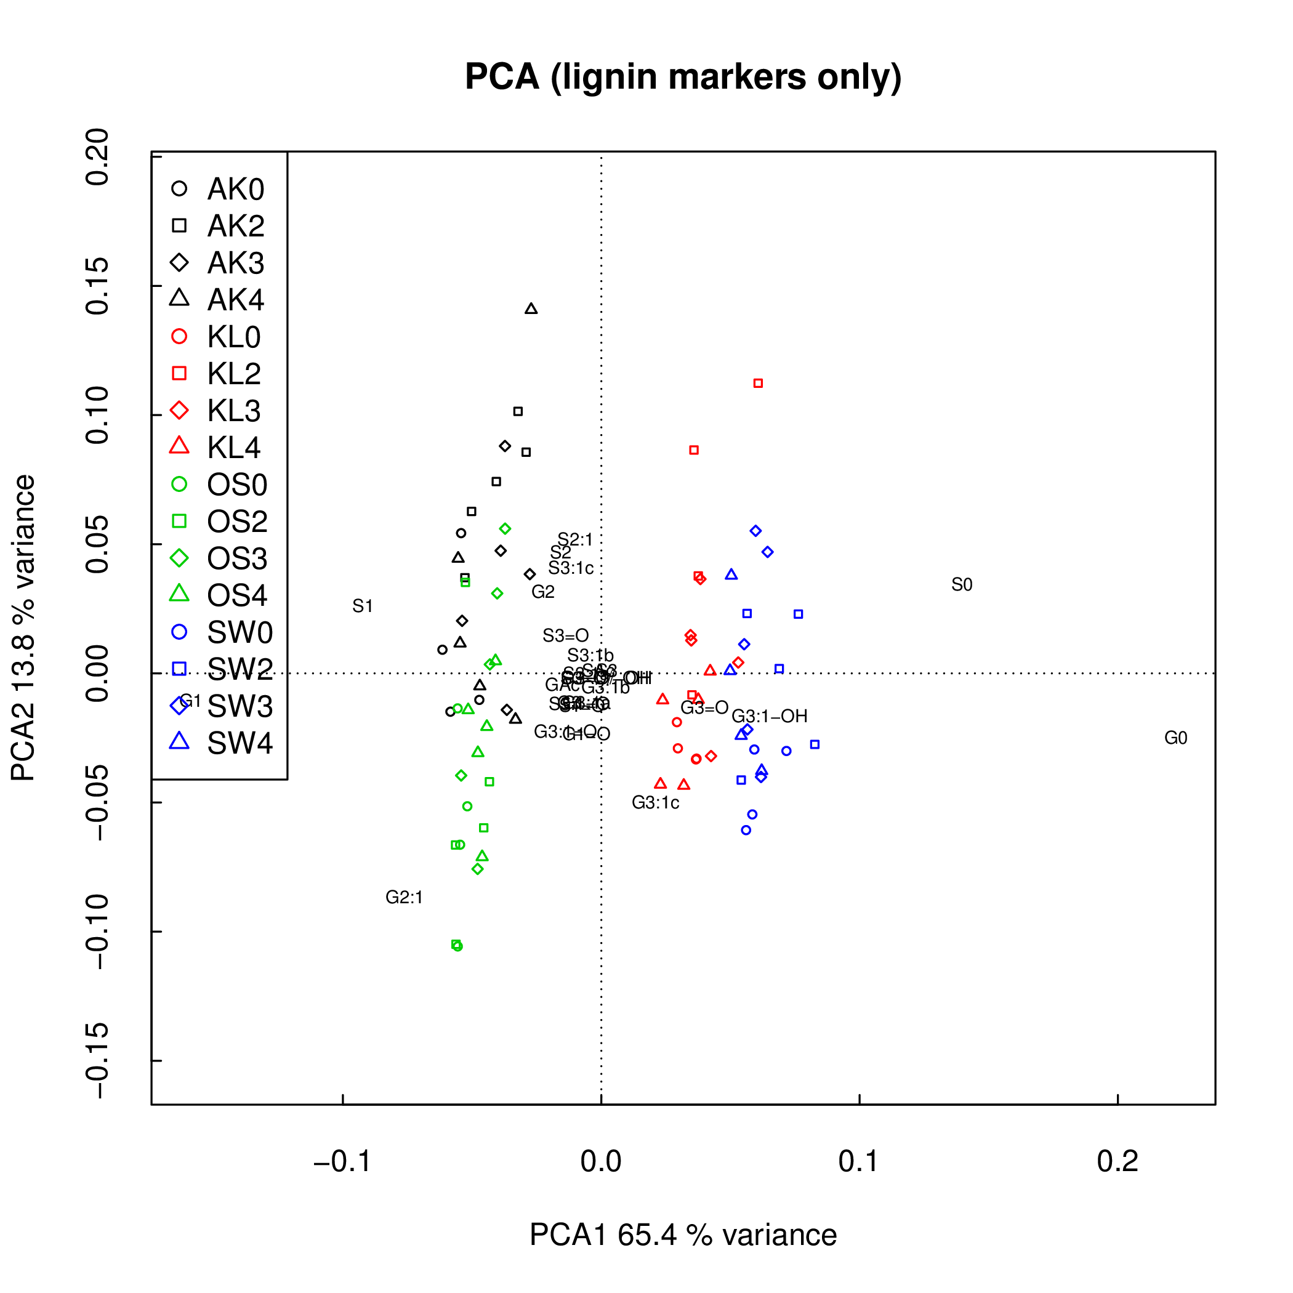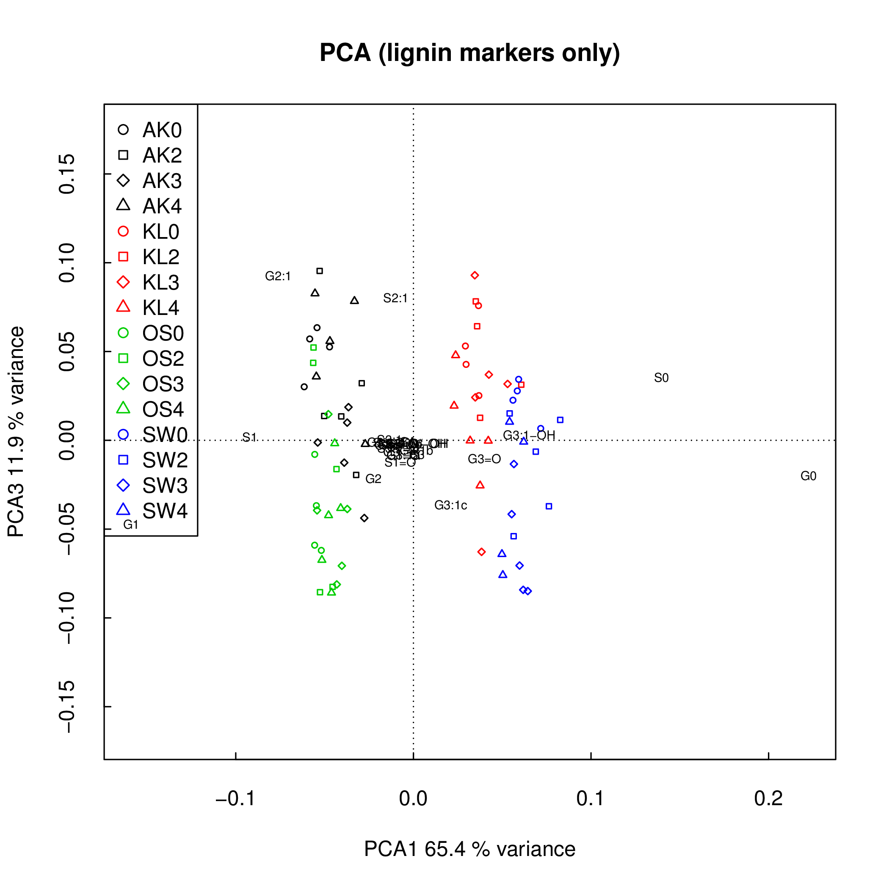
Figure 1: TEXT

