INZ004407L Computer Networks

*Group Number = 4*

*Mustafa Tayyip BAYRAM 257639*

*Furkan ÖCALAN 257638*

**Task 1 – Creation of LAN network topology with redundant connections between switches**

7. Check and save the Bridge ID, VLAN priority values and port costs on each switch.

S_L

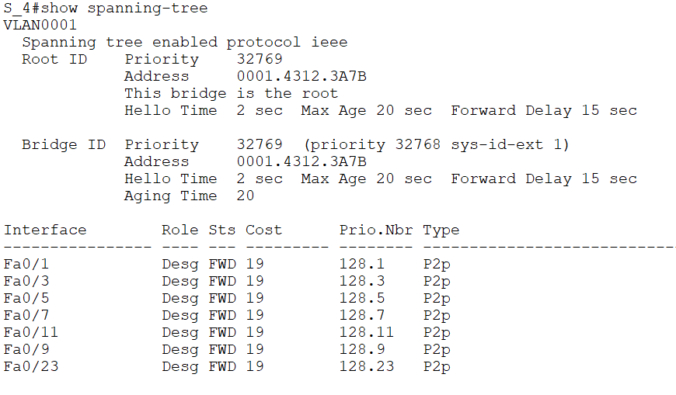

*S_M*

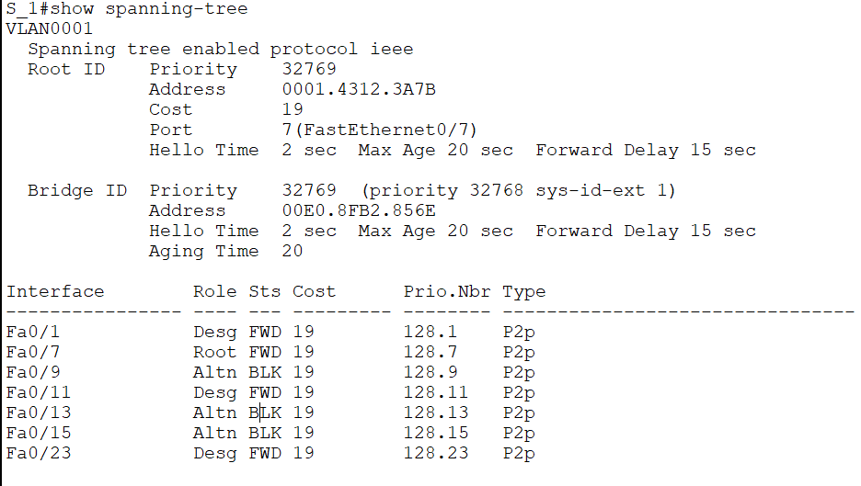

*S_K*

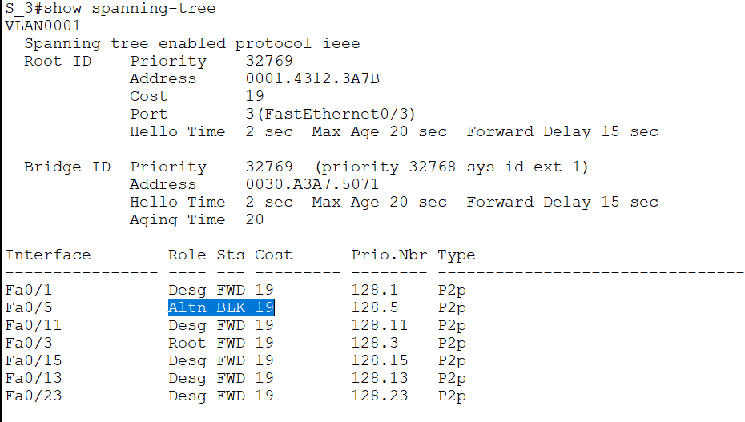

â€¢Desg (designated)

â€¢Root

â€¢Altn (alternate)

â€¢Back (backup)

Spanning trees use an algorithm to search for the redundant links in the LAN and select the best paths. It is mainly used to put all links in either forwarding or blocking.

If a bridging loop were happening the network would be unusable, STP protocol prevent this problem to making one way communication. The connections to the root switch are selected depends on the lowest priority, other unnecessary connections will be blocked by STP protocol. STL protocol makes status to Block for alternate ways( Non designated).

9. Check if the switches have disabled the previously predicted ports. In the case of mistakes, . correct and save your new calculations. Write in the notepad the states of all connected switch ports.

After Changing

S_L FA 0/7 – S_M FA 0/9

S_L FA 0/9 – S_M FA 0/7

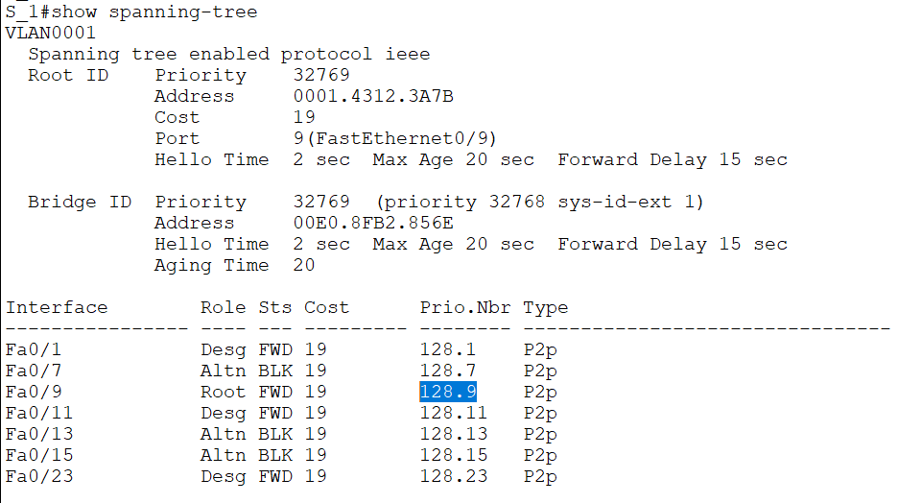

*Root role is changed. Costs are same*

11. Figure out and save which ports should be blocked.

After changing

S_K port Fa 0/5 - S_L port Fa 0/3

S_K port Fa 0/3 - S_L port Fa 0/5

12. Check which ports have been really blocked. In case of difference, repeat calculations. Write in the notebook the states of all connected switch ports.

After decreasing cost of blocked interface, it has to be root role.

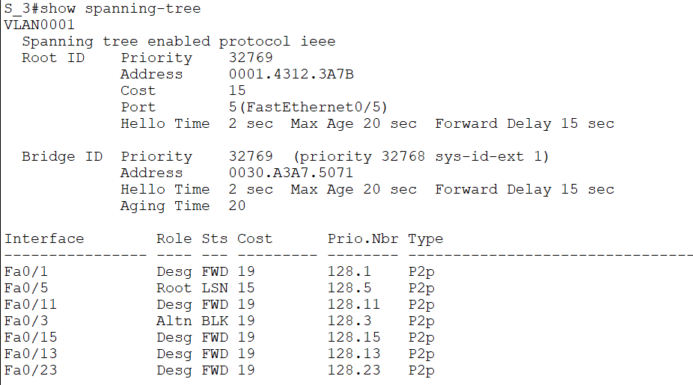

19. Figure out and save which ports should be blocked in new topology.

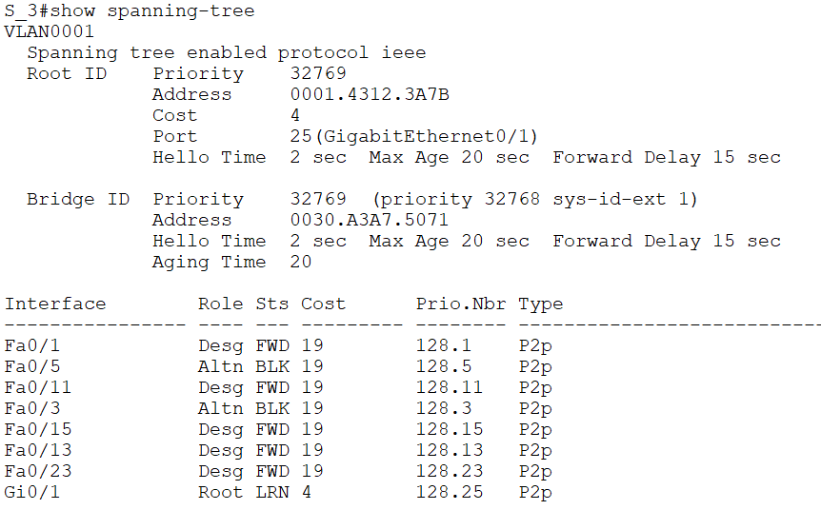

Fa0/3 and Fa0/5 is blocked because cost of Gi0/1 is less than others.

22. Check in practice which ports have been blocked. Write in the notepad the states of all switch ports.

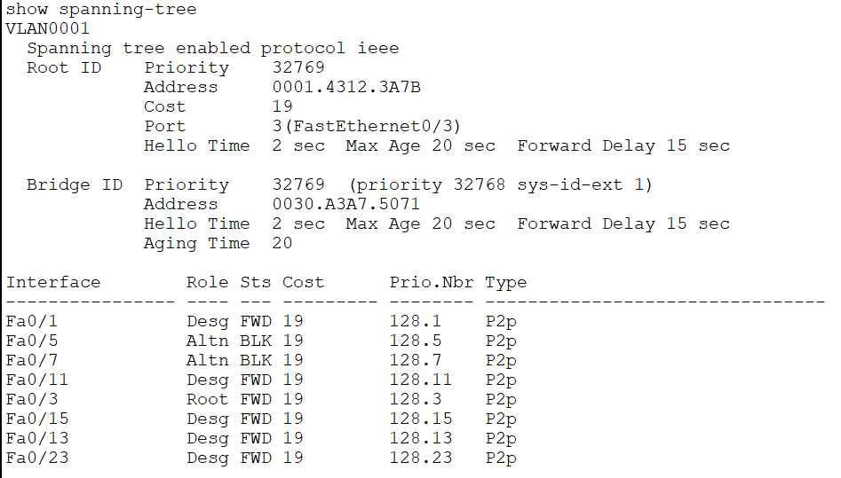

FA 0/5 and Fa 0/7 is blocked.

**Task 2 – Controlling the selection of the Root bridge for individual VLANs**

6. Check and save how much priority increase/decrease with the second command (... root

Priority increases 4096 with the second command.

**Task 3 – Configuration of the rapid STP protocol.**

Priority increase 4096 with the second command.

7. Measure the approximate convergence time of the STP protocol on trunk ports. Unplug and plug any trunk link. Check the amount of time the STP protocol needs for activation of new trunk connection. Observe the behavior of the LED on the port. Test the connection to remote switch with the ping -t command. Note the convergence time and number of ping loss.

**Pc-Switch**

**23 secs.**

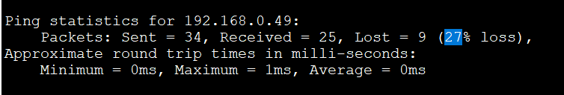

**Switch-Switch**

**45 sec**

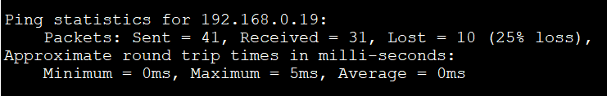

**After (Rapid PVST +) (BPGUARD) (PORTFAST) Protocol**

**PC – SWITCH**

**15 SEC**

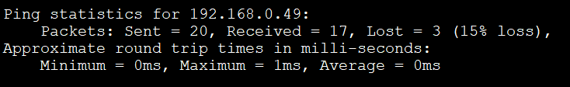

**SWITCH – SWITCH**

**40 SEC**

