# INZ004407L Computer Networks

**Laboratory tasks Data link layer – Ethernet**

*Group Number = 4*

*Mustafa Tayyip BAYRAM 257639*

*Furkan ÖCALAN 257638*

**TASK 1**

**Configure the IP address to static.**

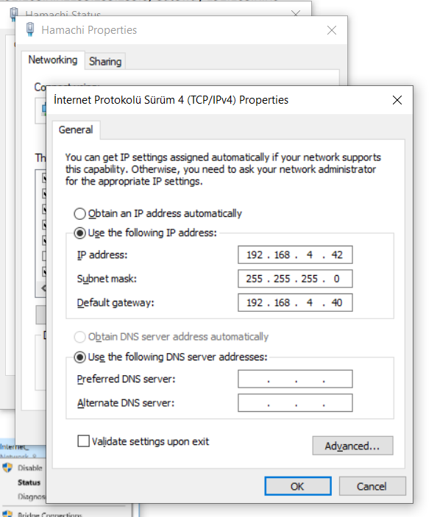

**After the configuration we should make IP address to dynamic for connection to teammate using Hamachi.**

**Hamachi ethernet adapter configurations.**

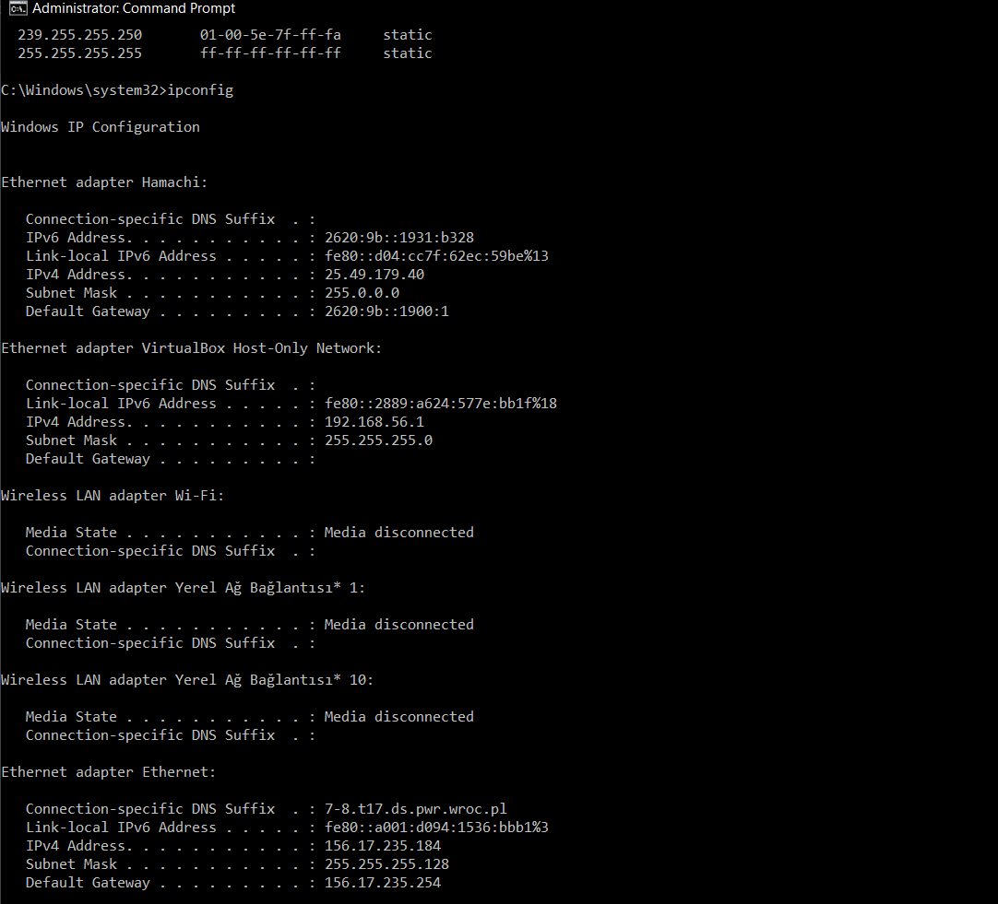

**Pinging to teammate.**

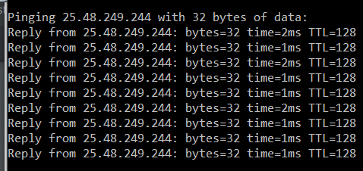

Task 2

**Tracking ICMP protocols ( sending ping to teammate) in Wireshark program**

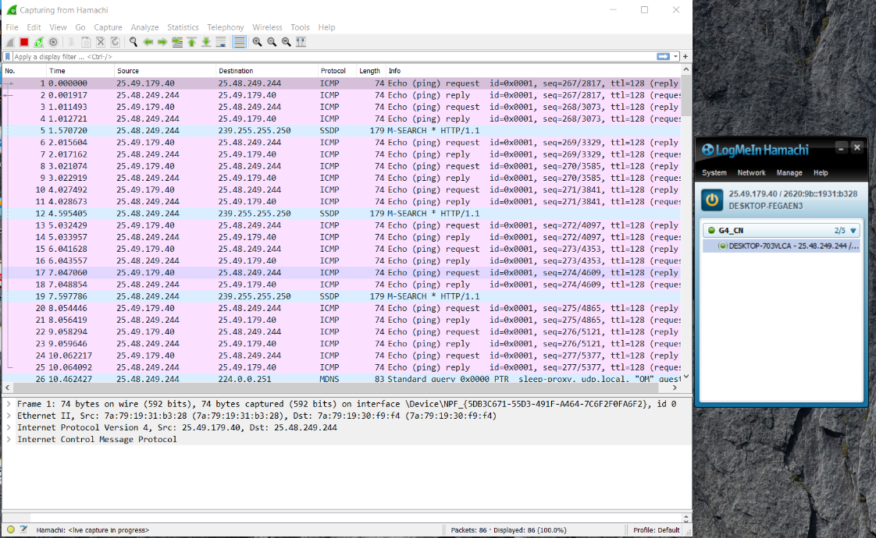

**Analyze the Ethernet frame**

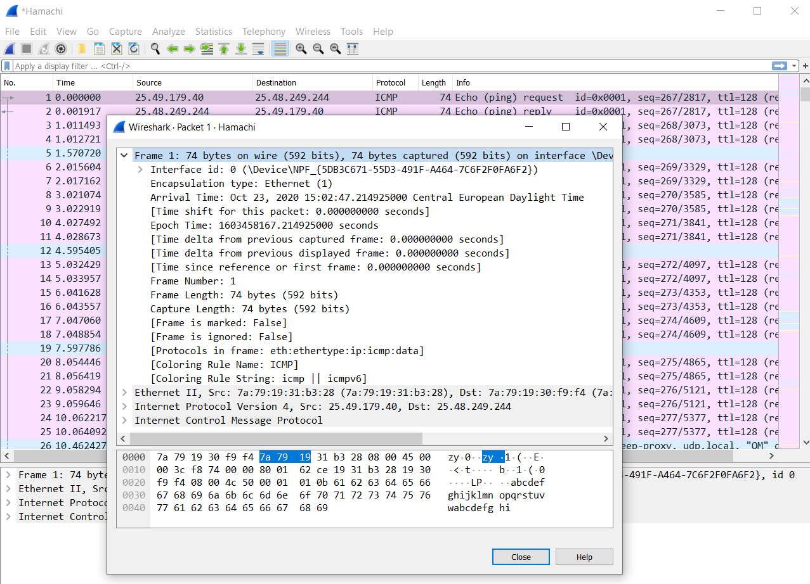

**Frame ID 1**

**Analyze the Ethernet frame. Find and write the following data:**

Frame 1: 74 bytes on wire (592 bits), 74 bytes captured (592 bits) on interface \Device\NPF_{5DB3C671-55D3-491F-A464-7C6F2F0FA6F2}, id 0

Ethernet II, Src: 7a:79:19:31:b3:28 (7a:79:19:31:b3:28), Dst: 7a:79:19:30:f9:f4 (7a:79:19:30:f9:f4)

0000 7a 79 19 30 f9 f4 7a 79 19 31 b3 28 08 00

Recipient MAC Address : 7a:79:19:30:f9:f4

Sender MAC Address : 7a:79:19:31:b3:28

Internet Protocol Version 4, Src: 25.49.179.40, Dst: 25.48.249.244

Internet Control Message Protocol

Destination MAC Address -> 7a:79:19:30:f9:f4 -> 7a79.1930.f9f4

Source MAC Address -> 7a:79:19:31:b3:28 -> 7a79.1931.b328

When we compare these, destination physical address (MAC addresses) is lower than source physical address. Because in the second part of addresses, 1 is bigger than 0. That means destination is lower and source is higher.

**TASK 3**

Check the IP addresses on the PC interfaces connected to the external network

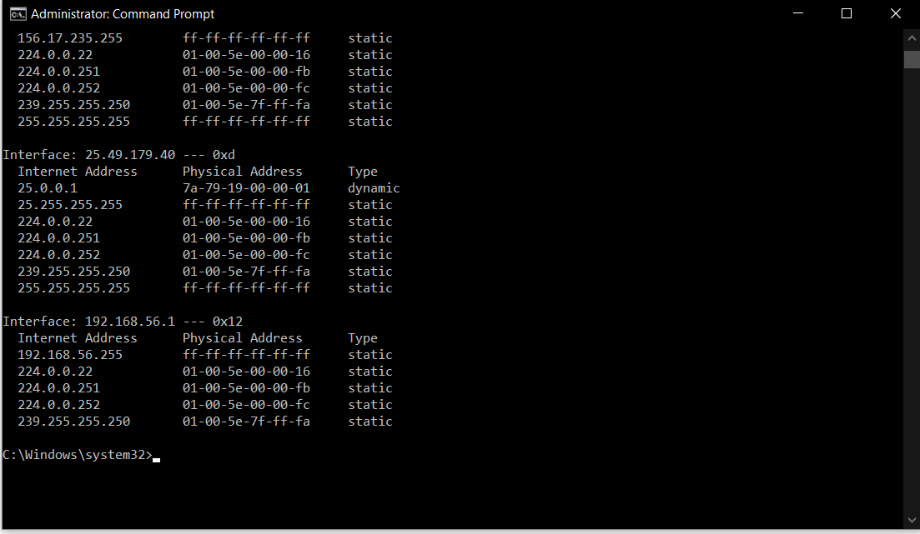

Analysis of the ARP3 protocol.

3. Checking physical addresses of external PC network interfaces

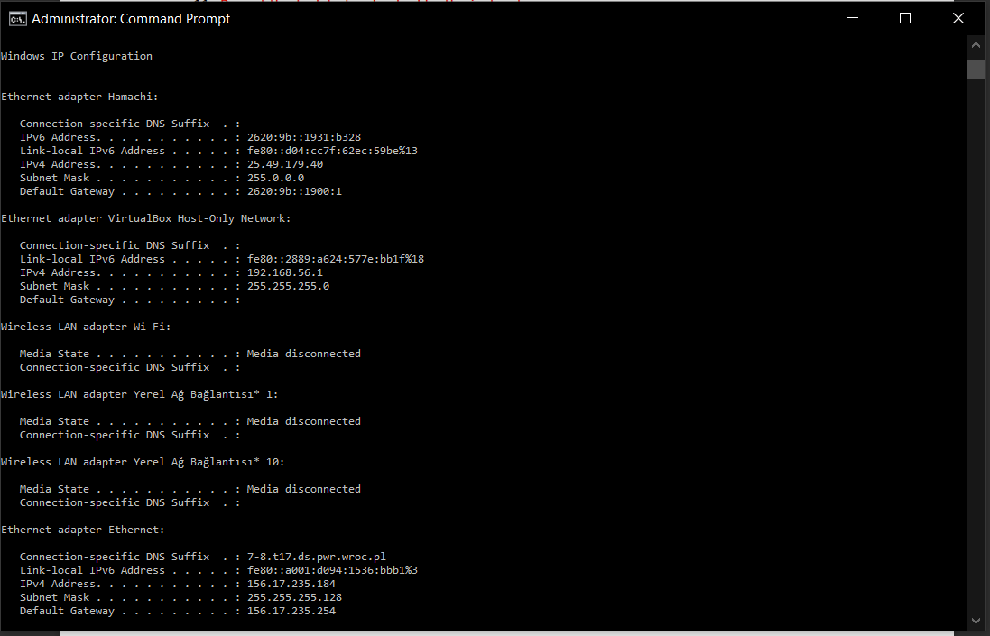

4. Analyze the contents of the ARP table of PCs in Windows.

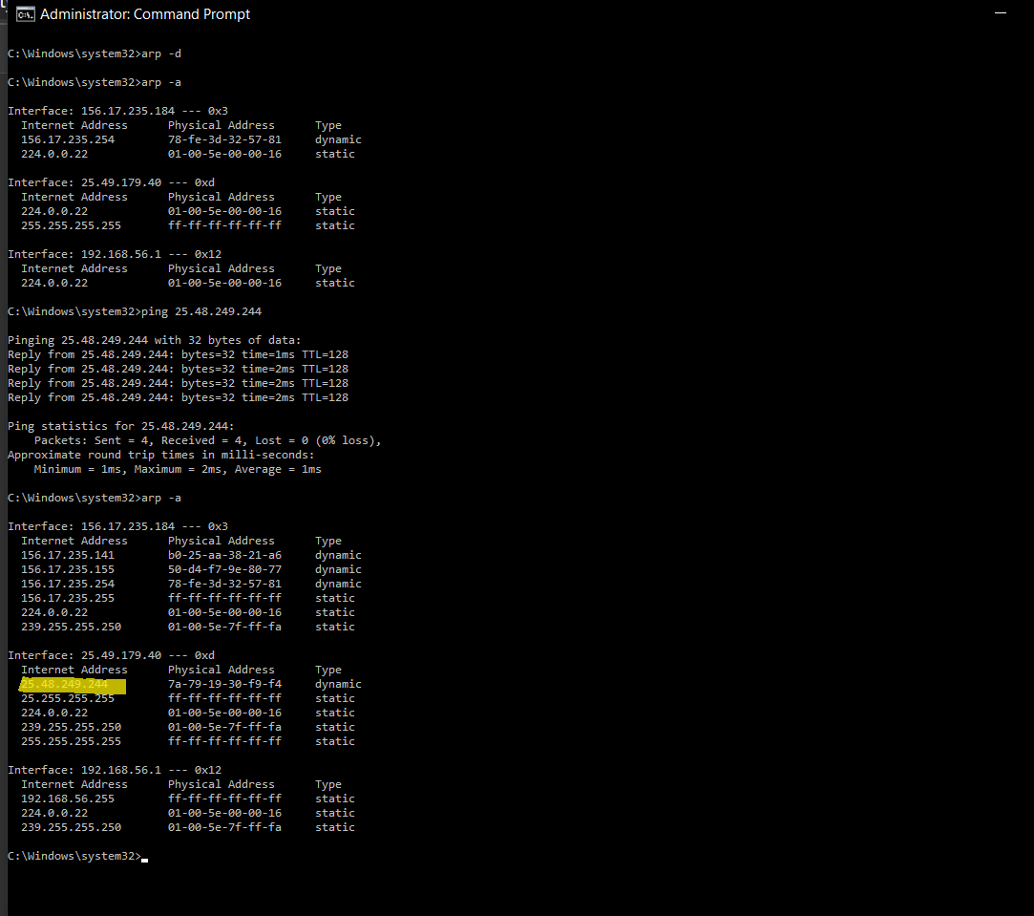,

9. Arp Frames

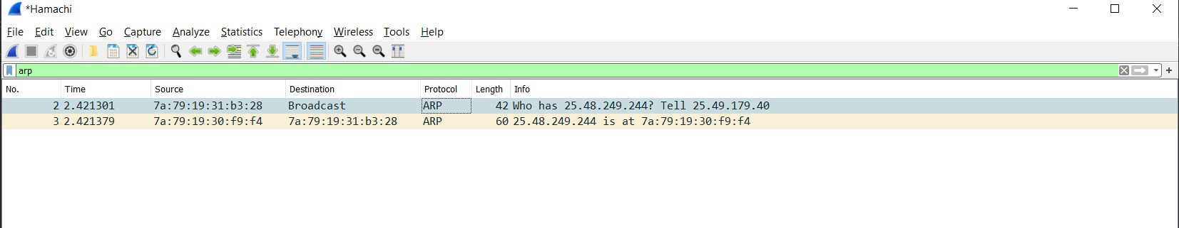

ID – Source and Destination MAC addresses – ARP content





ARP protocol analysis for external hosts communication. Analysis of MAC addresses of external hosts

239.255.255.250 IP is added to ARP table. This address is used UPnP / SSDP discover devices on a VLAN. That’s the answer of *“why these addresses are not different from each other”. So all data are sent via SSDP.*

