# INZ004407L Computer Networks

**Network layer of the ISO-OSI model**

*Group Number = 4*

*Mustafa Tayyip BAYRAM 257639 => IPv4 = 25.49.179.40 => IPv6 = 2620:9b::1931:b328 => PC_42*

*Furkan ÖCALAN 257638 => IPv4 = 25.48.259.244 => IPv6 = 2620:9b::1930:f9f4 => PC_41*

Task 1 – Connectivity test in IPv4 network. ICMP protocol

2. Configure the statics IP addresses on internal interfaces (Cisco) under MS Windows system. Use the addresses given in the instruction. Use the netsh command. Save the exact configuration formula. Check the correctness of configuration using ipconfig command.

[ We cannot configure IP addresses as a static because we are connected through Hamachi.]

4. Make the connectivity test between PC_X1 and PC_X2 computers. Use the ping command.

*We are connected each other through Hamachi. We are tested it using ICMP protocol and Wireshark program.*

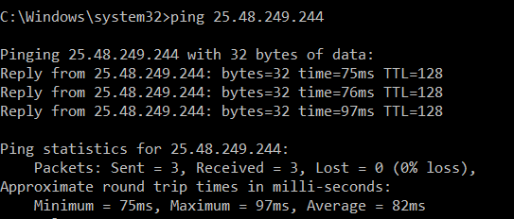

6. Find inside the Wireshark listing ICMP packets exchanged between PC_X1 and PC_X2. Note the frames IDs.

Request frame ID’s {1 ,3, 5}

Reply frame ID’s {2 ,4, 6}

7. Analyze the IPv4 and ICMP headers. Find and save the following fields values:

− Source IPv4 address; *25.49.179.40*

− Destination IPv4 address; *25.48.259.244*

− Value of TTL field; 128

− Types and names of ICMP packets; Type 0 (Echo(ping) reply )) and Type 8 (Echo(ping) request )

− Size and content of ICMP data field.; Data (32 bytes)

Data: 6162636465666768696a6b6c6d6e6f707172737475767761…

[Length: 32]

??8. Make the connectivity test to gogle.com server. Enlarge the size of ping packet and set the non-fragmentation bit. Check and save the maximum size of ping packet

9. Start the Wireshark on internal NIC. Capture the transmitted frames with increased size. Save the result in the user folder.

− Source IPv4 address; *25.49.179.40*

− Destination IPv4 address; *239.255.255.250*

− Value of TTL field; 1

−? Value of the non-fragment bit; 0

−? Types and names of ICMP packets; Type 0 (Echo(ping) reply )) and Type 8 (Echo(ping) request )

− ? Size and content of ICMP data field.; Data (32 bytes)

Data: 6162636465666768696a6b6c6d6e6f707172737475767761…

[Length: 32]

Task 2 – Connectivity test in IPv6 network. ICMPv6 protocol.

1. Create a text document in the user's home directory and save the course of exercise in it.

4. Make the connectivity test between PC_X1 and PC_X2 computers. Use the ping command. 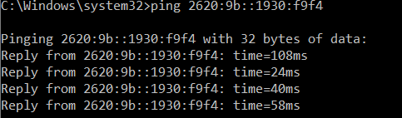

6. Find inside the Wireshark listing ICMPv6 packets exchanged between PC_X1 and PC_X2. Note the frames IDs.

Request frame ID’s {1 ,3, 5, 7}

Reply frame ID’s {2 ,4, 6,8}

7. Analyze the IPv6 and ICMP headers. Find and save the following fields values:

− Source IPv6 address; *2620:9b::1931:b328*

− Destination IPv6 address; *2620:9b::1930:f9f4*

− Value of TTL field; - Hop Limit: 128 [ *TTL is not actually thrown out in IPv6, it has just been renamed. The field is called the "hop limit" and has the same function as the TTL field in IPv4*.]

− Types and names of ICMPv6 packets; Type 129 (Echo(ping) reply )) and Type 128 (Echo(ping) request )

− Size and content of ICMPv6 data field.;

Data (32 bytes)

Data: 6162636465666768696a6b6c6d6e6f707172737475767761…

[Length: 32]

8. Make the connectivity test to PC_X2. Enlarge the size of ping packet and set the non-fragmentation bit. Check and save the maximum size of ping packet. Note: Packet fragmentation in the IPv6 protocol works on a different way than in the IPv4 protocol.

?Nonfragment

?Maximal size and content of ICMPv6 data field

Task 3 – Tracking the path in IPv4 network. Traceroute (tracert) command

4. In MS Windows system trace the network path to the any chosen Web server using tracert command.

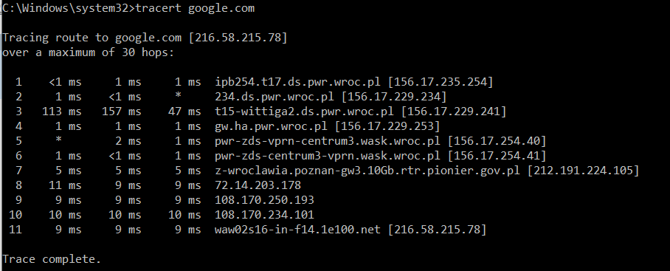

6. Find inside the Wireshark listing traceroute packets exchanged between PC_X1 and Web server. Note the frames IDs.

?8. Analyze the headers of firs six received traceroute packets. Find and save the values of the following fields:

?9. Answer the question: Why do intermediate nodes respond to traceroute packets even though they are not the destinations of these packets?

Task 4 – Connectivity test in IPv4 network between Linux hosts. ICMP protocol

8. Make the connectivity test to gogle.com server. Enlarge the size of ping packet and set the non fragmentation bit.

10 : ??????