INZ004407L

Computer Networks

Laboratory tasks Transport Layer of the ISO-OSI model - Transmission Control Protocol (TCP) - User Datagram Protocol (UDP)

*Group Number = 4*

*Mustafa Tayyip BAYRAM 257639 => IPv4 = 25.49.179.40 => IPv6 = 2620:9b::1931:b328 => PC_41*

*Furkan ÖCALAN 257638 => IPv4 = 25.48.249.244 => IPv6 = 2620:9b::1930:f9f4 => PC_42*

*LinuxPC => IPv4 => 25.41.182.15 (Hamachi NIC) <=> 192.168.137.182(Ethernet NIC )*

Task 1 – Analysis of the TCP protocol in Wireshark

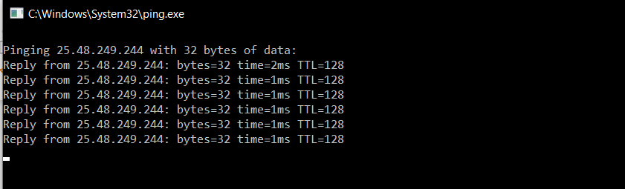

*We are connected.*

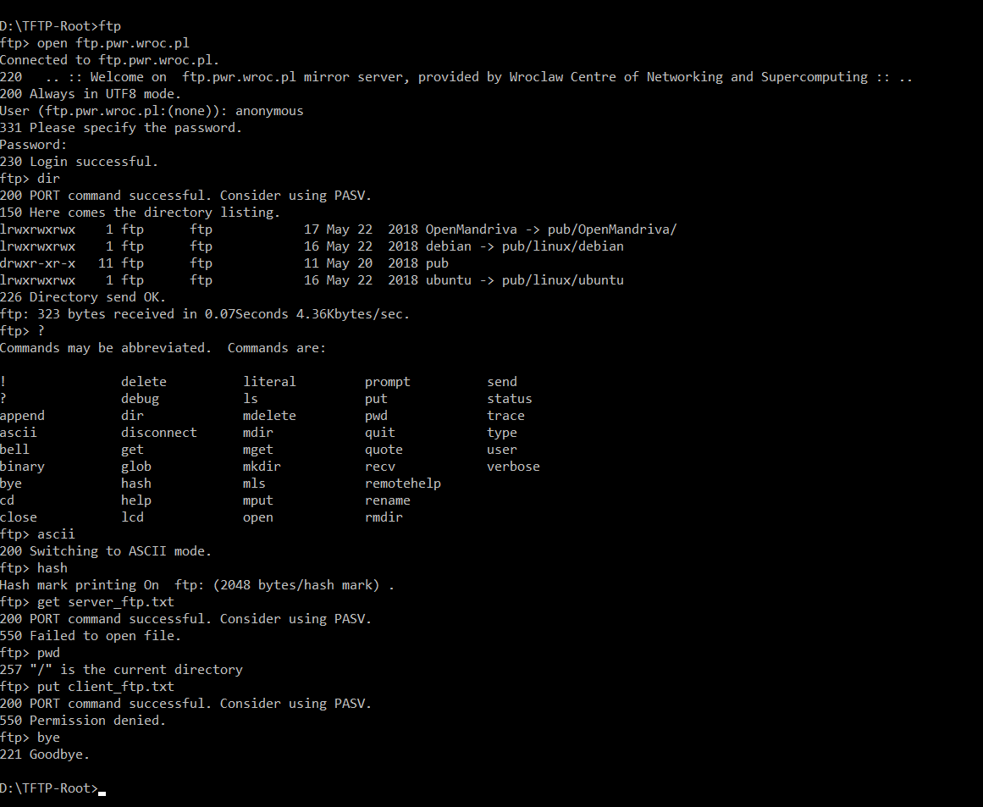

* 1. 9. Inside the Wireshark listing find and note the numbers of the following frames:
  2. a. Frames corresponding for establishing the TCP connection.
  3. 92-250-251
  4. b. Frames with FTP login name and password.
  5. 321-338-339
  6. c. Frames with directory listing – should contain list of FTP server files in TCP data part.

483----489

* 1. d. Frames containing copied file – should contain the user name in TCP data part.
  2. Get File : 766~-----~772 ( File cannot opened because we can’t completely access the server.
  3. Get File : 1247~-----~1254 ( Permission we can’t completely access the server.
  4. e. Frames corresponding to connection end.
  5. 1396------1401

Task 2 – Analysis of the UDP protocol

* 1. 4. Configure the PC_X1 computer as the FTP client
  2. a. In the *c:\ftp* folder, create the text file named *client_ftp.txt*. Save your name inside the file.
  3. b. Open *cmd* terminal and change the current directory to *c:\ftp*.
  4. c. Check PC_X2 IP address.
  5. d. Test the connectivity with *ping* command.

**

*We are connected.*

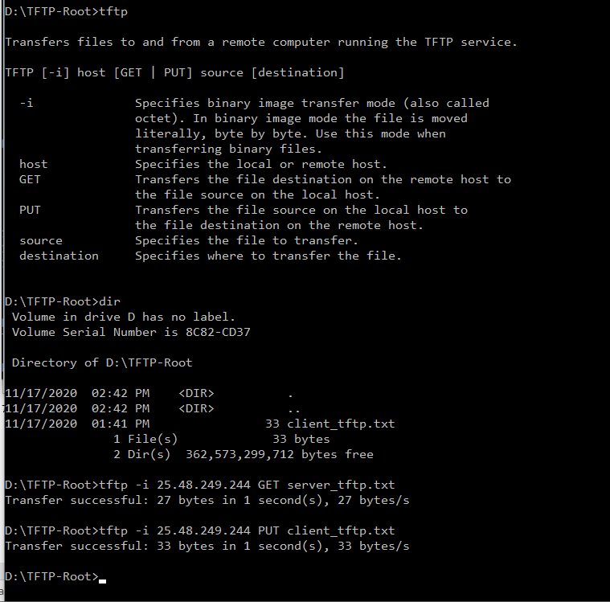

7. Transfers the created text files between your computers using the TFTP protocol.

*FILE : TASK2_8*

9. Inside the Wireshark listing find and note the numbers of the following frames:

a. Frames corresponding for establishing the UDP connection ?

Frame 1 : Read

Frame 6 : Write

b. Frames with TFTP login name and password ?

There is no login in TFTP connection, server just acknowledge connection.

Acknowledgements : 3, 7

c. Frames with directory listing ?

There is no directory listing support in tftp.

?d. Frames containing copied file – should contain the username in UDP data part.

Data Packets:

Read -> 2

Write->8

?e. Frames corresponding to connection end ?

* 1. After the acknowledgement of sending file, connection ends.

Task 3 – Comparison of TCP and UDP protocols

15. Analyze the captured frames from Wireshark. Use the appropriate filter to facilitate your work e.g.:

udp and ip.addr=={remote PC address}

* 1. a. Which default ports are used by the TFTP protocol (number <1024)?

for UDP : Src Port: 62016, Dst Port: 69

UDP/69 - The TFTP server uses this port for TFTP transfers.

* 1. b. Maximum number of data frames sent without acknowledgement?
  2. 512 Byte
  3. c. Find the data frames (fragment of file) and the corresponding ACK confirmation for this data.
  4. d. Calculate the maximum number of frames the TFTP server could send without confirmation ?
  5. ????????????
  6. e. How does the TFTP protocol ensure error-free data transmission (e.g. for IOS image)?
  7. Transfer is made block by block. Each block must be acknowledged via an acknowledgment packet before the next block can be sent. If an error occurs during the TFTP file transfer, this will result in an **error packet** being sent which will terminate the transfer in most cases.

1. Additional Task 4 – Comparison of TCP and UDP protocols in Linux

11. Analyze the UDP protocol operation. Compare the results with those obtained under Windows. Make a note of the observations and results in the text file. Answer the same questions as in the previous task.

* 1. a. Which default ports are used by the TFTP protocol (number <1024)?

for UDP : Source Port: 65233, Destination Port: 50675

UDP/69 - The TFTP server uses this port for TFTP transfers.

* + - 1. b. Maximum number of data frames sent without acknowledgement?
      2. 512 Byte
      3. c. Find the data frames (fragment of file) and the corresponding ACK confirmation for this data.
      4. d. Calculate the maximum number of frames the TFTP server could send without confirmation ?
      5. ???????????? 0
      6. e. How does the TFTP protocol ensure error-free data transmission (e.g. for IOS image)?
      7. Transfer is made block by block. Each block must be acknowledged via an acknowledgment packet before the next block can be sent. If an error occurs during the TFTP file transfer, this will result in an **error packet** being sent which will terminate the transfer in most cases.

12. Report the results stored in the text file to the instructor. Alternatively, save the answers and proceed to the next task.

Lengths of acknowledgement frames are different. In windows , it’s length 60 but it is 46 in linux.

Data packets sizes are same.