INZ004407L Computer Networks

*Group Number = 4*

*Mustafa Tayyip BAYRAM 257639*

*Furkan ÖCALAN 257638*

Task 1 - Establish a console connection with the selected Cisco device (router / switch)

Task 2 - Basic configuration of the Cisco router

* Configure the router name

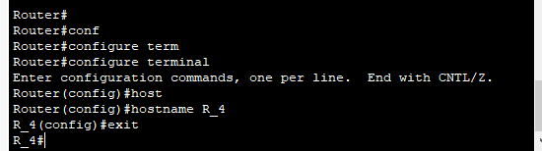

* Configure the message of the day (MOTD)

banner motd # A supervised system. Access only to authorized #



* Show running-config



* Configure LAN interface

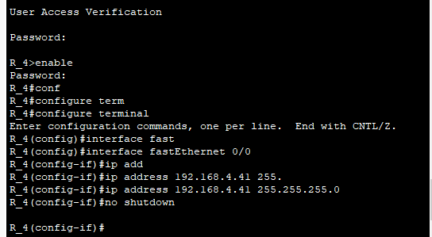

Task 3 - Basic configuration of the Cisco switch.

* Configuration of Hostname

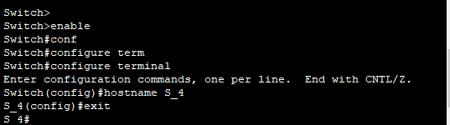

* Configure password

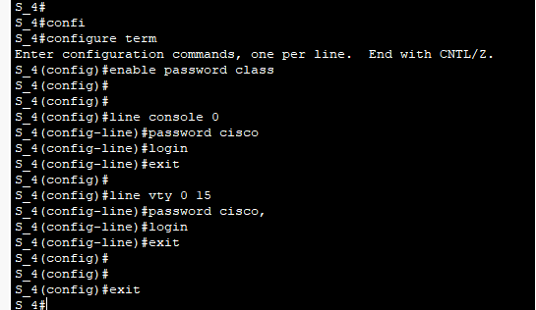

* Management VLAN

BEFORE :



AFTER :

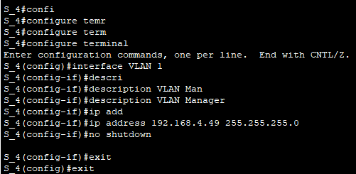



* Configure descriptions of connected interfaces (PC1, PC2, R_X).

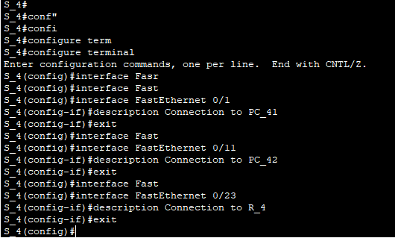

* Compare the configurations in RAM and NVRAM.
* Show running config







* Show start-up config



* Remember configurations in nvram.

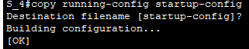

And then we see descriptions on the screen