INZ004407L Computer Networks

*Group Number = 4*

*Mustafa Tayyip BAYRAM 257639*

*Furkan ÖCALAN 257638*

Task 0 - Basic configuration

- Check the communication with the switch from both PCs,

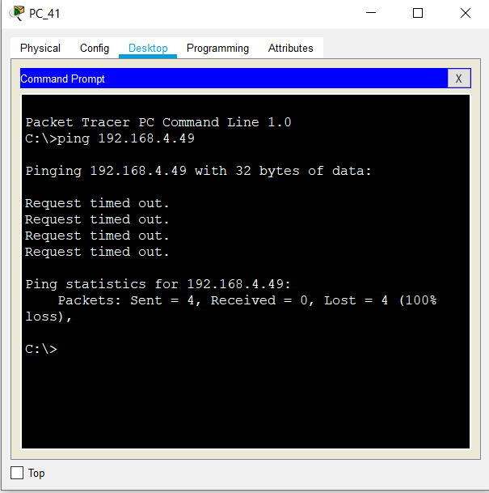

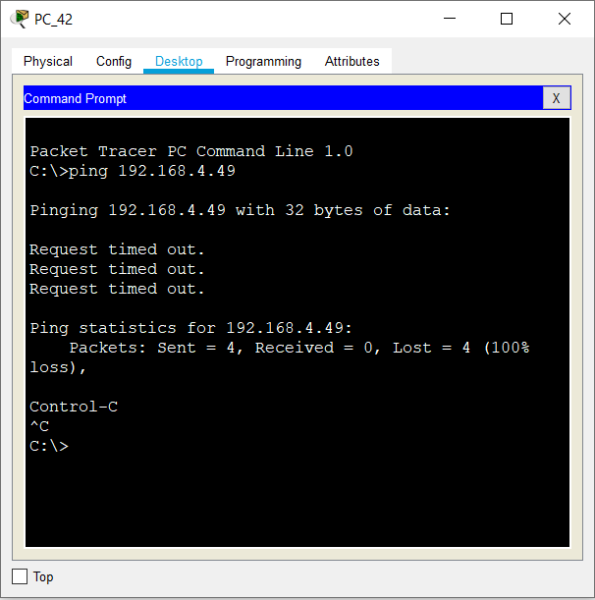

There is no communication among PC’s and Switch.

Is the PC-switch communication possible? Why?

* Because we must assign active ports to the management VLAN.

Before Assign Active Ports

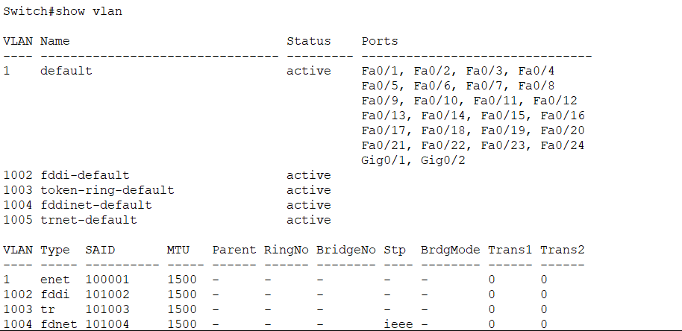

After Assign Active Ports

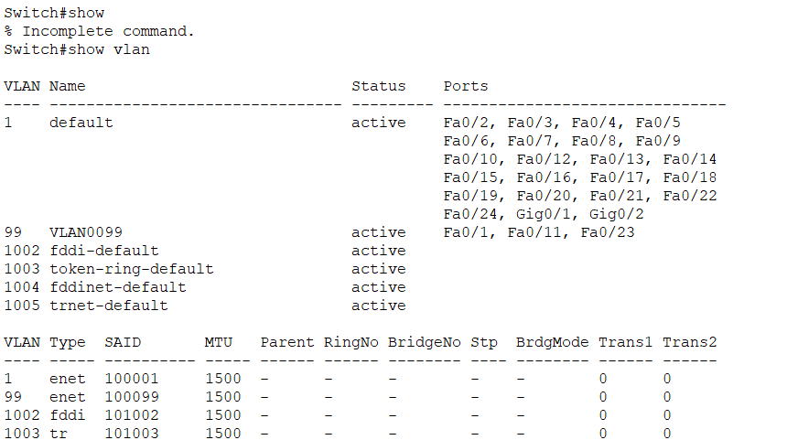

- Check the PCs - switch communication. In case of problems correct the configuration.

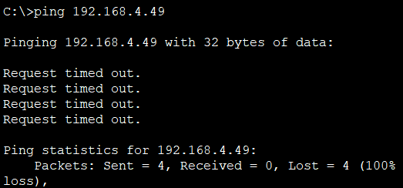

There is no connection

- Check the possibility of remote connection to the switch through telnet.

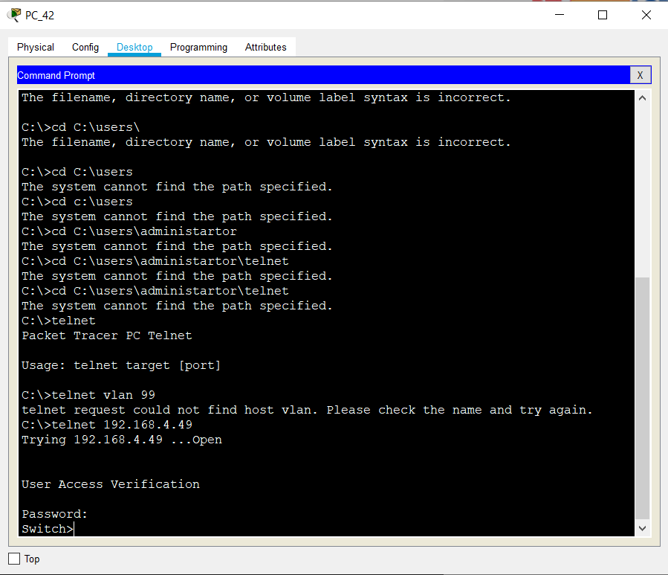

Check how the password is displayed int the current configuration. It is possible to guess the password.

It’s not possible to guess password.

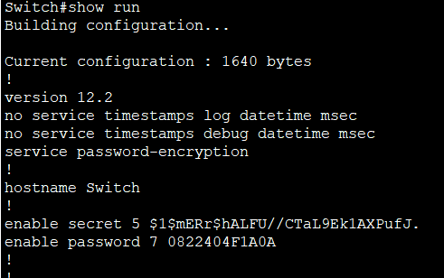

- Encrypt passwords that are shown as explicit text in the device configuration  
Check which passwords are readable.

None of them are readable because all passwords are encrypted.

-Encrypt passwords

S_X(config)#service password-encryption

Check which passwords are readable.

S_X#show run

Nothing changed.

Check port status

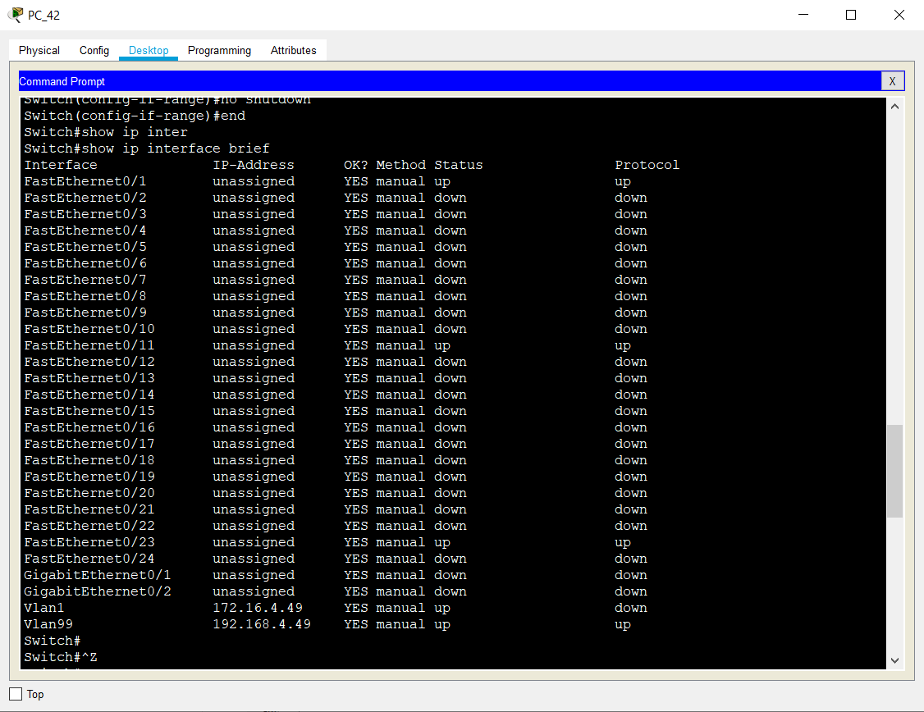

Check communication between all devices in the group (PC1, PC2 S_X, R_X). Use the ping command.

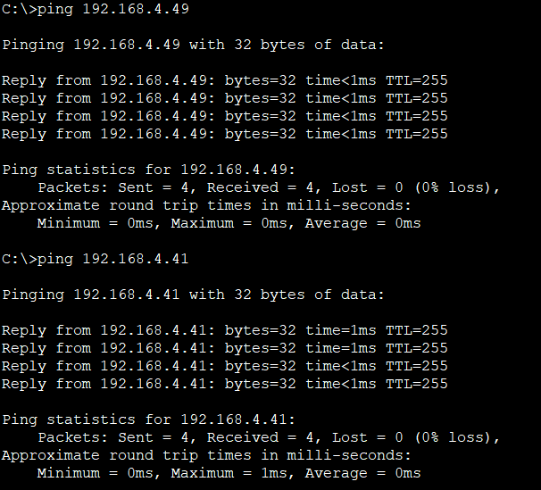

There is a connection to switch and pc41 from pc42.

-Check the communication with the router from both PCs,

From PC_41

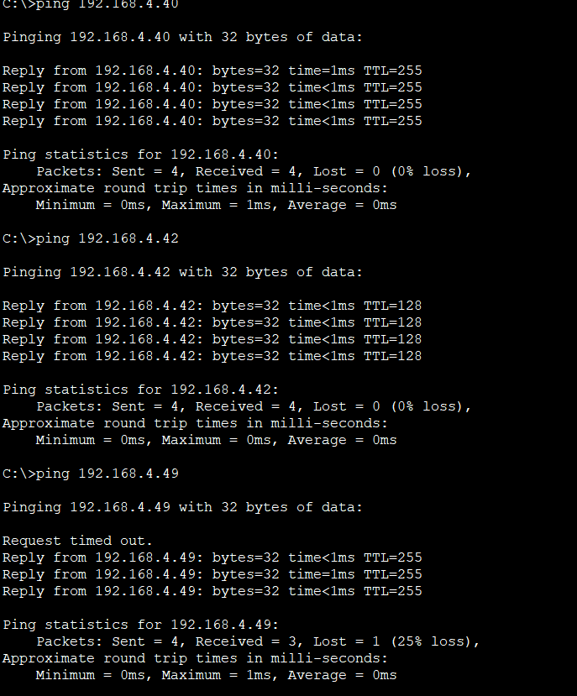

From PC_42

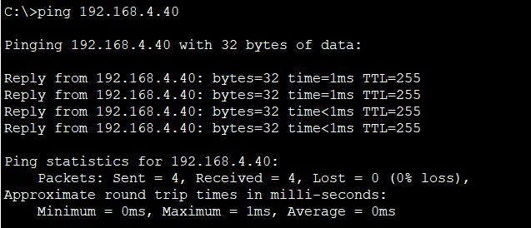

- Is the PC-switch communication possible? Yes, it is possible.

- Compare the configurations in RAM and NVRAM

Same.

- Check if you can set a shorter password

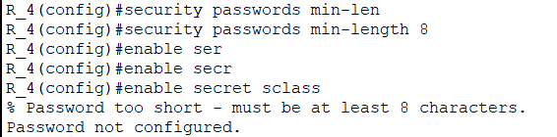

- Check communication between all devices in the group (PC1, PC2 S_X, R_X). Use the ping command.

#### Task 2 - Analyse telnet and ssh connection using wireshark.

#### Capture telnet and SSH communication with wireshark.

#### We can not use Wireshark because PT is just a simulator.

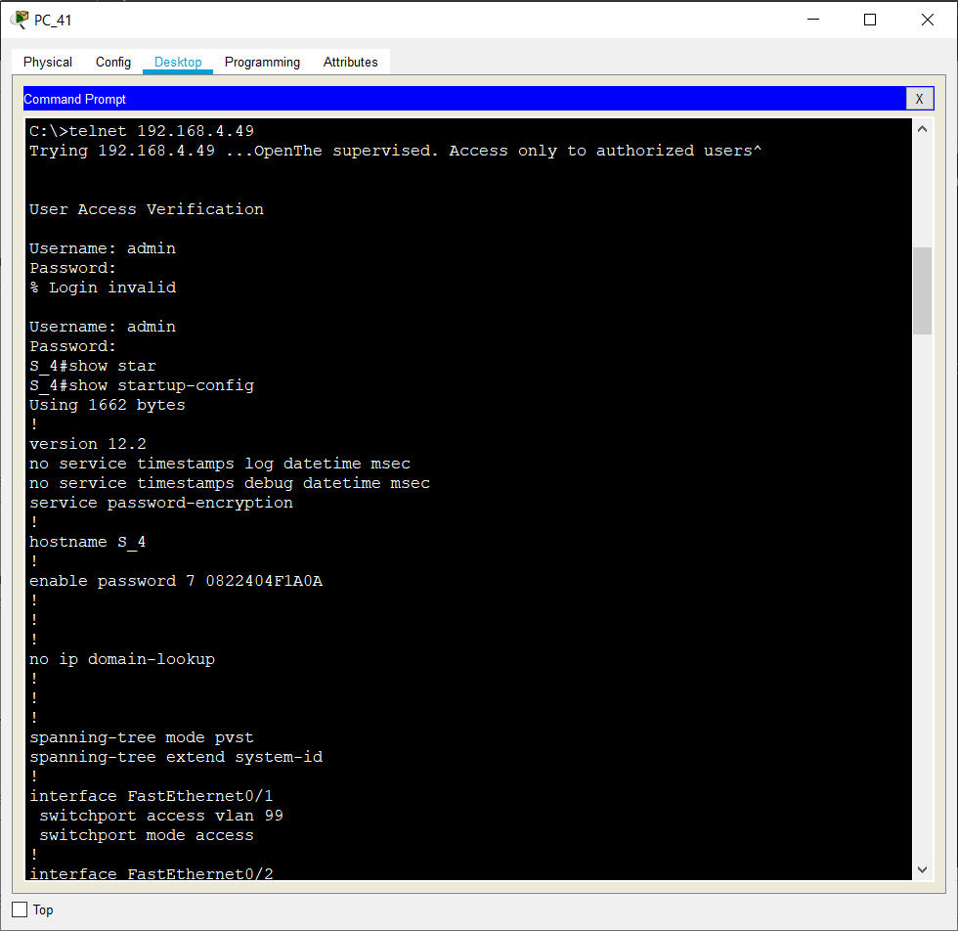

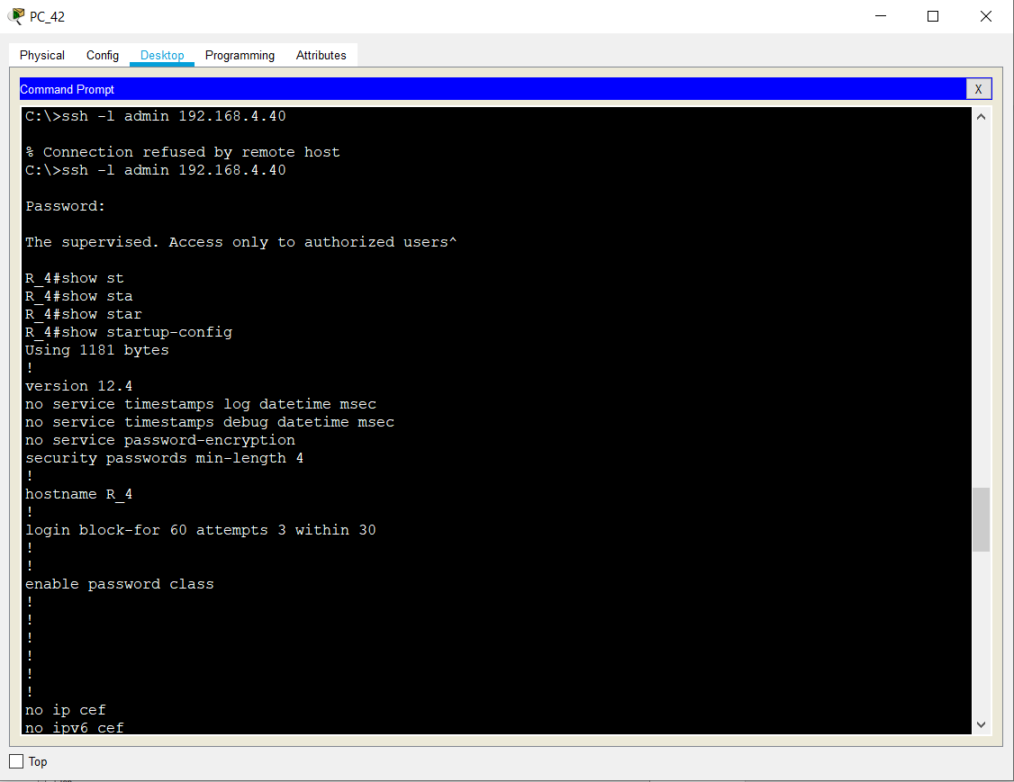

Users => Username : admin => password : adminpass

* Username : stud => password : studpass

#### Task 3 - Management of switch and router configuration: backup and restore

#### Configs are restored.

#### Task 4 - Password recovery on switch and router.

- Recover the router password.

*show version*

#### *Look the version and get the Config register ( 0x2102 )*

#### *reload (ctrl + c while reloading)*

#### *rommon shell will be open.*

#### *Confreg 0x2142*

#### *Reset the router*

#### *Open the CLI and in config mode.*

#### *Config-register 0x2102*

#### *-*Recover the switcher password.

#### *Click Power Cycle Devices*

#### *Click Mode Button*

#### *Enter CLI and write flash_init in (switch: ) shell*

#### *dir flash*

#### *rename-flash: config.text flash: config.old*

#### *boot*

#### *copy flash: running-config*

#### *config.old*

#### *delete flash: config.old*