INZ004407L Computer Networks

*Group Number = 4*

*Mustafa Tayyip BAYRAM 257639*

*Furkan ÖCALAN 257638*

Task 1 - Managing the MAC address table on the switch.

##### **PC configuration**

- Check the PC connection to the switch.

From PC_41

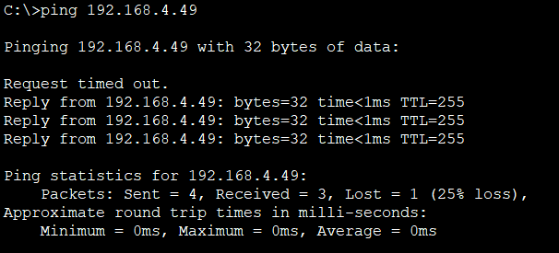

From PC_42

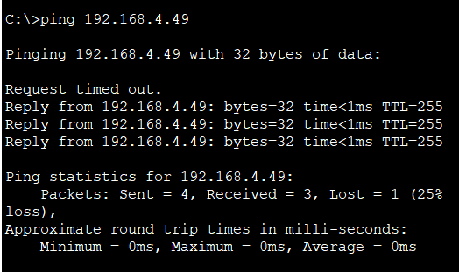

- Check created IP configuration.

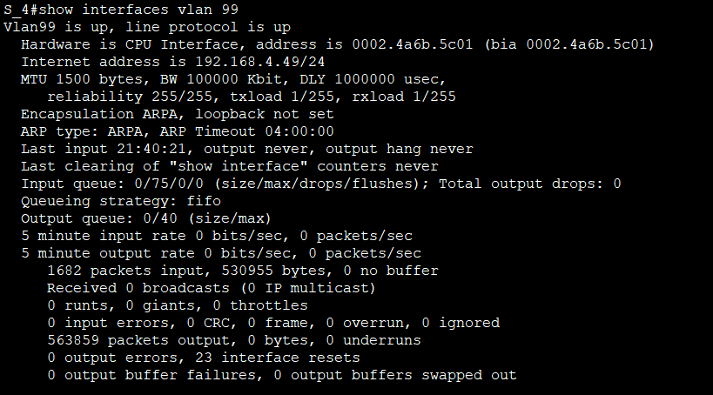

- Check and save the MAC addresses of cisco NIC from both PC.

FOR PC_41

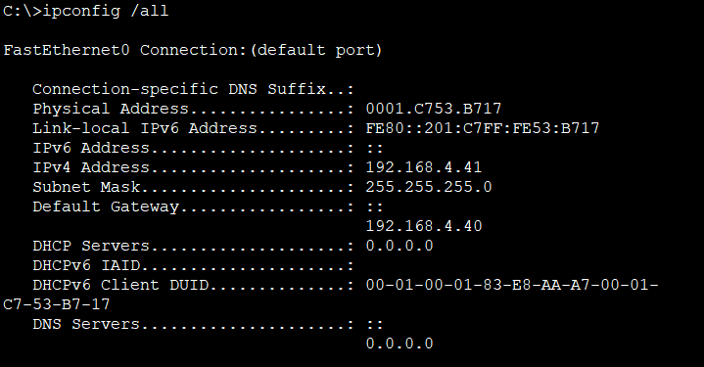

FOR PC_42

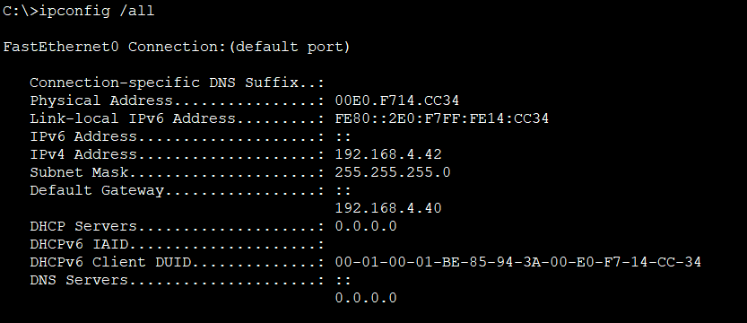

- Test the communication between the devices:

FROM PC_41 TO PC _42

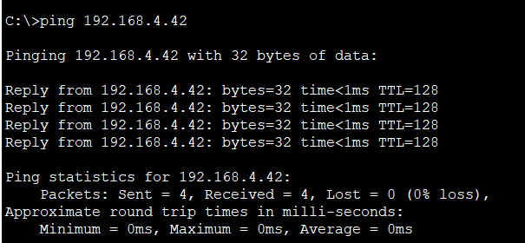

FROM PC_42 TO PC _41

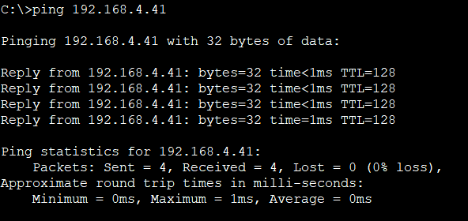

- Check communication between PC1 and PC2 and the switch

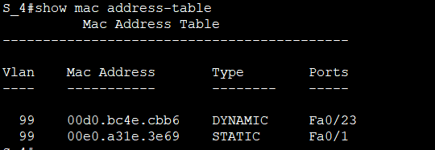

Is communication PC1 - switch possible? Why?

Is communication PC2 - switch possible? Why?

Both of communication is possible. Because they are connected on each other Fa.

- **Swap the computer cables** connected to switch.

- Check communication between PC1 and PC2 and the switch

There is no connection between switch and computers.

Did something change? There is no compatible among mac addresses and port numbers. They have to compatible because they are we changed as a static.

- Delete the static entry and check configuration

-Check communication between PC1, PC2 and switch.

They are connected each other because there is no static mac addresses. ( Wrong port numbers)

**Swap computer cables on the switch to correct ports.**

They are connected each other because there is no static mac addresses.

### Task 2 - Switch port configuration. Securing the switch ports.

-Check the configuration of PC1 port

Interface is enabled.

Check port MAC address. : 0001.c73e.2c97

Check the speed and duplex mode. : Full Duplex , 100Mb/s

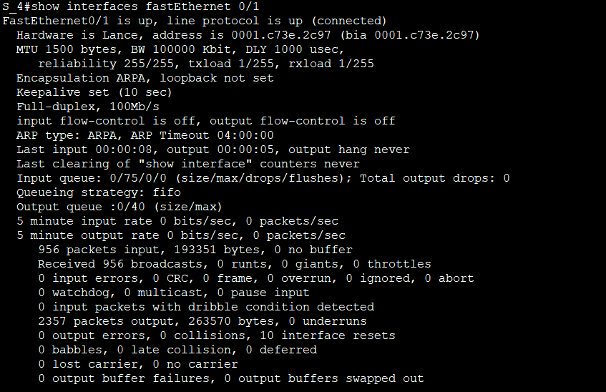

- Check the configuration.

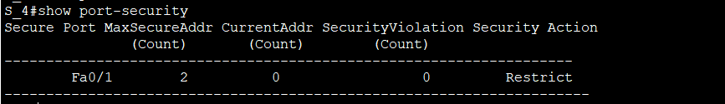

- Check if mac address of second device (computer/router) was memorized on the switch port.

Not memorized

- Connect PC2 to port Fa 0/1

Memorized.

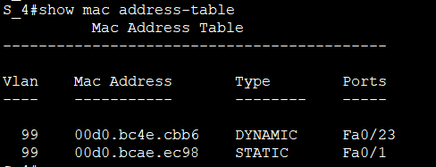

What happen after connection of second and third device to the Fa 0/1 port?

### Task 3 - Switch IPv6 configuration. SSH service configuration.

After this change reload the switch and proceed.

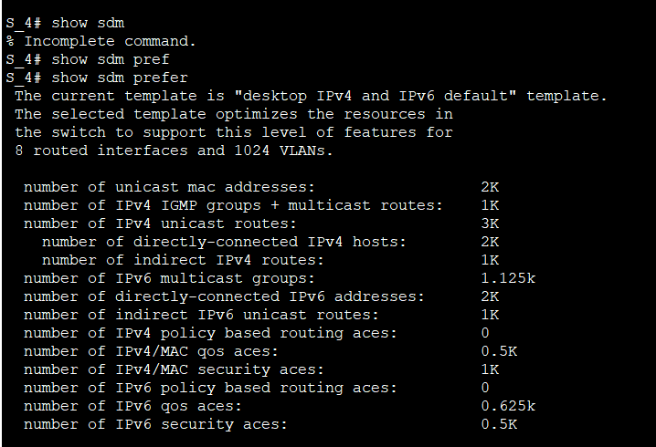

- Configure SSH server on the switch.

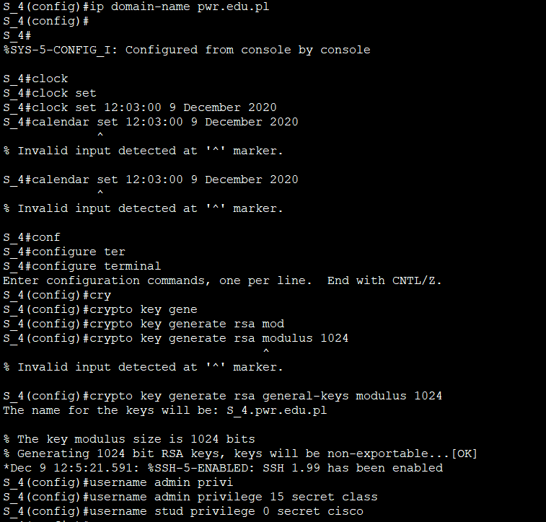

- test SSH connection to switch from the PCs.

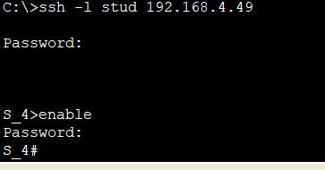

### Task 3 - Router and switch IP configuration. SSH service configuration.

- Check the ability to log on via the telnet service to the switch from PC computer. Try to connect via telnet to admin and stud account.

Note in notepad the difference between this two connections.

Stud account has no access to privileged mode but admin has.

What version of SSh is configured by default? Version 2.0

What is the maximum number of logon errors? 3  
What is the default idle time? 120secs

- Check if the new setting function correctly. Connect with putty SSH and wait 30 seconds

Test the SSH connection to switch. Use the Windows clock to calculate the elapsed time.  
Save in notepad the real exec time.

30secs

- Check if the new setting function correctly. Connect with putty SSH and wait about 30 seconds

Test the telnet and SSH connection to switch. Use the Windows clock to calculate the elapsed time.  
Save in notepad the real exec time for both connections.

Telnet : 20 secs

SSH : 15 secs

- Check if the new setting function correctly. Connect with putty SSH and wait about 60 seconds

Test the telnet and SSH connection to switch. Use the Windows clock to calculate the elapsed time.  
Save in notepad the real exec time for both connections.

Telnet : 30 secs

SSH : 30 secs