Command : docker build -t app-part1:v1 .
Description : Builds a Docker image using the Dockerfile in your current directory and assigns it the name app-part1 with the version tag v1.
Result :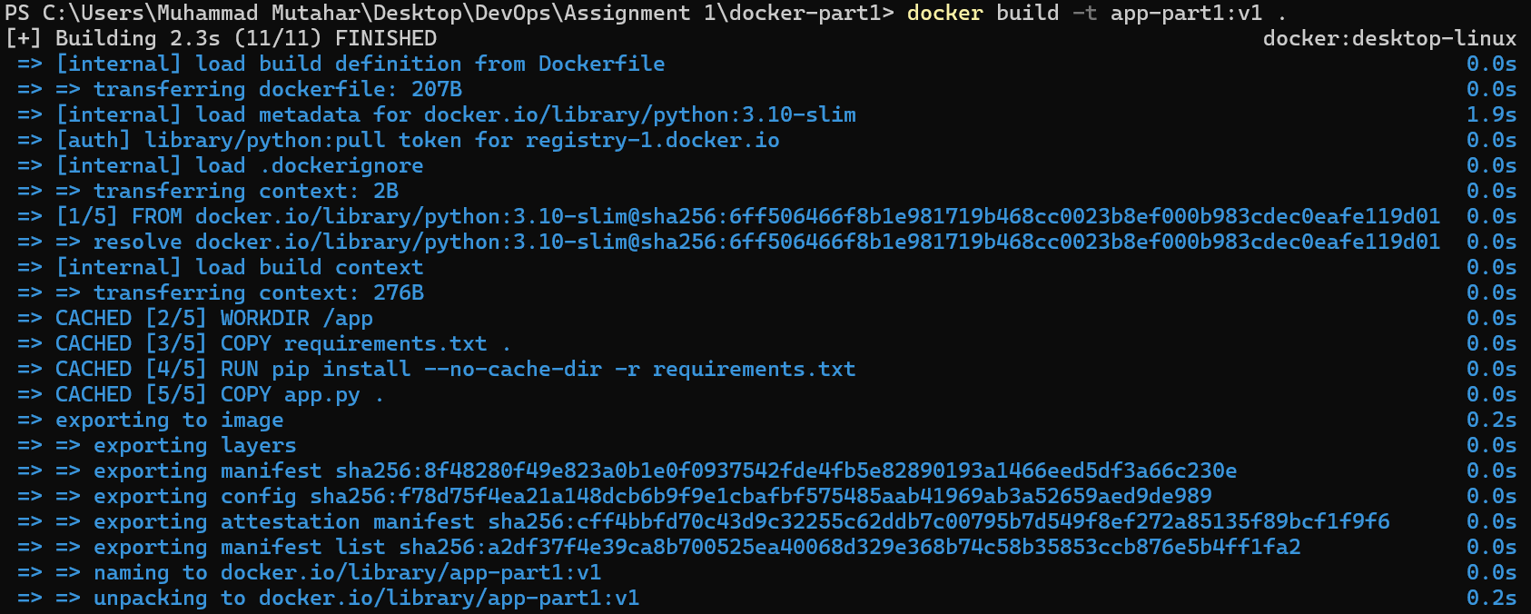

Command : docker run -d -p 5000:5000 --name test-app app-part1:v1
Description : Runs the app-part1:v1 image in the background as a container named test-app. Maps port 5000 of your computer to port 5000 inside the container for easy web access.
Result : ba427999b823c4165bf080b844db71446490fc6c00c164dece076414f461cae8

Command : docker tag app-part1:v1 mutahar938/app-part1:v1
docker push mutahar938/app-part1:v1
Description : Relabels your local image with your Docker Hub username (mutahar938) to prepare it for sharing. Uploads that tagged image to your online Docker Hub repository so it can be accessed from anywhere.
Result :
