1. Run the container
docker run -d -p 5000:5000 --name container-part2 mutahar938/app-part1:v1

# 2. List running containers
docker ps
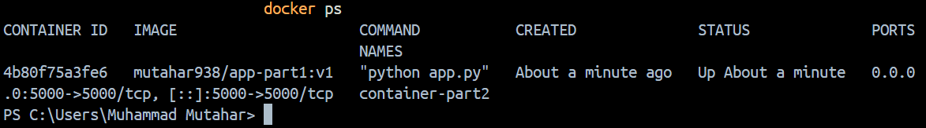

# 3. View container resource usage stats
docker stats --no-stream container-part2
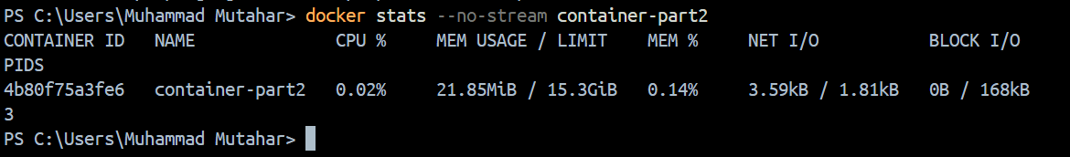

# 4. View processes inside container
docker top container-part2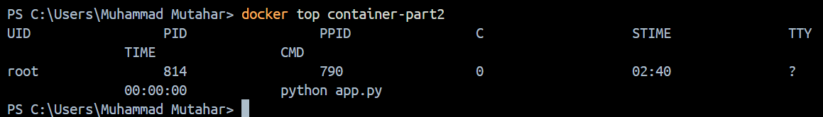

# 5. Display port mapping
docker port container-part2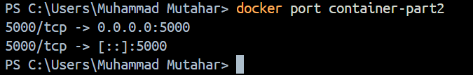

# 6. Execute command inside container
docker exec container-part2 ls -la /app
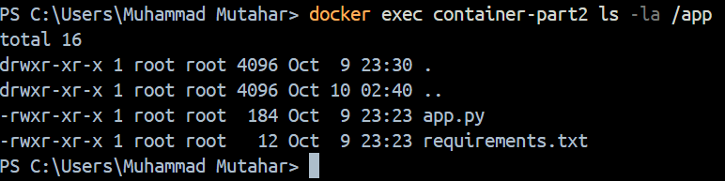

# 7. View container logs
docker logs container-part2
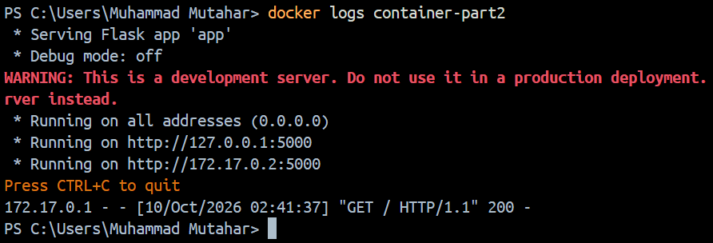
# 8. View full detailed specs
docker inspect container-part2
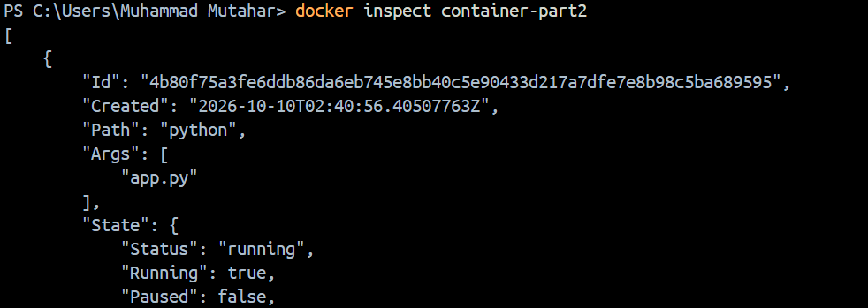
# 9. Copy file from container to host
docker cp container-part2:/app/app.py ./app_copy.py
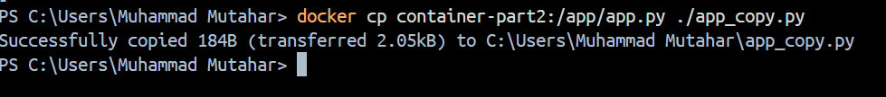

# 10. Copy file from host to container
docker cp ./app_copy.py container-part2:/app/app_backup.py

# 11. Rename container
docker rename container-part2 container-part2-renamed

# 12. Pause container
docker pause container-part2-renamed
# 13. Unpause container
docker unpause container-part2-renamed
# 14. Update container resource limits
docker update --memory "256m" container-part2-renamed

# 15. Commit container state to a new image
docker commit container-part2-renamed app-part2-modified:v1
# 16. Restart container
docker restart container-part2-renamed
# 17. Attach to container (Ctrl+C or disconnect to leave)
docker attach container-part2-renamed

# 18. Stop container
docker stop container-part2-renamed
# 19. Start container
docker start container-part2-renamed
# 20, 21. Stop wait and remove for container exit code
docker stop container-part2-renamed
docker wait container-part2-renamed
docker rm container-part2-renamed

