Create volume:
docker volume create my_volume

Run Nginx with volume mounted:
docker run -d -p 8080:80 --name nginx-container -v my_volume:/usr/share/nginx/html nginx
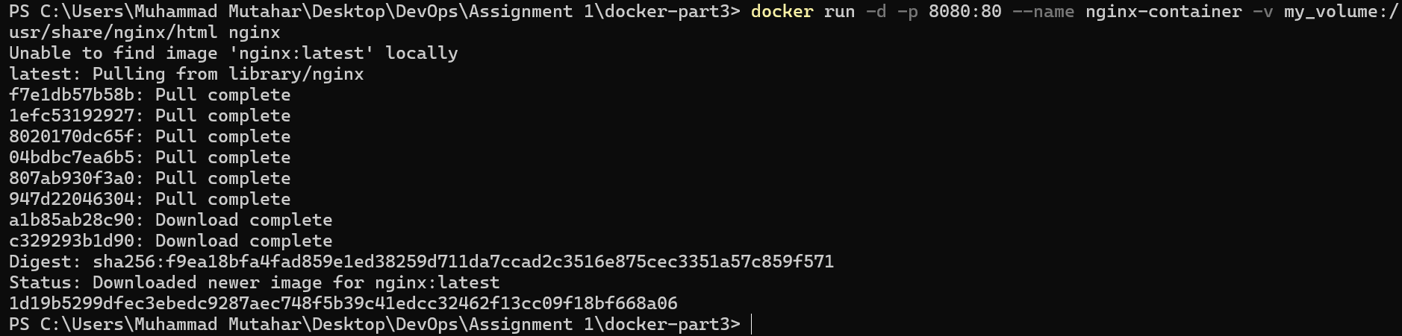

Verify host access: Open browser at http://localhost:8080 or run:
curl http://localhost:8080
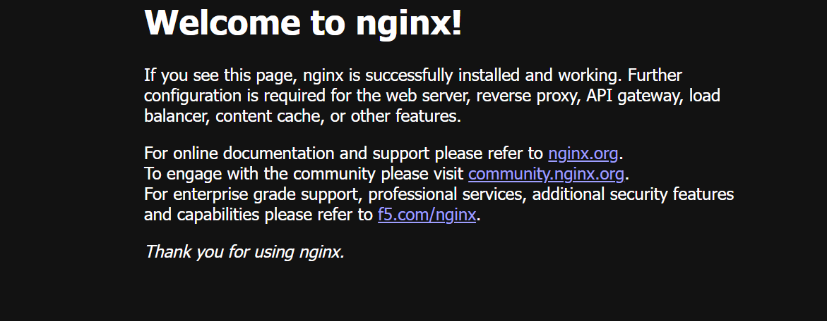

Create index.html on host:
echo "<h1>Hello from Docker Volume Index</h1>" > index.html

Copy index.html into volume via container:
docker cp index.html nginx-container:/usr/share/nginx/html/index.html

Verify modified page:
curl http://localhost:8080

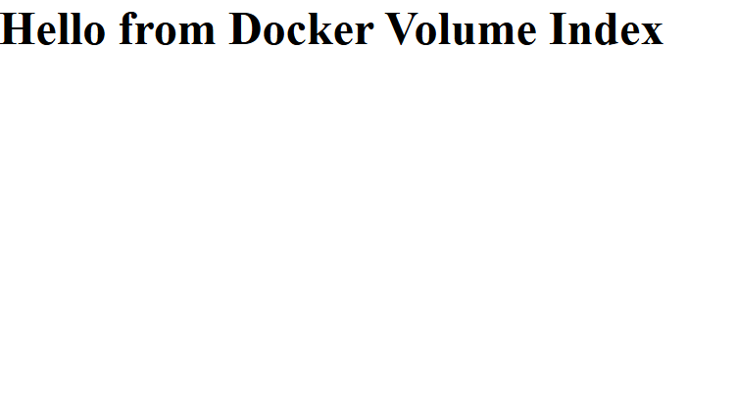
Stop and remove Nginx container:
docker stop nginx-container
docker rm nginx-container

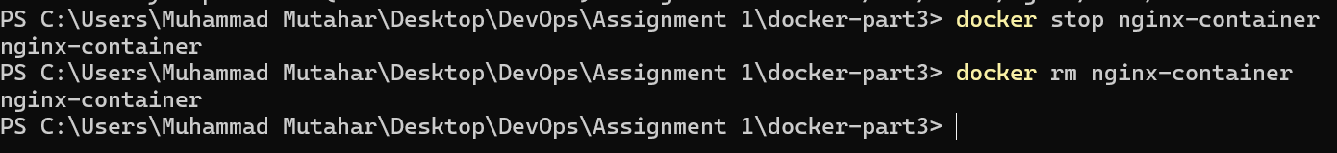
Run Apache (httpd) container mounting the same volume:
docker run -d -p 8081:80 --name apache-container -v my_volume:/usr/local/apache2/htdocs httpd
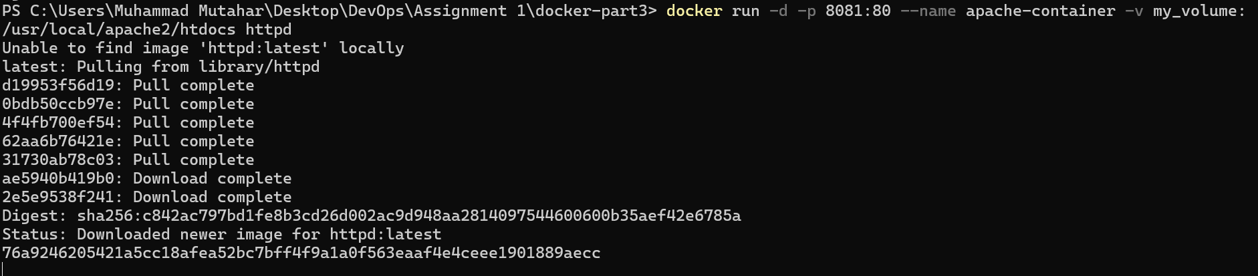

Verify default access on Apache:
curl http://localhost:8081

Create about.html on host:
echo "<h1>About Page stored in Docker Volume</h1>" > about.html

Copy about.html into volume:
docker cp about.html apache-container:/usr/local/apache2/htdocs/about.html

Verify about.html access:
curl http://localhost:8081/about.html


Stop and remove Apache container:
docker stop apache-container
docker rm apache-container
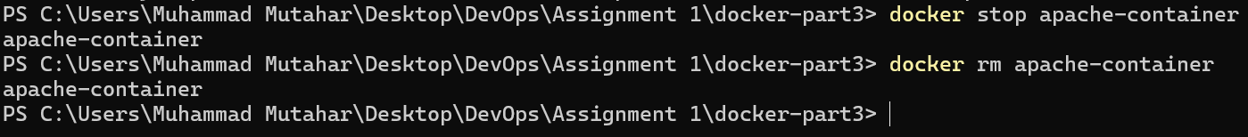

Verify volume files persistence: Run a temporary lightweight container to check volume contents:
docker run --rm -v my_volume:/data alpine ls -la /data

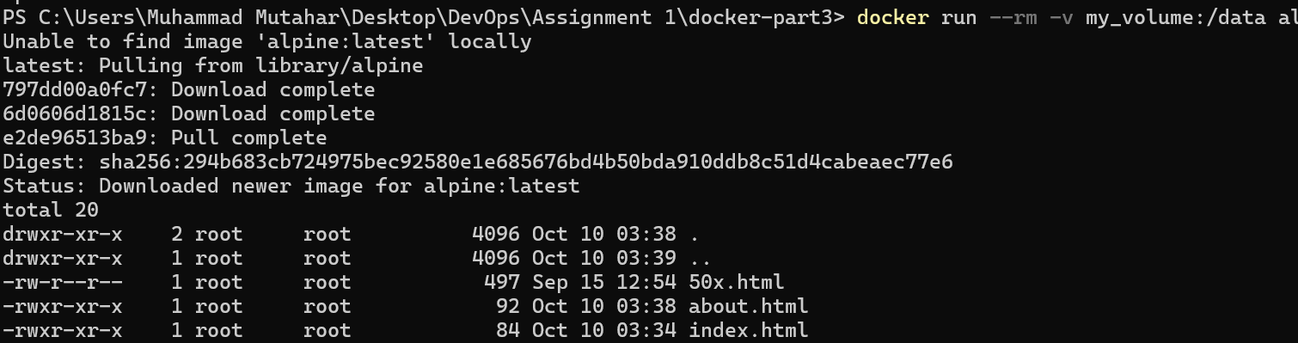
Cleanup volume:
docker volume rm my_volume

