2026 MUNICH TECH ARENA — TECHNICAL PROPOSAL
HELIX: Hybrid Ear Landmark Inference with eXplicit Shape Priors
Automatic Extraction of 85 Anatomical Landmarks of Pinna Shape from 3D Head Meshes
1 Basic Information
Team Name | 〈to be completed〉 | Contact Email | 〈to be completed〉
Challenge | Pinna landmark extraction (85 × 3 per ear, both ears) | Date | 29 July 2026

2 Core Idea and Innovation
We propose HELIX, a coarse-to-fine pipeline that treats the challenge as structured dense correspondence rather than 85 independent detections. The 85 targets are ordered samples of four anatomical contours, so the ground truth lies on a low-dimensional manifold: a PCA basis over the 255-dimensional landmark vector should explain more than 98 % of the variance in roughly 40 modes. Free coordinate regression discards that structure, which is why plain PointNet-style baselines plateau around 3–5 mm. HELIX instead predicts, for every surface point, an 85-channel heatmap and an offset vector; decodes each landmark by confidence-weighted voting after O’Sullivan and Zafeiriou [1]; emits a per-landmark aleatoric uncertainty σ̂k; and fuses the result with a statistical shape prior through a closed-form σ̂-weighted MAP fit. Confident landmarks are left untouched, while ambiguous ones — typically in the deep concha, which structured-light scanners shadow — are pulled back onto the anatomical manifold.
Five choices separate this from an off-the-shelf backbone:
1. Uncertainty-gated prior. The blending weight comes from predicted uncertainty rather than a fixed hyper-parameter. Because observation and prior are both Gaussian, the fit is a weighted linear least-squares problem with a closed-form solution — microseconds at inference, with no CPD/BCPD iteration to tune.
2. TPS shape-synthesis engine. Sampling the PCA basis and propagating the landmark displacement field to the mesh through a thin-plate spline [11] yields unlimited, exactly-labelled synthetic ears. This is the augmentation strategy behind the York Ear Model [5] and is the highest-leverage response to having only 400 real ears.
3. Optimise the actual metric. The coordinate loss is the challenge score itself — mean Euclidean norm, Huberised near zero — not MSE, whose squared penalty shifts the optimum toward outliers.
4. Contour-aware arc-length resampling. On smooth contours the tangential (along-curve) component dominates MD and is largely annotation-protocol mismatch, not perception error. Measuring the ground-truth spacing convention in Step 0 and resampling the predicted contour splines to match removes much of it at negligible cost.
5. Representation-diverse ensemble. Point, voxel and multi-view branches make decorrelated errors; averaging in landmark space is valid because all three outputs are already in correspondence.
3 Technical Solution
3.1 System Architecture
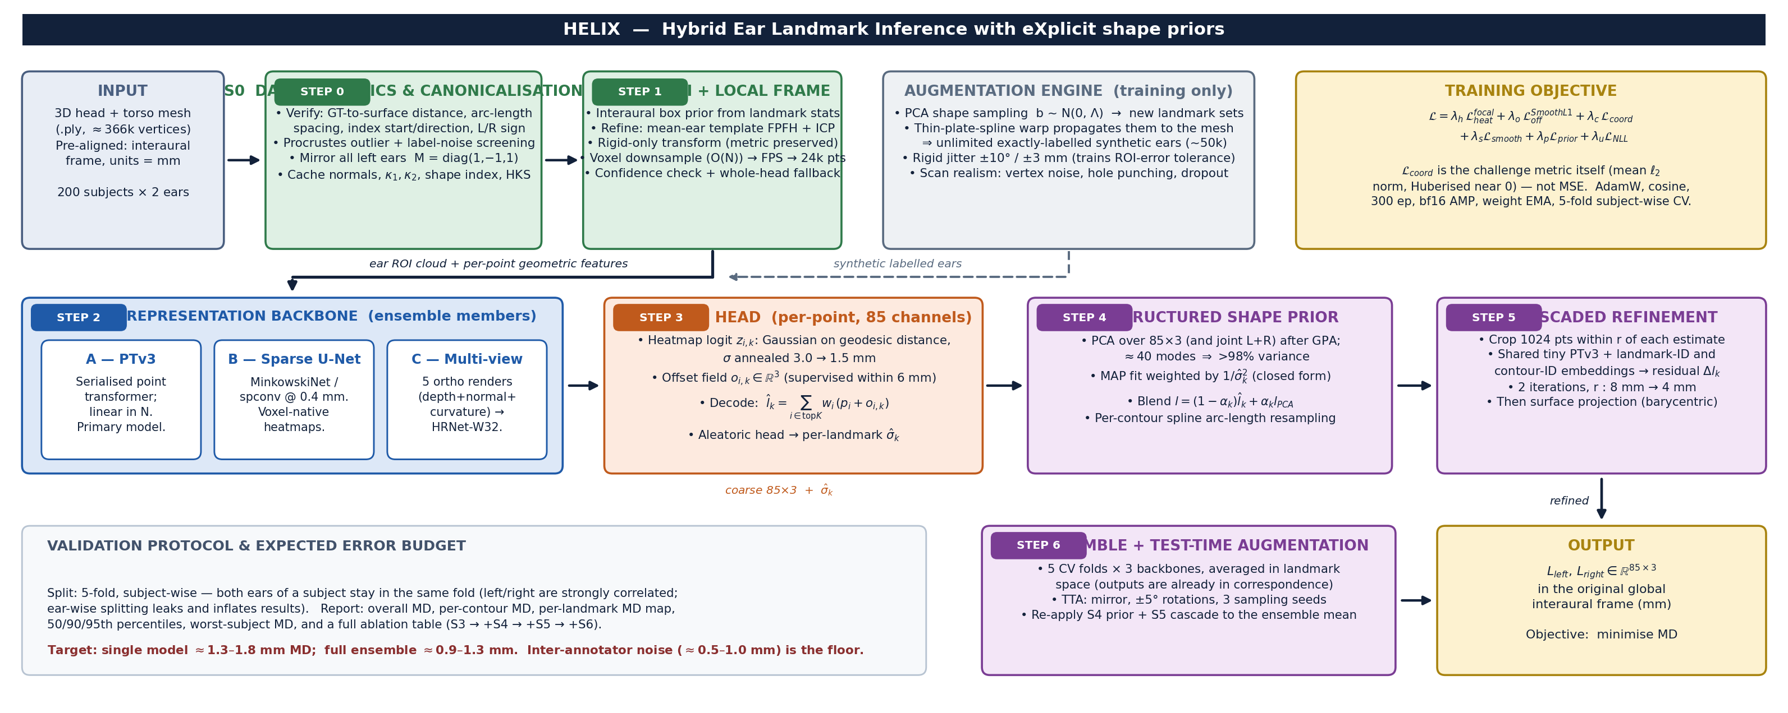
Figure 1 — End-to-end HELIX pipeline. Green = geometry preparation, blue = learned encoders, orange = prediction head, purple = structured post-processing.
Every stage is independently testable, and everything after Step 3 is a strict post-process, so the system degrades gracefully: if the shape prior or the cascade fail to earn their keep on validation, they are switched off without retraining the backbone. Step 0 is budgeted as heavily as the network itself. The largest single risk here is not architectural but a silent convention mismatch — mirror sign, contour start index, traversal direction, or whether the annotations lie exactly on the surface. In our reading of the sample, landmarks sit between vertices (mean nearest-vertex distance ≈ 0.25 mm on a ≈ 366 k-vertex mesh), which is consistent with lying on the surface but off-vertex; that must be confirmed by point-to-triangle distance before surface projection is trusted. Each of those checks is worth more than any backbone choice.
3.2 Implementation Plan
# | Stage | Method, algorithms and tooling | Output / acceptance test
0 | Data forensics & canonicalisation (Wk 1) | trimesh / Open3D. Measure point-to-triangle (not point-to-vertex) distance of every GT landmark; arc-length spacing per contour; L/R sign convention; per-ear Procrustes residual to flag reversed or mislabelled sequences. Mirror left ears with M = diag(1, −1, 1). Cache normals, curvatures, shape index and heat-kernel signatures. | QC report + 400 canonicalised ROIs; assertions pass, 20 random overlays checked visually.
1 | Ear ROI & local frame (Wk 1–2) | Interaural box prior from landmark statistics, refined by FPFH + RANSAC and point-to-plane ICP of a mean-ear template. Rigid only, so metric scale survives. O(N) voxel downsample → FPS → 24 k points (never FPS on 366 k). Whole-head fallback when ICP fitness is low. | 100 % ROI recall on train + val; median ROI-centroid error < 3 mm.
2 | Backbone (Wk 2–4) | (A) Point Transformer v3 [2] as primary — serialised attention, linear in N, proven on small medical-mesh sets at MICCAI 2024 [3]. (B) Sparse 3D U-Net (MinkowskiEngine / spconv) at 0.4 mm voxels. (C) Five orthographic depth + normal + curvature renders → HRNet-W32 [8], the configuration Mesh2PPM validated on pinnae [6]. PyTorch 2.x, PyTorch3D. | Three trained members, each below 1.8 mm MD standalone.
3 | Voting head (Wk 3–4) | Per-point 85-channel heatmap on a geodesic Gaussian, σ annealed 3.0 → 1.5 mm, plus an 85 × 3 offset field supervised within 6 mm. Decode by top-K (K = 64) softmax voting [9]. Aleatoric head trained with Gaussian NLL [10]. | Calibrated σ̂ₖ (reliability diagram within 10 %).
4 | Shape prior & contour regularisation (Wk 5) | Generalised Procrustes alignment, then PCA per ear and jointly over the L+R pair. Closed-form σ̂-weighted MAP fit with Tikhonov damping. Per-contour cubic smoothing spline resampled to the Step-0 spacing convention; monotone ordering repair. | ≥ 10 % MD reduction, no regression on high-confidence points.
5 | Cascaded refinement (Wk 5–6) | Shared tiny-PTv3 over 1024-point local crops, conditioned on landmark-ID and contour-ID embeddings; two residual passes at r = 8 mm then 4 mm, after D-CPT’s RefineNet [4]. Barycentric surface projection only if Step 0 confirms GT lies on the surface. | Further ≥ 10 % MD reduction; every point on the mesh.
6 | Ensemble, TTA & packaging (Wk 6–8) | 5 folds × 3 backbones; TTA over mirroring, ±5° rotations and 3 sampling seeds; average in landmark space, then re-apply Steps 4–5. Export TorchScript + a one-command CLI: .ply in, two 85 × 3 CSVs out. | Reproducible submission with documented runtime and VRAM.

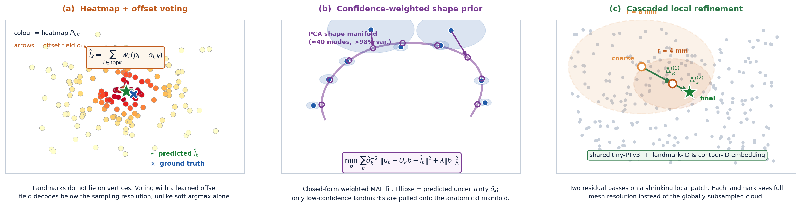
Figure 2 — The three components that carry most of the accuracy gain over a plain regression baseline.
Training. AdamW (backbone 3×10⁻⁴, heads 1×10⁻³), cosine schedule with 5-epoch warm-up, 300 epochs, batch 8, bf16 mixed precision, gradient clipping at 1.0 and an EMA of the weights. Augmentation: mirroring; ±10° / ±3 mm rigid jitter of the ROI frame — this is what makes Step 2 tolerant of Step 1 errors; ±5 % scale with matching label rescaling; TPS shape synthesis; vertex noise (σ = 0.15 mm); random hole punching and point dropout to imitate concha shadowing. Validation is 5-fold and subject-wise — both ears of a subject stay in the same fold, because left and right are strongly correlated and ear-wise splitting leaks and inflates the score. We report overall MD, per-contour MD, a per-landmark MD map, the 50/90/95th percentiles, the worst-subject MD, and a full ablation (S3 → +S4 → +S5 → +S6). A single RTX 4090 or A100 (24–40 GB) suffices at roughly 10–16 h per model. Expected: ≈1.3–1.8 mm for a single model and ≈0.9–1.3 mm ensembled, against an inter-annotator floor we estimate at 0.5–1.0 mm.
4 Risks and Challenges
Risk | Sev. | Mitigation and fallback
Only 200 subjects / 400 ears — heavy overfitting risk | High | TPS + PCA synthetic augmentation, mirroring, subject-wise CV, weight EMA, strong regularisation and a three-member ensemble. This is the risk every competing team shares; augmentation quality is where the challenge is actually won.
Silent convention mismatch (mirror sign, contour start index, traversal direction, surface adherence) | High | Step 0 is a dedicated, budgeted phase with explicit assertions and visual overlays. Every convention is measured from the data, never assumed. Cheap to check, catastrophic and invisible if wrong.
ROI / ear-detection failure on hair, occlusion or atypical anatomy | High | Box prior + template ICP with a fitness gate; the backbone is trained under ±10° / ±3 mm crop jitter so it tolerates a poor crop; whole-head fallback pass when the gate trips.
Scanner holes and noise in the deep concha — 30 of the 85 points sit there | Med–High | Screened-Poisson hole filling; hole and dropout augmentation; the uncertainty-weighted prior fills shadowed regions from anatomy rather than guessing; per-contour loss weighting.
Tangential ambiguity along smooth contours; annotation noise and inconsistent sequences | Medium | Arc-length resampling to the measured protocol plus an auxiliary head predicting the along-contour parameter; Procrustes-based outlier screening; heatmap label smoothing; Huberised ℓ₂ coordinate loss.
NDA and full-dataset access delay | Medium | Build and unit-test the entire pipeline on the provided sample plus public ear data (York Ear Model [5], SYMARE, HUTUBS, AudioEar [7]) with synthetic labels, so real data can be swapped in on day one of access.
Compute: 200 meshes at ≈366 k vertices each | Low–Med | Preprocess once and cache ROI clouds as .npz; O(N) voxel downsampling before any FPS; 24 k points is ample once the ROI is cropped.
5 Other Notes and Questions for the Organisers
Assumptions. Test meshes are delivered pre-aligned in the same interaural frame, in millimetres, with the same cleaning and hole-filling as the training set; MD is computed on raw submitted coordinates with no per-landmark weighting.
1. Do the ground-truth landmarks lie exactly on the mesh surface? This determines whether barycentric surface projection is a free accuracy gain or a source of systematic bias.
2. What is the inter- and intra-annotator variability in millimetres? It sets the achievable floor and tells us how much residual error is worth chasing.
3. Along each contour, are points spaced uniformly in arc length or anchored to semantic features? Which anatomical end is index 0, and is the traversal direction identical for left and right ears?
4. Is the held-out test set drawn from the same 200 subjects and the same EinScan Pro 2X protocol, or does it include a different scanner, preprocessing or demographic?
5. Is external data permitted, including publicly released pre-trained ear models such as the York Ear Model?
6. Are there inference runtime, memory or model-size limits, and is test-time ensembling allowed?
7. Are subject demographics (age, sex, ancestry) available, so we can stratify cross-validation and report bias across groups?
6 References
[1] O’Sullivan, E. & Zafeiriou, S. 3D Landmark Localization in Point Clouds for the Human Ear. IEEE FG 2020, 402–406. ieeexplore.ieee.org/document/9320194
[2] Wu, X. et al. Point Transformer V3: Simpler, Faster, Stronger. CVPR 2024. arXiv:2312.10035
[3] Kubík, T. et al. Leveraging Point Transformers for Detecting Anatomical Landmarks in Digital Dentistry. MICCAI 2024 Challenges, LNCS 15571, Springer 2025. arXiv:2504.11418
[4] Zhang, F. et al. 3D Landmark Detection on Human Point Clouds: A Benchmark and a Dual Cascade Point Transformer Framework (D-CPT). Expert Systems with Applications, 2025. arXiv:2401.07251
[5] Dai, H., Pears, N. & Smith, W. A Data-Augmented 3D Morphable Model of the Ear. IEEE FG 2018, 404–408; extended as Augmenting a 3D Morphable Model of the Human Head with High Resolution Ears, Pattern Recognition Letters 128, 2019. doi:10.1016/j.patrec.2019.09.026
[6] Pausch, F., Perfler, F., Holighaus, N. & Majdak, P. Prediction of Parameters of a Pinna Model from Synthetic Geometries Using a Vision Transformer (Mesh2PPM). J. Acoust. Soc. Am. 159(6), 5578–5598, 2026. doi:10.1121/10.0043919
[7] Perfler, F. et al. Parametric Model of the Human Pinna Based on Bézier Curves and Concave Deformations (BezierPPM). Computers in Biology and Medicine 188, 2025. doi:10.1016/j.compbiomed.2025.109817
[8] Sun, K. et al. Deep High-Resolution Representation Learning for Human Pose Estimation (HRNet). CVPR 2019. arXiv:1902.09212
[9] Sun, X. et al. Integral Human Pose Regression (soft-argmax). ECCV 2018. arXiv:1711.08229
[10] Kendall, A. & Gal, Y. What Uncertainties Do We Need in Bayesian Deep Learning for Computer Vision? NeurIPS 2017. arXiv:1703.04977
[11] Bookstein, F. L. Principal Warps: Thin-Plate Splines and the Decomposition of Deformations. IEEE TPAMI 11(6), 567–585, 1989.
[12] Cootes, T. F. et al. Active Shape Models — Their Training and Application. CVIU 61(1), 38–59, 1995.
[13] Choy, C., Gwak, J. & Savarese, S. 4D Spatio-Temporal ConvNets: Minkowski Convolutional Neural Networks. CVPR 2019. arXiv:1904.08755
[14] Engel, I. et al. The SONICOM HRTF Dataset. J. Audio Eng. Soc. 71(5), 2023.

