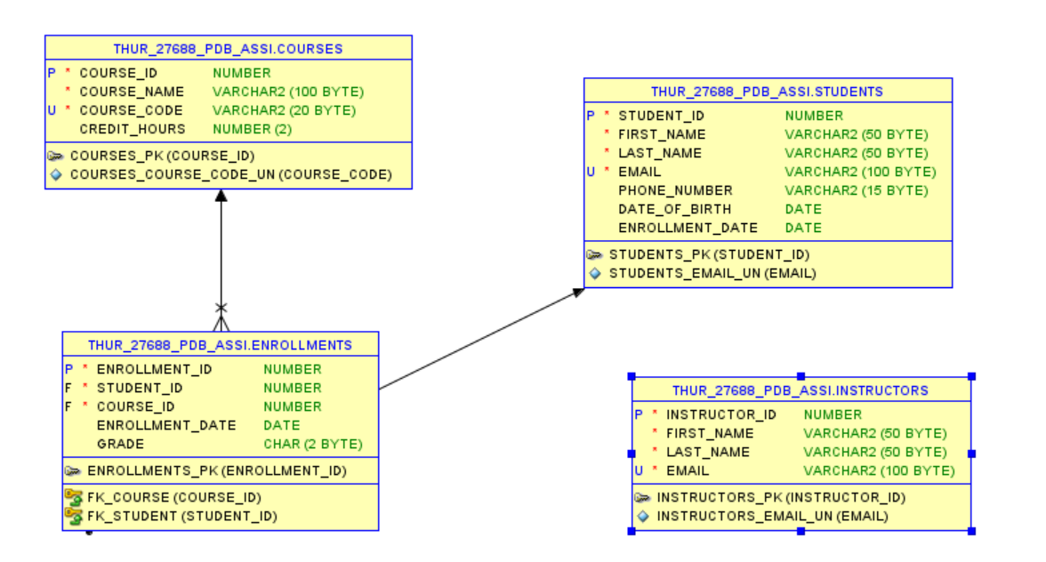

CREATE TABLE students (

student_id NUMBER PRIMARY KEY,

first_name VARCHAR2(50) NOT NULL,

last_name VARCHAR2(50) NOT NULL,

email VARCHAR2(100) UNIQUE NOT NULL,

phone_number VARCHAR2(15),

date_of_birth DATE,

enrollment_date DATE DEFAULT SYSDATE

);

CREATE TABLE courses (

course_id NUMBER PRIMARY KEY,

course_name VARCHAR2(100) NOT NULL,

course_code VARCHAR2(20) UNIQUE NOT NULL,

credit_hours NUMBER(2) CHECK (credit_hours BETWEEN 1 AND 6)

);

CREATE TABLE instructors (

instructor_id NUMBER PRIMARY KEY,

first_name VARCHAR2(50) NOT NULL,

last_name VARCHAR2(50) NOT NULL,

email VARCHAR2(100) UNIQUE NOT NULL

);

CREATE TABLE enrollments (

enrollment_id NUMBER PRIMARY KEY,

student_id NUMBER NOT NULL,

course_id NUMBER NOT NULL,

enrollment_date DATE DEFAULT SYSDATE,

grade CHAR(2), -- Example: A, B, C, D, F

CONSTRAINT fk_student FOREIGN KEY (student_id) REFERENCES students(student_id) ON DELETE CASCADE,

CONSTRAINT fk_course FOREIGN KEY (course_id) REFERENCES courses(course_id) ON DELETE CASCADE

);

INSERT INTO Students (Student_ID, First_Name, Last_Name, Email, Phone_Number, Date_of_Birth, Enrollment_Date)

VALUES (1, 'John', 'Doe', 'john.doe@example.com', '1234567890', TO_DATE('2000-05-15', 'YYYY-MM-DD'), SYSDATE);

INSERT INTO Courses (Course_ID, Course_Name, Course_Code, Credit_Hours)

VALUES (101, 'Database Systems', 'DB101', 3);

INSERT INTO Enrollments (Enrollment_ID, Student_ID, Course_ID, Enrollment_Date, Grade)

VALUES (1001, 1, 101, SYSDATE, 'A');

INSERT INTO Instructors (Instructor_ID, First_Name, Last_Name, Email)

VALUES (201, 'Dr. Smith', 'Anderson', 'smith.anderson@example.com');

UPDATE Students

SET Phone_Number = '9876543210'

WHERE Student_ID = 1;

DELETE FROM Enrollments

WHERE Enrollment_ID = 1001;

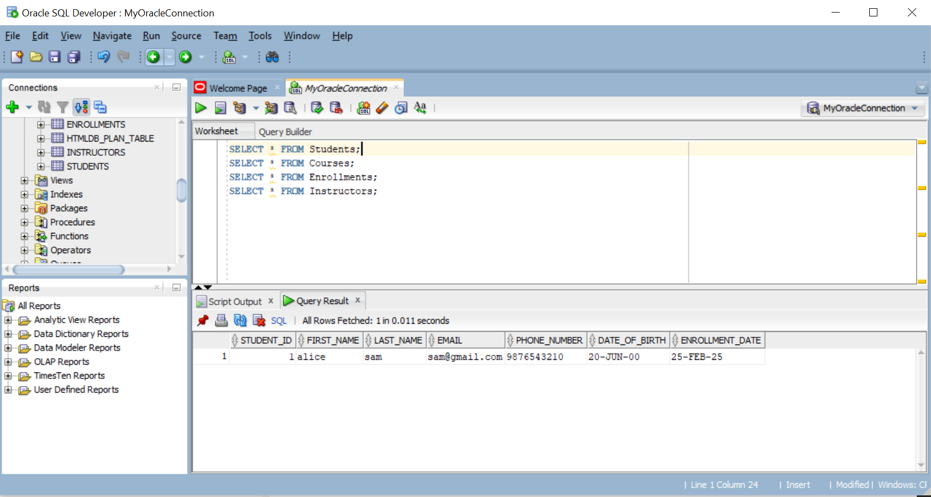

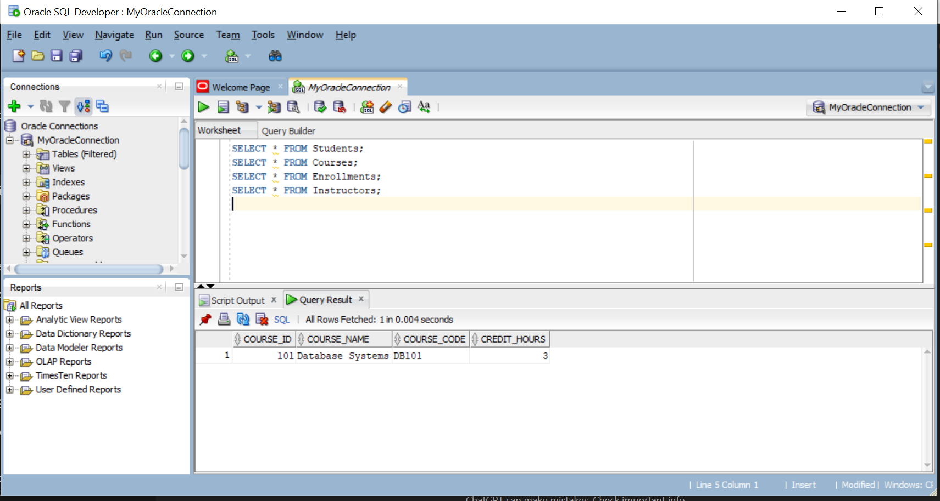

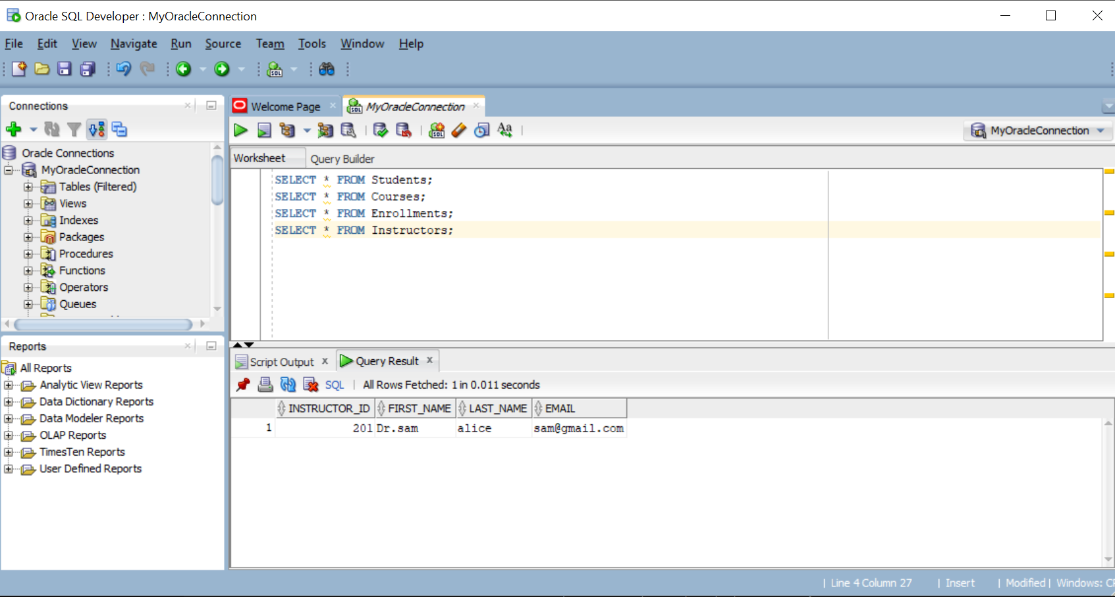

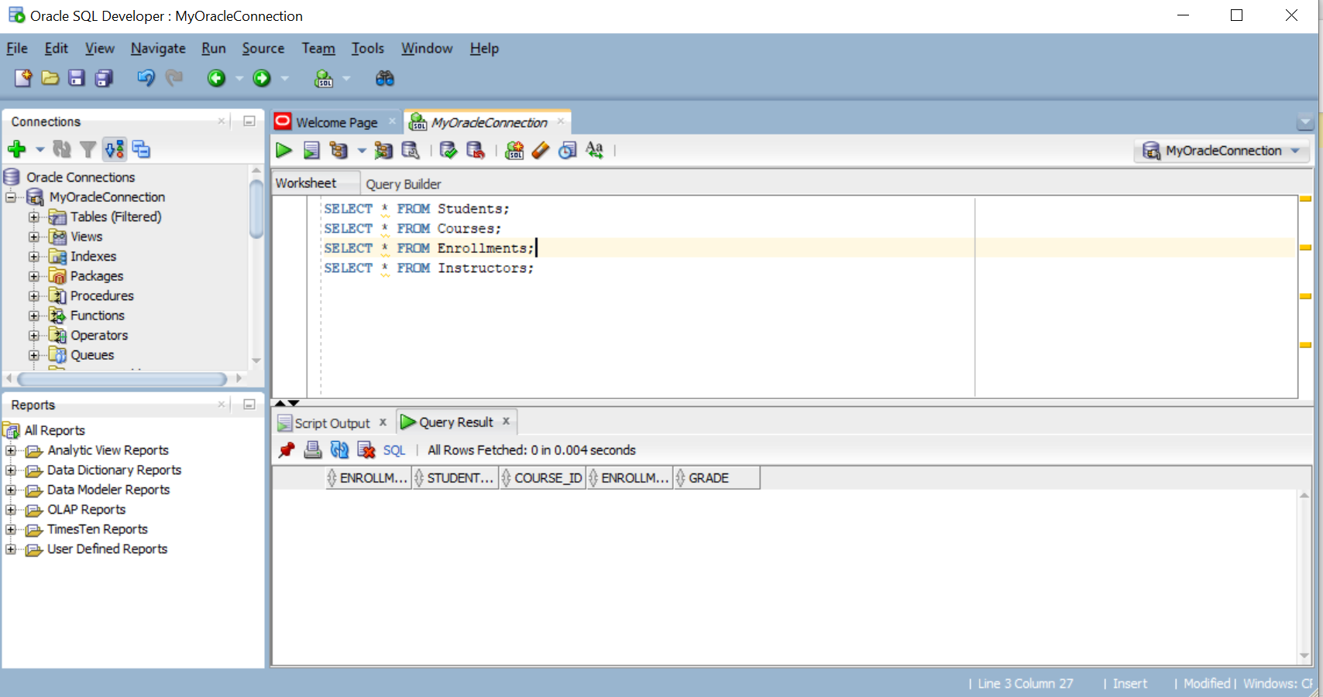

SELECT s.Student_ID, s.First_Name, s.Last_Name, c.Course_Name, e.Grade

FROM Students s

LEFT JOIN Enrollments e ON s.Student_ID = e.Student_ID

LEFT JOIN Courses c ON e.Course_ID = c.Course_ID;

SELECT s.Student_ID, s.First_Name, s.Last_Name, c.Course_Name, e.Grade

FROM Students s

LEFT JOIN Enrollments e ON s.Student_ID = e.Student_ID

LEFT JOIN Courses c ON e.Course_ID = c.Course_ID;

SELECT Student_ID, COUNT(Course_ID) AS Course_Count

FROM Enrollments

GROUP BY Student_ID

HAVING COUNT(Course_ID) > 1;

SELECT s.Student_ID, s.First_Name, s.Last_Name

FROM Students s

WHERE NOT EXISTS (

SELECT 1 FROM Enrollments e WHERE e.Student_ID = s.Student_ID

);

SELECT * FROM Students

WHERE Enrollment_Date >= SYSDATE - 7;

SELECT * FROM Enrollments

WHERE Enrollment_Date >= SYSDATE - 7;

SELECT * FROM (

SELECT s.Student_ID, s.First_Name, s.Last_Name, e.Grade

FROM Students s

JOIN Enrollments e ON s.Student_ID = e.Student_ID

ORDER BY e.Grade DESC

)

WHERE ROWNUM <= 5;

SELECT Student_ID, COUNT(Course_ID) AS Enrollment_Count

FROM Enrollments

GROUP BY Student_ID

HAVING COUNT(Course_ID) > 3;

INSERT INTO Enrollments (Enrollment_ID, Student_ID, Course_ID, Enrollment_Date, Grade)

VALUES (1002, 1, 101, SYSDATE, 'B');

COMMIT;

DELETE FROM Enrollments WHERE Enrollment_ID = 1002;

ROLLBACK; -- This will undo the DELETE if you haven't committed