**1.Compare Values with Previous or Next Records**

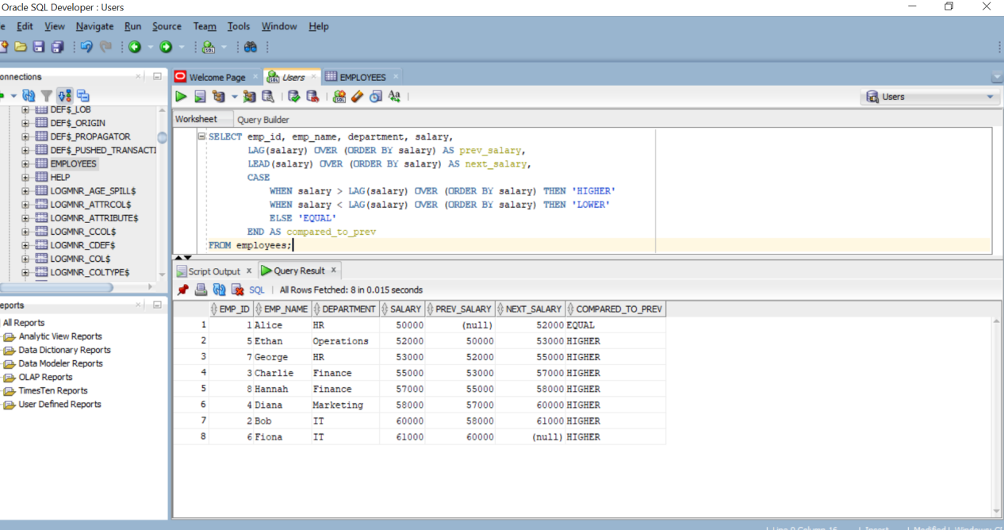

**2.Ranking Data within a Category**

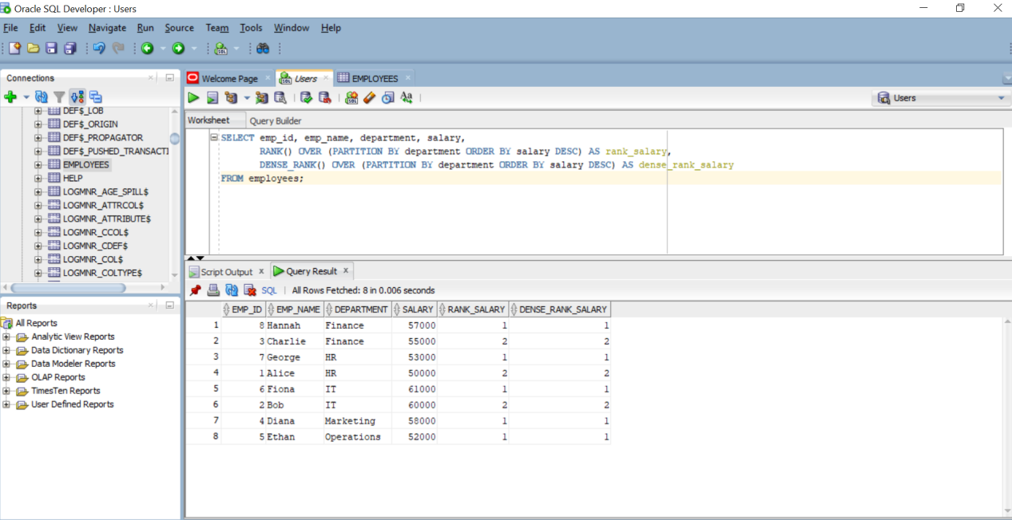

1. **Identifying Top Records**

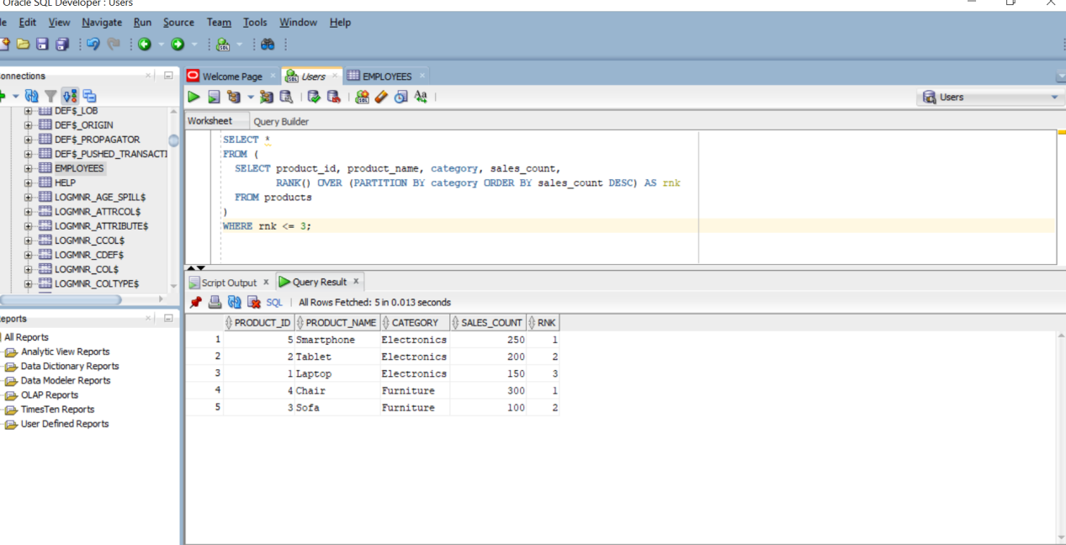

**4. Finding the Earliest Records**

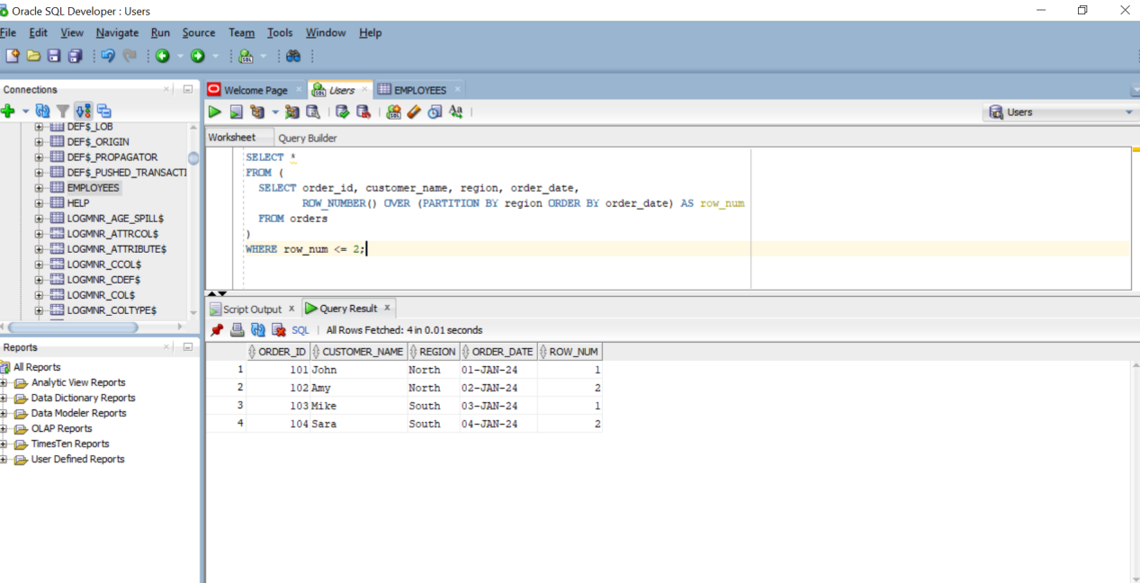

**5. Aggregation with Window Functions**

