

**NAME:** Joseph MUTANGANA

**STUDENT ID:** 29061

**COURSE NAME:** Computer Networks

**INSTRUCTOR NAME:** Joshua IRADUKUNDA

**ASSIGNMENT TITLE:** Assignment#1

**DATE:** Oct-12-2025

**DHCP CONFIGURATION LAB**

**HANDS-ON LAB**



**Prepared by: Joseph MUTANGANA**

**IN CISCO PACKET TRACER**

**Table of Contents**

1. Introduction 1

2. Network Topology Design 1

3. IP Addressing Scheme and DHCP configuration 2

4. Verifying DHCP Configuration on Router 3

5. Encountered Challenges 5

Summary 6

# 1. Introduction

In this topology, the Dynamic Host Configuration Protocol (DHCP) was implemented to automate the assignment of IP addresses to end devices across all subnets in both the Masoro and Gishushu LANs. Instead of manually configuring IP settings for each host, DHCP allows the routers to dynamically distribute network parameters such as IP addresses, subnet masks, default gateways, and DNS servers to client machines automatically.

# 2. Network Topology Design

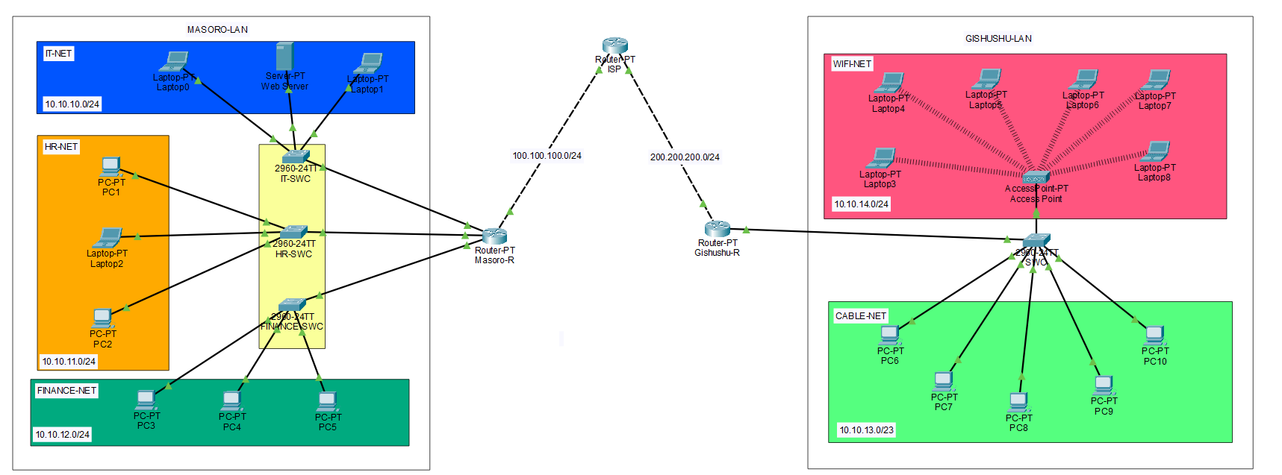

**Routers:** Used to make connect network and Acts as DHCP server

**Switch:** Connects multiple end devices

**End Devices (Server, PCs/Laptops):** Clients used in topology

# 3. IP Addressing Scheme and DHCP configuration

**Step 1:** Opened Router in Packet Tracer -> Opened CLI tab

**Step 2:** Enter Configuration global mode



**Step 3:** Excluded IP address



I only had one Static IP address on server, this command ensures that this IP address exclude from DHCP pool

**Step 4:** Create DHCP Pool

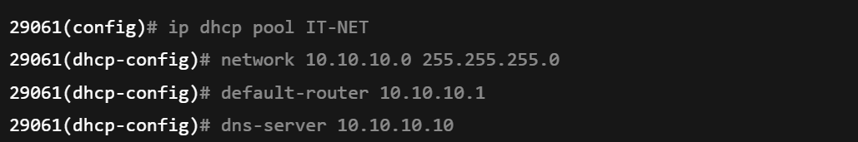

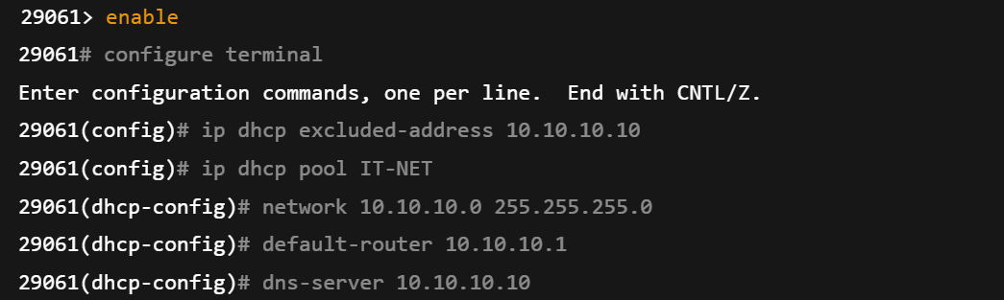

**Explanation of commands**

**enable:** this enable enter EXEC mode.

**configure terminal:** Enter global mode.

**ip dhcp excluded-address 10.10.10.10:** This tells dhcp pool to exclude that ip address.

**ip dhcp pool IT-NET:** This name of subnet you want pool address too.

**network:** Shows range of network and specify subnet mask

**default-router**: shows the gateway clients will use

**dns-server**: Sets domain name server

**Step 5:** Configure router interface

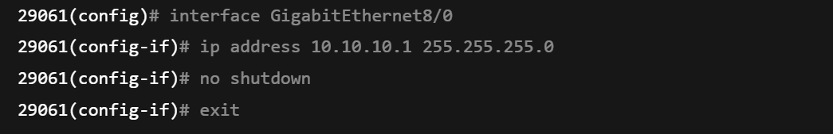

**Verification by using the command prompt**

**Step 1:** Open laptop device

**Step 2:** Navigate to Desktop tab

**Step 3:** Select command prompt

**Step 4:** type ipconfig or ipconfig /all

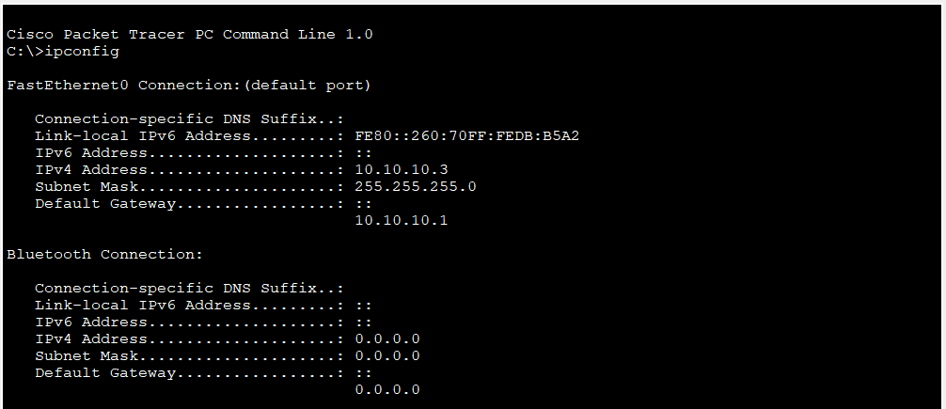

# 4. Verifying DHCP Configuration on Router

Use the following commands commands

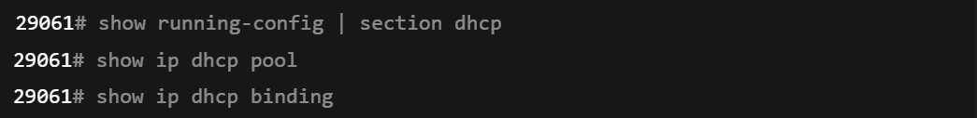

**Explanation of used command**

**Show running-conf | section dhcp:**  Shows current configurations

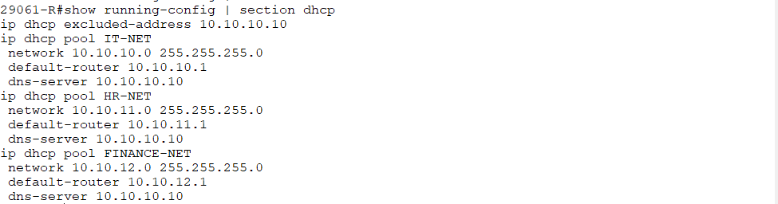

**Show ip dhcp pool:** Displays **details for each DHCP pool**

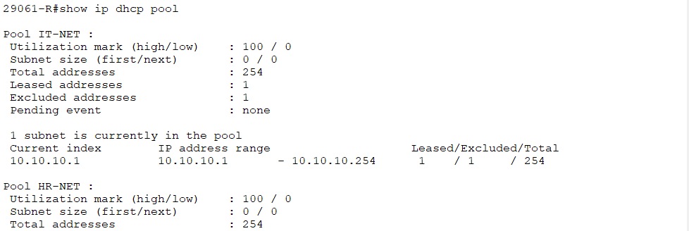

**show ip binding:** Shows a list of **IP addresses leased to clients**

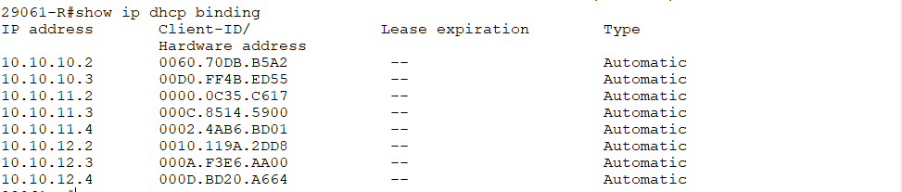

**On Clients laptops to get IP address Dynamically**

**Step 1: Open laptop device**

**Step 2:** Navigate to Desktop tab

**Step 3:** Select IP configuration

**Step 4:** Select DHCP

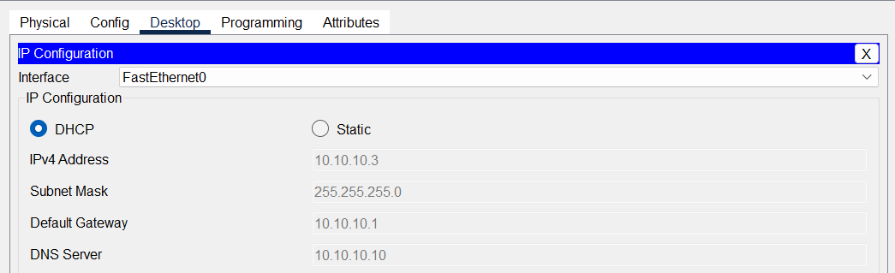

# 5. Encountered Challenges

In the **Gishushu LAN**, I initially struggled with assigning IP addresses to **WIFI-NET (10.10.14.0/24)** and **CABLE-NET (10.10.13.0/24)** because both networks were connected to the **same switch**, which in turn had only **one physical link to the router**. At first, I tried assigning only one IP address to the router port, but this did not allow both networks to communicate properly.

Later, I discovered the concept of **Router-on-a-Stick**, which allows a single physical router port to handle multiple IP subnets by creating **sub-interfaces**, each assigned to a specific VLAN. I configured the switch port connecting to the router in **trunk mode**, enabling it to carry traffic for multiple VLANs simultaneously. I then applied **NAT** on these sub-interfaces to allow the devices in both VLANs to access external networks.

Using this method, a single router port was able to serve multiple IP flows corresponding to their respective VLANs, resolving the connectivity issue and reinforcing my understanding of **inter-VLAN routing** and VLAN tagging.

**I corrected by following these steps**

**Step 1:** Configure sub-Interface

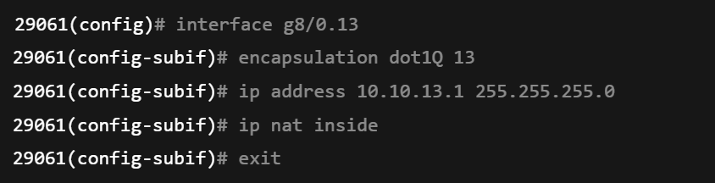

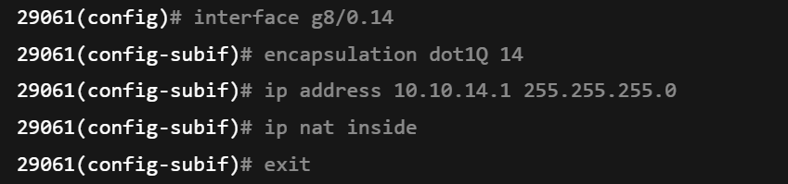

**Explanation of used Commands**

**Interface g8/0.13:** creates a sub-interface .13 on physical interface g8/0

**Interface g8/0.14:** creates a sub-interface .14 on physical interface g8/0

**encapsulation dot1Q:**  Assigns VLA 13 to this sub-interface using 802.1Q trunking.

**Ip address 10.**10.13.1 255.255.255.0: Assigns IP address for CABLE-NET (VLAN 13)

**Ip nat inside:** Marks sub-interface as inside for NAT

**exit:** Exit from sub-interface

**Step 2:** Switch port Trunking

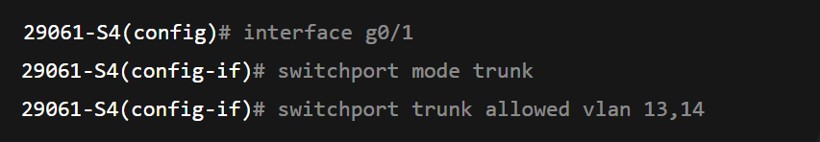

**Explanation of used commands**

**Interface g0/1:** entering the port connected to router

**switchport mode trunk**: Configure the switch port connectivity to router as trunk.

**switchport trunk allowed vlan 13,14:** Restrict the trunk to only VLAN 13 and VLAN 14

# Summary

During the activity, the following tasks were successfully completed:

1. **IP Addressing & Subnetting**:
   1. Masoro LAN: IT-NET (10.10.10.0/24), HR-NET (10.10.11.0/24), FINANCE-NET (10.10.12.0/24)
   2. Gishushu LAN: CABLE-NET (10.10.13.0/24), WIFI-NET (10.10.14.0/24)
   3. All subnets configured with mask 255.255.255.0, DNS server 10.10.10.10.
2. **DHCP Configuration**:
   1. Created pools for each subnet.
   2. Excluded critical IPs (like the DNS server).
   3. Configured default gateways and DNS settings for automated client IP assignment.

**END.**