

**STP/RSTP & PORT SECURITY CONFIGURATION LAB**

**NAME:** Joseph MUTANGANA

**STUDENT ID:** 29061

**COURSE NAME:** Computer Networks

**INSTRUCTOR NAME:** Joshua IRADUKUNDA

**ASSIGNMENT TITLE:** Assignment#1

**DATE:** Oct-12-2025

**HANDS-ON LAB**



**Prepared by: Joseph MUTANGANA**

**IN CISCO PACKET TRACER**

**Table of Contents**

1. Introduction 1

2. Network Topology Design 1

3. Port Security Configuration 2

Summary: 3

# 1. Introduction

In modern networks, security and loop prevention are critical for maintaining reliable and safe communication between devices. Two essential concepts in network design are Port Security and Spanning Tree Protocol (STP) / Rapid Spanning Tree Protocol (RSTP).

Port Security is a feature on switches that controls access to a switch port based on MAC addresses. It prevents unauthorized devices from connecting to the network, reducing the risk of attacks and misconfigurations. Administrators can limit the number of devices per port, specify allowed MAC addresses, and define the action when a violation occurs (e.g., shutdown the port, restrict access, or just log it).

# 2. Network Topology Design

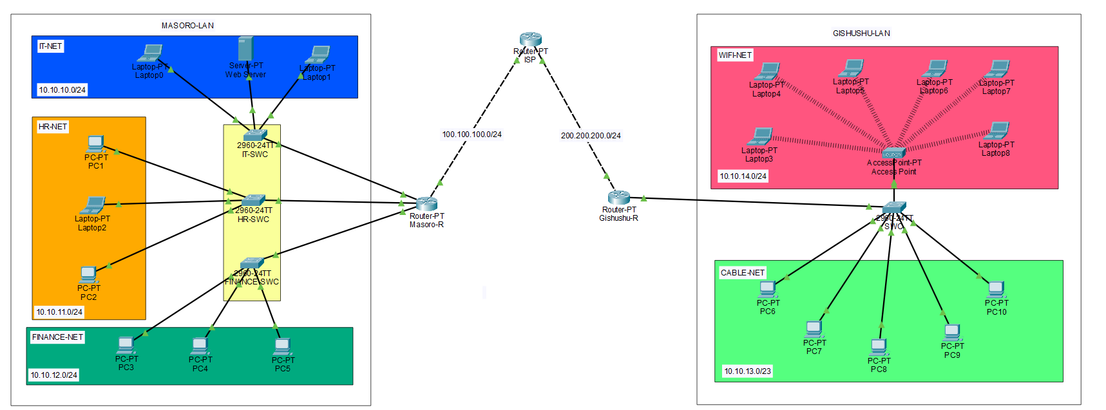

**Routers:** Used to make connect network and Acts as DHCP server

**Switch:** Connects multiple end devices

**End Devices (Server, PCs/Laptops):** Clients used in topology

3. STP/RSTP

**Use the following command**

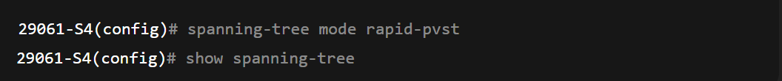

**Verification:**

Use the following command:

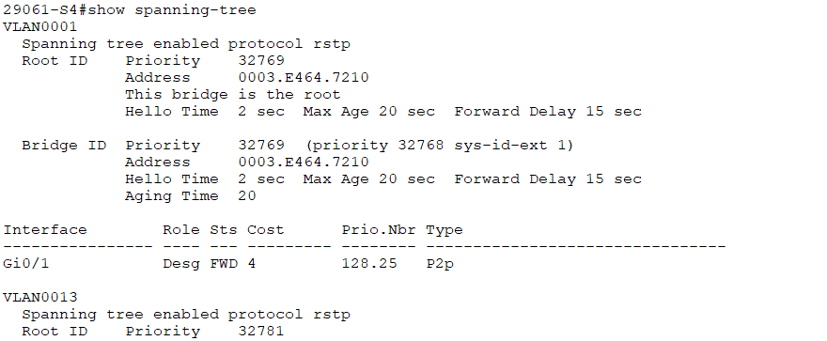

3. Port Security Configuration

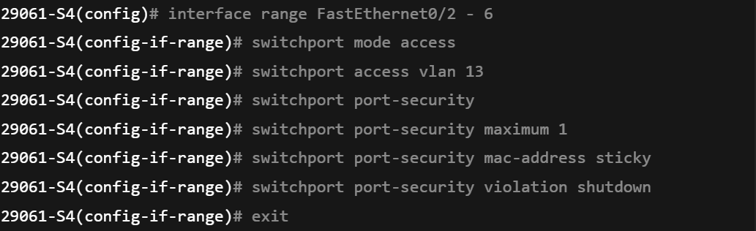

**Explanation of used commands**

**Interface range FastEthernet0/2 – 6:** This allows to apply configure same configuration on more than one port.

**switchport mode access:** forces port to work as access port.

**switchport access vlan 13:** Assign the port to vlan 13.

**switchport port-security:** Enables port security features on the port.

**switchport port-security maximum 1:** Limits each port to learn only one MAC addresss

**switchport port-security** **violation shutdown:** If violation occurs, the port goes into error.

**switchport port-security** **mac-address sticky**: Allows switch to store first connected MAC address in the running configuration

**Verification**



**show port-security interface f0/1:** displays the security set to specific port

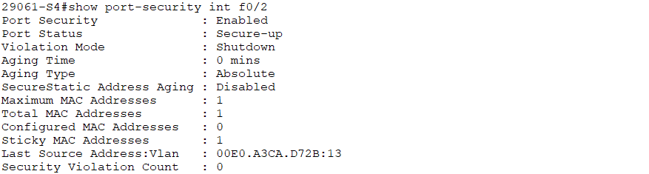

# Summary:

1. **Port Security:**
   * Limits devices per switch port.
   * Prevents unauthorized access using MAC address filtering.
   * Offers violation actions: **shutdown**, **restrict**, or **protect**.
2. **STP / RSTP:**
   * Prevents loops in networks with redundant links.
   * STP has slower convergence; RSTP is faster.
   * Ensures continuous communication without broadcast storms.
3. **Combined Benefit:**
   * Protects the network from unauthorized devices.
   * Ensures reliable, loop-free network topology.
   * Enhances both **security** and **network stability**.

**END.**