

**NAME:** Joseph MUTANGANA

**STUDENT ID:** 29061

**COURSE NAME:** Computer Networks

**INSTRUCTOR NAME:** Joshua IRADUKUNDA

**ASSIGNMENT TITLE:** Assignment#1

**DATE:** Oct-12-2025

**ROUTING CONFIGURATION LAB**

**HANDS-ON LAB**



**Prepared by: Joseph MUTANGANA**

**IN CISCO PACKET TRACER**

**Table of Contents**

1. Introduction 1

2. Network Topology Design 1

3. Routing between both LANs MASORO and GISHUSHU 2

4. Encountered Challenges 3

Summary 3

# 1. Introduction

In this topology, static routing was used to enable communication between all subnets across the Masoro, Gishushu, and ISP routers. Since each router connects to different networks, static routes were manually configured to ensure that data could be forwarded correctly between LANs and through the ISP.

The Masoro router was responsible for routing traffic from IT-NET, HR-NET, and FINANCE-NET subnets (10.10.10.0/24 – 10.10.12.0/24), while the Gishushu router handled routing for CABLE-NET and WIFI-NET subnets (10.10.13.0/24 and 10.10.14.0/24). The ISP router served as the intermediary between the two LANs, ensuring that packets from either side could be delivered to the correct destination.

# 2. Network Topology Design

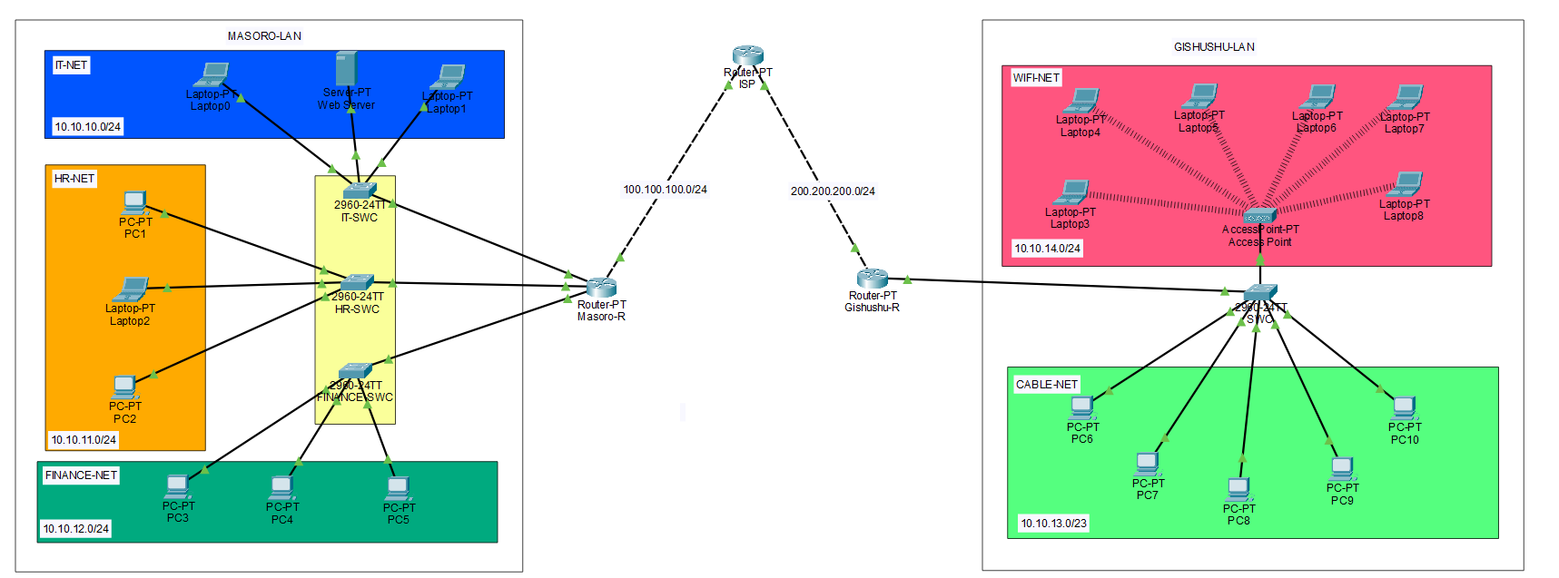

**Routers:** Used to make connect network and Acts as DHCP server

**Switch:** Connects multiple end devices

**End Devices (Server, PCs/Laptops):** Clients used in topology

# 3. Routing between both LANs MASORO and GISHUSHU

**Step 1:** Give IP address to all subnets

**Step 2:** Assigned IP address on ISP

* Interface that face to MASORO-LAN

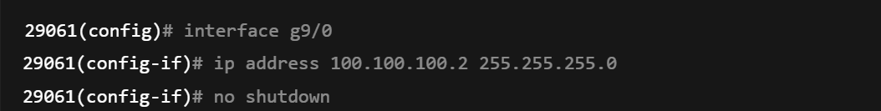

* Interface that face to GISHUSHU-LAN

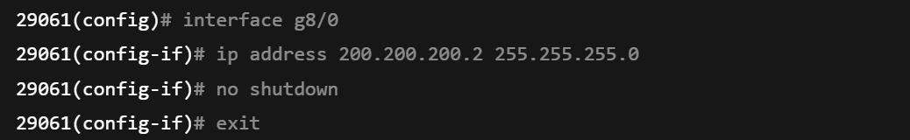

**Step 3:** Applied IP Route commands on GISHUSHU-ROUTER

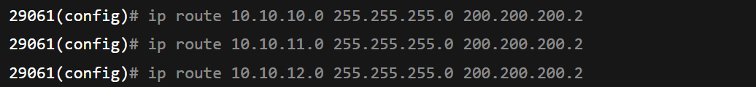

**Step 4:** Applied IP Route commands on MASORO-ROUTER



**Step 3:** Applied IP Route commands on ISP-ROUTER

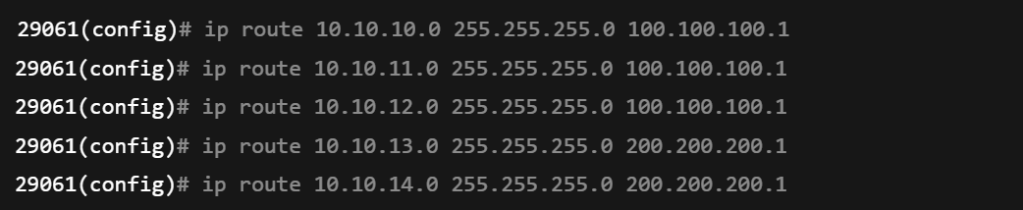

**ip route 10.10.10.0 255.255.255.0 200.200.200.2:** This tells Gishushu router to use 200.200.200.2 port faces to ISP to send traffic to network has this IP 10.10.10.0 in Masoro LAN, and vice versa.

# 4. Encountered Challenges

While configuring static routing, I initially struggled with connectivity between **Masoro and Gishushu LANs**. Devices in one LAN could not ping devices in the other

**Couse:**

The issue occurred because the **ISP router** had no static routes for the internal LANs of Masoro and Gishushu. The routers could reach the ISP, but the ISP didn’t know how to return packets to the internal networks.

**Solution:**

I solved this by adding static routes on the **ISP router** pointing to the next-hop interfaces connected to Masoro and Gishushu routers:

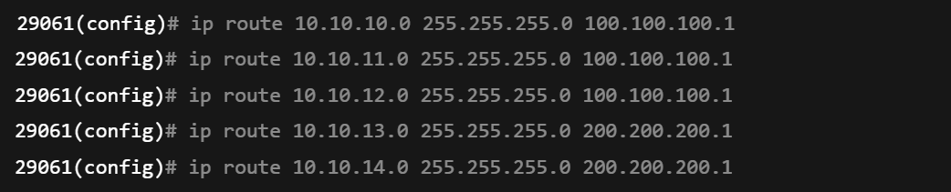

# Summary

After implementing static routing on all routers:

* The **Masoro router** used routes pointing to the ISP (100.100.100.2) to reach Gishushu networks.
* The **Gishushu router** used routes pointing to the ISP (200.200.200.2) to reach Masoro networks.
* The **ISP router** had routes for both Masoro and Gishushu LANs, forwarding packets to their respective next-hops.

End devices across all subnets could now successfully **ping** each other, showing that inter-network communication was fully functional.

**END.**