

**HTTP WEB SERVER & MAIL SERVER SET UP CONFIGURATION LAB**

**NAME:** Joseph MUTANGANA

**STUDENT ID:** 29061

**COURSE NAME:** Computer Networks

**INSTRUCTOR NAME:** Joshua IRADUKUNDA

**ASSIGNMENT TITLE:** Assignment#1

**DATE:** Oct-12-2025

**HANDS-ON LAB**



**Prepared by: Joseph MUTANGANA**

**IN CISCO PACKET TRACER**

**Table of Contents**

1. Introduction 1

2. Network Topology Design 1

3. HTTP Web Server Setup 2

On server 2

On Clients PCs/Laptops 2

4. Mail Server Configuration 3

On Clients Server: 3

On Clients PCs/Laptops: 3

5.Achieved Outcomes 5

Summary: 5

# 1. Introduction

In this lab, we configure **HTTP web and mail services on Cisco Packet Tracer servers** and enable client PCs to access them.

* The **HTTP web server** allows network PCs to access hosted web pages through browsers.
* The **mail server** allows PCs to **send and receive emails** within the network.

The purpose of this lab is to **learn how to set up servers, assign IP addresses, configure DNS (if needed), and verify client access** to these services in a simulated network environment.

# 2. Network Topology Design

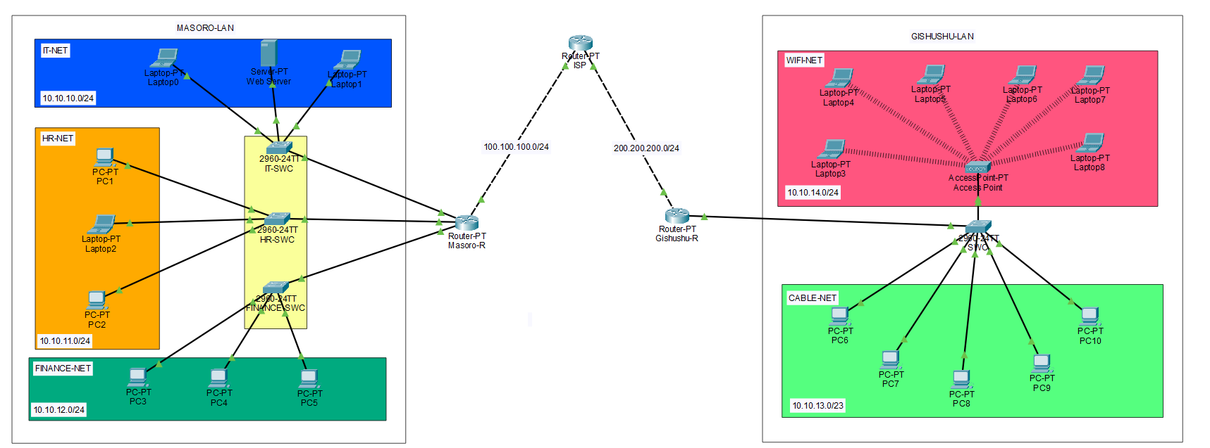

**Routers:** Used to make connect network and Acts as DHCP server

**Switch:** Connects multiple end devices

**End Devices (Server, PCs/Laptops):** Clients used in topology

# 3. HTTP Web Server Setup

## On server

**Step 1:** Open Server

**Step 2:** Go to service tab

**Step 3:** Select HTTP on left side

**Step 4:** Enable on button on HTTP

## On Clients PCs/Laptops

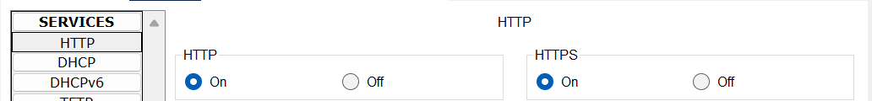

**Verification:**

**On Clients PCs/Laptops:**

**Step 1:** Open client

**Step 2:** Go to desktop tab

**Step 3:** Choose web browser

**Step 4:** In URL field type dns or server IP address

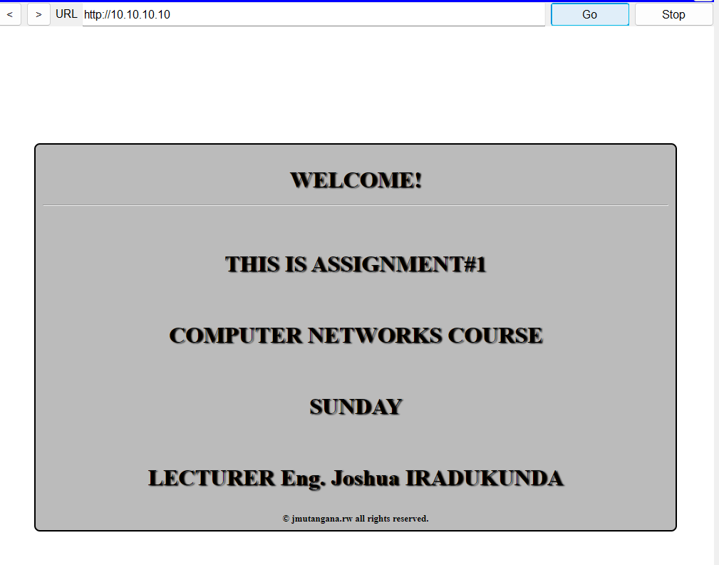

# 4. Mail Server Configuration

## On Clients Server:

**Step 1:** Open Server

**Step 2:** Go to service tab

**Step 3**: Select EMAIL on left side

**Step 4:** Enable (on) button to open SMTP

**Step 5:** Enter Domain Name

**Step 6:** Click set button

**Step 7:** Create user by Entering username and password

**Step 8:** Click on Plus Button on right side

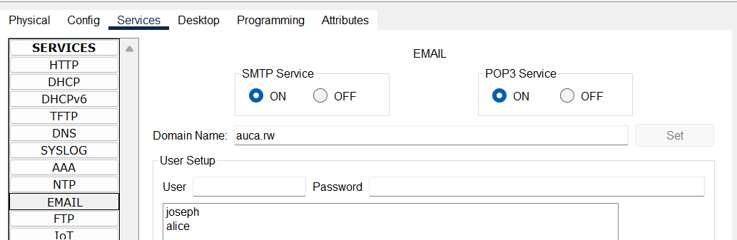

## On Clients PCs/Laptops:

**Step 1:** Open client

**Step 2:** Go to desktop tab

**Step 3:** Choose Email

**Step 4:** Fill required inputs

**Step 5:** Save

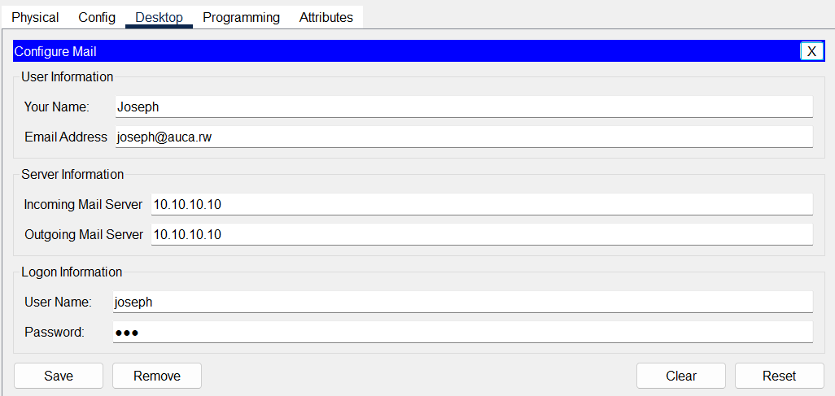

**Verification**

**On clients/PCs and Laptops**

**Compose email**

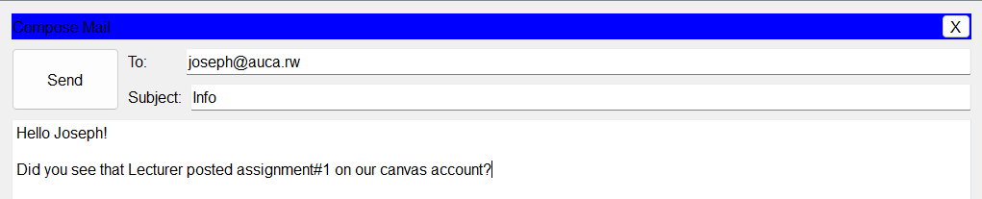

**Received mail**

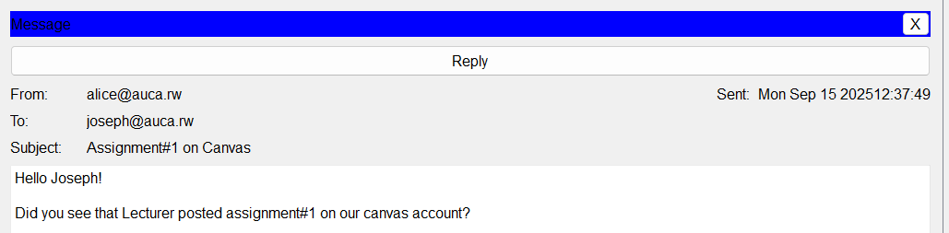

# 5.Achieved Outcomes

* Clients are able to send email
* Clients are able to access HTTP service
* Hands on work experience

# Summary:

* Enabled **HTTP service** on the web server and tested access from client PCs.
* Enabled **SMTP and POP3/IMAP services** on the mail server and verified email sending/receiving between PCs.
* Confirmed that tested PCs could **access web pages and exchange emails**, demonstrating correct server configuration and network connectivity.

**END.**