

**NAME:** Joseph MUTANGANA

**STUDENT ID:** 29061

**COURSE NAME:** Computer Networks

**INSTRUCTOR NAME:** Joshua IRADUKUNDA

**ASSIGNMENT TITLE:** Assignment#1

**DATE:** Oct-12-2025

**NAT CONFIGURATION LAB**

**HANDS-ON LAB**



**Prepared by: Joseph MUTANGANA**

**IN CISCO PACKET TRACER**

**Table of Contents**

1. Introduction 1

2. Network Topology Design 1

3. NAT (PAT & Static NAT) Configuration 2

4.Verification of NAT 3

5. Challenge Faced: 3

Summary: 3

# 1. Introduction

In this network topology, **Network Address Translation (NAT)** was configured to allow internal devices from both **Masoro** and **Gishushu LANs** to communicate with external networks through their respective routers. NAT enables multiple private IP addresses to share a single public IP, conserving address space and enhancing network security by hiding internal addresses from the outside world.

On the **Masoro router**, NAT was implemented using **Access List 12** to define the internal private networks (**10.10.10.0/24**, **10.10.11.0/24**, and **10.10.12.0/24**). On the **Gishushu router**, **Access List 15** was used to identify the internal networks (**10.10.13.0/24** and **10.10.14.0/24**). Each router used **Port Address Translation (PAT)**, commonly known as **NAT overload**, to allow multiple LAN devices to share the same public IP address — **100.100.100.1** for Masoro and **200.200.200.1** for Gishushu.

# 2. Network Topology Design

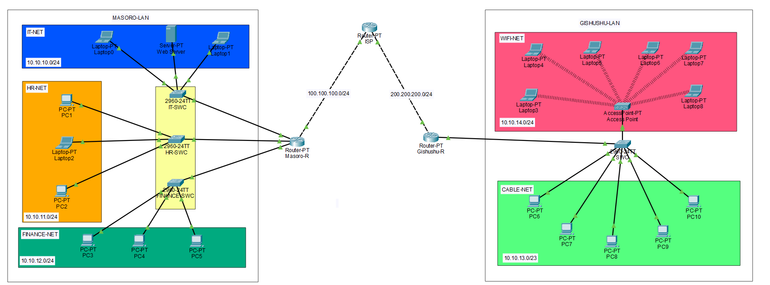

**Routers:** Used to make connect network and Acts as DHCP server

**Switch:** Connects multiple end devices

**End Devices (Server, PCs/Laptops):** Clients used in topology

# 3. NAT (PAT & Static NAT) Configuration

**Step 1:** Define inside and Outside Interface

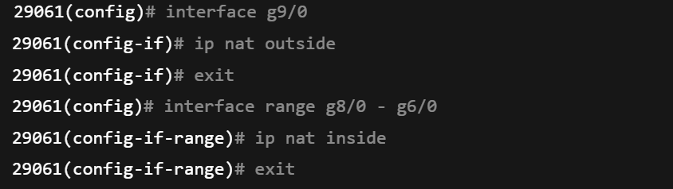

i**p nat outside:** Marks the WAN interface as outside

**ip nat inside:** Marks the LAN interfaces as inside for NAT

**Step 2: Create an Access List to define inside Address**

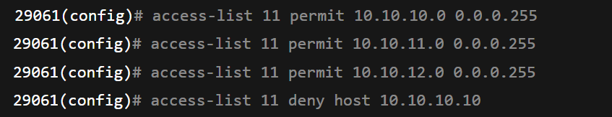

**access-lists 11 permit 10.10.10.0 0.0.0.255:** Defines which private IPs are allowed to be translated (Masoro’s LANs).

**access-lists 11 deny 10.10.10.10 0.0.0255:** Excludes the server IP from translation

**Step 3:** Apply NAT Overload (PAT)



**ip nat inside source list 11 interface g9/0 overload:** Tells the router to use the public IP of the outside interface (g9/0) for all internal users

**overload**: Enable PAT (Port Address Translation) many private IPs share one public IP, using different port numbers

# 4.Verification of NAT

**Use the following command**

**show ip nat translation:** displayes private ip address translated to public ip adderress

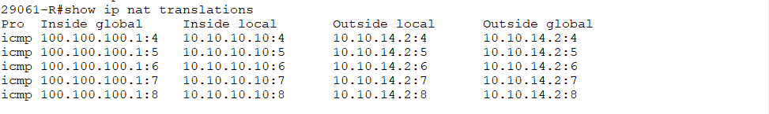

**show ip nat statistics:** table that shows nat details.

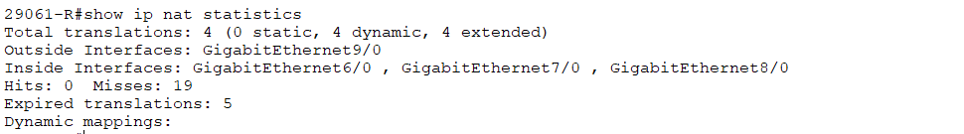

# 5. Challenge Faced:

After configuring **NAT overload**, I noticed that my network connections suddenly stopped working. Devices in the LAN could not access external networks, and pings to other routers failed.

**Cause:**

The issue occurred because **multiple overload configurations** were applied on the same router interface. This caused conflicting NAT translations, preventing the router from handling address mappings correctly.

**Solution:**

To resolve the problem, I disabled one of the overload configurations and kept only the correct one for the active outside interface.



# Summary:

After completing the NAT configuration on both routers:

Private networks in Masoro and Gishushu could access external networks using a single shared public IP (via overload).

The configuration used ip nat inside for LAN interfaces and ip nat outside for WAN interfaces.

Access Control Lists (ACLs) defined which networks were eligible for translation.

Verification with commands such as show ip nat translations and show ip nat statistics confirmed successful address translation.

**END.**