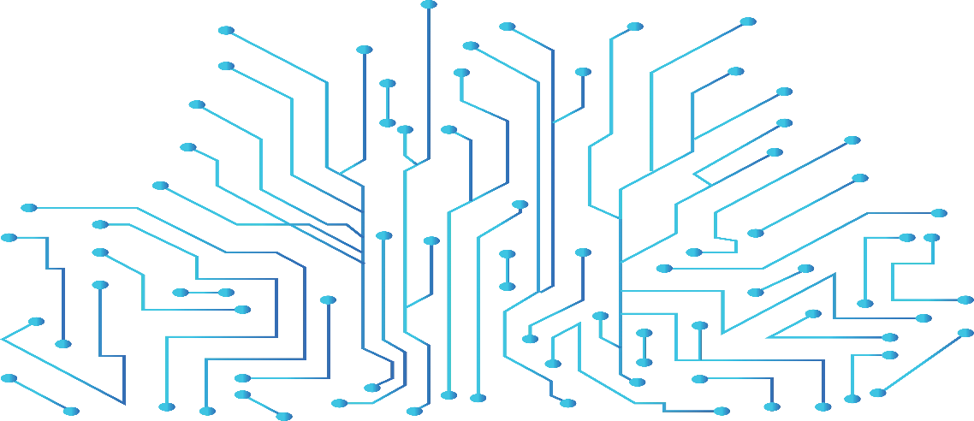

**SSH & TELNET CONFIGURATION LAB**

**NAME:** Joseph MUTANGANA

**STUDENT ID:** 29061

**COURSE NAME:** Computer Networks

**INSTRUCTOR NAME:** Joshua IRADUKUNDA

**ASSIGNMENT TITLE:** Assignment#1

**DATE:** Oct-12-2025

**HANDS-ON LAB**



**Prepared by: Joseph MUTANGANA**

**IN CISCO PACKET TRACER**

**Table of Contents**

1. Introduction 1

2. Network Topology Design 1

3. Remote Access Configuration (SSH) 2

Summary: 2

# 1. Introduction

In this network, Secure Shell (SSH) and Telnet were configured to enable remote management of routers and switches from any device within the network. Both protocols allow administrators to access and configure network devices without being physically connected to them.

Telnet provides remote access through plaintext communication, which makes it easy to use but less secure since passwords and data are transmitted unencrypted. On the other hand, SSH (Secure Shell) performs the same function but adds data encryption and authentication, ensuring secure management sessions.

# 2. Network Topology Design

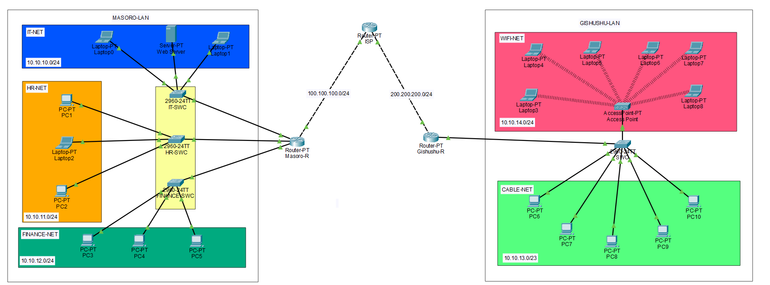

**Routers:** Used to make connect network and Acts as DHCP server

**Switch:** Connects multiple end devices

**End Devices (Server, PCs/Laptops):** Clients used in topology

# 3. Remote Access Configuration (SSH)

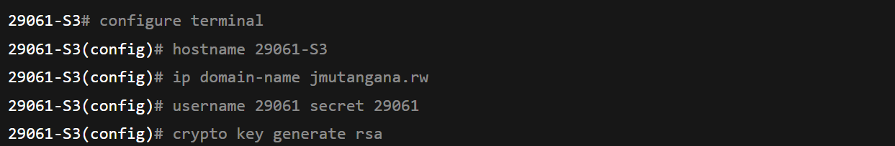

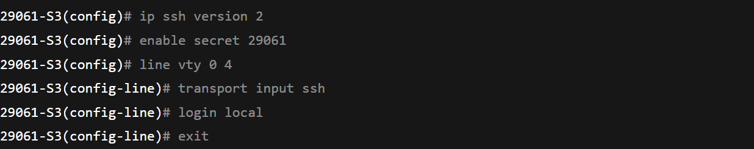

**Explanation of used Commands**

**ip domain-name jmutangana.rw:** defines the domain name for the router because SSH requires a domain to generate RSA encryption keys.

**username:** Allows to set name of user who is using the device.

**Secrete:** Allows to set secrete for user when try log in.

**crypto key generate rsa:** Generates RSA key used for SSH encryption.

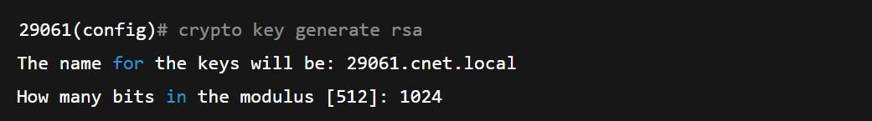

**ip ssh version 2:** Enable SSH version 2

**line vty 0 4:** Enters configuration for virtual terminal lines 0 to 4

**transport input ssh:** Restrict remote to SSH only.

**login local:** tells the router/switch to use local username and password

# Summary:

Configuring SSH and Telnet provided an understanding of how network devices can be managed remotely and securely. Telnet served as an example of basic remote access, while SSH demonstrated a more secure and modern method using encryption and authentication.

After completing the configuration, all routers were accessible remotely using SSH with local credentials, and Telnet access was disabled to enhance security. This ensured that network management traffic remained confidential, authenticated, and protected, strengthening the overall security posture of the topology.

**END.**