**COURSE NAME:** Descriptive Statistics

**ASSIGNMENT REPORT**

**GROUP MEMBERS:**

1. Joseph MUTANGANA 29061
2. MBONYINKWIYE Burumbuke Frank 28745
3. Ushimirwa ingabire Benitha 28747
4. Kubananayo Ismael 28920
5. Uwase Rubagumya Joseé ID:29181
6. Nyirahabinshuti Marlene 28884

$$ACTIVITY 1$$

$$Q1. By using Extended Grouped Frequency Distribution Table$$

$$Step 1: Find Total Number (N)$$

$$N = 62$$

$$Step 2: Find the number of class interval K$$

$$K = 1 + 3.322 * log10\left(N\right), K = 1 + 3.322 * log10\left(62\right), K = 6$$

$$Step 3: Find the length of class width C$$

$$C = (Maximum value – Minimum Value) / K$$

$$Max value = 96, Min value = 2, C =\frac{\left(96 – 2\right)}{6}, C = 16$$

$$Step 4: Find starting number and ending number of group 1$$

$$Step 5: Find midpoint, fi, and cfi$$

$$mi = (b + a) / 2$$

$$First mi will be (17 + 1)/2 = 18/2 = 9$$

|  |  |  |  |  |
| --- | --- | --- | --- | --- |
| $$i$$ | $$a-b$$ | $$mi$$ | $$fi$$ | $$cfi$$ |
| $$1$$ | $$1 - 17$$ | $$9$$ | $$8$$ | $$8$$ |
| $$2$$ | $$17 - 33$$ | $$25$$ | $$11$$ | $$19$$ |
| $$3$$ | $$33 - 49$$ | $$41$$ | $$21$$ | $$40$$ |
| $$4$$ | $$49 - 65$$ | $$57$$ | $$12$$ | $$52$$ |
| $$5$$ | $$65 - 81$$ | $$73$$ | $$6$$ | $$58$$ |
| $$6$$ | $$81 - 97$$ | $$89$$ | $$4$$ | $$62$$ |
| $$\sum_{i=1}^{6}{ }$$ |  |  | $$62$$ |  |

The reason why we choose Extended group frequency is that Since the octane values are in decimals, making a distinct table would be long and messy. Using an extended grouped frequency distribution helps us organize the data into clear intervals, making it easier to read and analyze

$$Q2. By using Extended Grouped Frequency Distribution$$

$$N = 14$$

$$K = 1 + 3.322 * log10\left(14\right)=>K = 1 + 3.322 * 1.14$$

$$K = 1 + 3.80K => 4.80K = 4.80, k≥6, k≤12,$$

$$C = (95.3 - 84.2) / 6=>C = 1.88 ≅2$$

$$Let (a) start from 84 then b will be (a + c) = 84 + 2 = 86$$

|  |  |  |  |  |
| --- | --- | --- | --- | --- |
| $$i$$ | $$a-b$$ | $$mi$$ | $$fi$$ | $$cfi$$ |
| $$1$$ | $$84-86$$ | $$85$$ | $$1$$ | $$1$$ |
| $$2$$ | $$86-88$$ | $$87$$ | $$3$$ | $$4$$ |
| $$3$$ | $$88-90$$ | $$89$$ | $$2$$ | $$6$$ |
| $$4$$ | $$90-92$$ | $$91$$ | $$4$$ | $$10$$ |
| $$5$$ | $$92-94$$ | $$93$$ | $$2$$ | $$12$$ |
| $$6$$ | $$94-96$$ | $$96$$ | $$2$$ | $$14$$ |
| $$\sum_{i=1}^{6}{ }$$ |  |  | $$14$$ |  |

**Q3. By using Frequency Distribution**

|  |  |  |  |  |  |  |  |  |  |  |
| --- | --- | --- | --- | --- | --- | --- | --- | --- | --- | --- |
| **xi** | 6 | 7 | 8 | 9 | 10 | 11 | 12 | 13 | 14 | 16 |
| **fi** | 1 | 1 | 4 | 5 | 5 | 9 | 3 | 3 | 2 | 2 |

**ACTIVITY 2**

$$Q4$$

|  |  |  |  |
| --- | --- | --- | --- |
| **i** | **xi** | **fi** | **xi.fi** |
| 1 | 5 | 4 | 20 |
| 2 | 10 | 6 | 60 |
| 3 | 15 | 8 | 120 |
| 4 | 20 | 7 | 140 |
| 5 | 25 | 3 | 75 |
| 6 | 30 | 2 | 60 |
|  |  |  |  |
| $$\sum_{i=1}^{6}{ }$$ |  | 30 | 475 |

|  |  |  |
| --- | --- | --- |
| **xi** | **fi** | **cf** |
| 0 | 1 | 1 |
| 1 | 3 | 4 |
| 2 | 10 | 14 |
| 3 | 7 | 21 |
| 4 | 4 | 25 |
| 5 | 2 | 27 |
| 6 | 2 | 29 |
| 7 | 1 | 30 |

$$Bar Chat$$

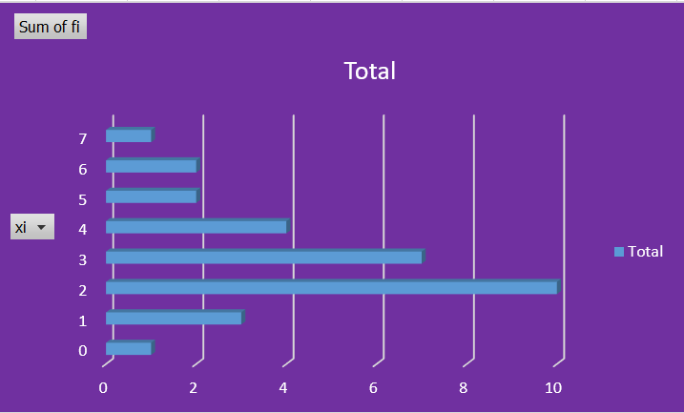

$$Cumulative frequency chart$$

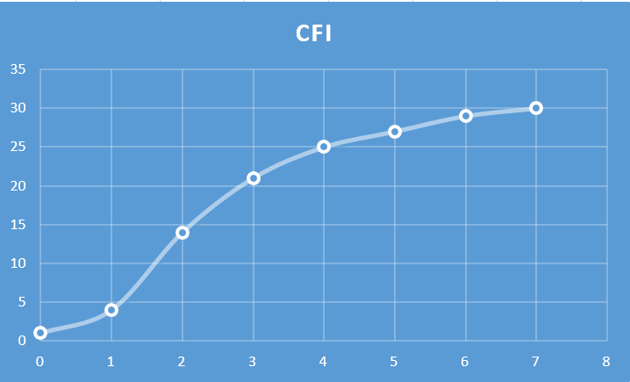

**Q6**

$$N = 40$$

$$K = 1 + 3.322 * log10\left(40\right)=>K = 1 + 3.322 * 1.6=>K = 1 + 5.3=>K = 5.3 ≅5$$

$$C = (59 - 10) / 6=>C = 8.1 ≅1$$

|  |  |  |  |  |
| --- | --- | --- | --- | --- |
| $$i$$ | $$a-b$$ | $$mi$$ | $$fi$$ | $$cfi$$ |
| $$1$$ | $$10-20$$ | $$15$$ | $$8$$ | $$8$$ |
| $$2$$ | $$20-30$$ | $$25$$ | $$9$$ | $$17$$ |
| $$3$$ | $$30-40$$ | $$35$$ | $$14$$ | $$31$$ |
| $$4$$ | $$40-50$$ | $$45$$ | $$11$$ | $$42$$ |
| $$5$$ | $$50-60$$ | $$55$$ | $$8$$ | $$50$$ |
| $$\sum_{i=1}^{6}{ }$$ |  |  | 50 |  |

**Histogram**

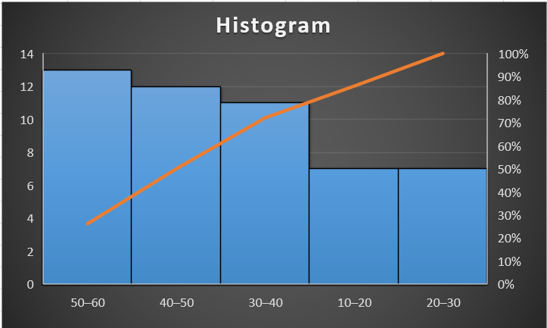

**Ogives/Cumulative frequency**

