MUTANGANA VS FLYER

AUCA Student Called Mutangana Joseph, On this day 30/01/2025, he heard his computer lecturer saying that he can give them a test to do flyer in word.

But Mutangana was indeed don’t know anything bout flyer!

So Mutangana was like, hey what is that teacher? Flyer!? Heiii! I’m dead!

But Teacher said this “Do not worry because I know some of you is not aware about to do flyer, but you better know that I can tell you to do it”.

FLYER STORY

Ohhh! With that Mutangana was like mhhh! Relaxed person was Mutangana!

Mutangana decided to look up forward how to make flyer. And he began with searching with some information about flyer.

And Mutangana found that flyer is printed advertisement like when you want to publish an information about concert,Product advertisement and other event related to advertising, sometime you need designed flyer

What do you think about that? Guess what!

After hearing that Mutangana Took his PC and he started writing this you are reading!

This is first flyer made by Mutangana. And he want to explore more about flyers!

Whatsapp: +250 780920096

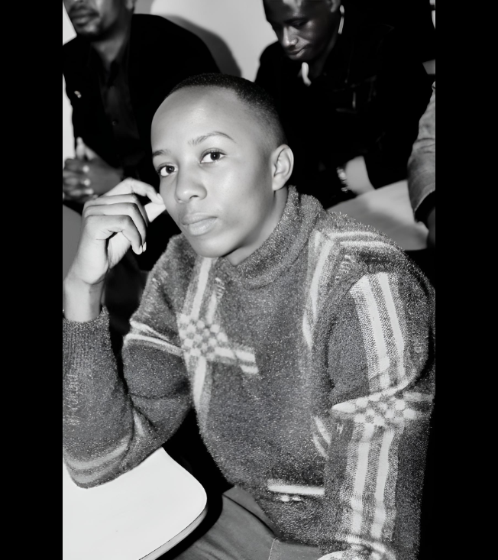 MUTANGANA Joseph

