**CIS 241, Homework 4, Winter 20**

BASH Shell

**Due**: Friday, April 10, 2020

**Hints:**

* It is always a good idea and a good way to learn to test your solution on a Linux system.
* Ask your instructor if you have questions.
* Start early.

1. (10 points) In terms of scope, what is the difference between a shell variable and an environmental variable? Give two methods to create or make a shell variable to be an environmental variable in a BASH shell environment.

**In terms of scope, shell variables have scope in the current shell session, and environmental variables have scope in not only the shell session it was created, but also for any process started from that session. Also, environmental variables have been ‘exported’.**

**So the first method is to export a shell variable. This will turn it into an environmental variable.**

**The second method is to add the variable to the .bashrc file in the $HOME directory.**

1. (10 points) Assume you have made the following assignment in a Linux terminal with BASH shell:

person=Zach

Give the output of each of the following commands:

* 1. echo $person

1. Zach
2. $person
3. Zach
4. There is no command ‘bash’
5. Question 2
   1. echo ‘$person’
   2. echo “$person”
   3. bash

echo $person

* 1. export my_var=”Question 2”

exit

echo $my_var

1. (10 points) Write a BASH script that takes one parameter from the command line. Assume this parameter is a file name. Add execute permission to the file for the user and group only. You don’t need to check on input errors for this question. Attach your script below as the answer to this question.

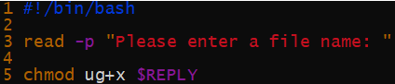

1. (10 points) Write a script to display the time every 2 seconds. Read the **date** man page and display the time using the **%r** field descriptor (**date +%r**). Clear the window each time before the time is shown. Attach your script below as the answer to this question.

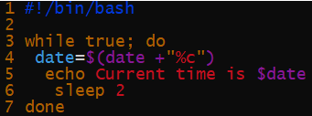

1. (10 points) What will get printed out when the following script is executed?

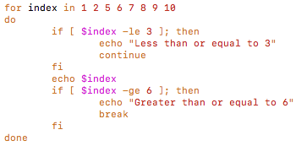

**Less than or equal to 3**

**Less than or equal to 3**

**5**

**6**

**Greater than or equal to 6**

1. (10 points) What are positional variables? What are they used for in a BASH shell script?

**This is a variable within a script. It’s set from an argument set in the command line and put into $1, $2, $3…etc.**

1. (10 points) Briefly explain the following special parameters in the BASH shell environment.
   1. $#
2. It shows the total number of parameters passed in the command line
3. This is similar to $@, used to expand into positional parameters starting from 1. When it occurs inside double quotes, it expands to a single word with the value of each parameter instead of separate words.
4. Used to get the exit status of the most recently executed command
5. Used to reference the process ID of the most recently executed command
6. Used to reference the process ID of the bash shell itself
   1. $*
   2. $?
   3. $!
   4. $$
7. (10 points) Write a script that run conitunuesly to accept user input. If the input is a regular file, display “A regular file”. If the input is a directory, display “A directory”. If the input is “q”, exit the execution. Attach your code below as the answer to this question.

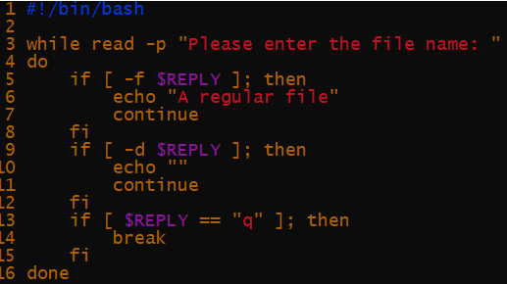

1. (10 points) Given the regular expresions. Please underscore the matches in the text following each of them.
   1. /[Bb]+ill/

**Bill** is ill and he is **bill**ed.

* 1. /\([^)]*\)/

This **(excluding this)** is just **(another)** example.

1. (10 points) In a given document, phone numbers are expressed in the following formats. Write a regular to match those expressions only.

aaa-ddd-nnnn (- is the delimeter)

aaa ddd nnnn (one space is the delimeter)

aaa.ddd.nnnn (. is the delimiter)

(aaa)ddd-nnnn (area code included in parentheses)

Where a, d and n can be any single digit (0 – 9).

**[(]*\d{3}[- .)]\d{3}[- .]\d{4}**

**Will export phone numbers as the readable format:**

**111-111-1111**

**111 111 1111**

**111.111.1111**

**(111)111-1111**