# **CIS 241**

# **Lab 5: Linked list**

**Due:** Friday, February 28

**Objectives**

This lab is designed to help students gain hands-on experience with linked list using C structures. Dynamic memory allocation and memory management are demonstrated. File I/O and the techniques to handle user input are also shown.

**Description**

Linked list is very commonly used to implement different data structures, including ques, stacks, trees and so on. It is a good option when the size of data set is not available at compile time. In this lab, you will learn how to implement a single linked list with C structures.

**Your Tasks**

Please do the following for this lab:

* Make a directory this this lab, for example, cis241/labs/lab5. And go to this directory.
* Use the command below to download the partially completed source code files from my web page to your current directory.

wget [http://cis.gvsu.edu/~wangx/teaching/cis241/lab5/{list.h,list.c,lab5.c,makefile,data}](http://cis.gvsu.edu/~wangx/teaching/cis241/lab5/%7blist.h,list.c,lab5.c,makefile,data%7d)

* Compile and run the code:

**make**

**make run**

The program will compile and run. It displays a self-explanatory menu shown below:

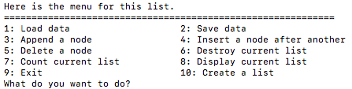

When user types in a number between 1 and 10, the program will perform corresponding function. It is simply a subset of operations on a linked list.

* Please study the code and understand what it does.
* Open the file **list.c**. You will find the following three functions are incomplete:

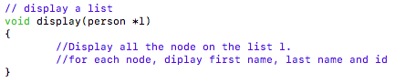

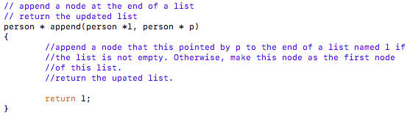

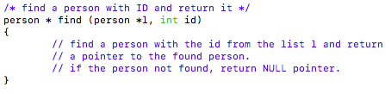

* **Please complete these three functions for this lab to make them perform the defined functionality.**
* Then, test your program by compiling and running it. Test the different functions using the self-explanatory menu and ensure your code works correctly.

To receive full credits for this lab assignment, please demo your program to me after you have done all the above successfully. If you cannot demo in class, please either demo at a later time or turn in all your files to Blackboard by due time.