**App developer: Alfonce Muthoka,** [**alfoncemuthoka@gmail.com**](mailto:alfoncemuthoka@gmail.com)**,**

**App Tester: Alfonce Muthoka**

**System functionality test**

First page:

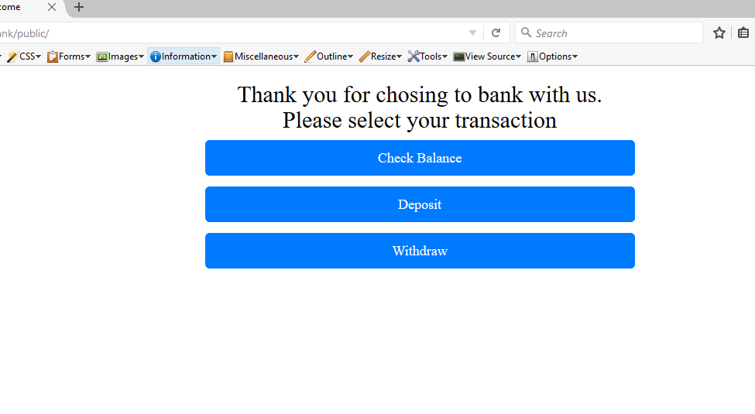

On clicking Check balance button:

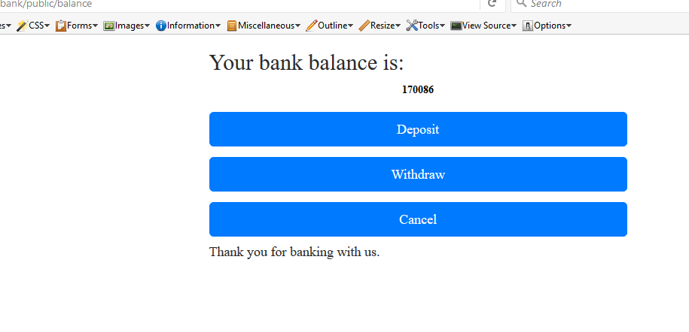

On clicking Withdraw button

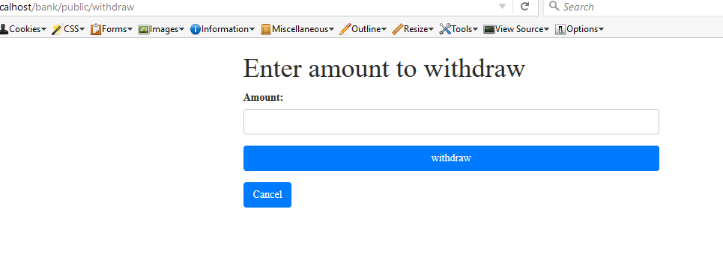

On clicking Deposit button:

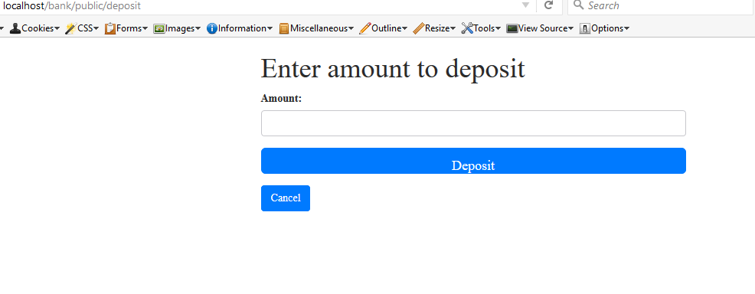

**Constrains handling**

Depositing more than $40,000 at once:

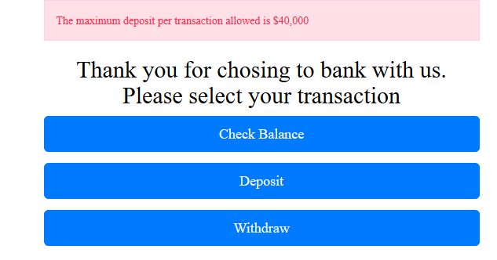

If withdrawing more than $20k,

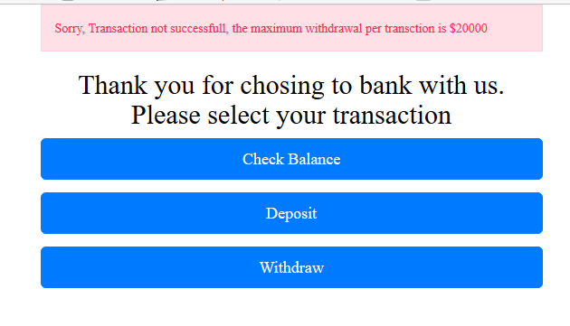

Maximum withdraw constraint:

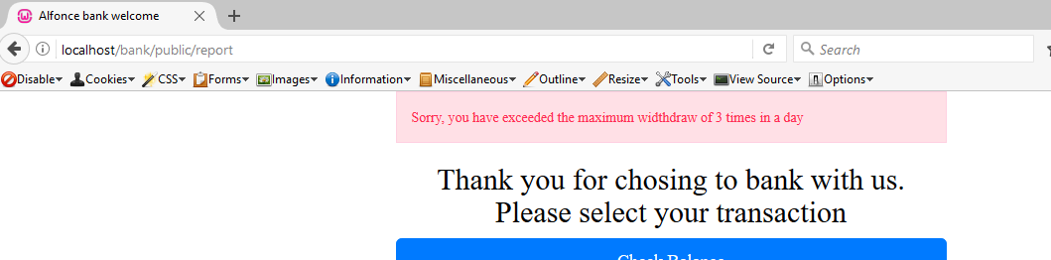

While trying to withdraw amount higher than $20,000

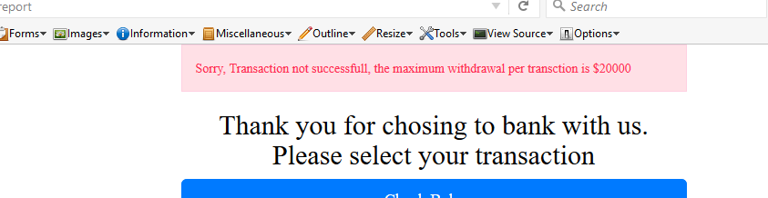

Depositing more than $150,000 in a day

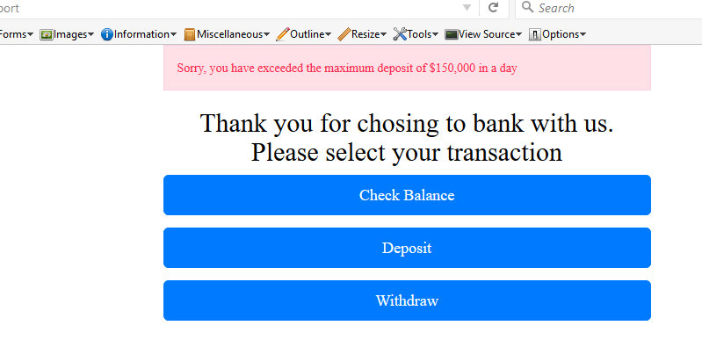

When try depositing more than 4 times in a day

