Fake News Detection using NLP

**Objective and goal of the project:**

The main aim of the project is to obtain a model which will help in detecting if a

news article is fake or not.

1. **Loading the Dataset**

Import the necessary libraries for data manipulation and preprocessing.

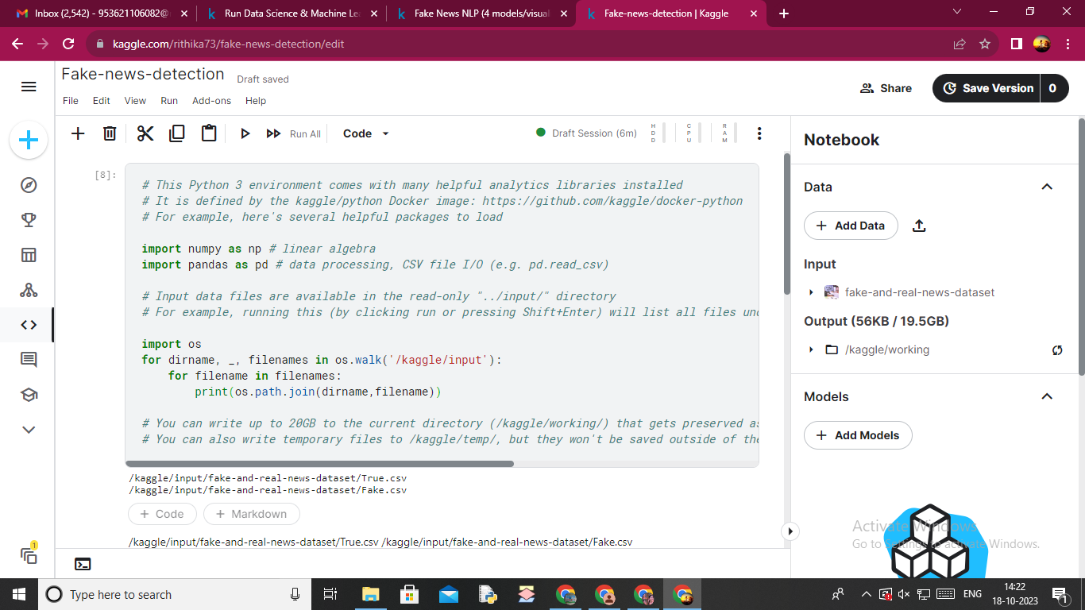

Load the fake dataset.

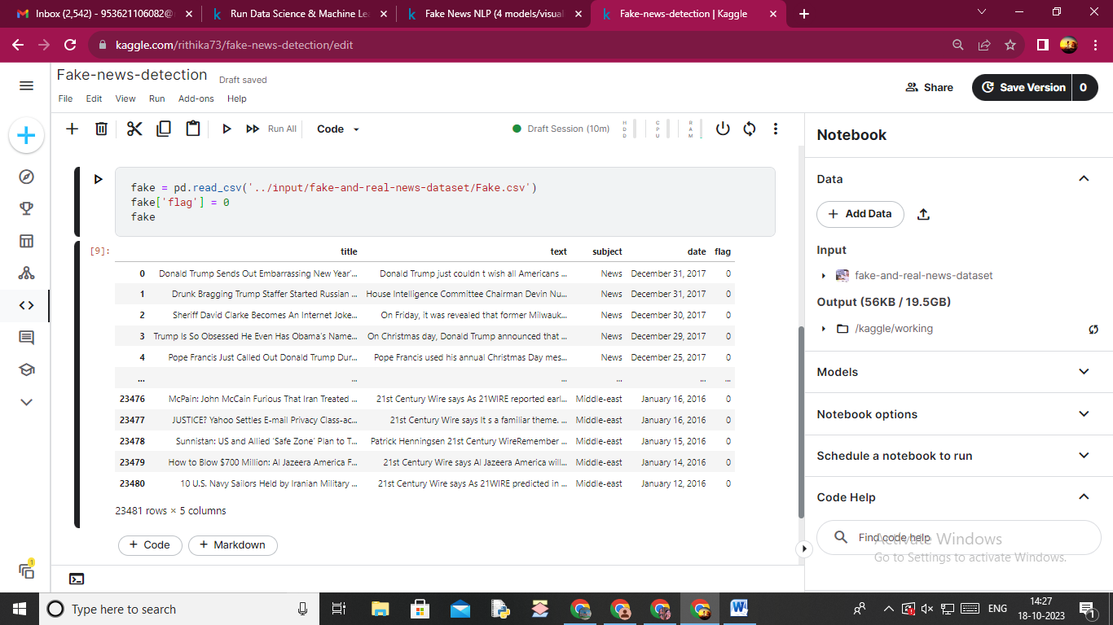

Load the real dataset

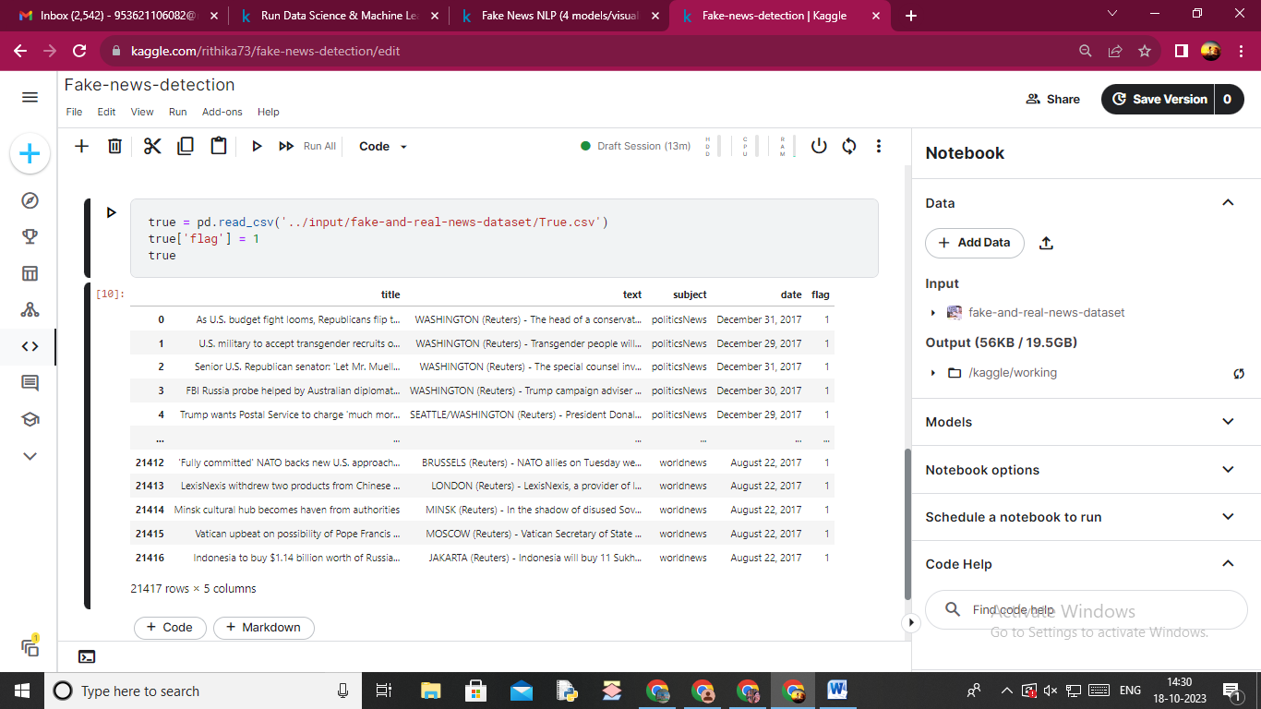

Combine the real and fake dataset using concat()

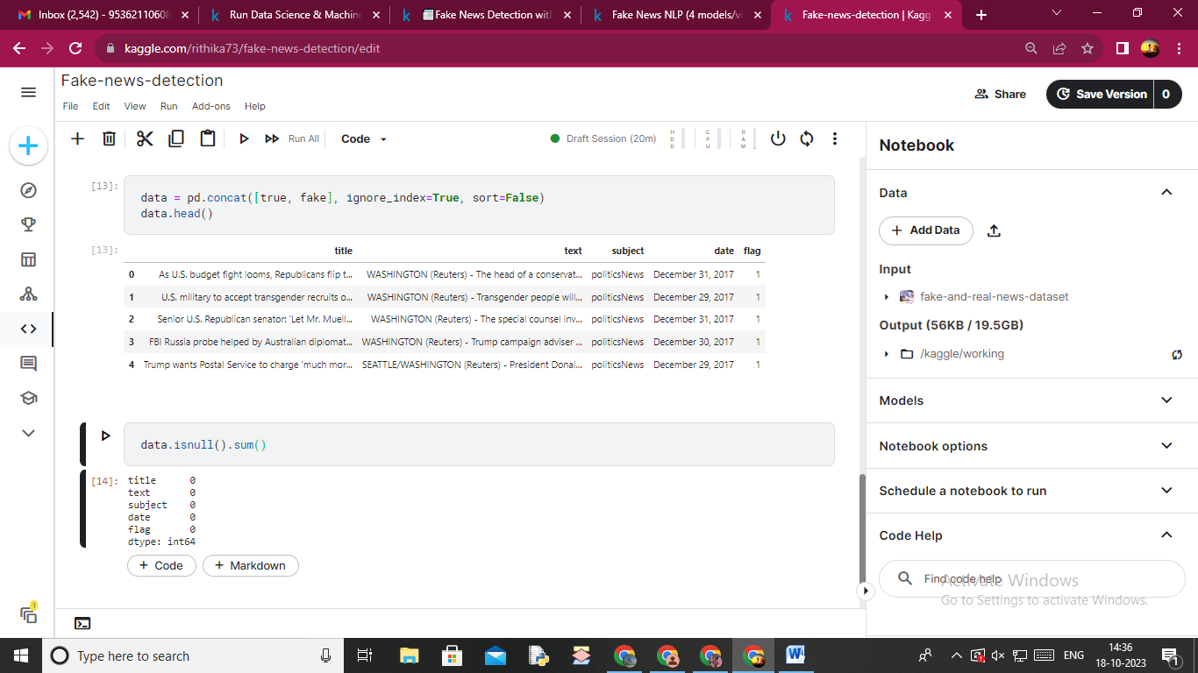

1. **Visualization**

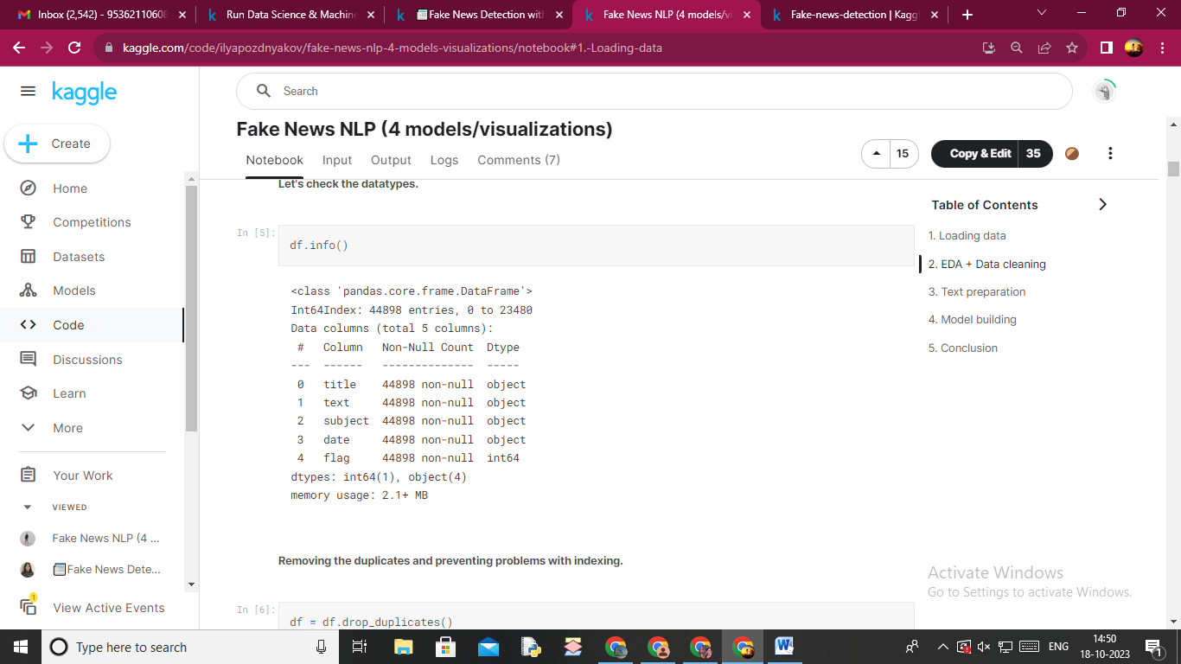

**Count of Fake and Real Data**

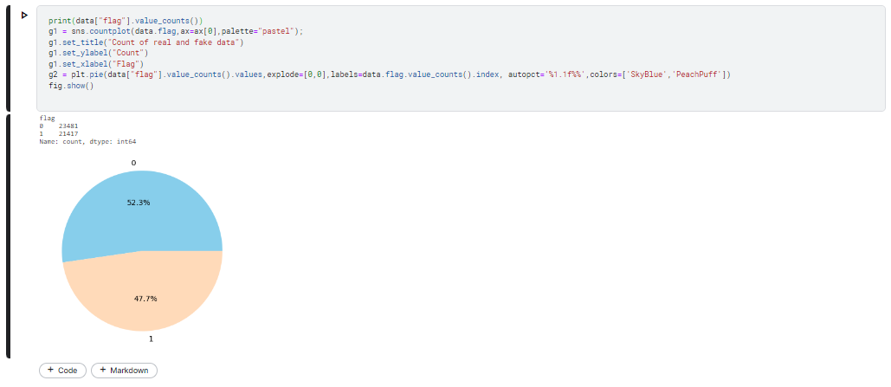

**Distribution of The Subject According to Real and Fake Data**

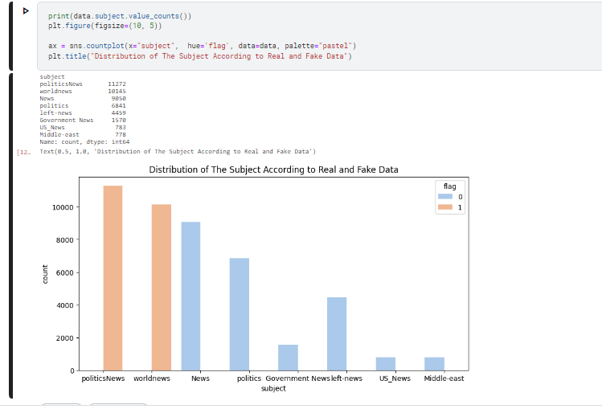

# Data Cleaning and Preprocessing

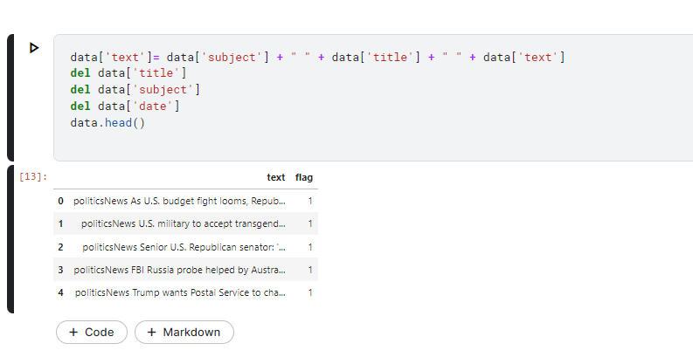

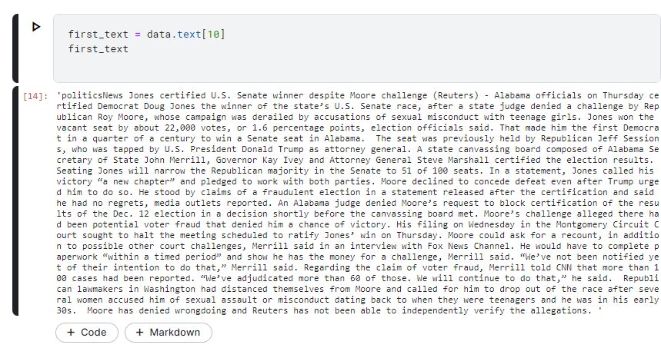

Removing HTML Contents

pip install bs4

from bs4 import BeautifulSoup

soup = BeautifulSoup(first_text, "html.parser")

first_text = soup.get_text()

first_text

**output:**

'politicsNews Jones certified U.S. Senate winner despite Moore challenge (Reuters) - Alabama officials on Thursday certified Democrat Doug Jones the winner of the state’s U.S. Senate race, after a state judge denied a challenge by Republican Roy Moore, whose campaign was derailed by accusations of sexual misconduct with teenage girls. Jones won the vacant seat by about 22,000 votes, or 1.6 percentage points, election officials said. That made him the first Democrat in a quarter of a century to win a Senate seat in Alabama. The seat was previously held by Republican Jeff Sessions, who was tapped by U.S. President Donald Trump as attorney general. A state canvassing board composed of Alabama Secretary of State John Merrill, Governor Kay Ivey and Attorney General Steve Marshall certified the election results. Seating Jones will narrow the Republican majority in the Senate to 51 of 100 seats. In a statement, Jones called his victory “a new chapter” and pledged to work with both parties. Moore declined to concede defeat even after Trump urged him to do so. He stood by claims of a fraudulent election in a statement released after the certification and said he had no regrets, media outlets reported. An Alabama judge denied Moore’s request to block certification of the results of the Dec. 12 election in a decision shortly before the canvassing board met. Moore’s challenge alleged there had been potential voter fraud that denied him a chance of victory. His filing on Wednesday in the Montgomery Circuit Court sought to halt the meeting scheduled to ratify Jones’ win on Thursday. Moore could ask for a recount, in addition to possible other court challenges, Merrill said in an interview with Fox News Channel. He would have to complete paperwork “within a timed period” and show he has the money for a challenge, Merrill said. “We’ve not been notified yet of their intention to do that,” Merrill said. Regarding the claim of voter fraud, Merrill told CNN that more than 100 cases had been reported. “We’ve adjudicated more than 60 of those. We will continue to do that,” he said. Republican lawmakers in Washington had distanced themselves from Moore and called for him to drop out of the race after several women accused him of sexual assault or misconduct dating back to when they were teenagers and he was in his early 30s. Moore has denied wrongdoing and Reuters has not been able to independently verify the allegations. '

Removing Punctuation Marks and Special Characters

import re

first_text = re.sub('\[[^]]*\]', ' ', first_text)

first_text = re.sub('[^a-zA-Z]',' ',first_text) *# replaces non-alphabets with spaces*

first_text = first_text.lower() *# Converting from uppercase to lowercase*

first_text

**Output:**

'politicsnews jones certified u s senate winner despite moore challenge reuters alabama officials on thursday certified democrat doug jones the winner of the state s u s senate race after a state judge denied a challenge by republican roy moore whose campaign was derailed by accusations of sexual misconduct with teenage girls jones won the vacant seat by about votes or percentage points election officials said that made him the first democrat in a quarter of a century to win a senate seat in alabama the seat was previously held by republican jeff sessions who was tapped by u s president donald trump as attorney general a state canvassing board composed of alabama secretary of state john merrill governor kay ivey and attorney general steve marshall certified the election results seating jones will narrow the republican majority in the senate to of seats in a statement jones called his victory a new chapter and pledged to work with both parties moore declined to concede defeat even after trump urged him to do so he stood by claims of a fraudulent election in a statement released after the certification and said he had no regrets media outlets reported an alabama judge denied moore s request to block certification of the results of the dec election in a decision shortly before the canvassing board met moore s challenge alleged there had been potential voter fraud that denied him a chance of victory his filing on wednesday in the montgomery circuit court sought to halt the meeting scheduled to ratify jones win on thursday moore could ask for a recount in addition to possible other court challenges merrill said in an interview with fox news channel he would have to complete paperwork within a timed period and show he has the money for a challenge merrill said we ve not been notified yet of their intention to do that merrill said regarding the claim of voter fraud merrill told cnn that more than cases had been reported we ve adjudicated more than of those we will continue to do that he said republican lawmakers in washington had distanced themselves from moore and called for him to drop out of the race after several women accused him of sexual assault or misconduct dating back to when they were teenagers and he was in his early s moore has denied wrongdoing and reuters has not been able to independently verify the allegations '

Removal of Stopwords

import nltk

nltk.download("stopwords")

from nltk.corpus import stopwords

*# we can use tokenizer instead of split*

first_text = nltk.word_tokenize(first_text)

first_text = [word for word **in** first_text if **not** word **in** set(stopwords.words("english"))]

Lemmatization

lemma = nltk.WordNetLemmatizer()

first_text = [ lemma.lemmatize(word) for word **in** first_text]

first_text = " ".join(first_text)

first_text

'politicsnews jones certified u senate winner despite moore challenge reuters alabama official thursday certified democrat doug jones winner state u senate race state judge denied challenge republican roy moore whose campaign derailed accusation sexual misconduct teenage girl jones vacant seat vote percentage point election official said made first democrat quarter century win senate seat alabama seat previously held republican jeff session tapped u president donald trump attorney general state canvassing board composed alabama secretary state john merrill governor kay ivey attorney general steve marshall certified election result seating jones narrow republican majority senate seat statement jones called victory new chapter pledged work party moore declined concede defeat even trump urged stood claim fraudulent election statement released certification said regret medium outlet reported alabama judge denied moore request block certification result dec election decision shortly canvassing board met moore challenge alleged potential voter fraud denied chance victory filing wednesday montgomery circuit court sought halt meeting scheduled ratify jones win thursday moore could ask recount addition possible court challenge merrill said interview fox news channel would complete paperwork within timed period show money challenge merrill said notified yet intention merrill said regarding claim voter fraud merrill told cnn case reported adjudicated continue said republican lawmaker washington distanced moore called drop race several woman accused sexual assault misconduct dating back teenager early moore denied wrongdoing reuters able independently verify allegation'