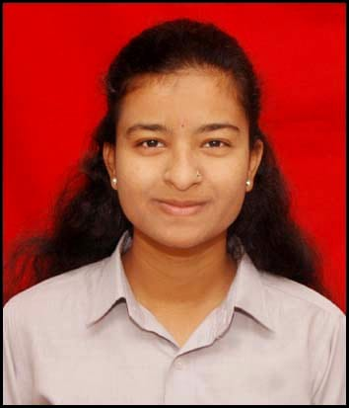    7248918550    muthiyansakshi@gmail.com    A/p – Ghodegaon, Tal – Ambegaon, Dist – Pune, Pincode – 412408    https://www.linkedin.com/in/sakshi-muthiyan-347795321  Technical Skills :  Core Programming:  Python (OOPs, Data Structures), SQL (Advanced)  Backend Frameworks: Django, Flask, FastAPIWeb Technologies & APIs: RESTful APIs, JSON, HTML5, CSS3, JavaScript Database Management:  PostgreSQL, MySQL, MongoDB, SQLiteDeveloper Tools & DevOps:  Git, GitHub, VS Code, Docker, PostmanLibraries & Data Tools: Pandas, NumPy, Scikit-LearnCore Concepts: Software Development Life Cycle (SDLC), Object-Oriented Programming, Database Normalization, Code Debugging. | Sakshi Vijaykumar Muthiyan  Python Developer  About Me:  Aspiring Python Developer with a strong engineering foundation in Artificial Intelligence and Data Science. I recently completed my T.E. from Jaihind college of engineering, kuran, near Junnar. Proficient in writing clean,efficient python code and designing relational databases with SQL.Experienced in building algorithmic solutions, automating tasks, and working with development environments like VS code. Eager to apply robust problem-solving skills to build and maintain backend software applications.  Education:  Class Percentage/SGPA  SSC 95.80%  HSC 64.83%  FE 8.14 SGPA  SE 9.14 SGPA  TE 9.19 CGPA  Certificates:  Skillected –  - Database Power Seamless Tech Integration Bootcamp (12 September 2024)  - Automation And AI/ML 1.0 (28 August 2024)  - Master Python With AI (27 July 2025)  Infosys –  - Database And SQL Course (16 January 2026)  - Python Fundamentals (14 January 2026)  Coursera -  - Data Analysis in Python using Pandas Dataframe (20 November 2025)  - U.S.T – Create your first Python Program from UST (09 January 2026)  Allpro Trainings –  - SQL Masterclass (26 July 2025)  HR Calcy –  - Python Developer Quiz (12 October 2025)  Internships –  - VKV Engineering Solutions | Python Intern:  Automated data workflows using Pandas.Optimized backend SQL queries.Cleaned high-volume engineering datasets.  - TATA & Commonwealth Bank | Virtual Intern:  Built predictive modules using Scikit-Learn.Developed automated data processing pipelines  Projects -  - AI Trends Dashboard [Python, LLMs, APIs]  Built LLM API pipelines for automated trend analytics.  - Student Management System [Python, SQL, OOP]  Developed secure databases and automated grading logic.  - Price Prediction Engine [Python, Scikit-Learn]  Created ML data pipelines and predictive models.

