**TUGAS 2**

**MATA KULIAH**

**ANALISIS DERET WAKTU**



Dosen Pengampu:

Ansari Saleh Ahmar, S.Si., M.Sc., Ph.d

Swi, S.pd, M.Si., Ph. d

Oleh :

Nama : Nafsul muthmainnah

NIM : 210112500009

Kelas : 03

**PROGRAM STUDI STATISTIKA**

**FAKULTAS MATEMATIKA DAN ILMU PENGETAHUAN ALAM**

**UNIVERSITAS NEGERI MAKASSAR**

**2023**

NO. 2 ADW

library(tseries)

## Warning: package 'tseries' was built under R version 4.2.3

## Registered S3 method overwritten by 'quantmod':  
## method from  
## as.zoo.data.frame zoo

library(forecast)

## Warning: package 'forecast' was built under R version 4.2.3

library(lmtest)

## Warning: package 'lmtest' was built under R version 4.2.3

## Loading required package: zoo

## Warning: package 'zoo' was built under R version 4.2.3

##   
## Attaching package: 'zoo'

## The following objects are masked from 'package:base':  
##   
## as.Date, as.Date.numeric

library(nortest)  
#Set working directory  
library(readxl)  
data <- read_excel("C:/Users/USER/Downloads/Data5.xlsx",   
 col_types = c("numeric", "numeric"))  
View(data)  
head(data)

## # A tibble: 6 × 2  
## t Zt  
## <dbl> <dbl>  
## 1 1 24.7  
## 2 2 25.7  
## 3 3 30.6  
## 4 4 47.5  
## 5 5 62.9  
## 6 6 68.5

tail(data)

## # A tibble: 6 × 2  
## t Zt  
## <dbl> <dbl>  
## 1 139 72   
## 2 140 71.1  
## 3 141 57.3  
## 4 142 52.5  
## 5 143 40.6  
## 6 144 26.2

#Plot time series  
#melabel data Zt dengan "Temperatur"  
Temperatur <- data$Zt  
Bulan <- data$t   
  
#Tahap Identifikasi  
ts.plot(Temperatur)

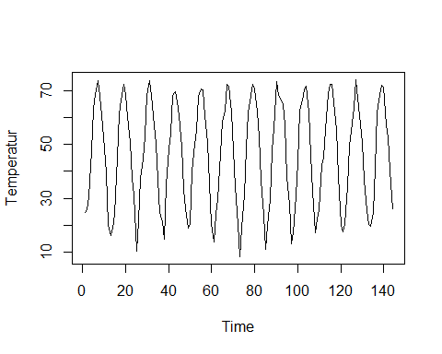

#Cek kestasioneran data  
adf.test(Temperatur)

## Warning in adf.test(Temperatur): p-value smaller than printed p-value

##   
## Augmented Dickey-Fuller Test  
##   
## data: Temperatur  
## Dickey-Fuller = -11.078, Lag order = 5, p-value = 0.01  
## alternative hypothesis: stationary

#Plot Autocorrelation (ACF) dan partial(PACF)  
acf(Temperatur, lag.max = 56)  
par(mfrow=c(1,2))  
acf(Temperatur,lag.max = 56)  
pacf(Temperatur,lag.max = 56)

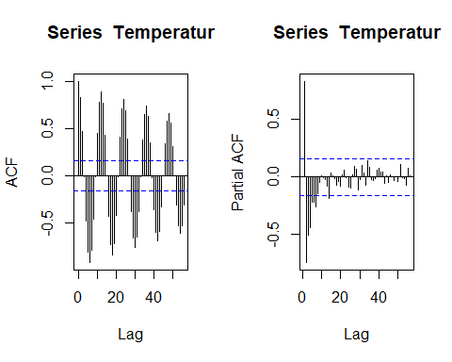

#differencing 1 non musiman dengan beberapa cara  
differencing1 <- diff(Temperatur, differences = 1)  
differencing1

## [1] 1.0 4.9 16.9 15.4 5.6 5.2 -5.8 -6.8 -12.6 -8.9 -19.6 -3.9  
## [13] 3.0 5.1 21.2 15.9 5.2 5.6 -3.7 -8.2 -9.3 -13.5 -6.3 -20.7  
## [25] 11.2 15.8 7.3 8.5 14.8 5.7 -5.5 -7.5 -10.5 -13.0 -12.6 -3.1  
## [37] -6.8 20.3 13.3 5.7 14.2 1.4 -3.9 -4.9 -11.7 -15.9 -7.2 -6.9  
## [49] 1.5 19.6 9.8 5.3 12.4 3.0 -0.4 -9.7 -9.9 -14.9 -15.1 -6.7  
## [61] 10.1 5.3 17.2 12.0 3.6 9.9 -0.4 -9.8 -14.3 -13.4 -13.8 -12.0  
## [73] 10.6 12.4 17.3 12.9 6.5 4.1 -1.6 -8.1 -9.8 -16.0 -12.9 -12.6  
## [85] 8.8 9.6 18.1 8.1 17.4 -5.2 -0.9 -2.2 -7.8 -19.5 -9.9 -14.5  
## [97] 4.0 13.6 12.9 18.6 4.1 3.8 1.4 -9.5 -16.1 -13.3 -15.4 5.2  
## [109] 3.2 16.6 2.9 10.3 13.4 3.4 0.0 -9.8 -6.9 -17.6 -17.6 -2.8  
## [121] 2.9 13.7 15.0 5.6 9.0 10.2 -6.9 -9.4 -6.9 -14.0 -11.3 -5.1  
## [133] -0.8 5.0 16.7 20.5 6.7 3.5 -0.9 -13.8 -4.8 -11.9 -14.4

#Plot time series dan plot Autocorrelation Function (ACF) dan Partial (PACF) data hasil differencing  
ts.plot(differencing1)  
par(mfrow = c(1,2))

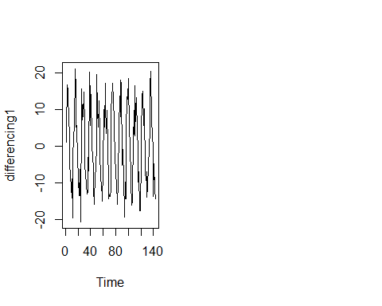

acf(differencing1, lag.max = 70)  
pacf(differencing1, lag.max = 70)

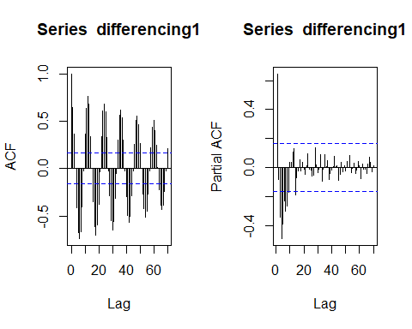

#Cek kestasioneran data  
adf.test(differencing1)

## Warning in adf.test(differencing1): p-value smaller than printed p-value

##   
## Augmented Dickey-Fuller Test  
##   
## data: differencing1  
## Dickey-Fuller = -10.846, Lag order = 5, p-value = 0.01  
## alternative hypothesis: stationary

#Differencing 1 musiman 12 dari data yang sudah di differencing 1 non musiman  
diffnonmus_mus12 <- diff(differencing1, lag = 12)  
diffnonmus_mus12

## [1] 2.000000e+00 2.000000e-01 4.300000e+00 5.000000e-01 -4.000000e-01  
## [6] 4.000000e-01 2.100000e+00 -1.400000e+00 3.300000e+00 -4.600000e+00  
## [11] 1.330000e+01 -1.680000e+01 8.200000e+00 1.070000e+01 -1.390000e+01  
## [16] -7.400000e+00 9.600000e+00 1.000000e-01 -1.800000e+00 7.000000e-01  
## [21] -1.200000e+00 5.000000e-01 -6.300000e+00 1.760000e+01 -1.800000e+01  
## [26] 4.500000e+00 6.000000e+00 -2.800000e+00 -6.000000e-01 -4.300000e+00  
## [31] 1.600000e+00 2.600000e+00 -1.200000e+00 -2.900000e+00 5.400000e+00  
## [36] -3.800000e+00 8.300000e+00 -7.000000e-01 -3.500000e+00 -4.000000e-01  
## [41] -1.800000e+00 1.600000e+00 3.500000e+00 -4.800000e+00 1.800000e+00  
## [46] 1.000000e+00 -7.900000e+00 2.000000e-01 8.600000e+00 -1.430000e+01  
## [51] 7.400000e+00 6.700000e+00 -8.800000e+00 6.900000e+00 1.421085e-14  
## [56] -1.000000e-01 -4.400000e+00 1.500000e+00 1.300000e+00 -5.300000e+00  
## [61] 5.000000e-01 7.100000e+00 1.000000e-01 9.000000e-01 2.900000e+00  
## [66] -5.800000e+00 -1.200000e+00 1.700000e+00 4.500000e+00 -2.600000e+00  
## [71] 9.000000e-01 -6.000000e-01 -1.800000e+00 -2.800000e+00 8.000000e-01  
## [76] -4.800000e+00 1.090000e+01 -9.300000e+00 7.000000e-01 5.900000e+00  
## [81] 2.000000e+00 -3.500000e+00 3.000000e+00 -1.900000e+00 -4.800000e+00  
## [86] 4.000000e+00 -5.200000e+00 1.050000e+01 -1.330000e+01 9.000000e+00  
## [91] 2.300000e+00 -7.300000e+00 -8.300000e+00 6.200000e+00 -5.500000e+00  
## [96] 1.970000e+01 -8.000000e-01 3.000000e+00 -1.000000e+01 -8.300000e+00  
## [101] 9.300000e+00 -4.000000e-01 -1.400000e+00 -3.000000e-01 9.200000e+00  
## [106] -4.300000e+00 -2.200000e+00 -8.000000e+00 -3.000000e-01 -2.900000e+00  
## [111] 1.210000e+01 -4.700000e+00 -4.400000e+00 6.800000e+00 -6.900000e+00  
## [116] 4.000000e-01 -7.105427e-15 3.600000e+00 6.300000e+00 -2.300000e+00  
## [121] -3.700000e+00 -8.700000e+00 1.700000e+00 1.490000e+01 -2.300000e+00  
## [126] -6.700000e+00 6.000000e+00 -4.400000e+00 2.100000e+00 2.100000e+00  
## [131] -3.100000e+00

#Plot time series, plot ACF dan PACF data hasil differencing data non musiman dan musiamn 12  
ts.plot(diffnonmus_mus12)  
par(mfrow = c(1,2))

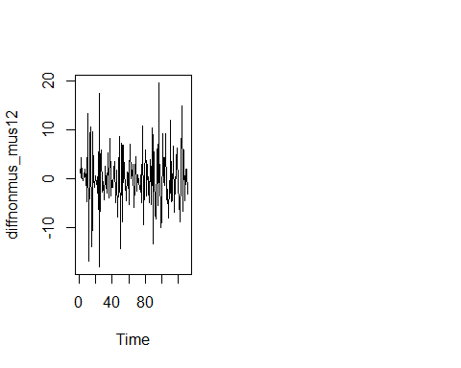

acf(diffnonmus_mus12, lag.max = 70)  
pacf(diffnonmus_mus12, lag.max = 70)

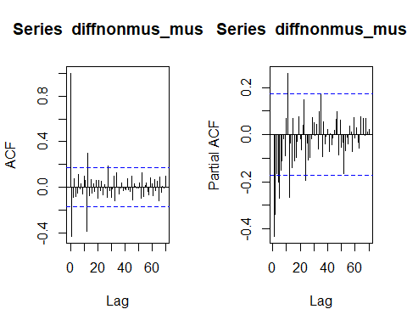

#Cek kestasioneran data  
adf.test(diffnonmus_mus12)

## Warning in adf.test(diffnonmus_mus12): p-value smaller than printed p-value

##   
## Augmented Dickey-Fuller Test  
##   
## data: diffnonmus_mus12  
## Dickey-Fuller = -8.3645, Lag order = 5, p-value = 0.01  
## alternative hypothesis: stationary

#Model ARIMA(0,0,0)(0,1,1), periode = 12  
fit <- arima(Temperatur, order = c(0, 0, 0), seasonal = list(order = c(0, 1, 1), period = 12), method = "ML")  
fit

##   
## Call:  
## arima(x = Temperatur, order = c(0, 0, 0), seasonal = list(order = c(0, 1, 1),   
## period = 12), method = "ML")  
##   
## Coefficients:  
## sma1  
## -1.0000  
## s.e. 0.0968  
##   
## sigma^2 estimated as 11.7: log likelihood = -364.54, aic = 733.07

#diagnostic checking  
#1. uji kesignifikanan parameter: uji t  
coeftest(fit)

##   
## z test of coefficients:  
##   
## Estimate Std. Error z value Pr(>|z|)   
## sma1 -1.000000 0.096805 -10.33 < 2.2e-16 ***  
## ---  
## Signif. codes: 0 '***' 0.001 '**' 0.01 '*' 0.05 '.' 0.1 ' ' 1

#2. pengujian residual apakah white noise  
Box.test(fit$residuals, type = "Ljung")

##   
## Box-Ljung test  
##   
## data: fit$residuals  
## X-squared = 0.90995, df = 1, p-value = 0.3401

#3. pengujian residual apakah berdistribusi normal  
shapiro.test(fit$residuals)

##   
## Shapiro-Wilk normality test  
##   
## data: fit$residuals  
## W = 0.98414, p-value = 0.09554

#Shapiro-Francia normality test  
sf.test(fit$residuals)

##   
## Shapiro-Francia normality test  
##   
## data: fit$residuals  
## W = 0.98359, p-value = 0.07688

#Forecasting untuk 12 tahap ke depan berdasarkan model terbaik  
forecasting <- forecast(Temperatur, model = fit, h = 12)  
forecasting

## Point Forecast Lo 80 Hi 80 Lo 95 Hi 95  
## 145 16.59167 12.02927 21.15406 9.61408 23.56925  
## 146 20.65000 16.08760 25.21240 13.67241 27.62758  
## 147 32.47500 27.91260 37.03740 25.49741 39.45258  
## 148 46.52500 41.96260 51.08739 39.54741 53.50258  
## 149 58.09166 53.52926 62.65406 51.11408 65.06925  
## 150 67.49999 62.93760 72.06239 60.52241 74.47758  
## 151 71.71666 67.15426 76.27906 64.73908 78.69425  
## 152 69.33333 64.77093 73.89573 62.35574 76.31091  
## 153 61.02499 56.46260 65.58739 54.04741 68.00258  
## 154 50.97500 46.41260 55.53739 43.99741 57.95258  
## 155 36.65000 32.08760 41.21239 29.67241 43.62758  
## 156 23.64166 19.07927 28.20406 16.66408 30.61925

plot(forecasting, main = "Plot Hasil Peramalan")

