WEPRO · SALES & LEASING DIVISION
Team Sales Performance Report
Period: 22 August – 21 September 2026
Prepared 21 September 2026
Source: WhatsApp lead pipeline (Supabase) — 2,022 leads · 8,766 logged activities · 24 active seats · 7 teams

Executive Summary
Across 7 sales teams and 24 active seats, this report summarizes the full lifetime of the WhatsApp lead pipeline through 21 September 2026.

Total leads | 2,022 | Connected | 1,116 (55%)
Meetings set | 366 | Site visits done | 25
Deals won | 5 (7 lost) | Revenue closed | BDT 9.87 Cr
Calls logged | 1,863 (32 talk hrs)

Lead Volume — Last 30 Days
Daily new-lead intake shows a sharp surge beginning 15 September: the four days before this report average 116 leads/day, against a 20/day baseline for the rest of the window.
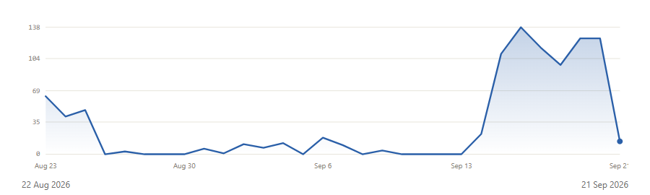

Pipeline Funnel
Every lead ever logged, by furthest stage reached. Deal Lost and Not Interested are exits; Deal Won is highlighted in green.
Stage | Leads | Share
New | 745 | 37%
Contacted | 455 | 23%
Interested | 93 | 5%
Meeting Set | 329 | 16%
Visit Scheduled | 4 | 0%
Visit Done | 20 | 1%
Negotiating | 1 | 0%
Deal Won | 5 | 0%
Deal Lost | 7 | 0%
Not Interested | 366 | 18%

Team Standings
Ranked by closed revenue. Connect rate is the share of a team’s leads ever reached (talked, or advanced past Contacted).
[object Object] | Seats | Leads | Connect | Calls | Won | Revenue
Team Dhaka's Team | 5 | 571 | 50% | 1,077 | 2 | BDT 6.43 Cr
Team DUBAI's Team | 3 | 510 | 14% | 99 | 2 | BDT 2.30 Cr
Maruf Alam's Team | 3 | 223 | 84% | 122 | 1 | BDT 1.14 Cr
Shabbir Newaz's Team | 3 | 247 | 70% | 142 | 0 | —
Masud Chowdhury's Team | 3 | 235 | 94% | 215 | 0 | —
Hillol Chowdhury's Team | 3 | 218 | 75% | 185 | 0 | —
Land's Team | 1 | 11 | 55% | 6 | 0 | —
Unassigned | 2 | 5 | 100% | 17 | 0 | —
Unassigned | 1 | 2 | 100% | 0 | 0 | —

Agent Leaderboard
All 24 active seats, ranked by closed revenue then connect rate. † marks a shared desk account (e.g. a team inbox), not an individual rep.
Agent | Team | Role | Leads | Connect | Calls | Meet. | Visits | Won | Revenue
REZAUL HAQUE LIMON | Team Dhaka's Team | Team Lead | 4 | 100% | 0 | 0 | 0 | 2 | BDT 6.43 Cr
Team DUBAI † | Team DUBAI's Team | Team Lead | 2 | 100% | 23 | 0 | 0 | 2 | BDT 2.30 Cr
Maruf Alam | Maruf Alam's Team | Team Lead | 8 | 75% | 1 | 0 | 0 | 1 | BDT 1.14 Cr
Parvez | Shabbir Newaz's Team | Meeting Agent | 68 | 100% | 8 | 0 | 0 | 0 | —
Mohidul | Maruf Alam's Team | Meeting Agent | 119 | 100% | 5 | 0 | 2 | 0 | —
Obaidullah Bin Faruk | Hillol Chowdhury's Team | Meeting Agent | 58 | 100% | 1 | 0 | 2 | 0 | —
Shoaib | Masud Chowdhury's Team | Meeting Agent | 41 | 100% | 19 | 0 | 5 | 0 | —
Unknown † | Unassigned | Unknown | 2 | 100% | 0 | 0 | 0 | 0 | —
Anika | Unassigned | Meeting Agent | 5 | 100% | 1 | 0 | 3 | 0 | —
Masud Chowdhury | Masud Chowdhury's Team | Team Lead | 4 | 100% | 0 | 0 | 0 | 0 | —
Meeting (dubai) † | Team DUBAI's Team | Meeting Agent | 30 | 100% | 2 | 0 | 2 | 0 | —
Hillol Chowdhury | Hillol Chowdhury's Team | Team Lead | 1 | 100% | 0 | 0 | 0 | 0 | —
Nasrin | Masud Chowdhury's Team | Initial Agent | 190 | 93% | 196 | 45 | 0 | 0 | —
Kamrul Shikdar | Team Dhaka's Team | Meeting Agent | 29 | 90% | 42 | 0 | 11 | 0 | —
Md.Azizul Haque | Team Dhaka's Team | Initial Agent | 321 | 67% | 542 | 3 | 0 | 0 | —
Any † | Hillol Chowdhury's Team | Initial Agent | 159 | 65% | 184 | 59 | 0 | 0 | —
Afrina Rashid | Maruf Alam's Team | Initial Agent | 96 | 65% | 116 | 125 | 0 | 0 | —
Jannat | Shabbir Newaz's Team | Initial Agent | 179 | 59% | 131 | 68 | 0 | 0 | —
Mainul | Land's Team | Executive | 11 | 55% | 6 | 0 | 0 | 0 | —
Israt Jahan Tania | Team Dhaka's Team | Initial Agent | 124 | 30% | 94 | 1 | 0 | 0 | —
Dubai(Initial) † | Team DUBAI's Team | Initial Agent | 478 | 8% | 74 | 32 | 0 | 0 | —
Mehjabeen Mumtaha Rahman | Team Dhaka's Team | Initial Agent | 93 | 8% | 399 | 26 | 0 | 0 | —
Naimul Islam | Unassigned | Initial Agent | 0 | 0% | 16 | 7 | 0 | 0 | —
Shabbir Newaz | Shabbir Newaz's Team | Team Lead | 0 | 0% | 3 | 0 | 0 | 0 | —

Lead Source Mix
Where the 2,022 leads in this book originated.
Source | Leads | Share
WhatsApp Ads | 1,492 | 74%
LinkedIn | 250 | 12%
Event | 218 | 11%
Personal | 26 | 1%
Unspecified | 23 | 1%
Team Lead | 11 | 1%
Meta Ads | 4 | 0%
Hotline | 1 | 0%

Methodology & Notes
Revenue: counts only leads with status Deal Won, summed on deal value.
Connect rate: share of a person’s leads either flagged talked or that reached Contacted or later, over leads assigned. Calls, meetings and visits are counted from the activity log and lead-record flags, not estimated.
Reading the leaderboard: Deal Won volume is thin (5 across the whole book), so the revenue column reflects which deals closed, not a stable per-agent close rate. Weight connect rate and call volume more heavily for day-to-day coaching decisions.
Shared accounts: “Any”, “Team DUBAI”, “Dubai(Initial)” and “Meeting (dubai)” are shared desk accounts routed through a single login, not individual reps — marked † in the leaderboard.
Report data as of 21 September 2026, 05:11 UTC.

